Title (WIP): Across-host population genetics analysis reveals disparate trends of demographic history in oral and gut microbiota

Introduction (WIP)

Previous studies show broad reductions in genetic diversity in the human gut microbiome when urbanizing diets (Sonnenburg, Shnorr 2014, Wibowo). Sonnenburg et. al show that when comparing human populations in hunter-gatherer societies and human populations in urbanized societies, urbanized populations demonstrate a reduction of within-species genetic diversity. This reduction of genetic diversity can be attributed to a combination of factors, including changes in both environmental and behavioral conditions, e.g., diet and hygiene. The effect of these reductions in genetic diversity has been shown to be associated with increased vulnerability of the immune system (Sonnenburg) and elevated rates of horizontal gene transfer (Groussin). Similar trends of reduction in genetic diversity due to urbanization have been found in Prevotella copri (Tett), while an opposite trend has been found in various species present in the oral microbiome, e.g., Strep (Achtman, Zhou, Cornejo). Here, we examine within-species changes in genetic diversity in both the oral and gut microbiomes due to human urbanization. This has broad implications for both translational medical questions concerning the immune system and antibiotics as well as fundamental basic evolutionary biology questions concerning human demographic and microbial evolution.

* Previous studies show broad reductions in genetic diversity in the microbiome when urbanizing diets.
  + Not just diet, also sanitation (hygiene hypothesis)
  + Also Antibiotics -- Read (Missing Microbes)
* Within-species genetic diversity is reduced for many prevalent species when transitioning from hunter-gatherer to agricultural society (Sonnenburg)
  + Tie in with general health effects? E.g., “Vulnerability of the industrialized microbiota (Sonnenburg)
  + Elevated rate of HGT (Groussin)
* Not only are we losing wihin species diversity, but we are also losing whole clades, as seen in Prevotella (Tett 2019)
* Here we examine within-species changes in genetic diversity due to urbanization etc. (Sonnenburg, Schnorr 2014, Wibowo)
* Mention with context of species-specific work, e.g., Cornejo (strep), Tett 2019 and 2021 (P. copri), Achtman and Zhou (Strep), Hershberg (M. tuberculosis) + Liu + Pepperell 2013
* Mention with context of linking human demographics with microbiome, e.g., Eisenhofer (Japan), Nandita’s 2019 paper,

Results

1. Pi between Madagascar / Ethiopian populations vs. HMP data
   1. A priori expectation is that there is a difference in pi between these two populations
   2. Possibly some form of table which shows the values (placeholders relative to difference between two populations)  
        
      I expect there to be more nucleotide diversity in the oral microbiome when transitioning to an urbanized microbiome as shown in Cornejo. I expect the opposite trend in the gut microbiome based on our preliminary data

|  |  |  |
| --- | --- | --- |
|  | Rural | Urbanized |
| Oral | Expect lower pi | Expect higher pi |
| Gut | Expect higher pi | Expect lower pi |

* 1. If possible, it’d be nice if we could show rural vs urbanized microbiome for both oral and gut

1. SFS of prevalent microbial species (maybe multiple species), perhaps *Prevotella*?  
   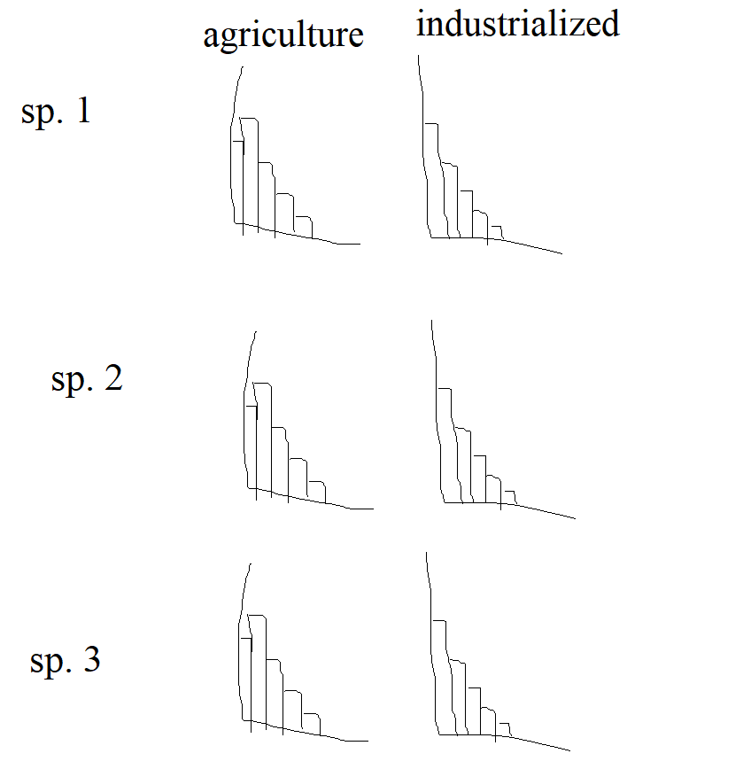
   1. A priori I expect that in urbanized populations there is a relative increase in common variants in the gut microbiome due to demographic contractions. I think it’d be cool to display this as some form of panel where we show the same array of species in different human populations but with an (ideally) visual difference in trend.
2. SFS with negative selection  
   Chart, bar chart

   Description automatically generated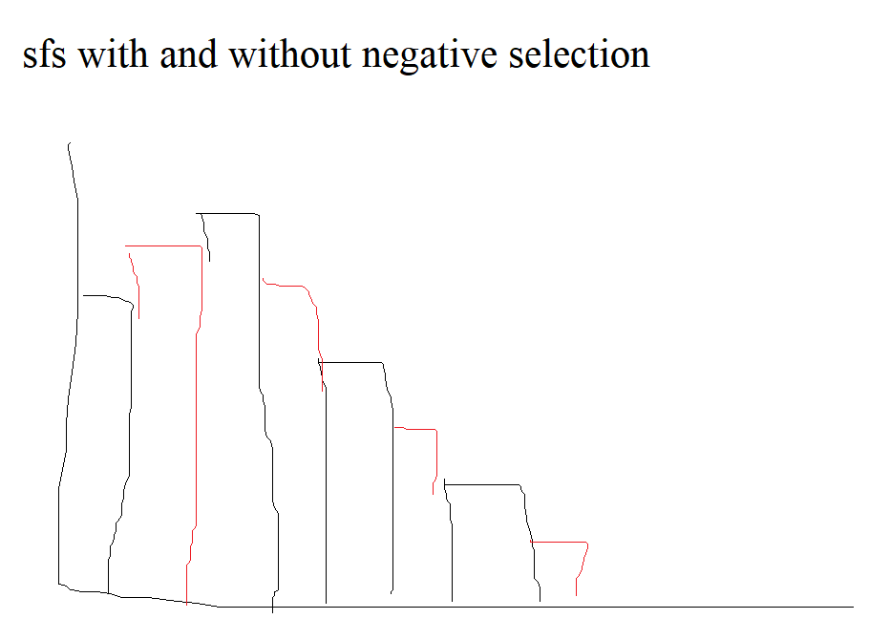  
   I think we should frame this similarly to how negative selection is addressed in Cornejo. In summary, when accounting for negative selection in our model, we are able to fit a model SFS which has better(?) model fit than an sfs without negative selection, which suggests that our data has undergone negative selection 🡪 further evidence for population bottleneck.
   1. We can contrast the sfs with negative selection for rural vs. urbanized microbiomes.
      1. Maybe urbanized has more negative selection, or the incorporation of negative selection has better fit for the urbanized model(haven’t checked this out yet)
3. Demographic modelsDiagram

   Description automatically generated
   1. A picture containing scatter chart

      Description automatically generatedTimeline

      Description automatically generated with low confidence
   2. We can do this kind of figure for other summary statistic.
   3. Ideally some sort of large summary figure which shows a clear difference between fecal and oral bacteria
   4. Prioritize data for urbanized populations as demographic inference will tell us what happened since migration out of Africa.
4. Model comparison or evaluation metric, e.g., LD
   1. If this does not work correctly, we can describe how to improve models
   2. This can probably be shown with a table for each species, or something along those lines. Alternatively, this is really data heavy so maybe something for the supplement?

|  |  |  |  |  |  |
| --- | --- | --- | --- | --- | --- |
| Species 1 | | | | | |
| Model | LL | N_a | N_e | T1 | T2 |
| 2 epoch |  |  |  |  |  |
| 3 epoch |  |  |  |  |  |
| Bottleneck |  |  |  |  |  |
| Exp. Growth |  |  |  |  |  |

1. Possibly phylogeny or some different method to validate model findings  
   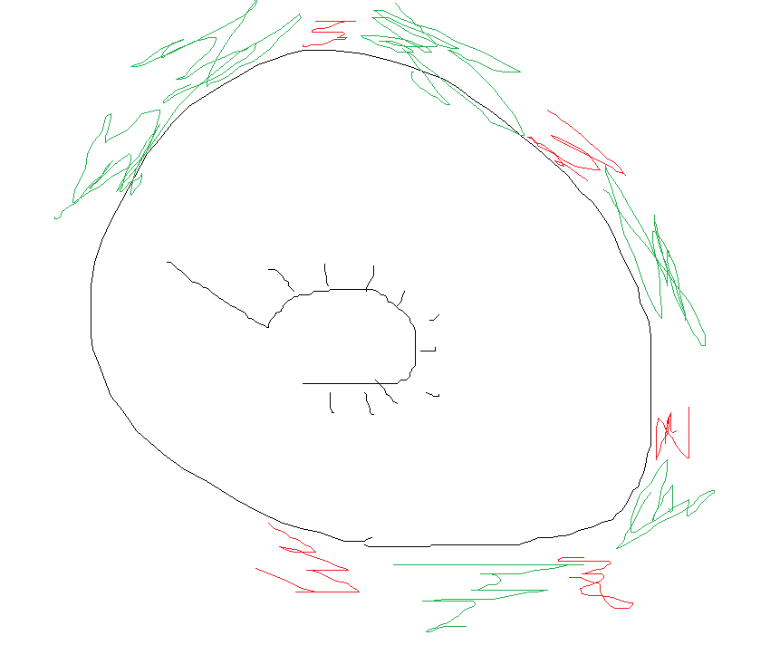  
   I’m thinking something like a phylogenetic tree diagram (like this one):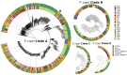  
   where we show in green clades which have persisted from rural to urbanized and then in red we show clades which only exist in rural microbiomes. In this way we can demonstrate that there is loss of clade and/or loss of genetic diversity associated with urbanization of the human microbiome.

Discussion

* Pending on results
* In summary, I think our big takeaway is that we can:
  + Perform within-species population genetics and demographics analysis on a wide array of microbiome species (oral and gut)
  + When doing so, we find that (RESULTS PENDING) there is an environment-wide increase in genetic diversity in the oral microbiome when urbanizing the diet / microbiome, and vice versa for the gut microbiome
  + This has *implications* (I need to read more about the implications) for human health