REPORT
Introduction
This website was made to highlight my abilities and advancements in web development, showcasing my real-world application of HTML, CSS, and JavaScript for academic purposes. My professor at the university is supposed to evaluate my technical skills, learning progress, and comprehension of fundamental web technologies.

I planned my website by first identifying its purpose and intended audience, which guided my layout and design choices. I chose a clean and simple layout to ensure the content is easy to navigate and clearly present my skills and progress. The structure was organised into clear sections, with consistent spacing and colouring to maintain readability and professionalism. These layout choices were made to highlight functionally over decoration, allowing the focus to remain on demonstrating my understanding of HTML, CSS and Java Script.

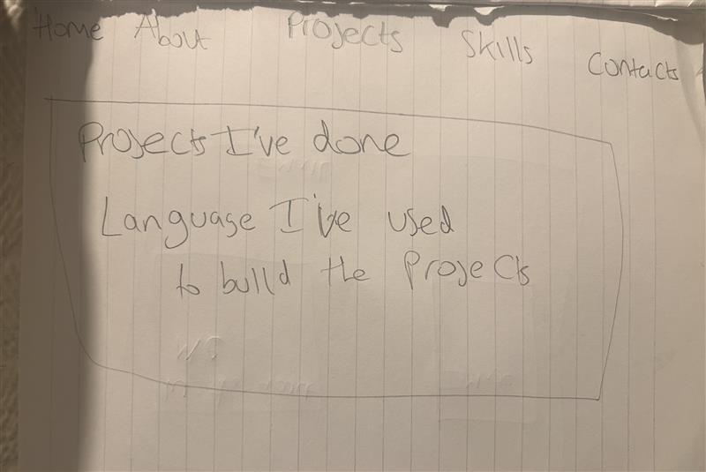
WIREFRAME
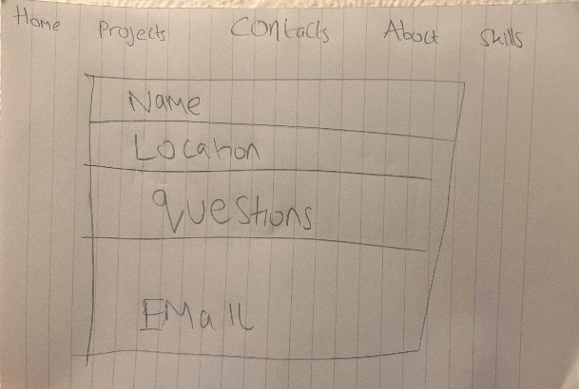

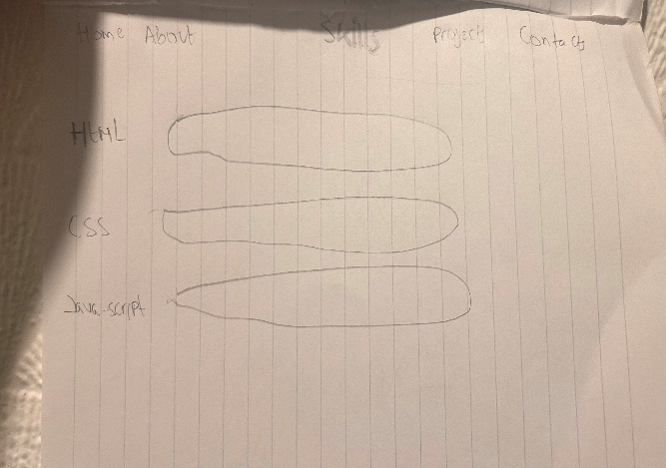
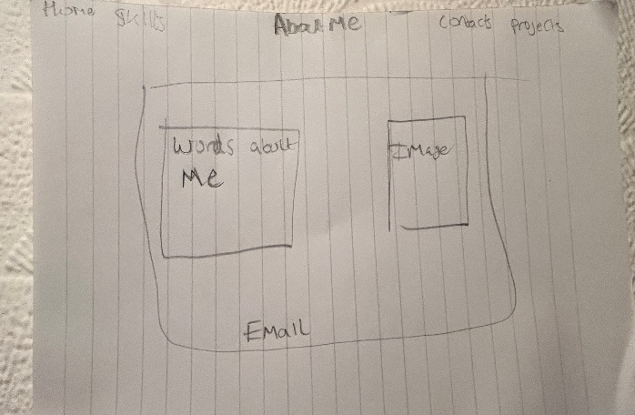

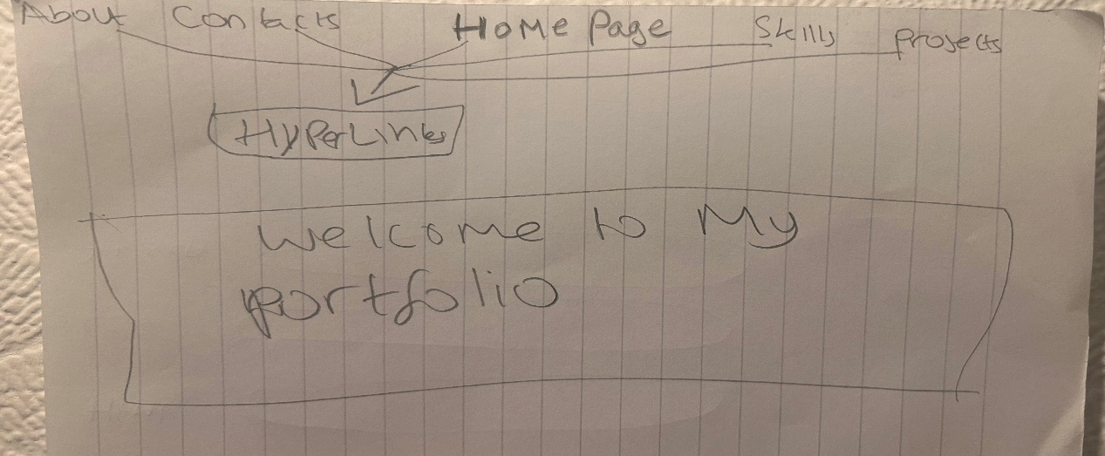

This wireframe shows the basic layout and structure of a website with five main pages: the Home page, About Me page, Projects page, Skills page, and Contact page. It emphasizes usability and clear navigation over visual design. The Home page acts as the main entry point, guiding users with a simple header and navigation menu for easy access to all other pages. The About Me page presents background information clearly, helping users understand who the site is about. The Projects page displays work or achievements in a clean, logical layout, making it easy for users to browse and explore different projects. The Skills page lists key abilities in a straightforward way for better clarity and quick understanding. The Contact page makes communication simple and accessible, with clearly placed contact details or forms. Overall, the wireframe focuses on simplicity, accessibility, and intuitive navigation. It provides a solid foundation for future design and development while ensuring users can easily find information and navigate the website.

HTML STRUCTURE
The Page structure was built using HTML with a clear logical layout to improve readability and accessibility. I used semantics HTML elements such as <header> for the top section of the page, <nav> for navigation links so it can take me page after page. <main> to contain the primary content, <section> to group related information and lastly <footer> for the bottom of the page. These semantics elements help define the purpose of each page of my website. These syntax makes my website more organised, Easier to maintain and more accessible for users especially for my professor.

CSS DESIGN CHOCIES
My CSS design choice was to focus much more on the colouring especially in the background so my website can look very professional. I selected a background choice so my entire background can look very professional and readable so that people can enjoy looking at my website and so that they can get to know more about me and my design.

JAVASCRIPT FUNCTIONAILTY
The JAVASCRIPT functionality was implemented on the contacts page to allow users to interact with the website by asking questions. JAVASCRIPT is used to handle form interactions such as validating user inputs and providing feedbacks, ensuring the contact process is clear and user-friendly. This functionality demonstrates my ability to use JavaScript to add interactivity improve the overall user experience of the website.

FILE MANAGEMENT
The website file is organised in a clear and structured way to make the project easy to manage and maintain. HTML files are stored separately from the CSS style page and JAVASCRIPT, with the CSS files placed in a dedicated styles folder and JAVASCRIPT files in a script folder. Images media are stored onto, above the HTML pages. This file structure helps improve readability, makes updates easier and reflects good web development practices.
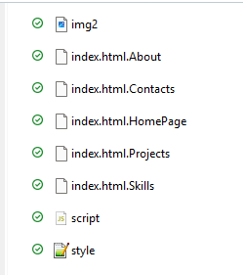


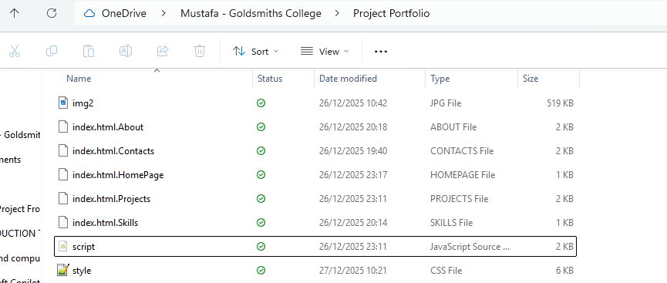

REFLECTION
Overall, the development of my website went well and helped me strengthen my understanding of HTML, CSS and JAVASCRIPT. I successfully created multiple web pages and linked them all together, allowing smooth navigation from page to page. I was able to structure content correctly using html, style the website professionally with CSS and add interactivity with JavaScript. This project helped me improve my confidence in combining all three technologies to build a functional and well-organised website. The challenges I uncounted was that I struggled to make the hyperlink pages look professional and that also happened in my previous group project and thankfully I improved on it. The future improvements I would make if I would make a website for anyone, I would make it more professional and interactive.
WEBSITE LINK
file:///C:/Users/asus/OneDrive%20-%20Goldsmiths%20College/Project%20Portfolio/index.html.Contacts

