FieldSync
Worker Quick-Start Guide
Everything you need to know to use FieldSync —
check your shifts, request time off, and sync your calendar.
Spring Creek & Mission Viejo Youth Baseball / Softball
Season 2026

1. Signing In
Open FieldSync in your browser on any device — phone, tablet, or computer. No app download needed.

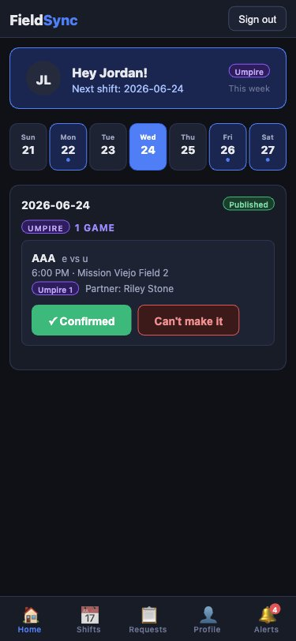 | Steps to log in  1. Tap the Worker button at the top of the login screen.  2. Enter the email address your manager set up for you.  3. Enter your password and tap Sign in.  💡 Forgot your password? Tap "Forgot password?" on the login screen. Your manager will be notified to reset it.  What you see after logging in  • Your name and role badge (Umpire, Field Crew, or Concessions)  • Your next upcoming published shift  • A week strip showing which days you work  • Today's game details with Confirm / Can't make it buttons

2. Home — Today's View
The Home screen is your daily dashboard. When you log in, it opens automatically and shows what's happening today.

 | Reading the week strip  The 7-day strip across the middle shows the current week. Tap any day to see that day's shift details.  A blue dot under a date means you have a published shift that day.  Confirming your shift  Each game card shows the division, time, location, and your partner (for umpires). Tap the button that applies:  ✅. Confirmed — you're planning to be there.  ❌. Can't make it — alerts your manager to find a replacement.  💡 Only published shifts appear on your Home screen. If you don't see a shift yet, the manager hasn't published that week.

3. My Shifts
My Shifts shows your full season schedule — every game or crew day you're assigned to, past and upcoming.

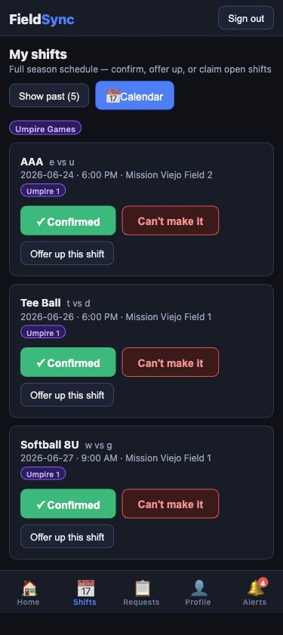 | What you can do here  Your shifts are grouped by role (Umpire Games, Field Days, etc.) and listed chronologically.  Confirm or decline  Each shift card has Confirmed and Can't make it buttons — same as on the Home screen.  Offer up a shift  If you can't make a shift, tap Offer up this shift to post it to the open-shift board. Another available worker can then claim it.  Show past shifts  Tap Show past to see previous shifts for the season. Useful for tracking your hours.  Sync your calendar  • Tap the Calendar button at the top of My Shifts.  • Tap "Generate my calendar link" — this creates a personal feed.  • Choose Apple Calendar, Google Calendar, or Outlook.  • Your shifts will appear and update automatically when the manager publishes changes.

4. Requests
Use the Requests tab to submit time-off requests or schedule swaps. Your manager reviews and approves them.

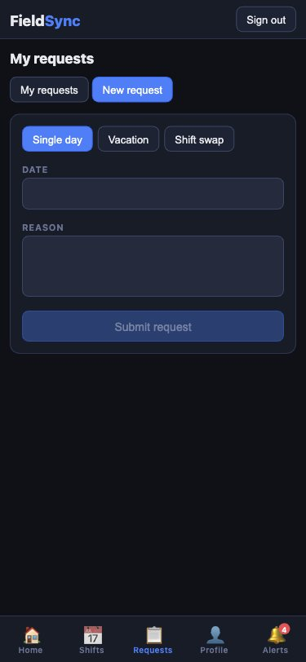 | Submitting a time-off request  1. Tap the Requests tab at the bottom of the screen.  2. Tap New request.  3. Select Time Off as the request type.  4. Pick the date (or date range) you need off.  5. Add a reason if you like, then tap Submit.  Requesting a shift swap  1. Tap New request → Shift Swap.  2. Select the date and location of the shift you want to swap.  3. Add a note explaining the swap and tap Submit.  💡 Submit requests as early as possible. The manager needs time to find coverage and re-publish the schedule.  Tracking your requests  • Tap My requests to see all requests you've submitted.  • Pending = under review. Approved = confirmed. Denied = not approved.  • You'll receive an alert notification when the manager acts on your request.

5. My Profile
Update your contact info, availability, and password from the Profile tab.

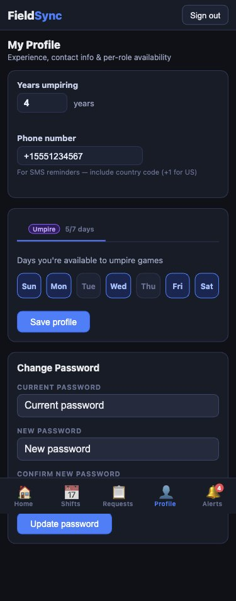 | Years of experience  Enter your years of experience. The manager uses this for scheduling — more senior workers get first pick of shifts.  Phone number  Add your phone number (include country code, e.g. +1). This is used for SMS shift reminders.  Availability  Toggle each day of the week on or off to show which days you can work. If you hold multiple roles, you'll see a separate availability tab for each role.  Tap Save profile when done.  Change password  Enter your current password, then your new password twice, and tap Update password.  💡 Keep your availability up to date. The scheduler uses it to auto-assign crew — if a day is marked unavailable, you won't be scheduled that day.

6. Alerts
The Alerts tab shows all notifications from your manager — schedule updates, reminders, rainouts, and request outcomes.

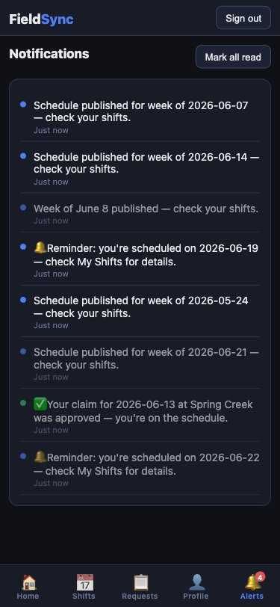 | Types of alerts  Schedule published — the manager has published a week and your shifts are now visible.  Shift reminder — a heads-up that you're on the schedule soon.  Claim approved — a shift you claimed from the open board was approved.  Rainout — a game has been cancelled due to weather.  Mark as read  Tap Mark all read to clear the notification badge. Unread alerts show as blue dots.  The red badge on Alerts  • The number on the bell icon shows how many unread notifications you have.  • Always check Alerts after the manager publishes a new week.  • Rainout notifications are urgent — they mean a game is cancelled.

Quick Reference

I want to… | Go to…
See today's shift | Home tab → today's game card
Confirm I'm coming | Home or Shifts → tap Confirmed
Report I can't make it | Home or Shifts → tap Can't make it
See my full schedule | Shifts tab
Add shifts to my calendar | Shifts tab → Calendar button → Generate link
Offer up a shift | Shifts tab → shift card → Offer up this shift
Request time off | Requests tab → New request → Time Off
Request a shift swap | Requests tab → New request → Shift Swap
Update my availability | Profile tab → toggle days → Save profile
Check for schedule updates | Alerts tab
Change my password | Profile tab → Change Password section
Reset a forgotten password | Login screen → Forgot password?
Questions? Contact your manager.

