 | INDIAN INSTITUTE OF TECHNOLOGY ROORKEE
Programming in C and C++ (CSC-101)

Assignment 1 : Prerequisite for C programming (Understanding basic of Linux)
All the below questions will be done on Linux Terminal using commands

Garv

25114035

Problem 1: Creating directory and Files in Linux

- In the home directory create a folder named <Your_Rollnum>.
- Write appropriate commands to go inside the folder created and create a folder named Assignment1.
- Inside Assignment1, create three subdirectories: Question1, Question2, Question3, Question4, Question5 .
- Inside Question1, create five empty files named log1.txt to log5.txt in one single command. List the contents of the current directory.
- Verify the directory structure using the appropriate command. Install the corresponding package to see the directory structure

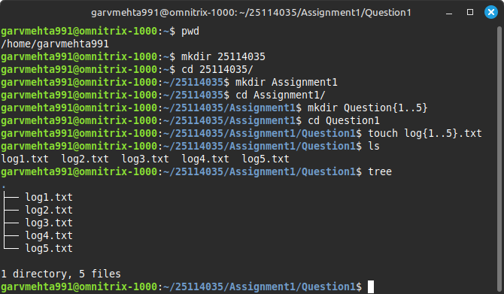

Problem 2: Adding and Modifying the contents of a file

- Go to the folder Question2, create a new empty file named notes.txt.
- Add the text “Welcome to Linux Lab” into notes.txt (without opening an editor).
- Append a new line “This is the second line.” to the same file without erasing the previous content without using the editor.
- Display the contents of notes.txt on the terminal.
- Overwrite the file notes.txt so it only contains “Linux is powerful!”.
- Append the output of the date command to notes.txt.
- Append the names of all .txt files in the current directory into notes.txt using the command line.
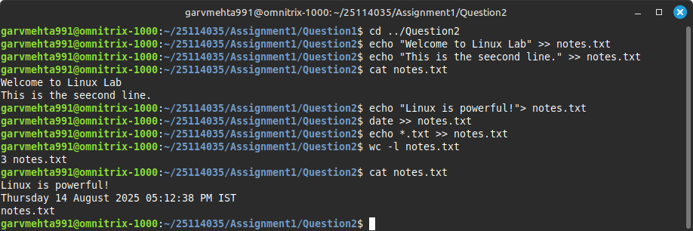
- Verify the number of lines in notes.txt.

Problem 3: Renaming , copying and moving files

- Inside Question3, create the following empty files file1.txt, file2.txt, file3.txt
in a single command.
- Rename file1.txt to report.txt. Copy report.txt into a new file named
report_backup.txt (in the same folder).
- Create a subdirectory named Archive inside Question3 and move file2.txt
into it.
- Copy all .txt files from Question3 into Archive in one single command.
- Rename file3.txt to data_2025.txt. Create three files named data_2024.txt,data_2023.txt,data_2022.txt in the current directory. Move all files starting with data into the Archive folder.
- Create a folder Backup inside your home directory and copy the entire Question3 folder (including its files & subdirectories) into Backup.
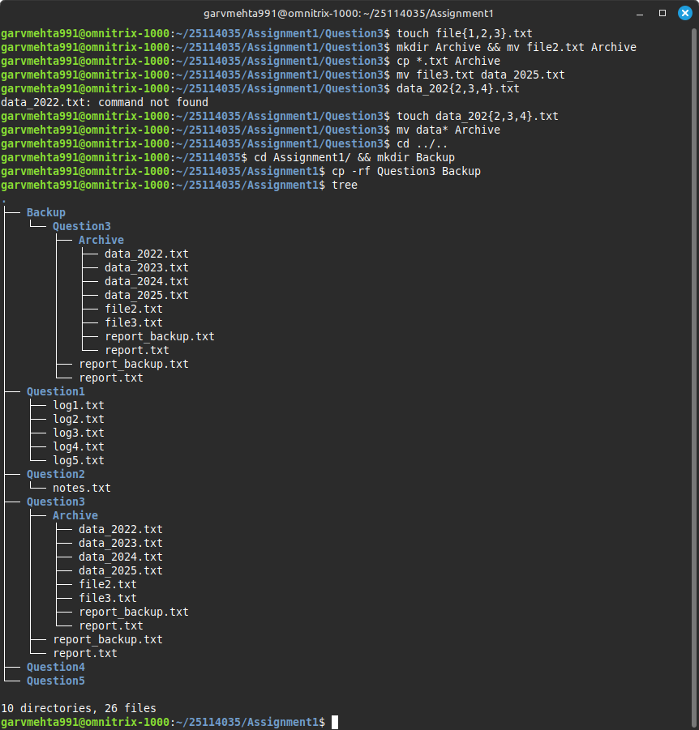

Problem 4: Modifying and changing permission of the files

- In the directory named Question4 in your home directory, create a file
notes.txt and add some text to it. View the current permissions of notes.txt.
- Remove the write permission for others on notes.txt. Add execute permission for the owner of notes.txt.
- Create three new files in Lab4 in a single command.
  - Give read-only permission to everyone for file1.txt.
  - Give read & write permission to owner, but read-only to group & others for file2.txt.
  - Make file3.txt executable by everyone.
- Create a subdirectory Scripts inside Lab4 and give all permission to everyone

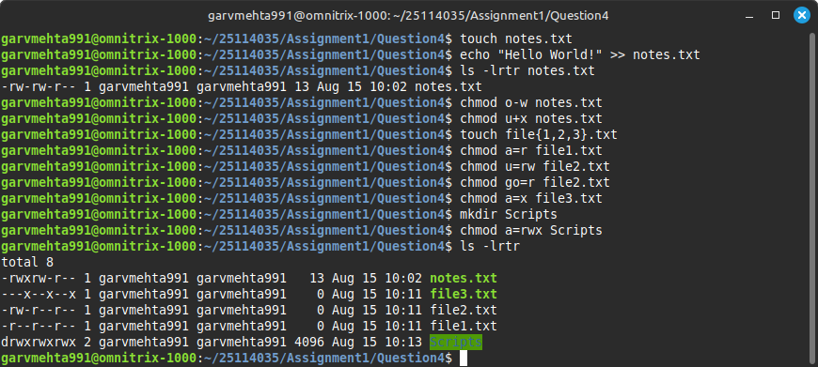

Problem 5: Writing the first C program, compiling and running

- Inside the directory Question5 in your current directory create a new file MyfirstProgram.c and write a simple C program that prints “Hello World”.
- Compile the program using gcc and generate an executable named hello. Run the program and capture its output.
- Modify the program to also print

“Bingo!!! I learnt to compile and run a C program in Linux!!! I will always use Linux for programming in future.”
- Compile hello.c with all warnings enabled (-Wall) and save the executable as hello_v2. Run the program with hello_v2 and check if it works without warnings.

