 | INDIAN INSTITUTE OF TECHNOLOGY ROORKEE
Programming in C and C++ (CSC-101)

Assignment 2 (Basics of printf)

Garv
25114035

Q-1) Write a C program to print the following using a single printf statement.
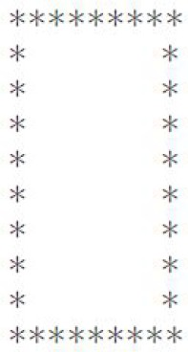
[5 marks]
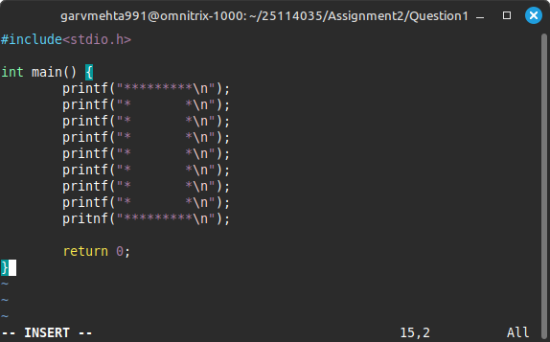
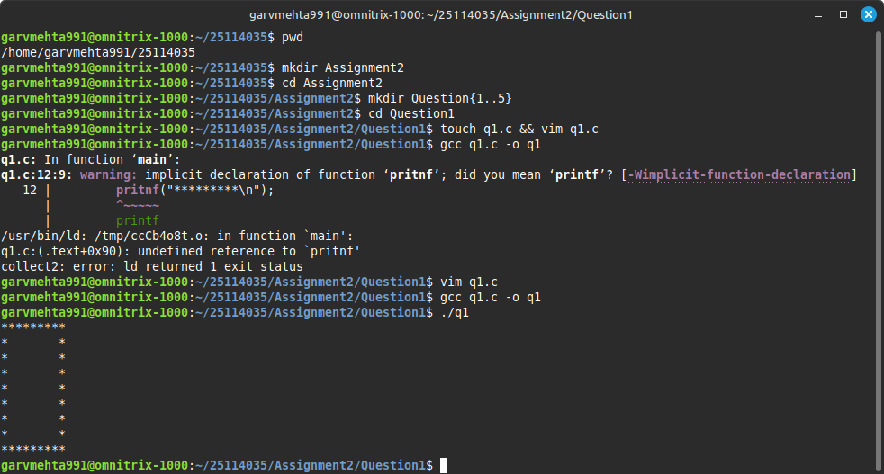

Q-2) Write a C program to print your Name, Roll No and Branch on the terminal. Compare the preprocessed file, assembly file and object file generated using the gcc command. Explain your observation. [10 marks]
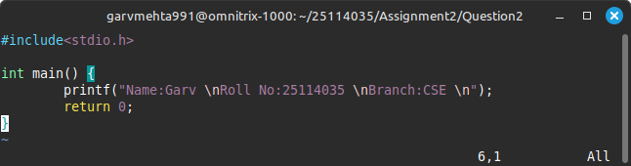
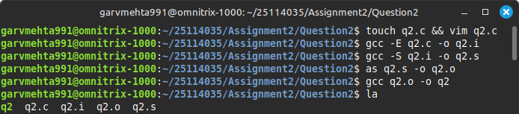
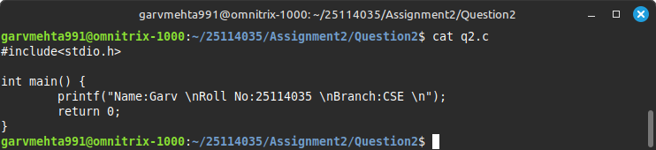
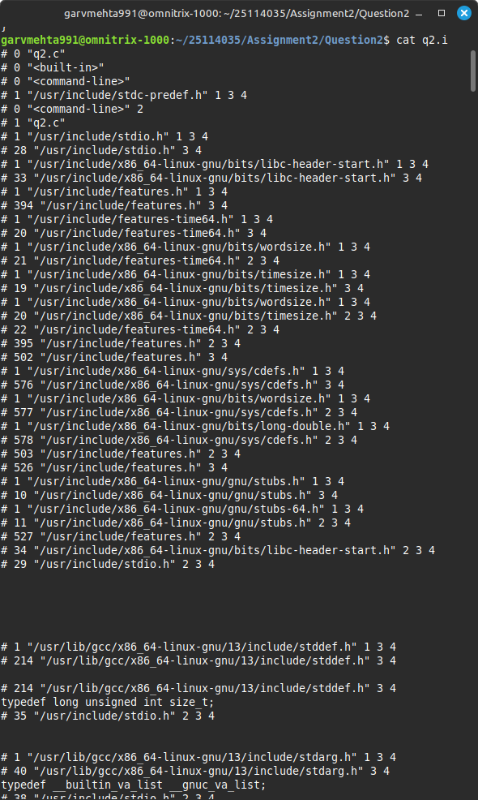
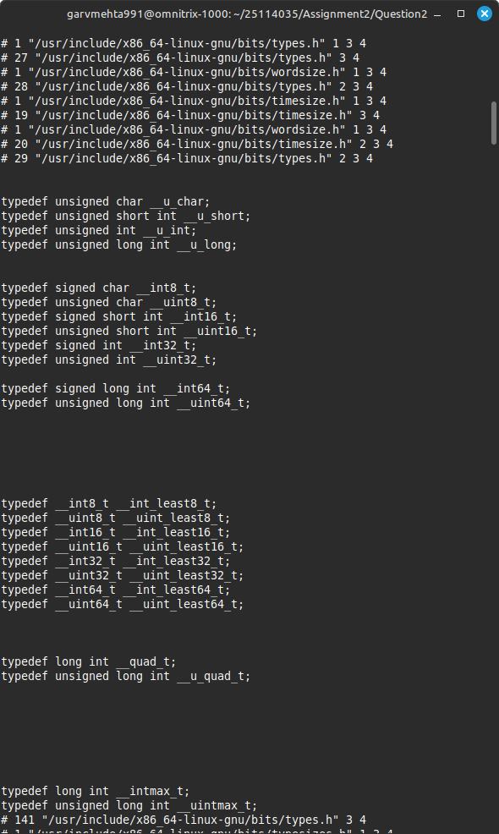
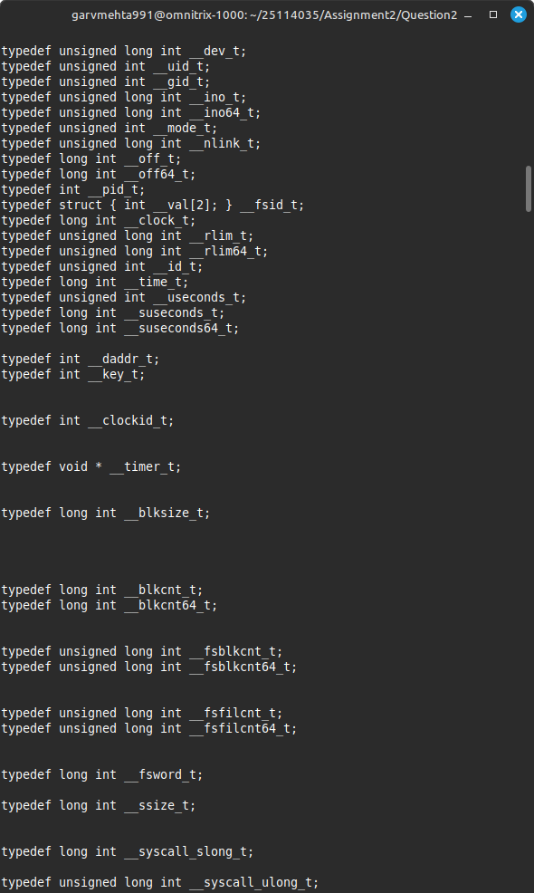
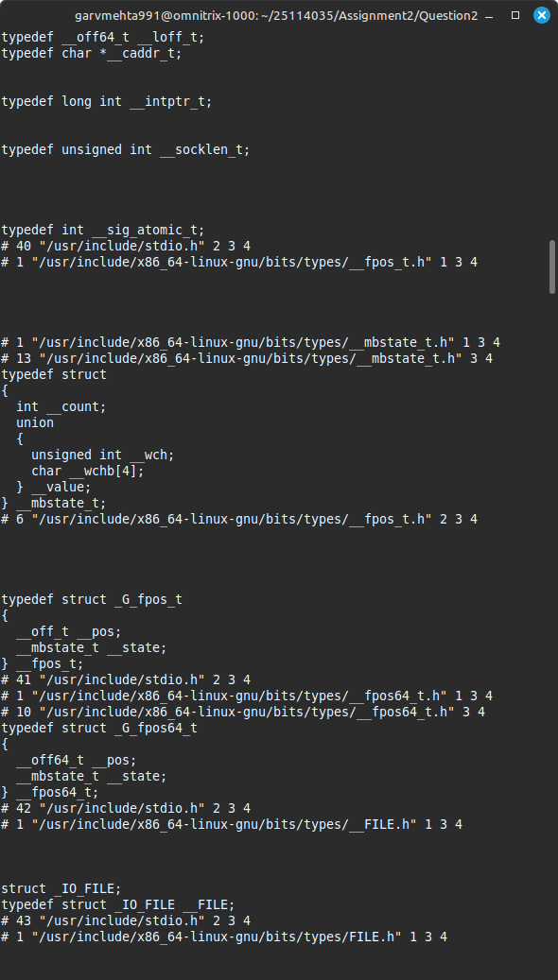

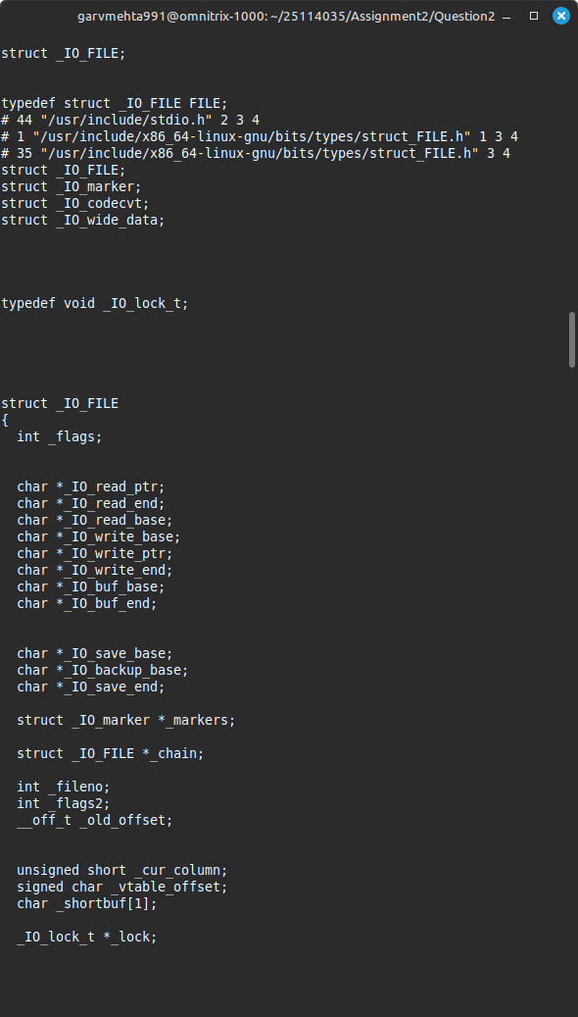
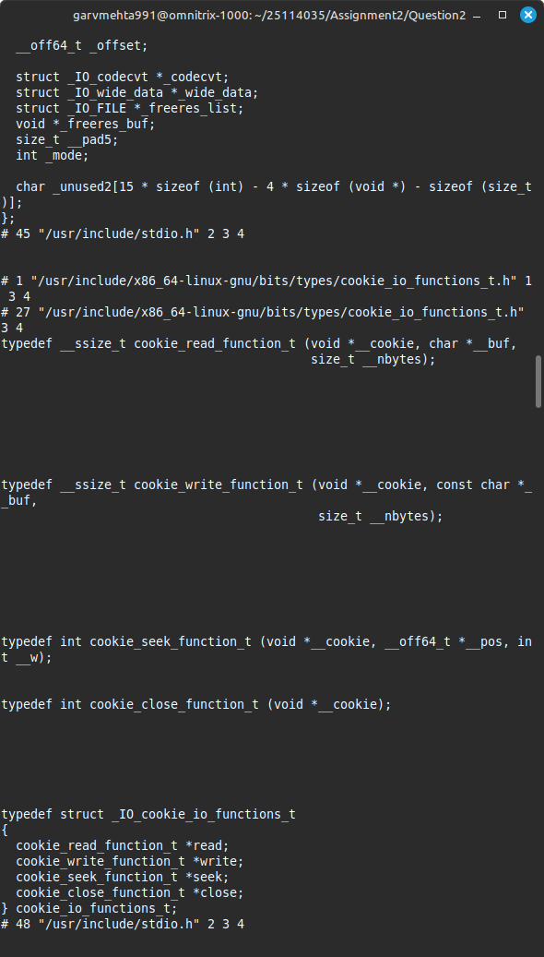
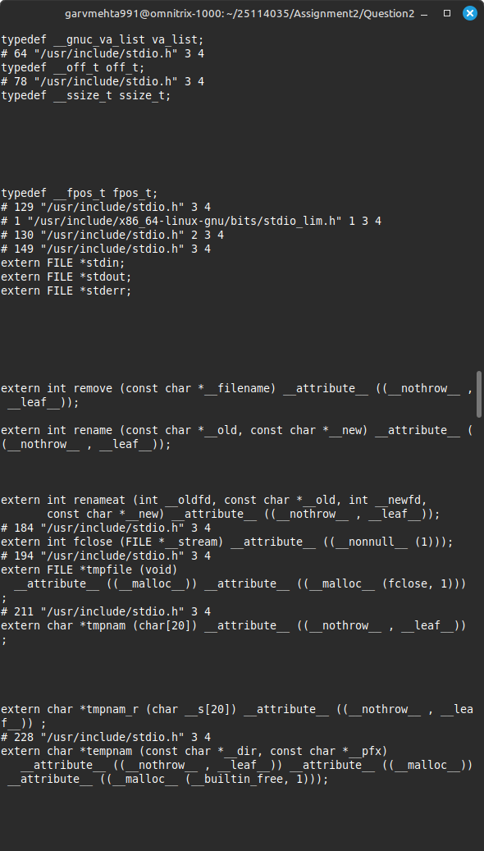
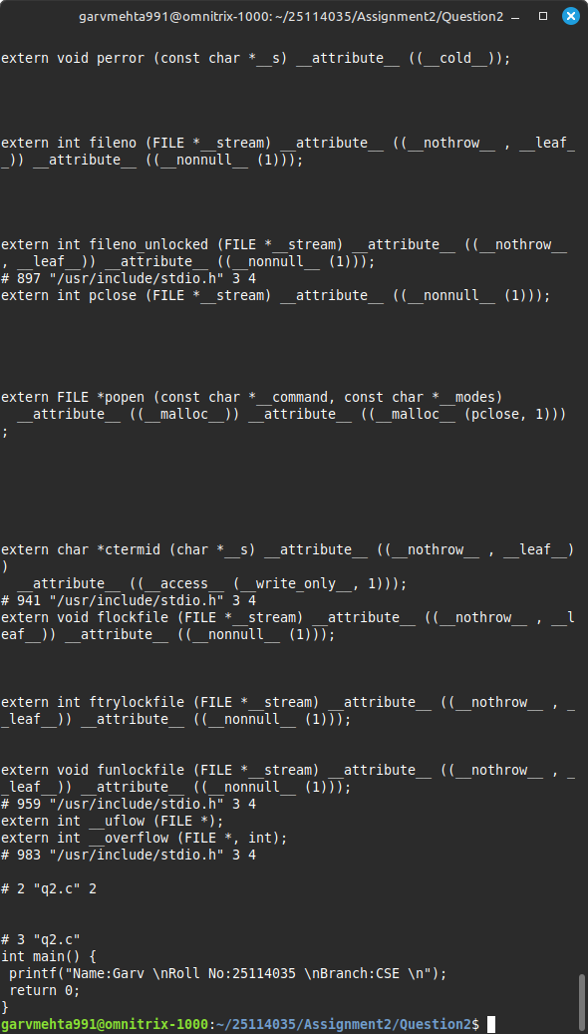

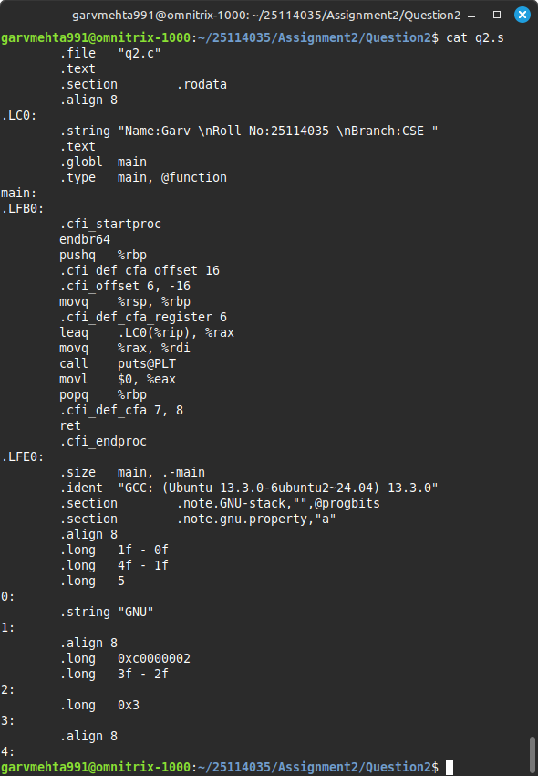

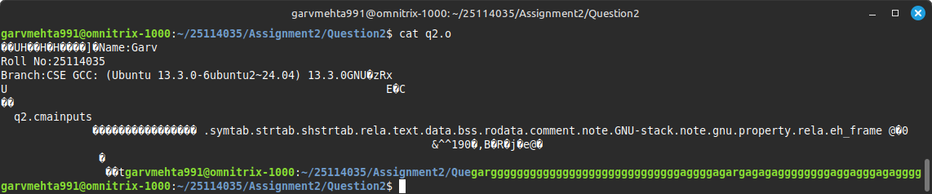
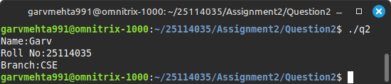

Q-3) You are working as a software intern at a company. One of your tasks is to write lightweight and efficient C code which contains only printf() statements for logging, debugging, and feature-specific outputs that can be easily enabled or disabled at compile time using preprocessor directives. Write an appropriate C program for the same using preprocessor directives. [20 marks]

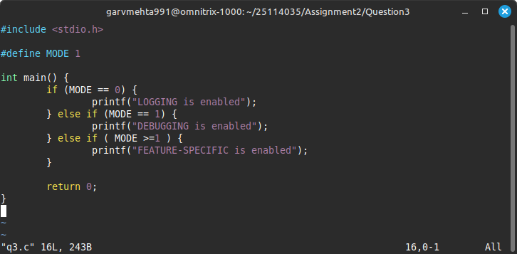
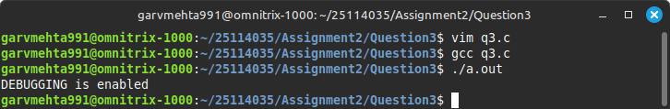

Q-4) Write code in C language to print the following outputs using a single print statement:

- Hello World
- “Hello World”
- This is \n a line
- How are you (without manually giving spaces)
- Bank provides 10% interest
- Hello
[20 marks]
World! (using a single printf statement)
- ??!
- Good /\ Day!
- For printing \n we use \\n
- “He”llo wo“rld
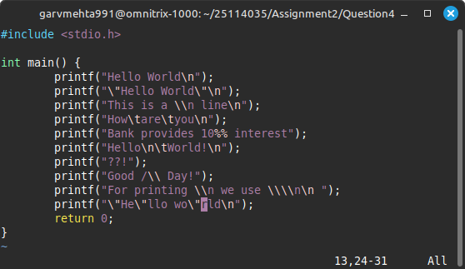
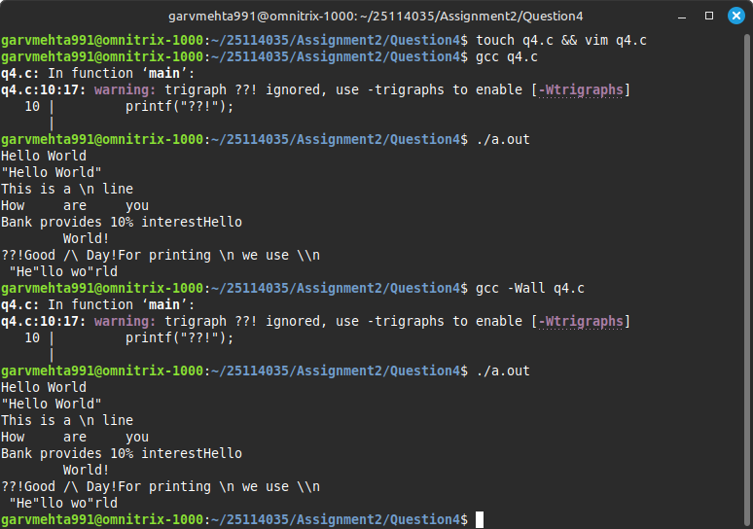

Q-5) Write a C program to print “Hello World” without using a semicolon. [15 marks]

