 | INDIAN INSTITUTE OF TECHNOLOGY ROORKEE
Programming in C and C++ (CSC-101)

Assignment 3

Garv
25114035

Q-1) Take an integer number of seconds as input, print the equivalent time in hours, minutes, and seconds as output. The recommended output format is: 7322 seconds is equivalent to 2 hours, 2 minutes, and 2 seconds.
[10 marks]

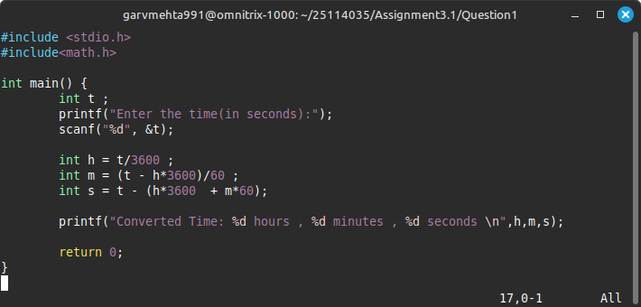
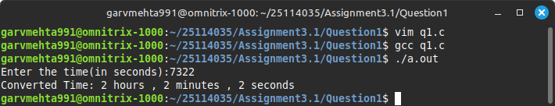

Q-2) Write a C program to reverse a 3-digit number without using a loop. [10 marks]

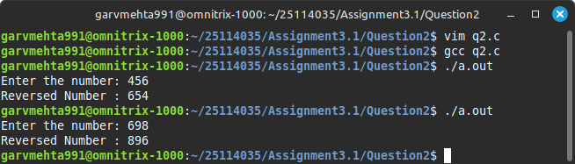
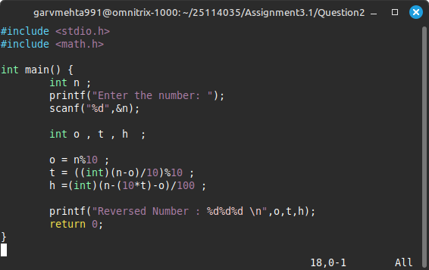

Q-3) Write a C program to print the corresponding Celsius to Fahrenheit. Print as floating point, 3 numbers after decimal point. [10 marks]
Formula : F = (9/5 * C) + 32

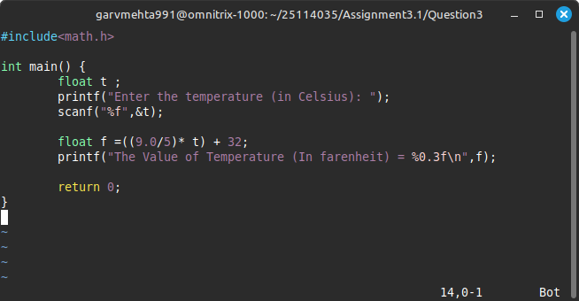
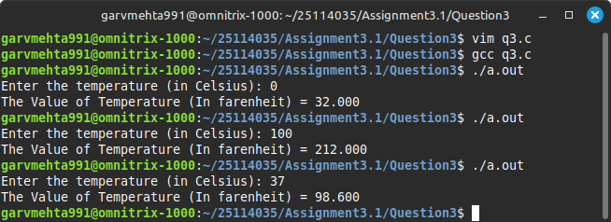

Q-4) Take the input x, y coordinate of a point, calculate and print the squared distance of the point from the origin. [10 marks]

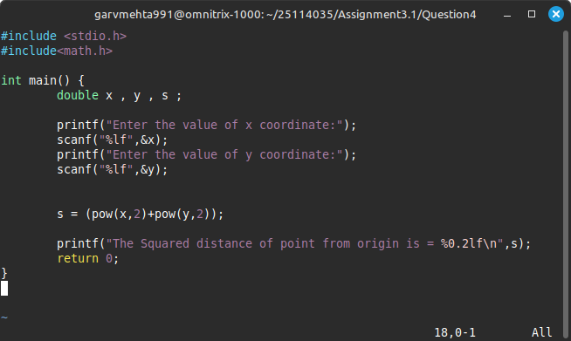
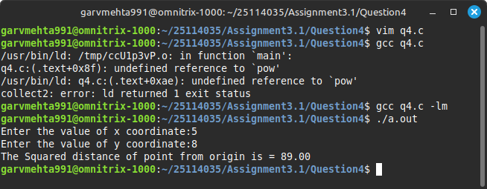

Q-5) Write a program to swap two numbers without using a third variable. [10 marks]

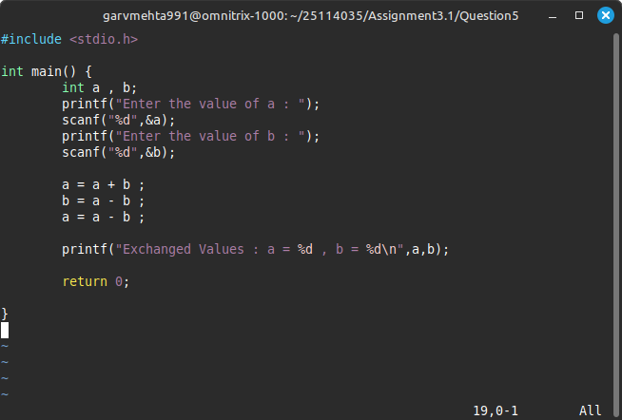
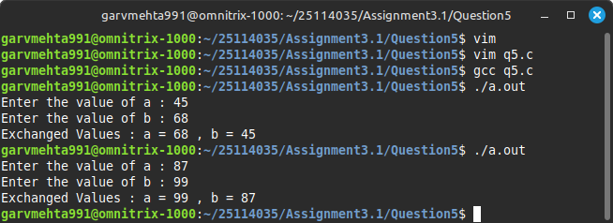

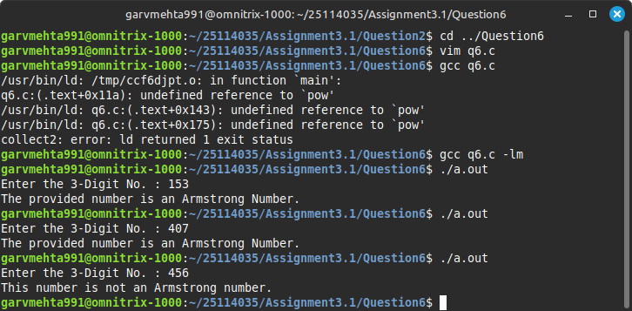
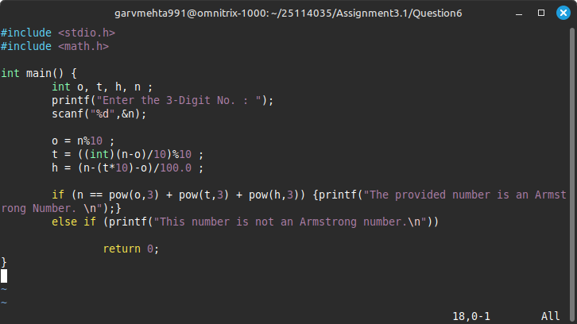
Q-6) Write a C program to take a 3-digit number as input and print whether the number is an Armstrong number or not. (An Armstrong number is a number for which the sum of the cubes of its digits equals the number itself, e.g., 153 = 1³ + 5³ + 3³) [10 marks]

