 | INDIAN INSTITUTE OF TECHNOLOGY ROORKEE
Programming in C and C++ (CSC-101)

Assignment 3 60 marks

Garv
25114035

Q-1) Write a C program to compute the area, circumference, and diameter of a circle. Use PI as a macro in your program, and also include the standard header file that provides the value of PI. Ensure both methods of using PI are implemented correctly and clearly in the code. [5 marks]

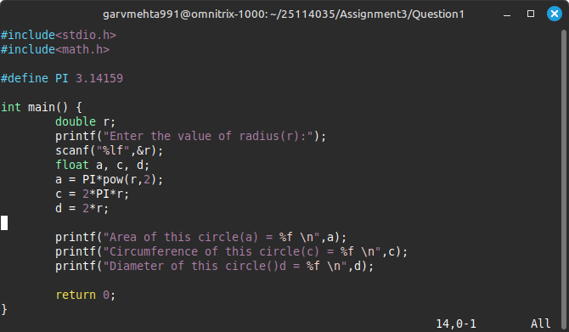
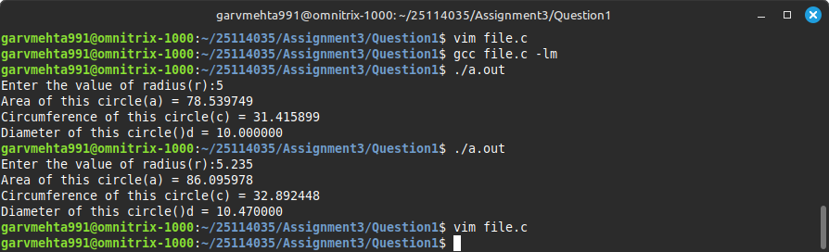

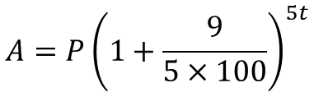
Q-2) Write a C program to take input for principal (P) and time (t), then compute the final amount (A) using the below formula. [For example : If you enter P: 100000, t: 6, the A is 170778.56] [5 marks]

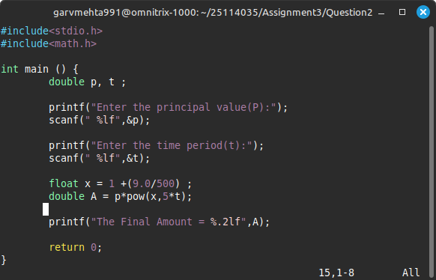

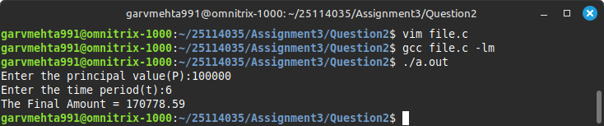

Q-3) You are developing an application for embedded systems with limited memory. To optimize your program and ensure it fits within memory constraints, you need to find out how much memory different data types like integers, floating-point numbers, and characters occupy on the target machine. Write a C program that helps you inspect the memory size (in bytes) required to store different primitive data types on the system where the program runs [5 marks]
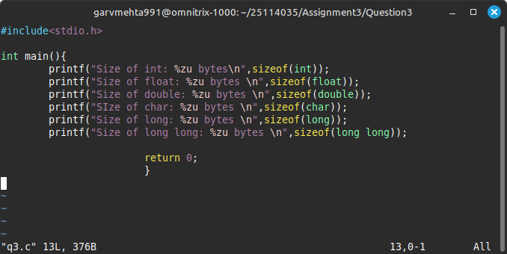

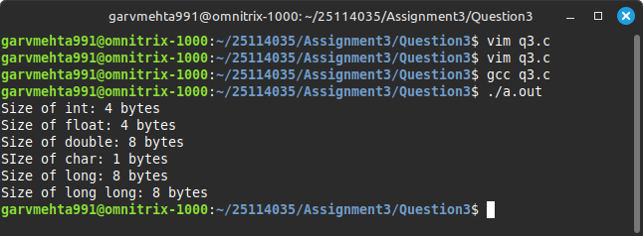

Q-4) Write a program to convert a small letter char to a capital letter char and vice-versa - a -> A, b -> B , B -> b……….

[15 marks]
[Note : Do NOT use any if statements or conditional operators (?:). Use only arithmetic operators (+, -, *, /, %) for computations. Use the following header files and their features:
#include <stdbool.h>: to declare variables of type bool (which stores values
1 or 0)
#include <ctype.h>: to use the functions islower(ch) and isupper(ch) to check whether a character (ch) is lowercase or uppercase.]
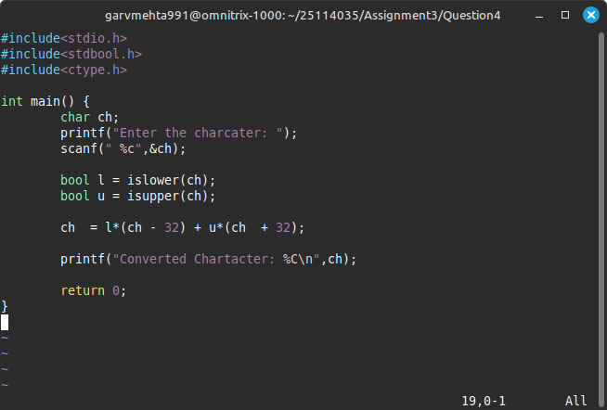
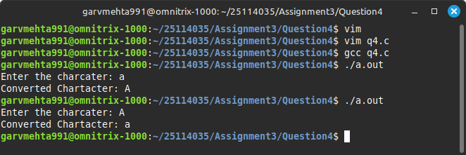

Q-5) Declare a float type variable e= 2.718281828 and print the following using variable e. [15 marks]
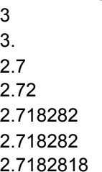

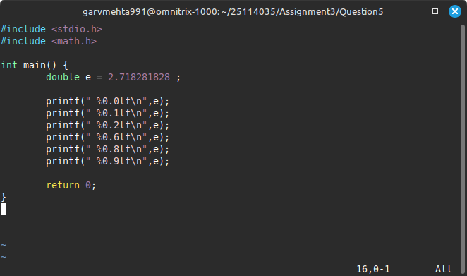
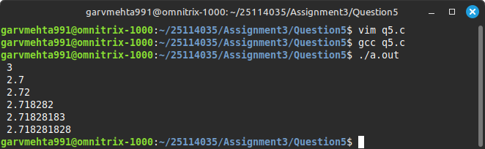
Q-6) Write a C programme to print formatted output using different variables. Let's say a=1,b=12,c=123,d=1234,f=12345. Print the values of a to f such that it looks like as shown in a. Similarly take different character type variables and print these variables as shown in b. [Do not use space or print ‘0’ to get the desired output] [15 marks]
