 | INDIAN INSTITUTE OF TECHNOLOGY ROORKEE
Programming in C and C++ (CSC-101) - Lab 4

Assignment 4 40 marks

Note : (No loops/ switch condition are allowed to be used)
Q-1) Write a program that calculates the Body Mass Index (BMI) based on weight and height inputs. Classify the BMI according to the World Health Organization's categories:

Underweight: BMI < 18.5
Normal weight: BMI >= 18.5 and < 25 Overweight: BMI >= 25 and < 30 Obesity: BMI >= 30
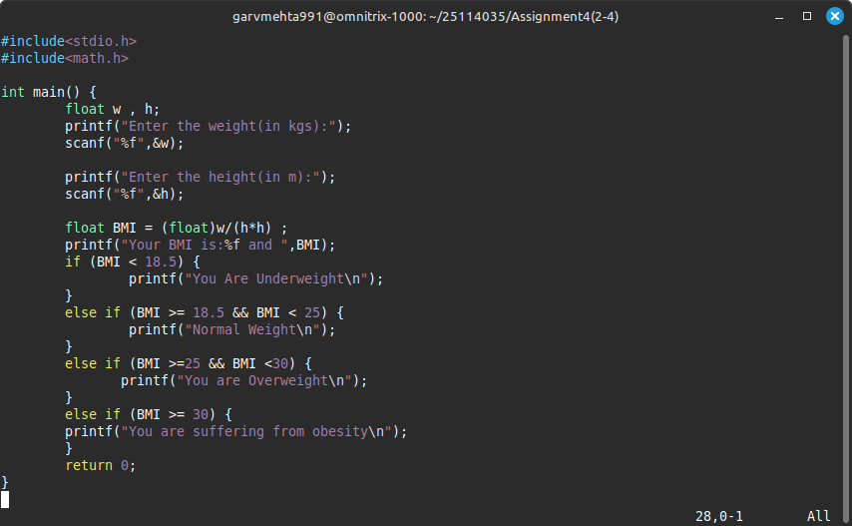
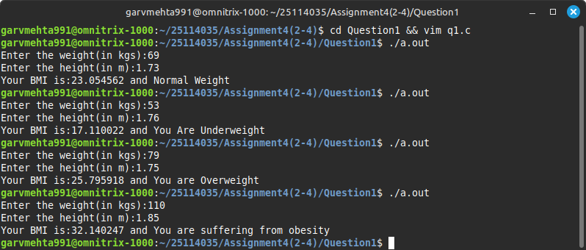

Q-2) On a standard N×N chessboard, each square is identified by a coordinate pair (x, y), where x represents the row number and y represents the column number. The rows and columns are numbered from 1 to N. The square in the top-left corner (1,1) is Black, and the colors alternate between Black and White as you move to the right or downward. For example, (1,2) is White, (1,3) is Black again, and so on. Write a C program that takes two integers as input, representing the coordinates (x, y) of a square on the chessboard. The program should determine whether the square is Black or White. Also, take the N as input and check that the inputs (x,y) will always be between 1 and N. If not then give error to the user.
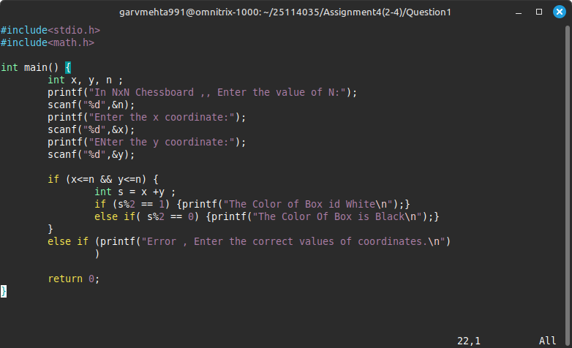
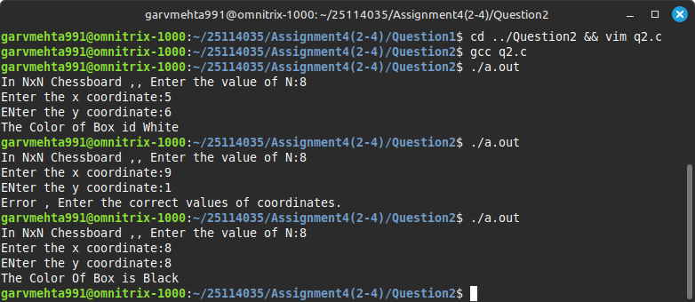

Q-3) An alien gives you a four-digit number ranging between 1000 and 9999. Your task is to write a C program that analyzes this number based on the following mysterious rules:

- If the sum of the outer digits (i.e., the 1st and 4th digits) is equal to the product of the inner digits (i.e., the 2nd and 3rd digits), then the number is to be "Accepted".

- If the outer digits are both prime numbers and the inner digits are both even numbers, then the number should be "Considered".

- For any other case, the number should be "Rejected".
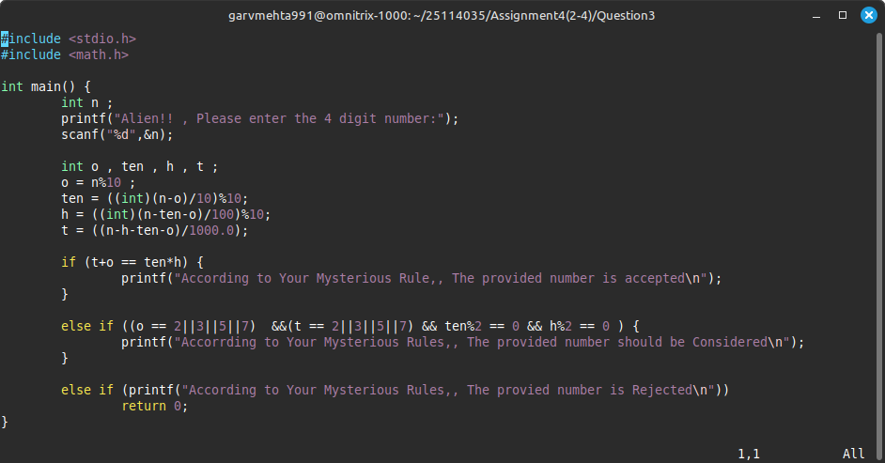
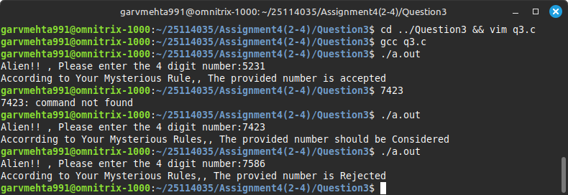

Q-4) You are given a 3-digit number where each digit is represented as a, b, and c (from hundreds to units place). Your task is to write a C program that analyzes the number and categorizes it based on specific patterns found in the digits:

- If the digits are in strictly ascending order and the sum of the digits is divisible by 15, classify the number as "Magic".
- Otherwise, if the digits are in strictly descending order and the product of the digits is even, classify it as "Mystic".
- If the number forms a palindrome (i.e., a == c), classify it as "Enigma".
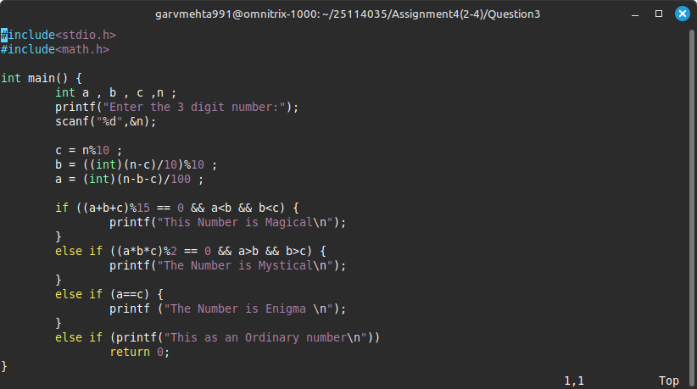
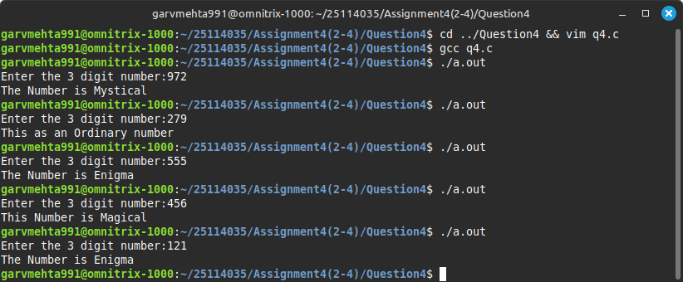
- For all other cases, classify the number as "Ordinary".

