 | INDIAN INSTITUTE OF TECHNOLOGY ROORKEE
Programming in C and C++ (CSC-101)

Assignment 6

Garv
25114035

Q-1) Write a program to print all numbers from 1 to 50, but skip those divisible by 3 using continue inside a for loop.
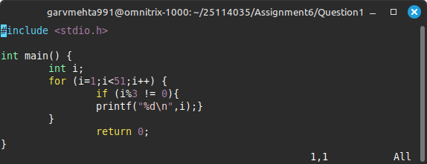

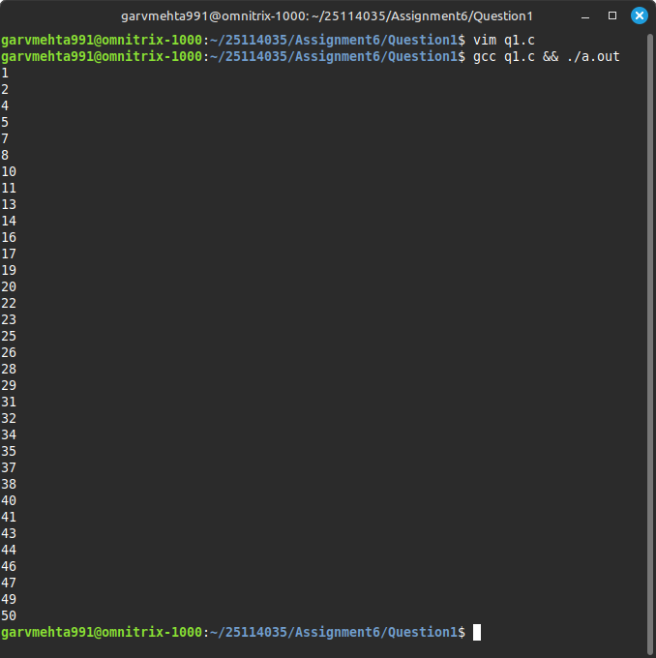

Q-2) Write a C program that takes an integer input from the user and determines whether the entered number is even or odd using switch case. Note: you are not allowed to use if-else statement.

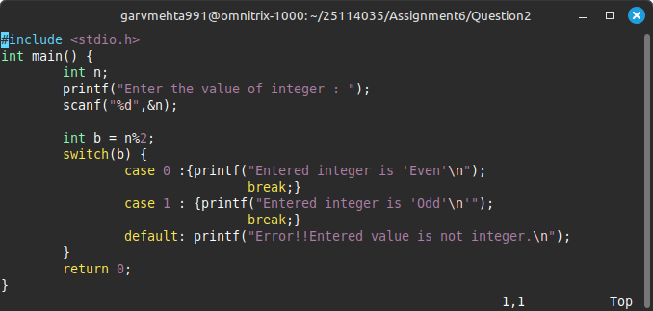

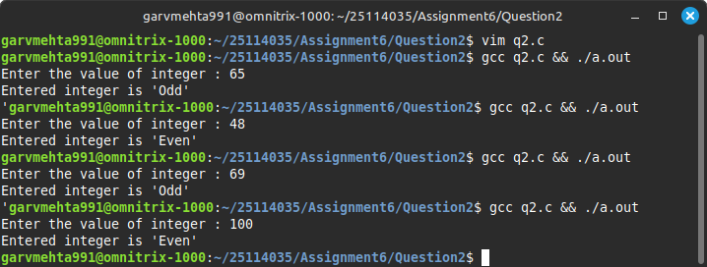

Q-3) Two numbers are entered through the keyboard. Write a program to find the HCF and LCM of those numbers.

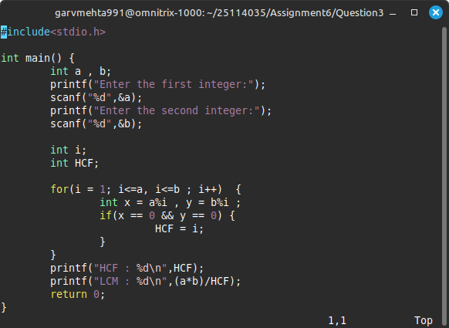

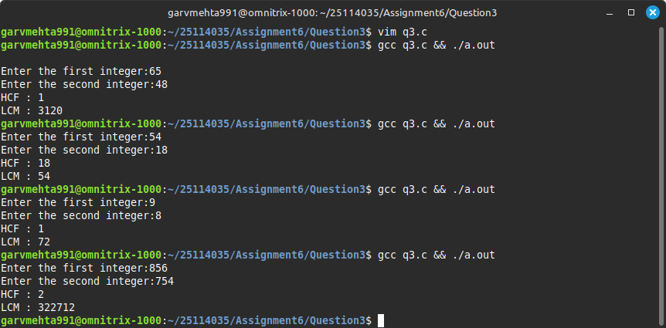

Q-4) Find the maximum of N numbers using a do-while loop.

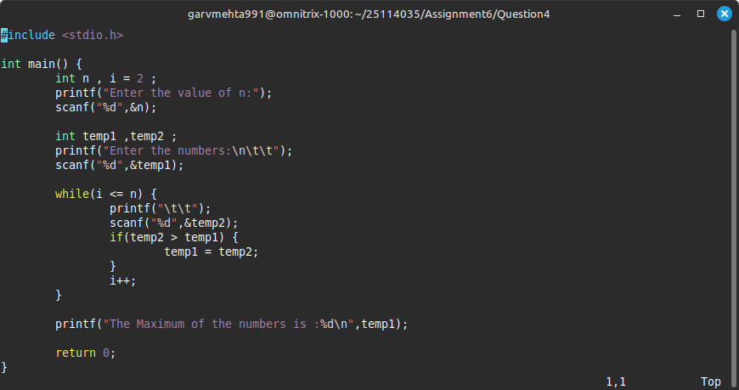

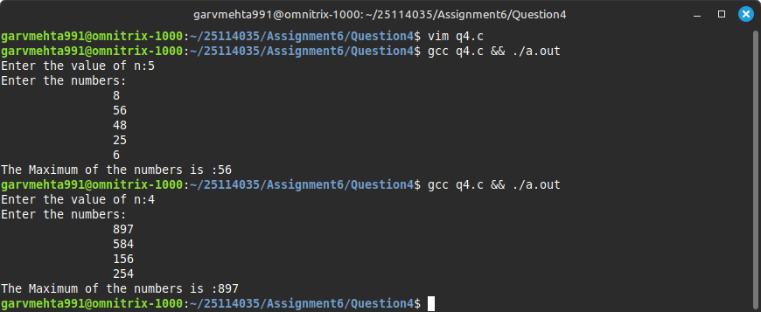

Q-5) Write a program that takes a number (1–12) and uses a switch statement to print how many days are in that month (assume it's not a leap year).

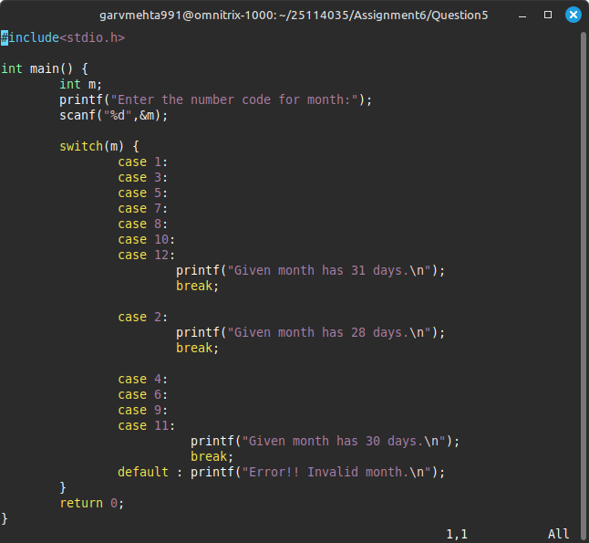

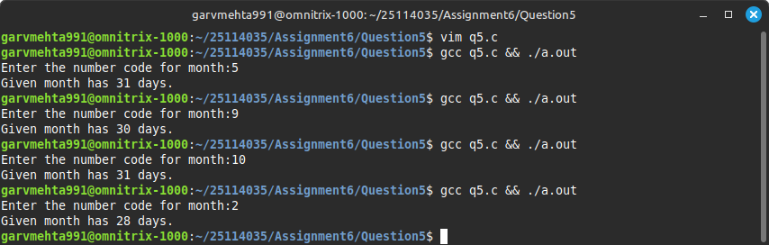

Q-6) Write a C program to print the Fibonacci Series.

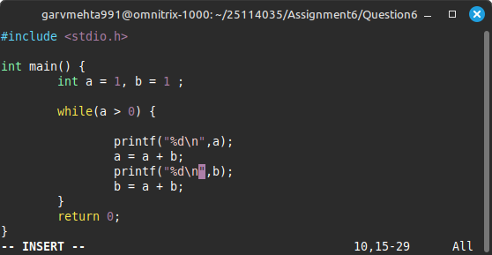

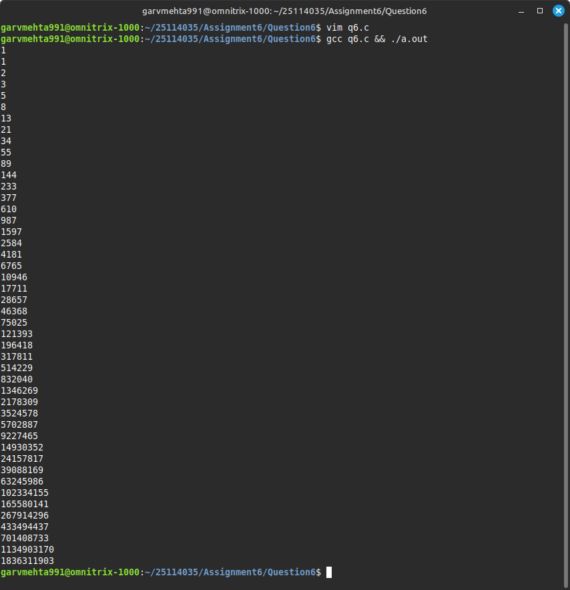

Q-7) Write a C program to find the factorial of a number.
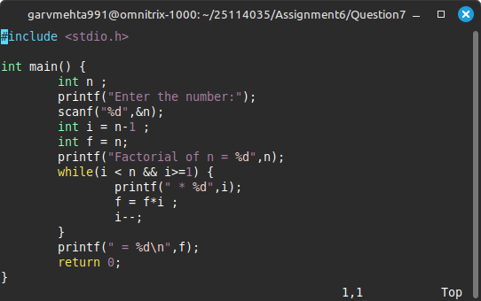

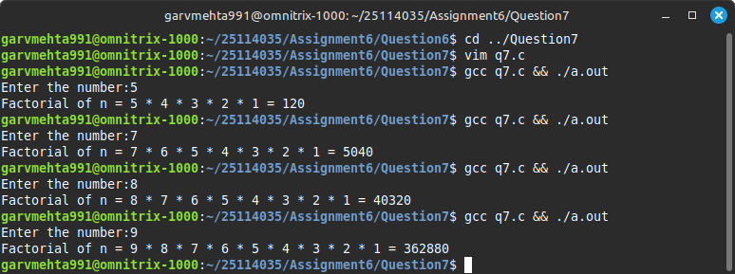

Q-8) Write a C program to multiply two numbers without using the * operator.
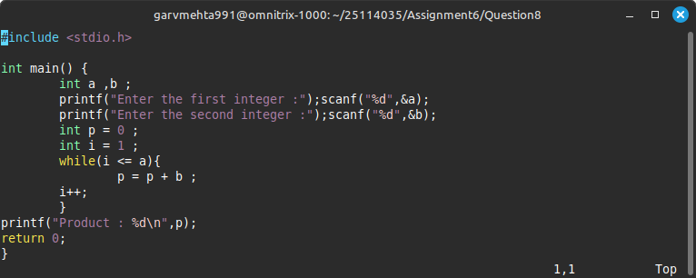

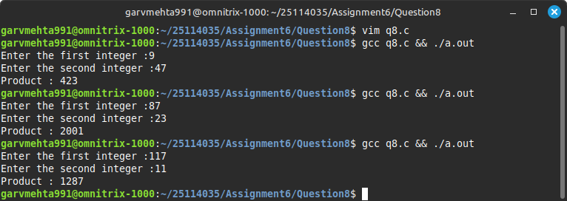

Q-9) Write a program to find the reverse of a number using do-while, while, for loop.
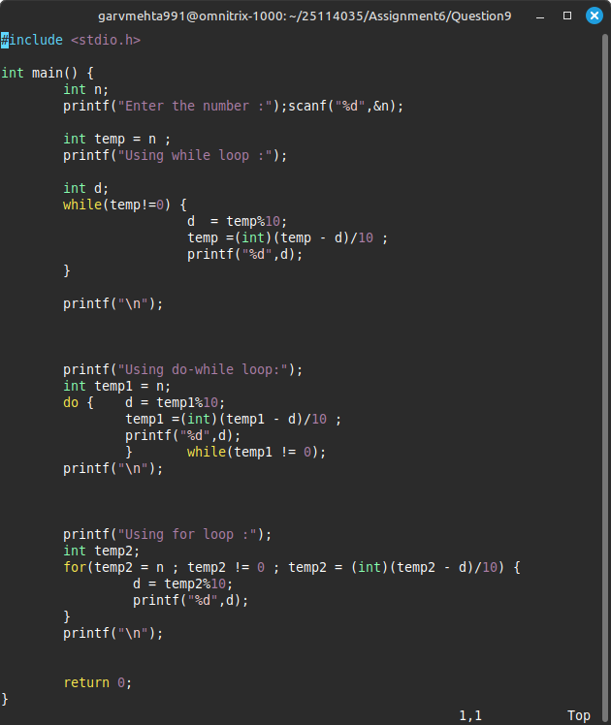

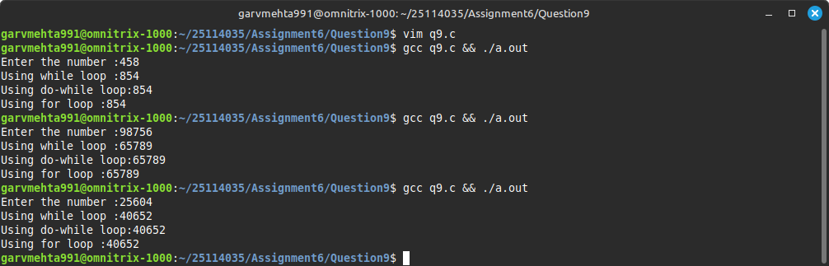

Q-10) Write a C program to determine whether a given integer n is a power of 2. Additionally, write a separate or the same program to generate the first 50 powers of 2.
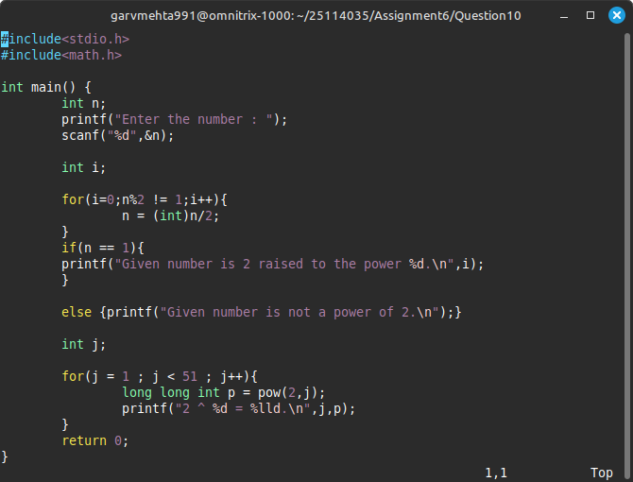

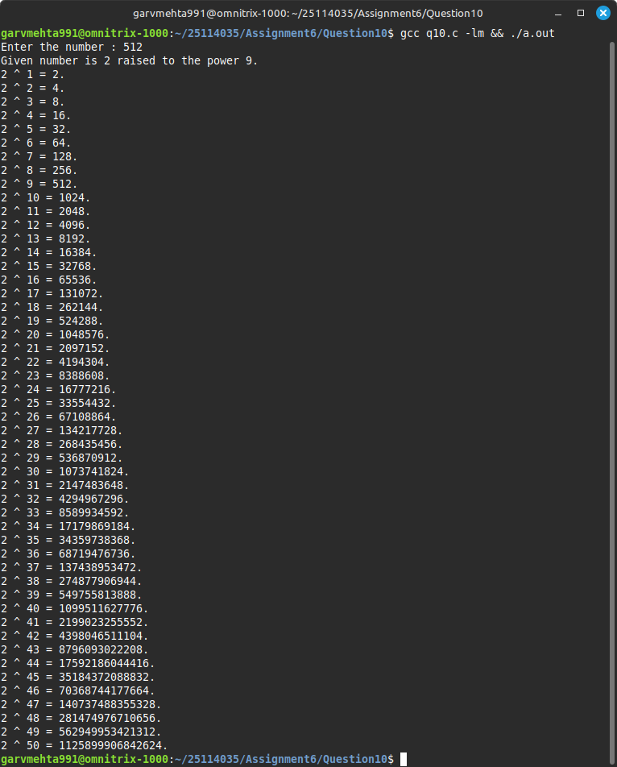

Q-11) Write a C program to simulate a calculator where the user enters two integer numbers and an operator (+, -, *, /, %). The program then carries out the specified operation and displays the result. Write using if statements as well as a switch statement.
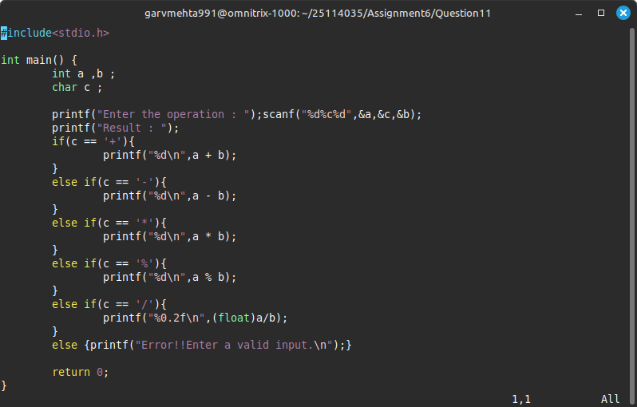

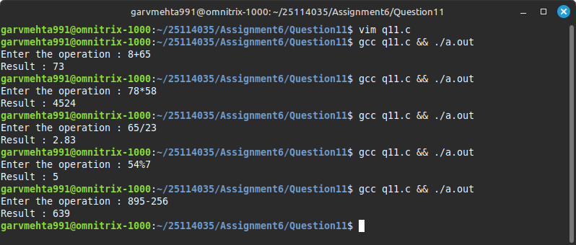

Q-12) Write a C program to check if the given two numbers are relatively prime or not.
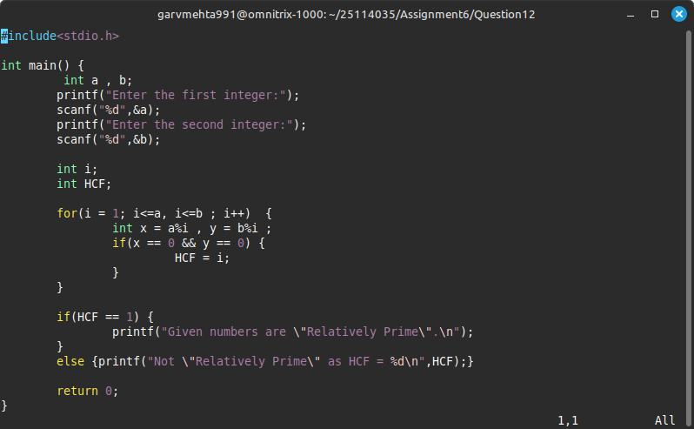

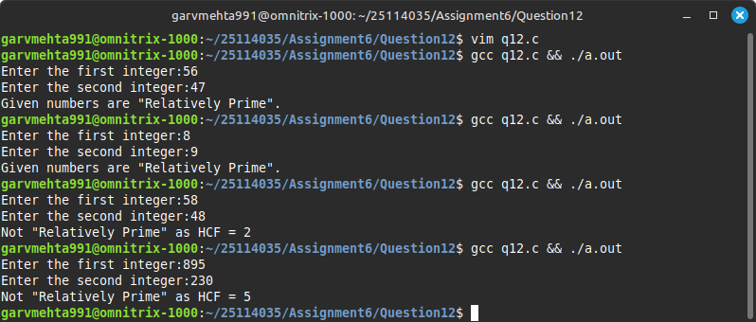

Q-13) Write a C program that takes a decimal number and prints its binary equivalent and then reveres the bits and prints it.
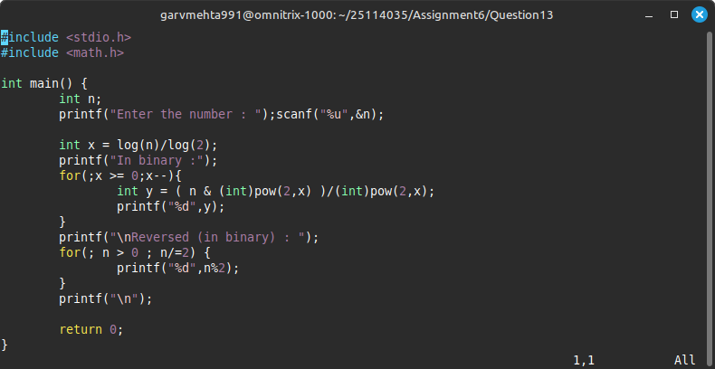

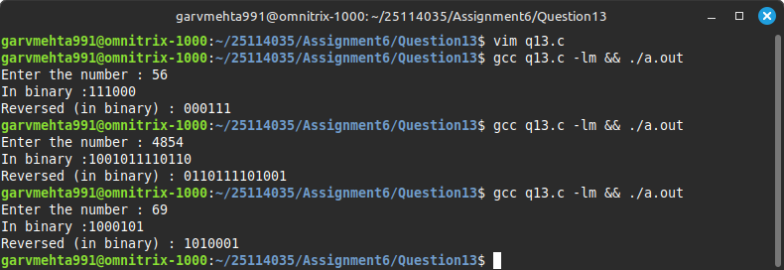

Q-14) Write a C program that does the following:

- Displays a menu with different modes of transport:

    - Bus - ₹5 per km
    - Car - ₹10 per km
    - Train - ₹3 per km 4. Flight - ₹50 per km
- Prompts the user to enter:

○ Choice of transport (1–4)

○ Distance to travel in kilometers

- Uses a switch statement to calculate the total cost based on the selected transport and distance.

- Prints the selected mode of transport, distance, and total price.
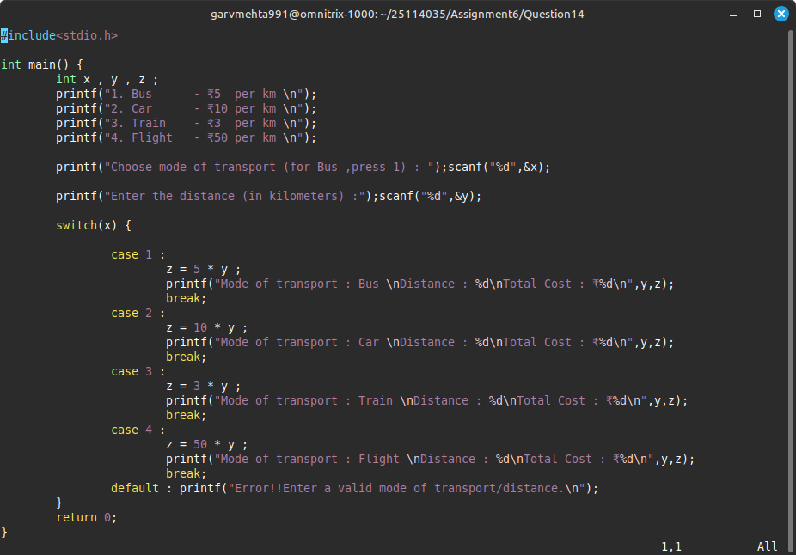

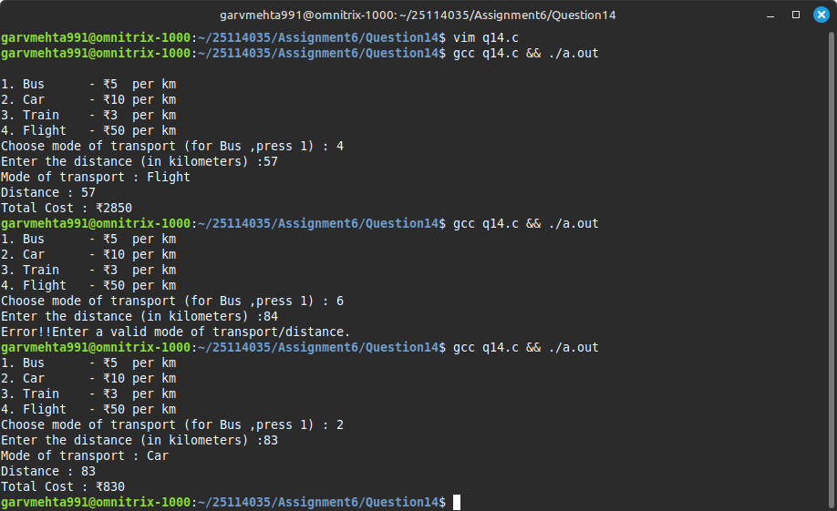

Q-15)Write a C program to find the roots of the quadratic equation and display a message that roots are equal or distinct or real or complex.
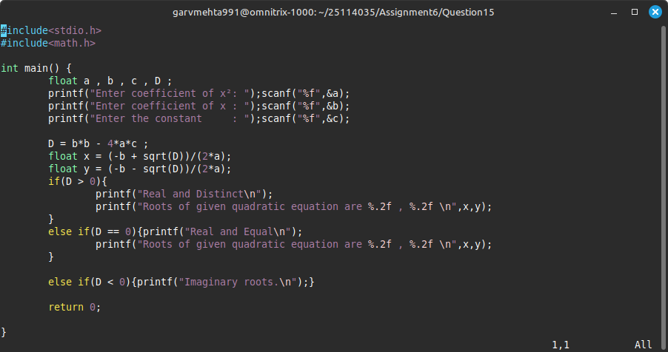

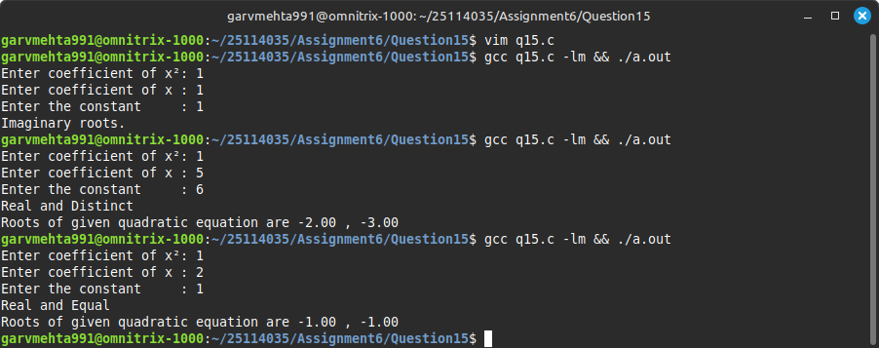

Q17) Write a C program to print the following pattern
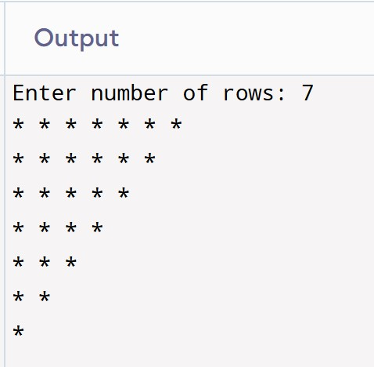
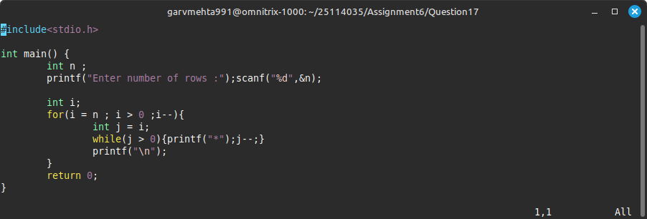

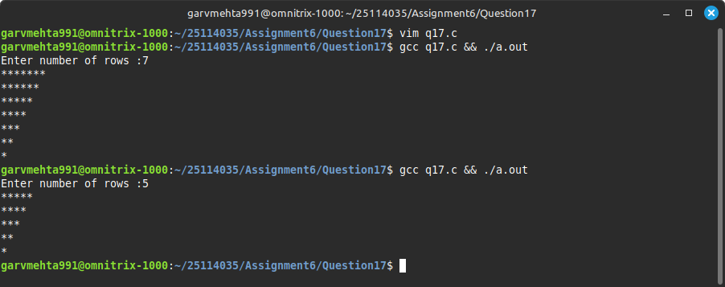

Q18)Write a C program to print the following butterfly pattern
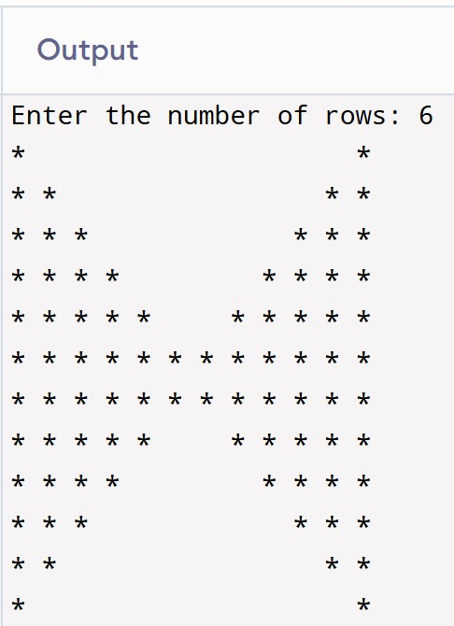
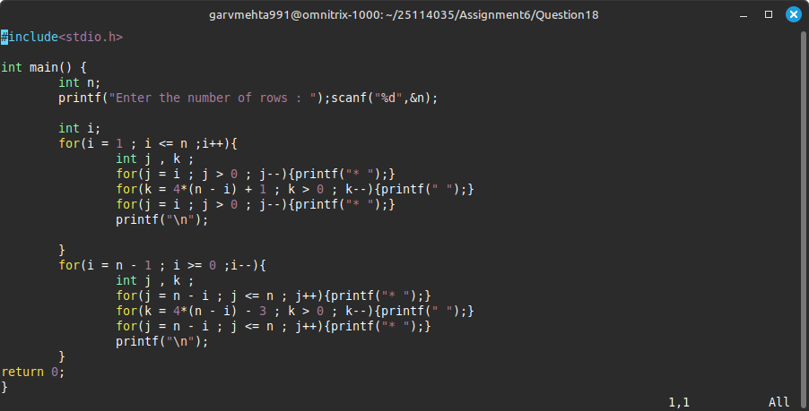

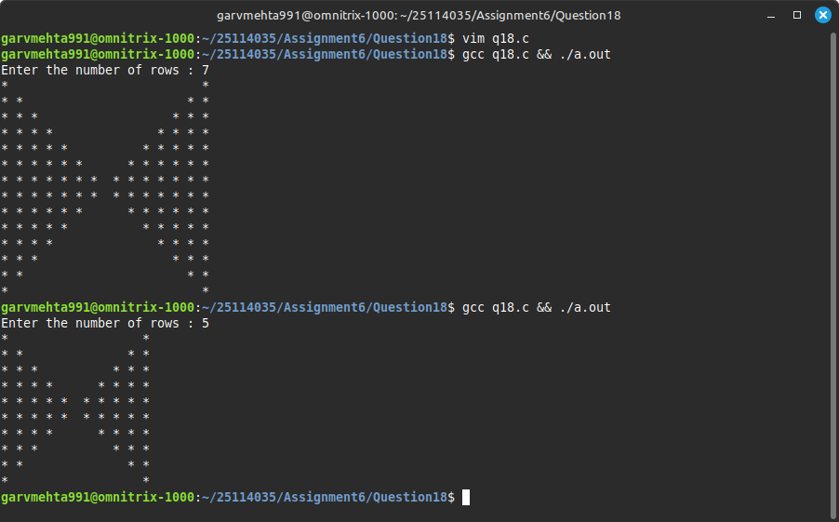

Q19)Write a C program that takes an integer input from the user and prints the given pattern of asterisks (*).

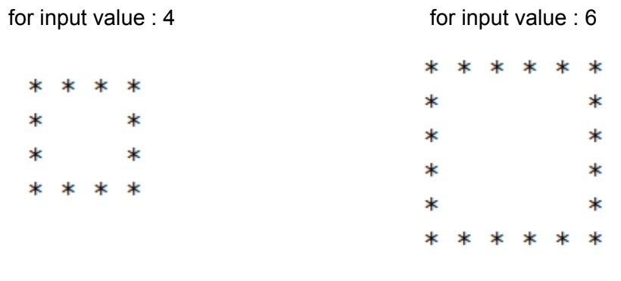

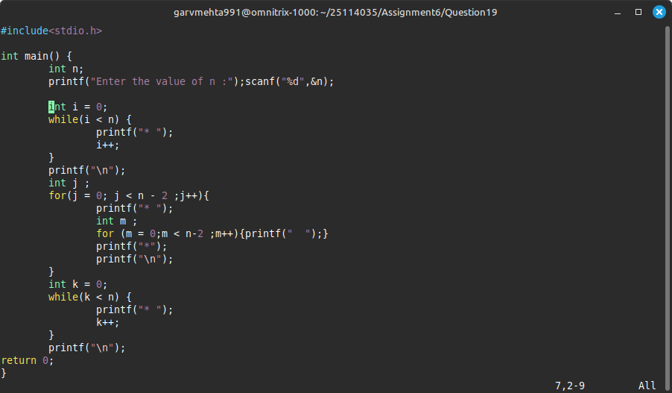

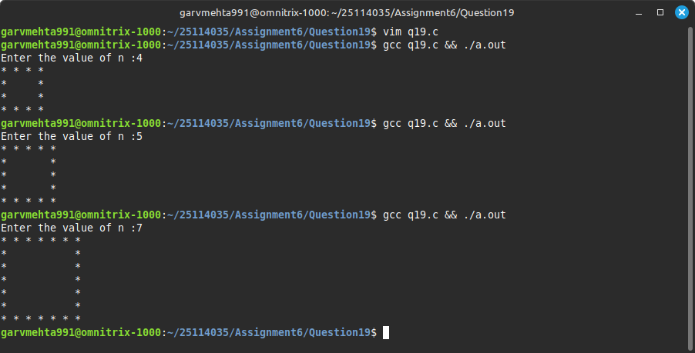

Q20)Write a C program to print a right triangle pattern of characters:
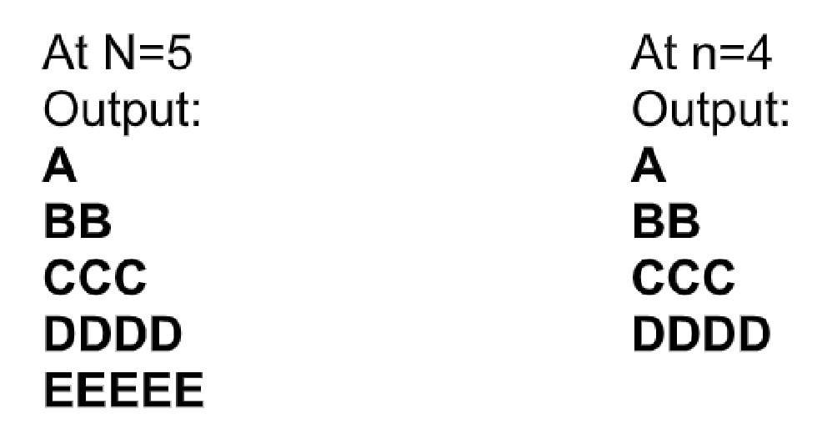

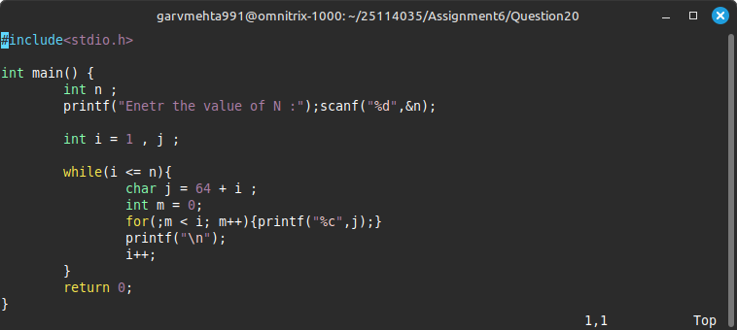

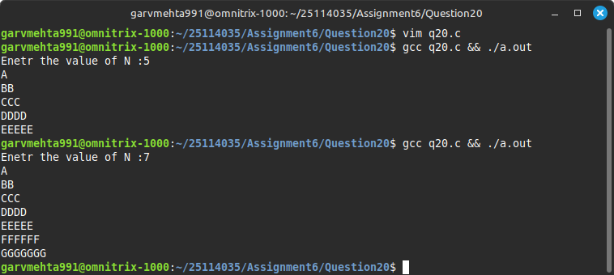

Q21)C code to print a symmetric number pyramid, where each row forms a centered number pattern (increasing then decreasing)

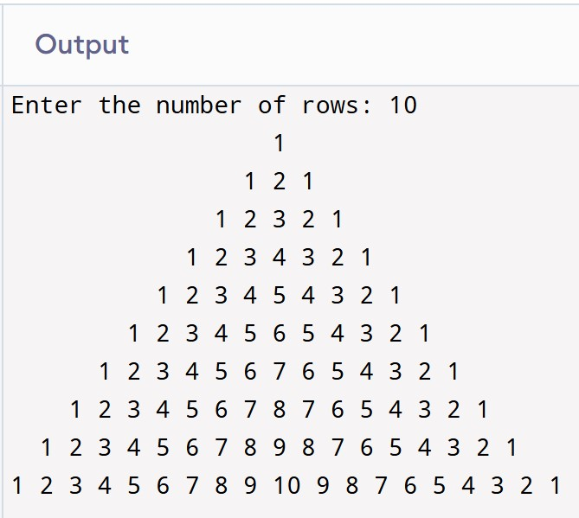

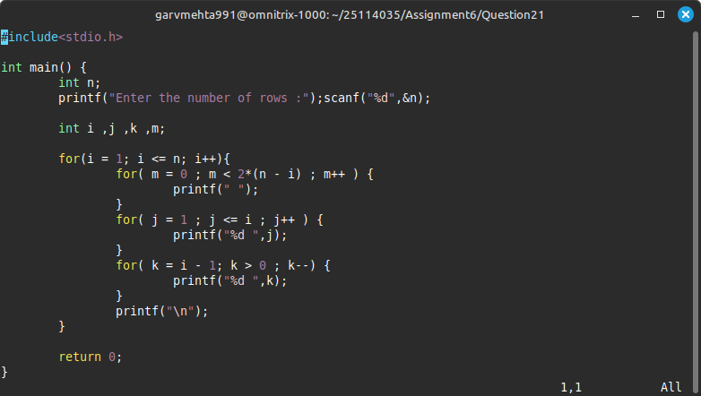

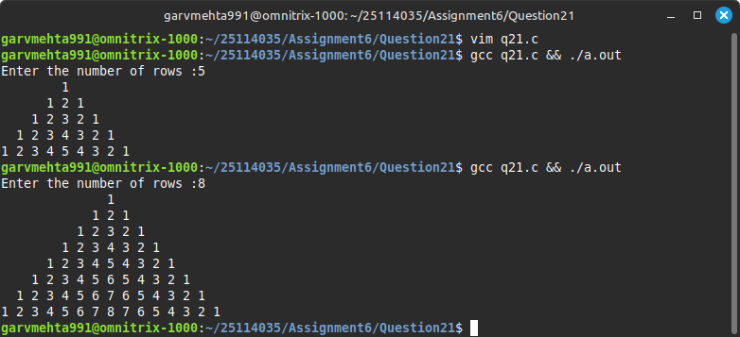

Q22)Print square within square for numbers.

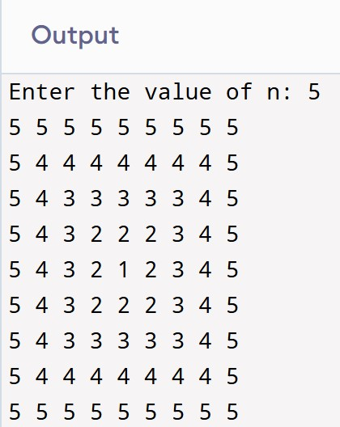

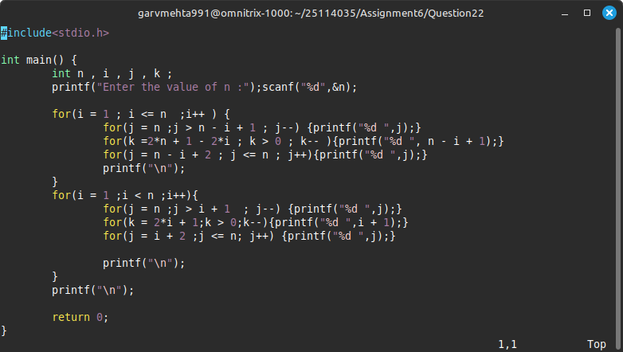

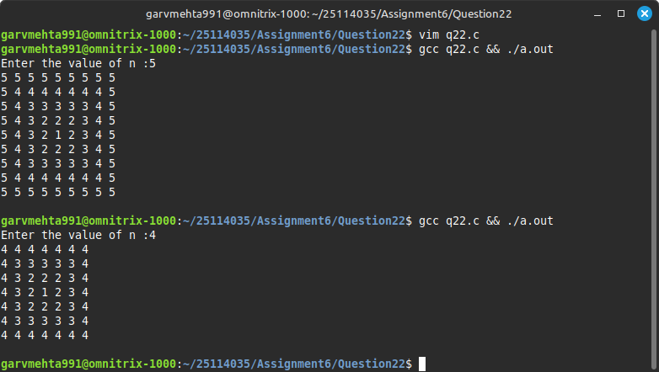

Q23)Write a program to compute:

Sum=1−2+3−4+5−6+…±n

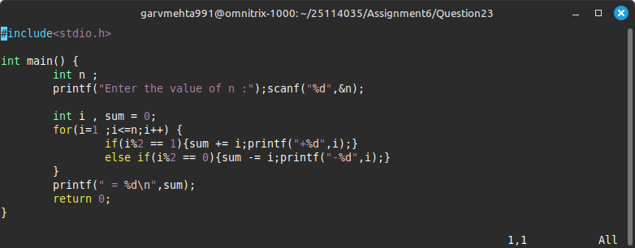

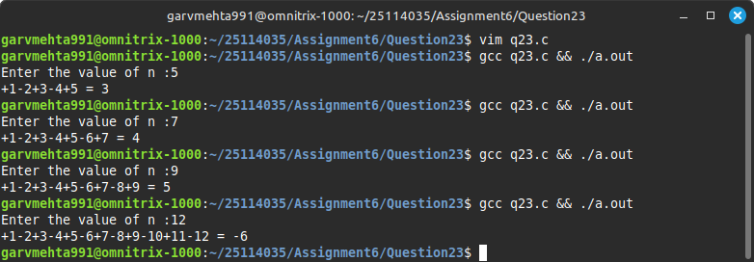

Q24)Compute the sum:

Sum=1!+2!+3!+…+n!

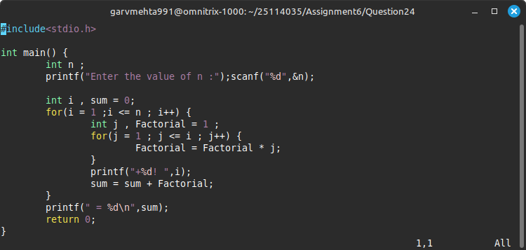

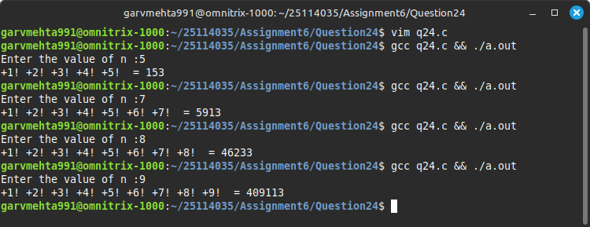

Q25)Write a C program to convert a decimal number to hexadecimal.

