SIZE AND TIME
CALCULATIONS

The RISC201 Arithmetic Logic Unit (ALU) and Floating-Point Unit (FPU) are implemented using static CMOS logic, where the chosen algorithmic complexity directly dictates physical silicon area and critical path delay. This document analyzes the structural footprint in Gate Equivalents (GE) and the propagation bottlenecks of both the combinational and sequential execution datapaths.

1. Silicon Area and Gate Equivalents (GE)
In static CMOS, physical area is measured in Gate Equivalents (where 1 GE $≈$ 4 transistors, representing a standard NAND2 gate). The implementation relies on standard cell mapping:
- AND / OR: $≈$ 1.5 GE (6 transistors)
- XOR / 2:1 MUX: $≈$ 2.5 to 3 GE (8–12 transistors)
The area complexity scales dramatically depending on whether iterative algorithms (multiplication, division) are unrolled combinationally or folded sequentially.

Hardware Module | Architectural Composition | Combinational (Unrolled) Area | Sequential (Folded) Area
Kogge-Stone Adder | $O(NlogN)$ prefix tree + XORs | $≈620$ GE | $≈620$ GE
Barrel Shifter | $O(NlogN)$ multiplexer network | $≈480$ GE | $≈480$ GE
Radix-4 Booth Multiplier | 16 stages of (Decoder + MUX + Adder) | $≈11,500$ GE | $≈800$ GE
Non-Restoring Divider | 32 stages of (Adder/Subtractor + MUX) | $≈22,000$ GE | $≈900$ GE
FPU Alignment & Rounding | LZC + Guard/Round/Sticky (GRS) Logic | $≈1,500$ GE | $≈1,500$ GE
Combined ALU + FPU Total | Full Datapath | $≈77,500$ GE | $≈8,500$ GE

2. Time Complexity and Critical Path Bottlenecks
Propagation delay limits the maximum achievable clock frequency (f_max). Delay is measured in standard gate delays (Δ), where a basic logic gate is 1Δ and an XOR/MUX is ≈2Δ.

Core Module Delays:
- 5-Stage Barrel Shifter: O(log N) depth → ≈10Δ
- Kogge-Stone Adder: O(log N) depth → ≈14Δ

FPU Execution Lane Bottlenecks:
- FADD / FSUB Lane: Operates in O(log N) time. The critical path cascades through exponent subtraction (14Δ), mantissa alignment shifting (10Δ), mantissa addition (14Δ), normalization shifting (10Δ), and rounding (14Δ).
- Total FADD Delay: ≈62Δ
- FMUL Lane (Unrolled): Operates in O(N log N) time. The signal must ripple through 16 sequential Kogge-Stone additions.
- Total FMUL Delay: 16 × 14Δ ≈ 224Δ
- FDIV Lane (Unrolled): Operates in O(N log N) time. The signal must ripple through 32 sequential Kogge-Stone add/subtract operations.
- Total FDIV Delay: 32 × 14Δ ≈ 448Δ

3. Architectural Resolution
If synthesized as a purely single-cycle combinational datapath, the 32-stage Non-Restoring Divider becomes the system's absolute bottleneck, forcing a minimum clock period of >448Δ and severely crippling processor performance.

To resolve this bottleneck, the multiplier and divider must be synthesized as Multi-Cycle Sequential blocks. By placing flip-flop registers at A, Q, and M and looping the combinational signals back through a single shared Kogge-Stone adder over 32 clock cycles, the processor's critical path is reduced from 448Δ down to ≈14Δ. This allows the overarching CPU clock frequency to scale up by a factor of 30, at the cost of taking multiple cycles to retire FMUL and FDIV instructions.

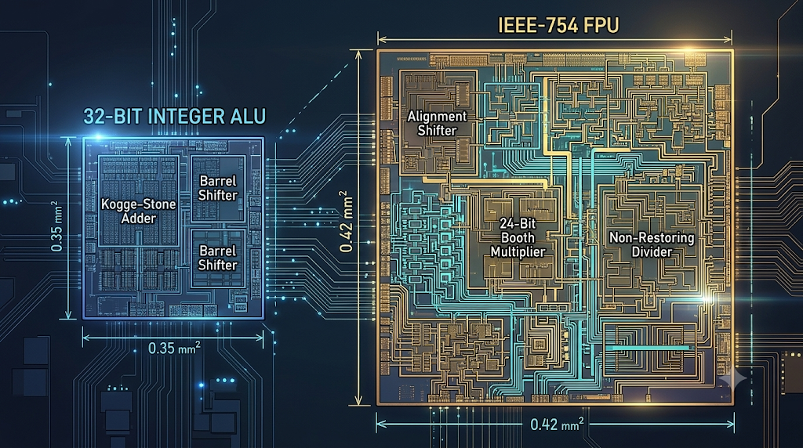
Approximate calculated size of alu and fpu on RISC201 processor

