Version 0.2
Revised and Extended Implementation
Project name: Foresight — Student Performance Analytics

Revision Summary (Version 0.1 → 0.2)
Version 0.1 of this report described a working prototype: a five-table MySQL database, a Flask backend of a single file, and three HTML pages. It met the objectives of the original problem statement but carried a number of correctness and security weaknesses, and its analytical capability was limited to a single average and a hard-coded 'weak student' rule.
Version 0.2 documents a substantially rebuilt system, renamed Foresight. The database has grown from five tables to nine, and now makes deliberate use of views, triggers, stored procedures and stored functions rather than performing all computation in application code. The backend has been restructured into a layered architecture with token-based authentication and role-based access control. The interface has been rebuilt around a design-token system, and the whole project is covered by an automated test suite and a continuous integration pipeline.
Summary of Changes
Area | Version 0.1 | Version 0.2
Database tables | 5 | 9 (plus 6 views, 8 triggers, 7 routines)
Backend structure | Single 218-line file | Application factory, 6 blueprints, service layer
API endpoints | 6 | 36
Authentication | Plain comparison, no session | Signed JWT with expiry and rate limiting
Authorisation | None — every route open | Three roles enforced on every endpoint
Analysis | Average marks; fixed 'Weak' label | Weighted 0–100 risk score with written reasons
Ranking | Not available | Cohort rank and percentile via window functions
Data entry | One student at a time | Bulk CSV import with per-row validation
Auditing | None | Trigger-written audit log
Testing | Manual only | 165 automated tests, CI on every push
Deployment | Manual setup | Single-command Docker Compose

Introduction
Educational institutions generate a continuous stream of academic data: marks from assessments, daily attendance registers, enrolment records and examination outcomes. This data is routinely stored but seldom interpreted. By the time poor performance becomes visible in a final result, the opportunity to intervene has usually passed.
Foresight is a full-stack academic analytics system built to close that gap. It stores student, subject, assessment and attendance data in a normalised relational database, and converts that data into a ranked and explained view of academic risk. The central design goal is that the system should not merely report what happened, but indicate which students need attention and state the reason for each.
The project demonstrates the practical application of database management concepts studied in the course: entity-relationship modelling, normalisation, referential integrity, indexing, views, triggers, stored procedures, stored functions, transactions and window functions. It also demonstrates full-stack integration, applied security, automated testing and containerised deployment.
Version 0.2 differs from the earlier version in an important respect. Where the prototype performed nearly all computation in application code, this version deliberately places derived values — percentages, ranks, pass rates and risk scores — inside SQL views. The reasoning is given in the chapter on database design.

Problem Definition
Academic data in most institutions is recorded accurately but analysed manually. A teacher holding a spreadsheet of marks can compute an average, but cannot easily answer the questions that actually matter: which students are falling behind, how far behind they are relative to their peers, whether a student is improving or declining, and which subjects are failing large numbers of students.
The prototype developed in version 0.1 addressed storage and retrieval but exhibited several concrete problems, each of which motivated a specific change in this version:
• Analysis was reduced to a single threshold. A student was labelled 'Weak' if average marks fell below 40 or attendance below 60. A student at 39.9 per cent with three failed subjects was indistinguishable from one at 39.9 per cent with none, and the label offered no reason.
• The calculation failed on incomplete data. A student with no marks recorded produced a SQL NULL average, which the application then compared against a number, raising a runtime error.
• Marks were stored as a single value per subject, making it impossible to observe change over time or to weight a final examination differently from a short quiz.
• Attendance was stored as a pre-computed percentage, which could drift out of agreement with the underlying register and could not be audited.
• No endpoint verified who was making a request. Any signed-in user could retrieve another student's marks by altering the identifier in the URL.
• Passwords were stored and compared as plain text, and the administrative interface was protected only by the fact that it was not linked.
The objective of version 0.2 is therefore not only to store and display academic data, but to model it in a way that supports genuine analysis, to enforce access control, and to guarantee correctness through database constraints and automated tests.

Objectives
• To design a normalised relational schema that models assessments and attendance as individual dated records rather than as summary values, so that trends over time can be analysed.
• To place derived academic measures — subject percentages, attendance percentages, credit-weighted averages, cohort rank and pass rates — in SQL views, so that every consumer of the data obtains identical results.
• To use triggers to enforce validation that must not be bypassed, and to maintain an audit trail that the application cannot omit.
• To use stored procedures for operations that span several tables, so that such operations either complete entirely or not at all.
• To replace a single fixed threshold with a weighted risk score that ranks students by severity and states, in words, the reason for each score.
• To implement token-based authentication and role-based access control, ensuring a student can access only their own records.
• To provide bulk data entry through validated CSV import, since entering a term of marks through a form is impractical.
• To verify the system through an automated test suite executed by a continuous integration pipeline on every change.
• To package the application so that it can be run reproducibly with a single command.

System Overview
Foresight is a three-tier application. A browser-based interface communicates over HTTP with a Flask API, which in turn communicates with a MySQL database. The interface is written in HTML, CSS and JavaScript without a build step or framework, so that the source that runs in the browser is the source stored in the repository.
Figure: system architecture
Browser (HTML / CSS / JavaScript, no build step)
|
| HTTPS request carrying a signed JWT
v
Flask API (36 endpoints across 6 blueprints)
|
| routes/ -> HTTP concerns only
| services/ -> business decisions, independently testable
| db.py -> pooled connections, parameterised SQL
v
MySQL 8 (9 tables, 6 views, 8 triggers, 5 procedures, 2 functions)

Design Principle: Thin Routes
The backend follows a strict separation. A route function reads the request, verifies permission, calls a service and returns JSON; it contains no decision about the data itself. All such decisions reside in the service layer, which can therefore be tested without issuing an HTTP request. Rules that must hold regardless of application behaviour are placed in the database as constraints and triggers.
User Roles
Role | Permitted actions
Student | View only their own marks, attendance, rank, trend and report card
Faculty | All student analytics for any student, cohort statistics, marks entry, CSV import and export
Admin | All of the above, plus creating students, resetting and viewing credentials, and reading the audit log

The distinction between faculty and admin is deliberate: entering marks is an academic task belonging to teaching staff, whereas creating login accounts and reading credentials is account administration. Each role is enforced by a decorator on every endpoint and is verified by tests that attempt each route as each role.

Entity-Relationship Design
The schema of version 0.2 contains nine entities. Three of the original five are retained in extended form; the remainder are new, and two of the original tables have been replaced by more expressive structures.
Entities
Entity | Purpose | Key attributes
branches | Lookup of departments | branch_id (PK), code (UQ), name
students | Student master record | student_id (PK), roll_no (UQ), email (UQ), branch_id (FK), semester, is_active
subjects | Subjects offered | subject_id (PK), code (UQ), branch_id (FK), semester, credits, pass_mark
users | Login accounts | user_id (PK), username (UQ), password, role, student_id (FK, UQ)
enrollments | Student ↔ subject for an academic year | enrollment_id (PK), student_id (FK), subject_id (FK), academic_year
assessments | Individual graded items | assessment_id (PK), enrollment_id (FK), type, marks_obtained, max_marks, assessed_on
attendance_records | One row per class held | record_id (PK), enrollment_id (FK), class_date, status
audit_log | Record of every data change | log_id (PK), actor, action, entity, entity_id, details (JSON)
login_attempts | Durable brute-force record | attempt_id (PK), username, ip_address, succeeded

Three Modelling Decisions
1. Enrolment as an associative entity
In version 0.1, marks and attendance referred directly to a student and a subject through a composite primary key. This made it impossible for a student to take the same subject in a later academic year, as the second record would violate that key. Version 0.2 introduces the enrollments entity, which links a student to a subject for a particular academic year. Marks and attendance now reference the enrolment. A re-sit in a later year is a distinct enrolment and therefore permitted.
2. Assessments instead of a single mark
A single marks column cannot express change over time, and cannot distinguish a twenty-mark quiz from a hundred-mark final examination. Each assessment is now stored as its own row carrying its own maximum. The subject percentage is calculated as the sum of marks obtained divided by the sum of maxima, so that each assessment influences the result in proportion to its weight. Averaging the individual percentages instead would incorrectly treat a quiz as equal to a final.
3. Attendance as dated records
Attendance was previously stored as a percentage. A stored percentage can disagree with the register it was derived from, and cannot answer questions about particular dates. Version 0.2 records one row per class with a status of present, absent, late or excused. The percentage is derived by a view: a student marked late is counted as having attended, and an excused absence is removed from the denominator rather than counted against the student.
Relationships and Cardinality
• branches (1) —— (M) students : one branch has many students.
• branches (1) —— (M) subjects : one branch offers many subjects.
• students (1) —— (M) enrollments (M) —— (1) subjects : the many-to-many relationship between students and subjects, resolved by enrollments.
• enrollments (1) —— (M) assessments : one enrolment has many graded items.
• enrollments (1) —— (M) attendance_records : one enrolment has many class records.
• students (1) —— (1) users : one student has at most one login account, enforced by a UNIQUE constraint on users.student_id.
Constraints
• Primary keys on every table; surrogate keys are used throughout so that natural keys such as roll numbers can be corrected without cascading.
• Foreign keys with ON DELETE CASCADE from students to their enrolments and login, so that removing a student cannot leave orphaned records.
• UNIQUE (student_id, subject_id, academic_year) on enrollments, permitting a re-sit in a later year while preventing duplicates.
• UNIQUE (enrollment_id, class_date) on attendance_records, so a student cannot be marked twice for the same class.
• UNIQUE (student_id) on users, guaranteeing at most one login per student.
• CHECK constraints on semester (1–8), credits, pass marks and email format.
• A CHECK constraint requiring that a student account references a student row and that a staff account does not, making an orphaned login impossible to create.

Database Schema
The complete schema is defined in database/schema.sql. Representative definitions are reproduced below; the remaining tables follow the same conventions.
Students
CREATE TABLE students (
student_id INT AUTO_INCREMENT PRIMARY KEY,
roll_no VARCHAR(20) NOT NULL UNIQUE,
name VARCHAR(100) NOT NULL,
email VARCHAR(150) NOT NULL UNIQUE,
branch_id INT NOT NULL,
semester TINYINT NOT NULL,
admission_year YEAR NOT NULL,
is_active BOOLEAN NOT NULL DEFAULT TRUE,
created_at TIMESTAMP NOT NULL DEFAULT CURRENT_TIMESTAMP,
updated_at TIMESTAMP NOT NULL DEFAULT CURRENT_TIMESTAMP
ON UPDATE CURRENT_TIMESTAMP,

CONSTRAINT fk_students_branch
FOREIGN KEY (branch_id) REFERENCES branches(branch_id),
CONSTRAINT chk_students_semester CHECK (semester BETWEEN 1 AND 8),
CONSTRAINT chk_students_email CHECK (email LIKE '%_@_%._%')
) ENGINE=InnoDB;

CREATE INDEX idx_students_cohort
ON students (branch_id, semester, is_active);

The composite index reflects the actual query pattern: the administrative student list is always filtered by branch and semester and usually restricted to active students, so indexing that exact combination allows the filter to be satisfied from the index.
Enrollments
CREATE TABLE enrollments (
enrollment_id INT AUTO_INCREMENT PRIMARY KEY,
student_id INT NOT NULL,
subject_id INT NOT NULL,
academic_year YEAR NOT NULL,

CONSTRAINT fk_enroll_student FOREIGN KEY (student_id)
REFERENCES students(student_id) ON DELETE CASCADE,
CONSTRAINT fk_enroll_subject FOREIGN KEY (subject_id)
REFERENCES subjects(subject_id) ON DELETE CASCADE,

-- One enrolment per student, subject and year. A re-sit in a
-- later year is permitted because the year forms part of the key.
CONSTRAINT uq_enrollment UNIQUE (student_id, subject_id, academic_year)
) ENGINE=InnoDB;

Assessments
CREATE TABLE assessments (
assessment_id INT AUTO_INCREMENT PRIMARY KEY,
enrollment_id INT NOT NULL,
type ENUM('quiz','assignment','midterm','final') NOT NULL,
marks_obtained DECIMAL(5,2) NOT NULL,
max_marks DECIMAL(5,2) NOT NULL DEFAULT 100.00,
assessed_on DATE NOT NULL,

CONSTRAINT fk_assess_enroll FOREIGN KEY (enrollment_id)
REFERENCES enrollments(enrollment_id) ON DELETE CASCADE,
CONSTRAINT chk_assess_max CHECK (max_marks > 0),
CONSTRAINT chk_assess_obtained CHECK (marks_obtained >= 0)
) ENGINE=InnoDB;

CREATE INDEX idx_assess_trend ON assessments (enrollment_id, assessed_on);

Users
CREATE TABLE users (
user_id INT AUTO_INCREMENT PRIMARY KEY,
username VARCHAR(50) NOT NULL UNIQUE,
password VARCHAR(100) NOT NULL,
email VARCHAR(150) NULL UNIQUE,
role ENUM('admin','faculty','student') NOT NULL,
student_id INT NULL,
is_active BOOLEAN NOT NULL DEFAULT TRUE,
last_login_at TIMESTAMP NULL,
must_change_pw BOOLEAN NOT NULL DEFAULT TRUE,

CONSTRAINT fk_users_student FOREIGN KEY (student_id)
REFERENCES students(student_id) ON DELETE CASCADE,

-- At most one login per student. MySQL permits many NULLs in a
-- UNIQUE column, so all staff rows coexist with student_id NULL.
CONSTRAINT uq_users_student UNIQUE (student_id),

CONSTRAINT chk_users_student_link CHECK (
(role = 'student' AND student_id IS NOT NULL) OR
(role IN ('admin','faculty') AND student_id IS NULL)
)
) ENGINE=InnoDB;

Views: The Analytical Layer
Six views form the analytical core of the system. The decision to place this logic in the database rather than in application code is deliberate. Percentages, ranks and pass rates are derived facts. If each route recalculated them independently, two routes would eventually disagree. Defining each measure once as a view guarantees that the dashboard, the CSV export and the at-risk report are computed by the same expression and therefore cannot differ.
Figure: view dependency hierarchy
v_enrollment_summary one row per (student, subject)
|
+--> v_student_overall credit-weighted per-student totals
| |
| +--> v_student_rank adds rank and percentile
| |
| +--> v_at_risk_students adds risk score
|
+--> v_subject_stats per-subject averages and pass rates

v_enrollment_summary
The base view, defining the two measures every other view inherits.
-- Marks: summed before dividing, so each assessment counts in
-- proportion to what it was worth.
ROUND(SUM(a.marks_obtained) / SUM(a.max_marks) * 100, 2) AS mark_percent,

-- Attendance: 'late' counts as attended; 'excused' is removed from
-- the denominator rather than counted as an absence.
COUNT(*) AS total_classes,
SUM(status IN ('present','late')) AS attended_classes,
SUM(status <> 'excused') AS counted_classes

The attendance figures are aggregated in a subquery rather than joined directly. Joining two child tables to the same parent in one query multiplies the rows and would silently corrupt both averages — a defect that produces plausible but incorrect numbers.
v_student_rank
Cohort standing is computed using SQL window functions. Ranking is partitioned by branch and semester, since comparing a third-semester student against a fifth-semester student would be meaningless. RANK is used rather than ROW_NUMBER so that equal averages genuinely share a position.
RANK() OVER (PARTITION BY branch_id, semester
ORDER BY avg_mark_percent DESC) AS class_rank,
COUNT(*) OVER (PARTITION BY branch_id, semester) AS cohort_size,
ROUND(PERCENT_RANK() OVER (PARTITION BY branch_id, semester
ORDER BY avg_mark_percent ASC) * 100, 1)
AS percentile

v_at_risk_students
This view replaces the single threshold of version 0.1 with a weighted score between 0 and 100, allowing students to be ranked by severity rather than merely filtered.
Signal | Maximum contribution | Rule
Marks below the pass mark | 40 | Scaled by shortfall; zero marks contributes the full 40
Attendance below 75 per cent | 30 | Scaled by shortfall
Backlogs | 20 | 10 per failed subject, capped at 20
Bottom-quartile standing | 10 | Applied when percentile is below 25

The cap on backlogs is significant: without it, a student with ten failed subjects would saturate the score and become indistinguishable from any other such student, defeating the purpose of ranking.
Triggers
Eight triggers perform two distinct functions. The first is validation that must not be bypassed. A CHECK constraint cannot compare one column against another and report which values were at fault; SIGNAL within a trigger can reject the row with a message the API passes directly to the user.
CREATE TRIGGER trg_assessment_before_insert
BEFORE INSERT ON assessments
FOR EACH ROW
BEGIN
IF NEW.marks_obtained > NEW.max_marks THEN
SIGNAL SQLSTATE '45000'
SET MESSAGE_TEXT = 'marks_obtained cannot exceed max_marks';
END IF;

IF NEW.assessed_on > CURDATE() THEN
SIGNAL SQLSTATE '45000'
SET MESSAGE_TEXT = 'assessed_on cannot be a future date';
END IF;
END

Because this rule resides in the database, it holds for every route in the application and equally for a statement typed directly into a SQL client. The following statement is rejected:
mysql> INSERT INTO assessments (enrollment_id, type, marks_obtained,
max_marks, assessed_on)
VALUES (1, 'quiz', 99, 20, '2025-01-01');
ERROR 1644 (45000): marks_obtained cannot exceed max_marks

Auditing
The second function is maintenance of the audit log. Had this been implemented in application code, any future code path that omitted the logging call would produce an untracked change. Implemented as a trigger, the omission is structurally impossible.
CREATE TRIGGER trg_assessment_after_update
AFTER UPDATE ON assessments
FOR EACH ROW
BEGIN
-- Only records a row when a mark actually changed, so that
-- re-saving an unmodified form creates no audit noise.
IF NEW.marks_obtained <> OLD.marks_obtained THEN
INSERT INTO audit_log (actor, action, entity, entity_id, details)
VALUES (@app_user, 'assessment.update', 'assessment',
NEW.assessment_id,
JSON_OBJECT('old_marks', OLD.marks_obtained,
'new_marks', NEW.marks_obtained));
END IF;
END

The session variable @app_user is set by the API immediately after it obtains a connection, allowing the trigger to attribute the change to a named user. When a change is made directly through a SQL client the variable is unset and the entry is recorded with a null actor, which is itself a useful signal.
Trigger Inventory
Trigger | Purpose
trg_assessment_before_insert | Rejects marks above the maximum and future dates
trg_assessment_before_update | Rejects marks above the maximum on update
trg_assessment_after_insert | Audits creation of a mark
trg_assessment_after_update | Audits a changed mark, recording old and new values
trg_assessment_after_delete | Audits deletion of a mark
trg_attendance_before_insert | Rejects attendance dated in the future
trg_student_after_update | Audits changes to a student record
trg_student_after_delete | Audits removal of a student

Stored Procedures and Functions
Five stored procedures and two stored functions are used for operations that either span several tables or are required in more than one place.
sp_enroll_student
Enrolling a student affects several tables. Performed from application code this would require multiple round trips, and a failure midway would leave a student holding a login but no subjects. The procedure performs the work within a single transaction, with an exception handler that rolls back and re-raises, so the operation either completes in full or has no effect.
CREATE PROCEDURE sp_enroll_student(
IN p_student_id INT,
IN p_academic_year YEAR,
OUT p_enrolled INT)
BEGIN
DECLARE EXIT HANDLER FOR SQLEXCEPTION
BEGIN
ROLLBACK;
RESIGNAL;
END;

START TRANSACTION;

SELECT branch_id, semester INTO v_branch, v_semester
FROM students WHERE student_id = p_student_id;

-- INSERT IGNORE relies on uq_enrollment, so a repeated call adds
-- only newly offered subjects instead of failing.
INSERT IGNORE INTO enrollments (student_id, subject_id, academic_year)
SELECT p_student_id, s.subject_id, p_academic_year
FROM subjects s
WHERE s.branch_id = v_branch AND s.semester = v_semester;

SET p_enrolled = ROW_COUNT();
COMMIT;
END

Other Routines
Routine | Type | Purpose
sp_enroll_student | Procedure | Enrols a student in every subject of their cohort, transactionally
sp_record_assessment | Procedure | Resolves student and subject to an enrolment, then inserts or updates the mark
sp_student_report_card | Procedure | Returns two result sets: per-subject rows and a summary with GPA
sp_cohort_summary | Procedure | Headline figures for a branch and semester; NULL parameters mean 'all'
sp_promote_semester | Procedure | Advances a cohort, holding back students with two or more backlogs
fn_letter_grade | Function | Converts a percentage to a letter grade
fn_grade_point | Function | Converts a percentage to a point on a ten-point scale

The two functions exist so that the grading scale is defined once. Were the equivalent CASE expression repeated across several queries, a future change to the scale would have to be applied in each, and any omission would produce inconsistent grades.

SQL Queries Used in the System
The system exercises all major categories of SQL. Representative examples follow.
Data Definition Language
Beyond CREATE TABLE, the schema uses DDL to define indexes, views, triggers and routines, as shown in the preceding chapters.
Data Manipulation Language
-- Every value is bound as a parameter. The driver transmits the
-- statement and the data separately, so a value such as ' OR 1=1--
-- is only ever compared as text and cannot alter the statement.
INSERT INTO students (roll_no, name, email, branch_id, semester,
admission_year)
VALUES (%s, %s, %s, %s, %s, %s);

-- Deactivation rather than deletion. A DELETE would cascade and
-- destroy the marks on which the cohort statistics depend.
UPDATE students SET is_active = FALSE WHERE student_id = %s;

Data Query Language
-- Per-subject comparison of a student against the class average.
SELECT v.subject_code,
v.mark_percent AS student_percent,
s.avg_mark_percent AS class_average,
ROUND(v.mark_percent - s.avg_mark_percent, 2) AS difference
FROM v_enrollment_summary v
JOIN v_subject_stats s ON s.subject_id = v.subject_id
WHERE v.student_id = %s
ORDER BY v.subject_code;

This query illustrates the value of the view layer: a question that would otherwise require several nested aggregations is expressed as a join between two views.
-- Grade distribution, bucketed in SQL rather than in application
-- code, so that only seven rows cross the network.
SELECT CASE WHEN avg_mark_percent >= 90 THEN 'A+'
WHEN avg_mark_percent >= 80 THEN 'A'
WHEN avg_mark_percent >= 70 THEN 'B'
WHEN avg_mark_percent >= 60 THEN 'C'
WHEN avg_mark_percent >= 50 THEN 'D'
WHEN avg_mark_percent >= 40 THEN 'E'
ELSE 'F' END AS grade,
COUNT(*) AS student_count
FROM v_student_overall
WHERE avg_mark_percent IS NOT NULL
GROUP BY grade;

System Implementation
Backend
The backend is written in Python using Flask and is organised using the application factory pattern, in which a function constructs and returns a configured application rather than creating one at import time. This allows the test suite to build an application with test settings, and allows a production server to call the factory itself.
Module | Responsibility
app.py | Application factory; registers blueprints and handlers
config.py | Settings read from the environment; refuses unsafe production configuration
db.py | Connection pool, parameterised query helpers, transaction handling
security.py | Password verification, JWT issue and validation, role decorators, rate limiting
security_headers.py | Content-Security-Policy and related HTTP security headers
validators.py | Input validation with specific error messages
errors.py | Uniform JSON error responses with correct HTTP status codes
json_provider.py | Serialises DECIMAL as a number and timestamps with a UTC offset
routes/ | Six blueprints covering authentication, students, catalogue, analytics, administration and documentation
services/ | Risk analysis, CSV import and report generation

Connection Handling
Version 0.1 opened a new database connection for each request and closed it only on the successful path, so any query that raised an exception leaked the connection. Version 0.2 opens a pool once at startup and attaches a connection to each request, releasing it in a teardown handler that executes whether the request succeeded or failed. An uncommitted transaction is rolled back on release, so a route that fails before committing changes nothing.
Frontend
The interface is written in HTML, CSS and JavaScript with no build step. Styling is organised as a token system: colours, spacing, radii and typography are declared once as CSS custom properties, and no rule elsewhere hard-codes a value. Scripts are divided into an API client, a user-interface module and a charting module, with one script per page.
Deployment
The application is packaged with Docker. A single command starts a MySQL container, loads the schema, views, triggers and routines, populates a demonstration dataset and starts the API behind a production WSGI server. The same source also runs directly against a locally installed MySQL, and both modes share one configuration file.
$ docker compose up --build

foresight-db Up (healthy)
foresight-api Up (healthy)

Application: http://localhost:5000
API docs: http://localhost:5000/api/docs

Working of the System
Authentication
A user submits a username and password. The request is first checked against a rate limiter, before the database is consulted, so that repeated guessing cannot be used to load the server. The submitted password is compared using a constant-time comparison, so that the duration of a failed attempt does not reveal how many characters were correct. Every failure returns an identical message, so that a valid username cannot be distinguished from an invalid one.
On success the server issues a JSON Web Token containing the user identifier, role and, for students, their student identifier. The token is signed; altering any claim invalidates the signature. This is the principal security improvement over version 0.1, in which the role was stored in browser local storage and could be edited by the user.
Request Authorisation
Each protected endpoint carries a decorator declaring the roles permitted to call it. Endpoints that name a student additionally verify ownership: a student may read only their own record, whereas staff may read any. The endpoint used by the student dashboard takes no identifier at all, reading it instead from the signed token, so that there is no value in the request for a user to alter.
Data Entry
Marks and attendance may be entered individually or imported in bulk from a CSV file. The importer validates the entire file before writing any row. If any row is rejected, nothing is imported and the response identifies each faulty line:
HTTP 422 — 3 row(s) rejected. Nothing was imported.

line 2 : marks_obtained (55) exceeds max_marks (50)
line 3 : 'NOSUCH999' is not enrolled in 'AI301'
line 4 : type 'banana' must be one of: assignment, final, midterm, quiz

This all-or-nothing behaviour is deliberate. Writing rows until one fails would leave the operator with a partially imported file and no straightforward means of determining where to resume.
Analysis and Output
Once data is stored, no recalculation step is required. Because the derived measures are views, they are computed at the moment they are read. Uploading a term of marks therefore updates subject percentages, cohort ranks, risk scores, the at-risk list and every chart simultaneously.

Security
Version 0.1 contained several weaknesses characteristic of a prototype. Each has been addressed and is covered by an automated test.
Weakness in v0.1 | Resolution in v0.2
Role held in browser storage; editing it granted administrative access | Role carried in a signed JWT; alteration invalidates the signature
Any student could read another student's marks by changing the URL | Student identity taken from the token; ownership verified on every per-student route
Administrative page protected only by not being linked | Role decorator on every administrative endpoint
Password reset required only a username | Requires the username and the registered email; rate limited
Unlimited login attempts | Five attempts per five minutes per user and address, with a durable record
Values concatenated into SQL | All values bound as parameters; sortable columns resolved through a whitelist
Database values written to the page as HTML | Text assigned as text, never parsed as markup
Database password committed to the repository | Configuration read from an untracked environment file
Initial passwords derived from the student's name | Twelve random characters from a cryptographic source
No HTTP security headers | Content-Security-Policy that forbids inline script, together with related headers

Content-Security-Policy
Because no page contains an inline script element, the policy can omit the unsafe-inline keyword from its script-src directive. This is what makes the policy effective rather than decorative: script injected into the page would not execute, as it would originate neither from a permitted host nor carry the nonce issued for that request. The single inline script required by the API documentation page carries a nonce generated per request.
Password Storage
Passwords are stored as plain text in this build. This is a deliberate trade-off rather than an oversight: the system is operated as a personal administrative tool, and the administrator requires the ability to read a student's existing password rather than only to issue a replacement. The consequence is stated plainly — any party able to read the users table can read every password.
Two compensating measures apply. Comparison is performed in constant time, which is independent of storage format and closes a timing side channel. More significantly, every retrieval of a password is written to the audit log together with the administrator responsible, the student concerned, the time and the originating address. Plain storage removes the guarantee that a password cannot be read; auditing preserves the guarantee that it cannot be read anonymously. The audit entry records that a retrieval occurred and never the password itself.
Substituting a salted hash requires changing a single function in backend/security.py; the surrounding code is unaffected.

Testing and Verification
The system is verified by 165 automated tests executed against a real MySQL database rather than a substitute. This choice follows from the architecture: since much of the logic resides in views and triggers, a mocked database would confirm only that the application issued a query, never that the query was correct.
Test module | Coverage
test_auth.py | Password handling, token issue, tampering, expiry, password policy, rate limiting
test_authorization.py | Every route attempted as every role; ownership checks; security headers
test_analytics.py | Risk scoring, trend detection, and agreement between the SQL view and the Python implementation
test_data_integrity.py | Triggers, constraints, CSV import, timestamp correctness, injection attempts

The test database is constructed from the same schema files that the application uses, so a schema change that breaks the application also breaks the tests. A continuous integration workflow runs the suite and a linter on every push, and separately loads all five SQL scripts into an empty MySQL instance to confirm that every view, trigger and routine is created.
Defects Identified During Development
Several defects were found by executing the system rather than by reading it. They are recorded here because each produced plausible but incorrect output, and each is now covered by a regression test.
• DECIMAL columns were serialised as JSON strings. In JavaScript the comparison "44.82" > 40 evaluates to false, so the fault produced incorrect results while appearing to function.
• A collation mismatch between a CASE expression and the table columns caused a filter on the risk band to fail at runtime for some connections and not others.
• Timestamps were returned without a time-zone offset. As JavaScript interprets an unmarked timestamp as local time, a sign-in that had just occurred was displayed as having occurred five hours earlier.
• The administrative overview used a code path that omitted the explanatory text, so the column intended to state why a student was at risk was empty.
• A join added to the student list assumed one login per student, which no constraint enforced. A UNIQUE constraint was added so that the assumption is guaranteed rather than merely usual.

Screenshots
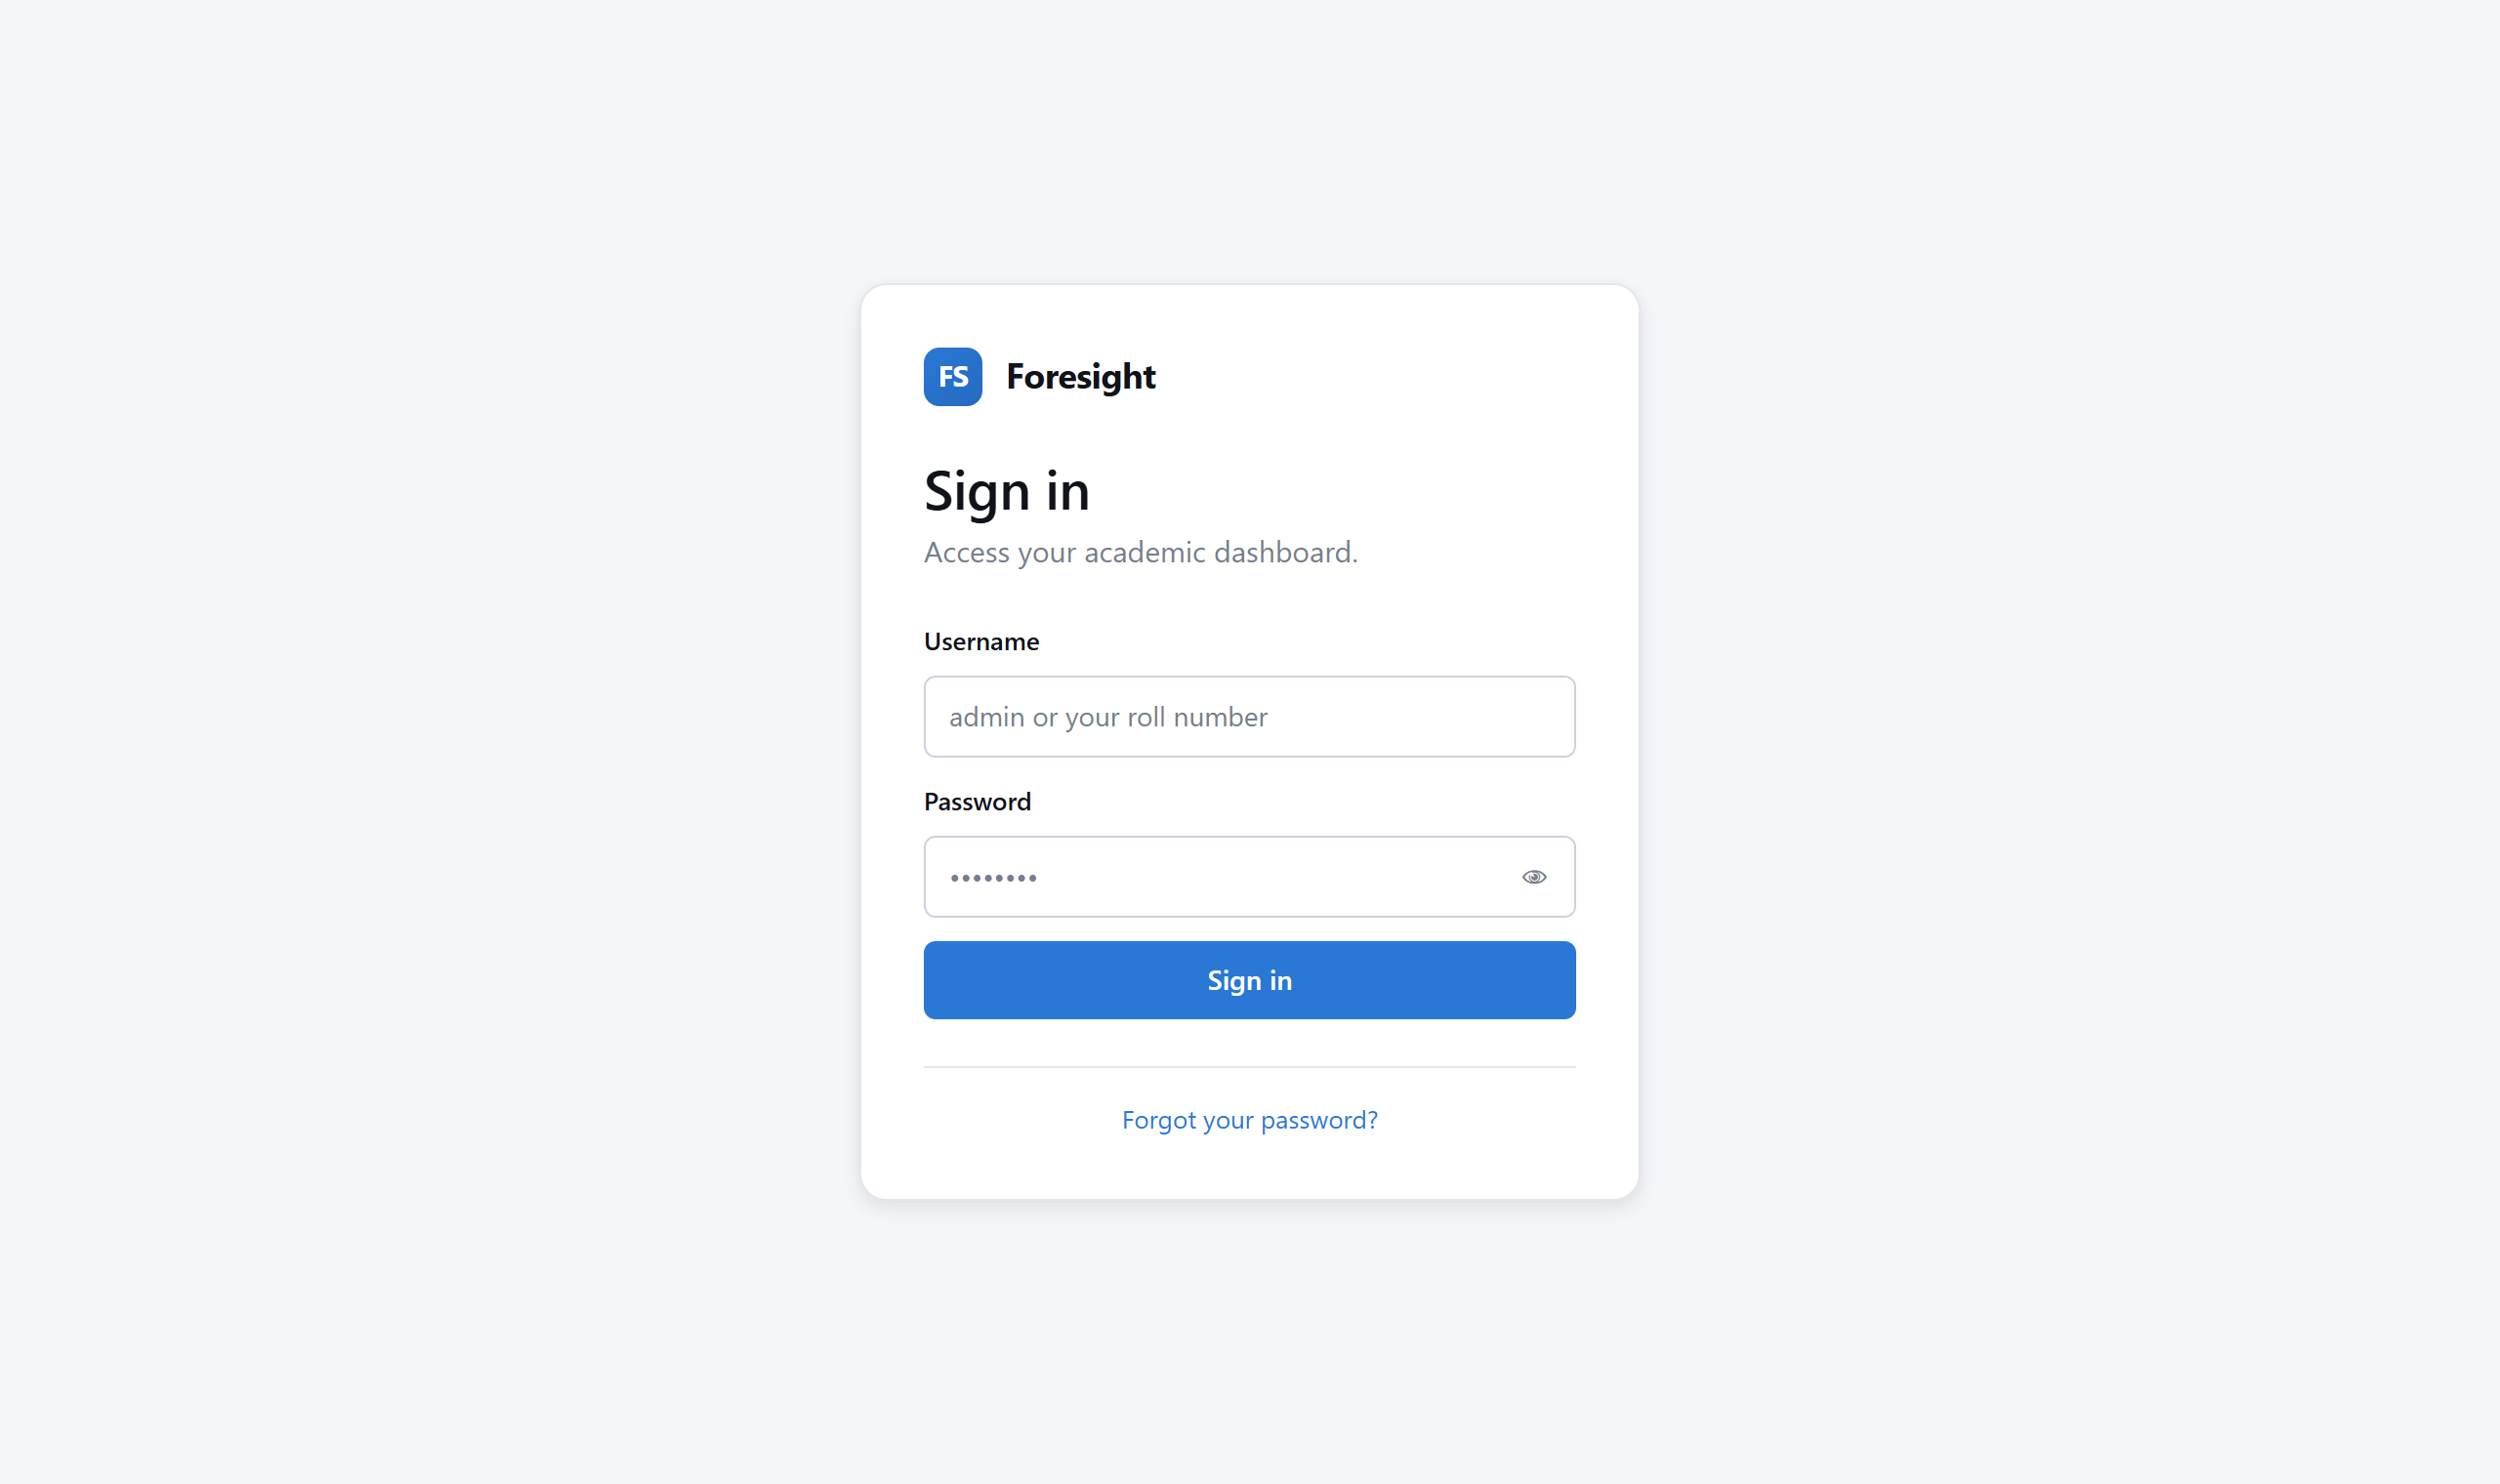
Fig. 1 Sign-in page
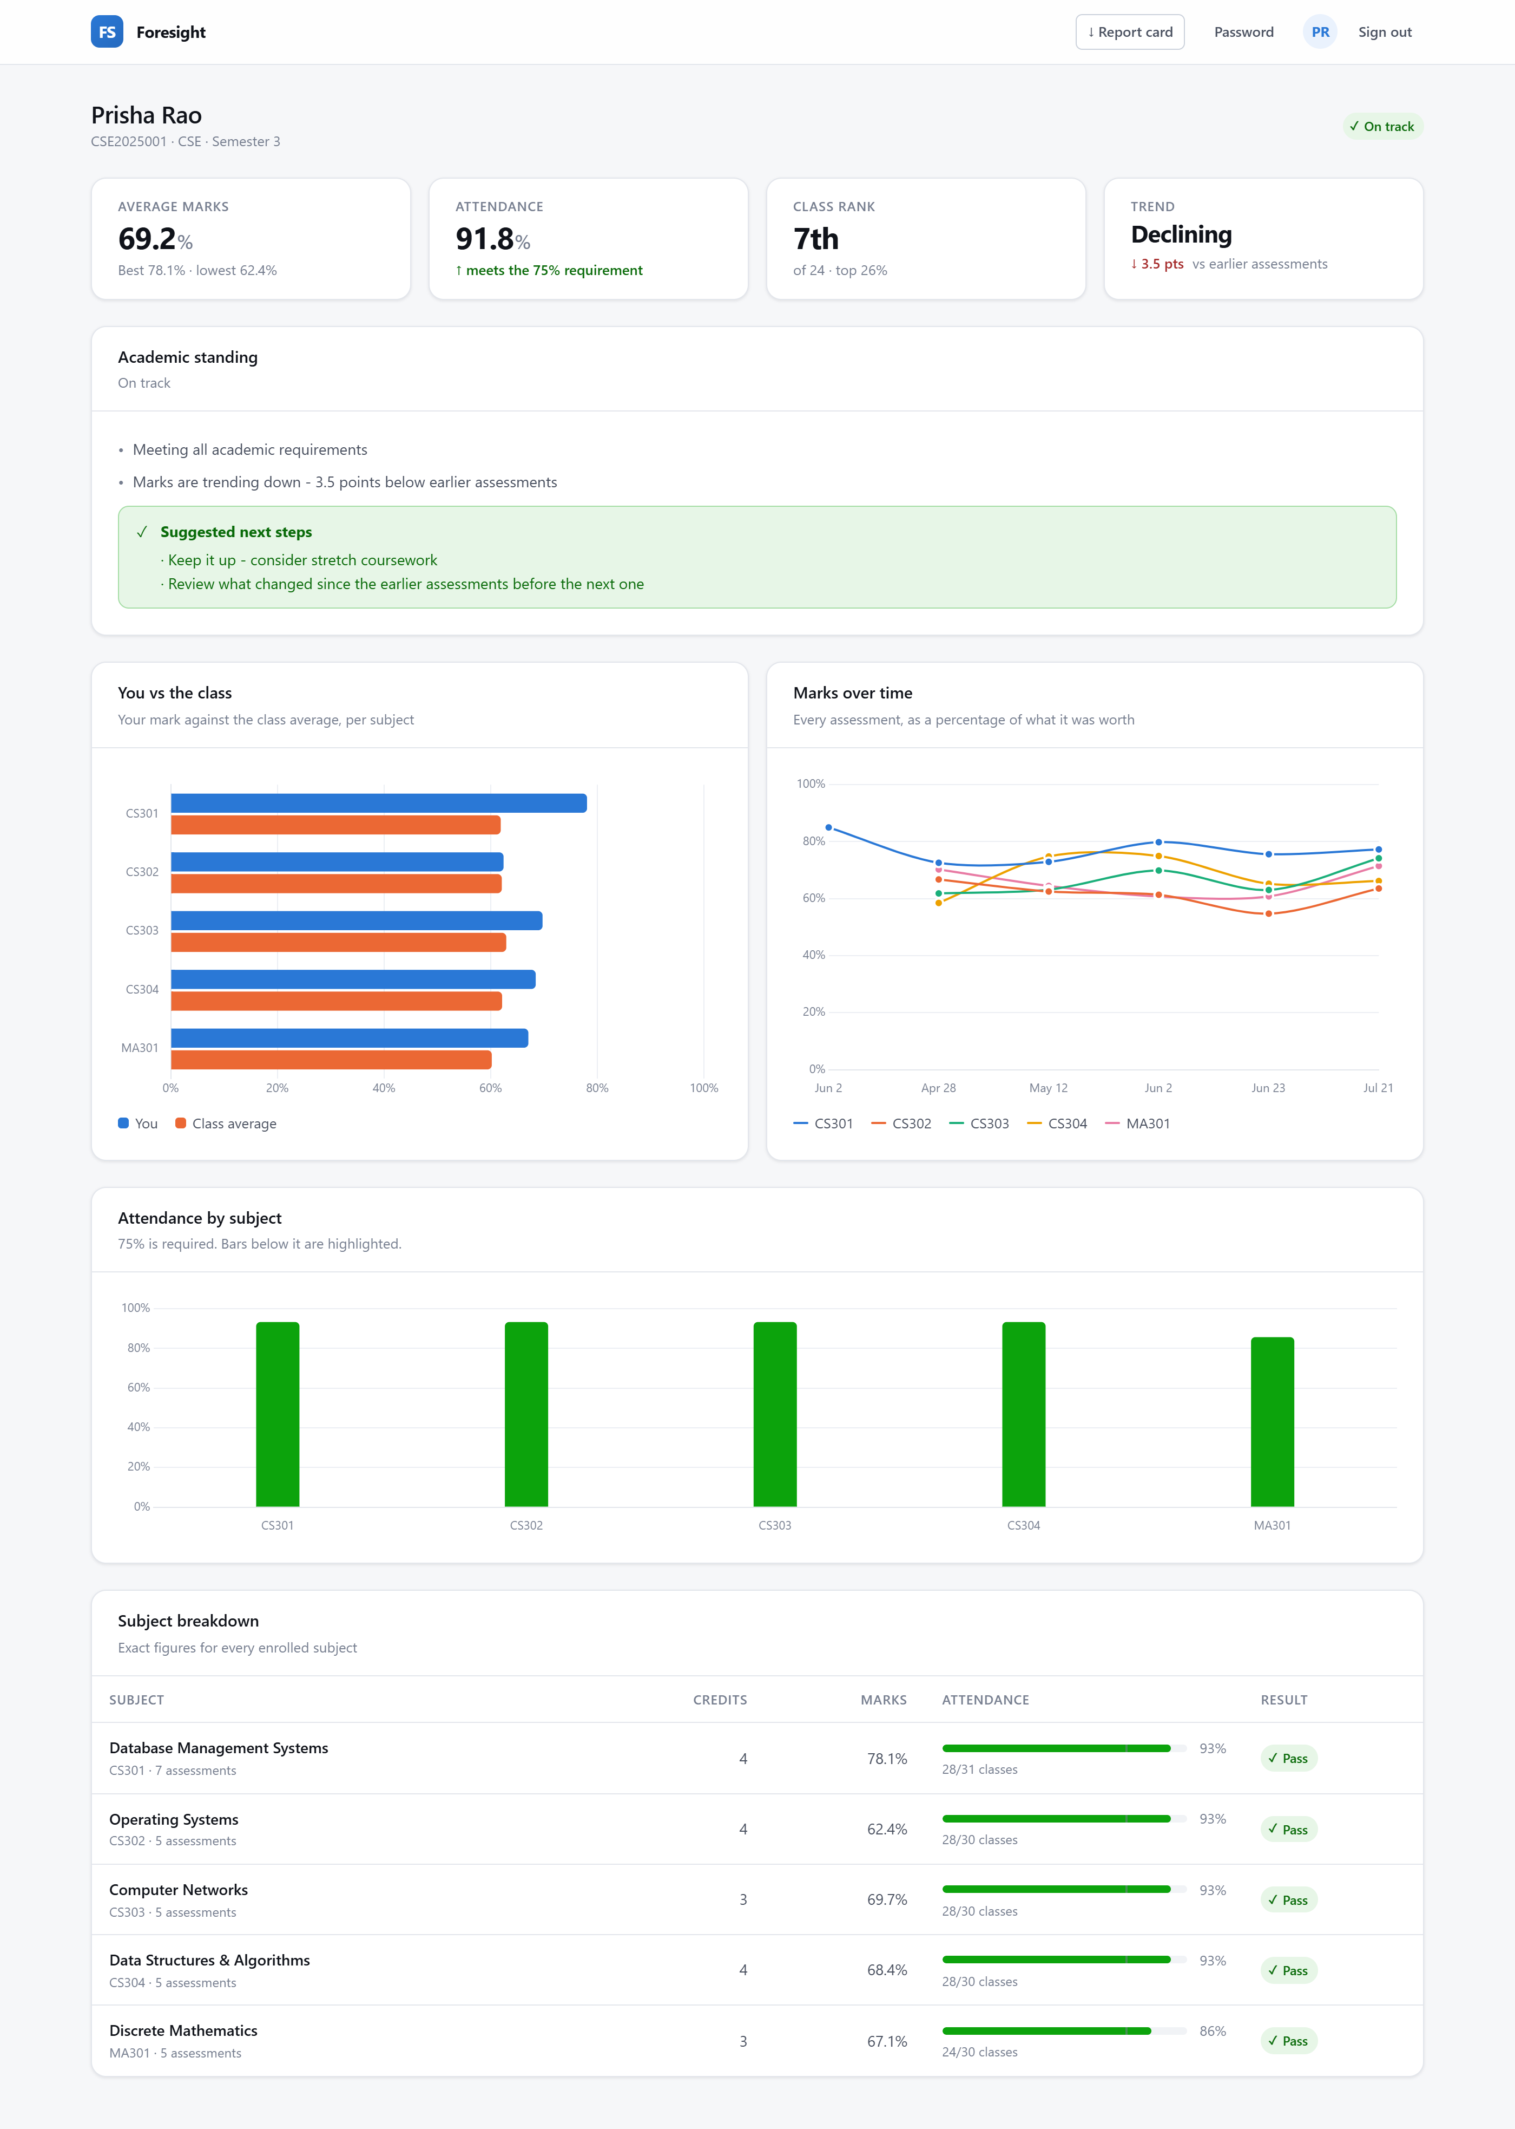
Fig. 2 Student dashboard: summary figures, academic standing with stated reasons, comparison against the class average, assessment trend, attendance and per-subject breakdown
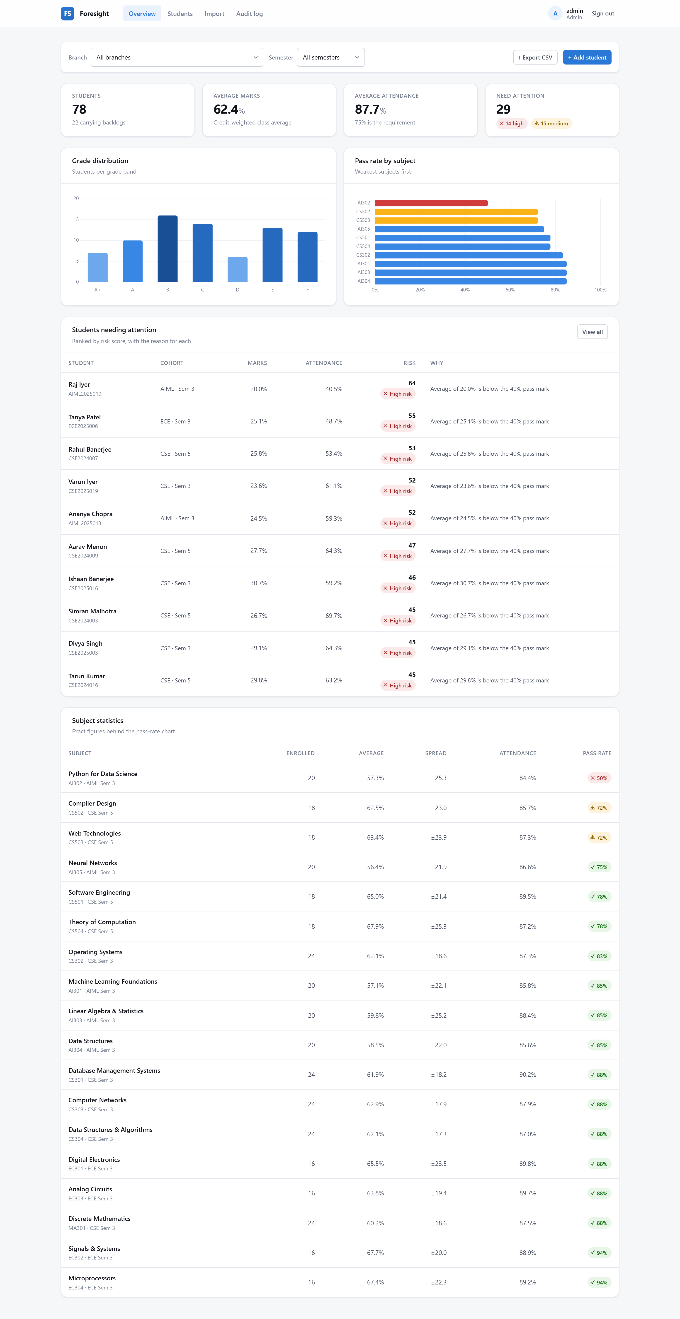
Fig. 3 Administrative overview: cohort figures, grade distribution, subject pass rates and students requiring attention
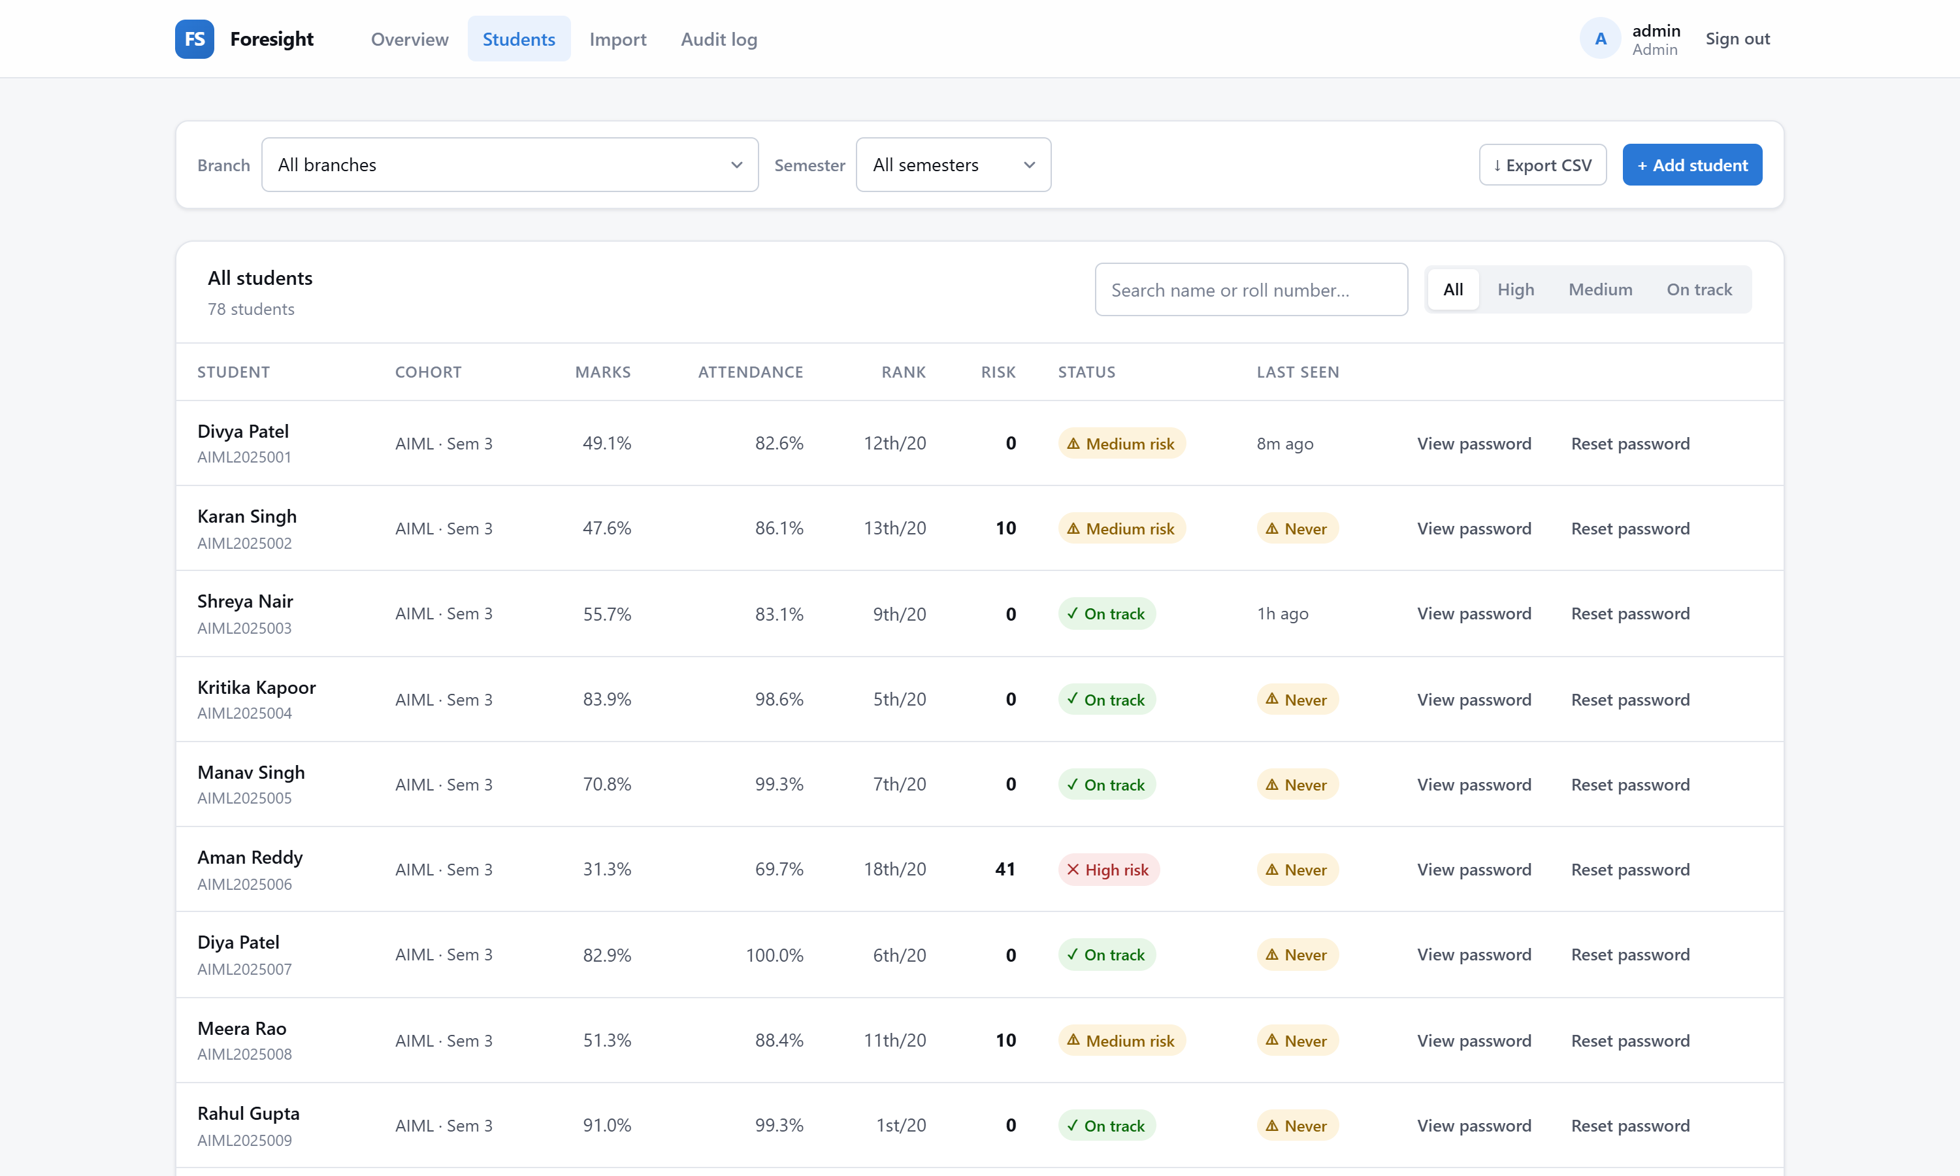
Fig. 4 Student list with search, risk filter, sorting and last sign-in
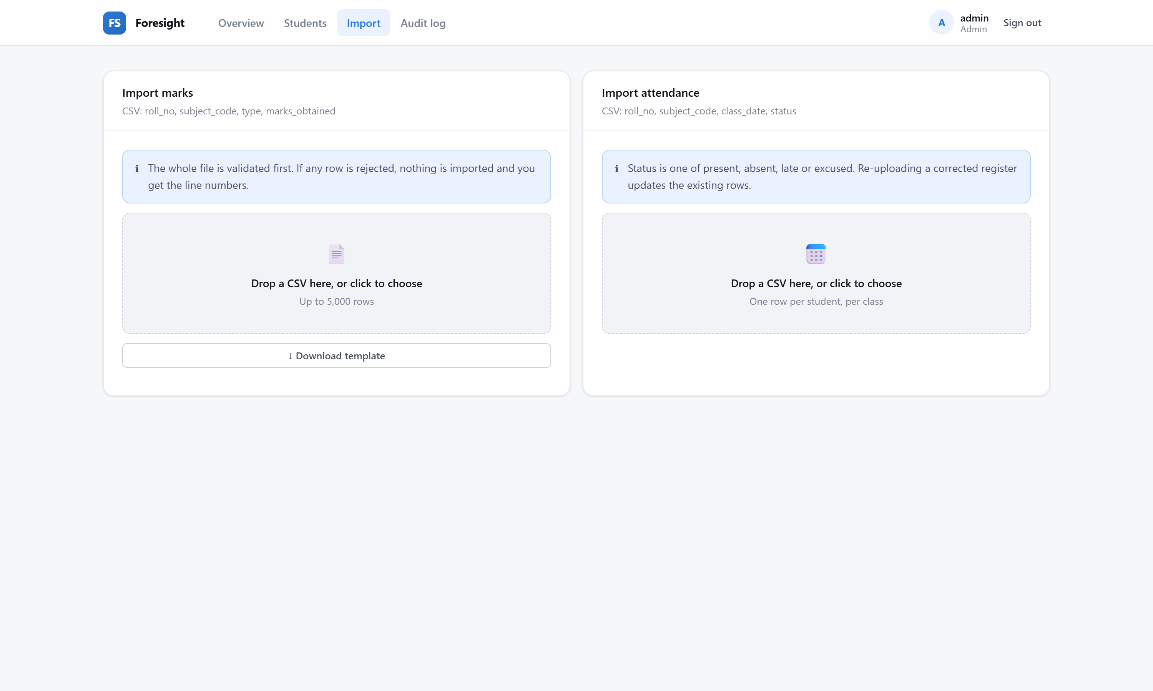
Fig. 5 Bulk CSV import for marks and attendance
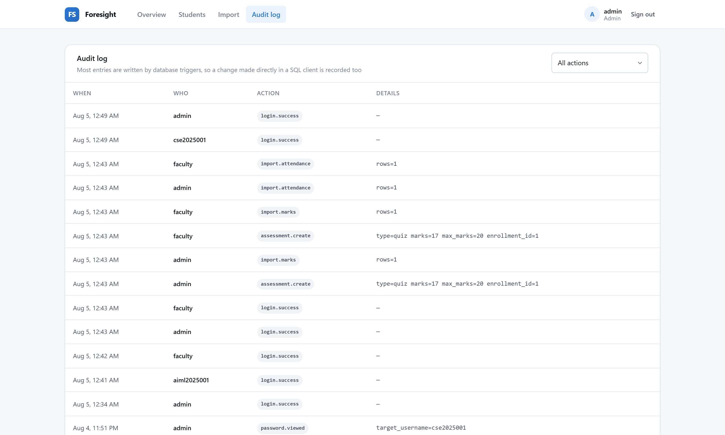
Fig. 6 Audit log; entries written by database triggers are attributed to the user responsible
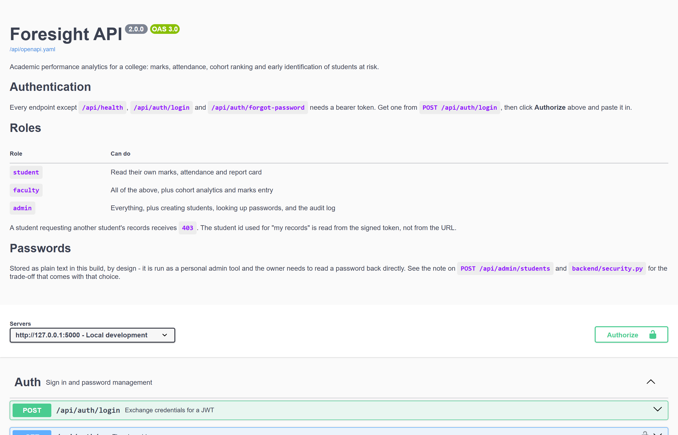
Fig. 7 Interactive API documentation

Results
The system was populated with a generated dataset representing four cohorts across three branches, and was exercised through both the interface and the API.
Measure | Value
Students | 78 across 4 cohorts
Subjects | 18
Enrolments | 356
Assessment records | 1,782
Attendance records | 10,681
Audit entries | 1,817
Cohort average | 62.38 per cent
Risk distribution | 14 high, 15 medium, 49 low
API endpoints | 36
Automated tests | 165, all passing

The analytical objectives were met. The system identifies students requiring attention, ranks them by a score derived from four weighted signals, and states the reason for each — for example, that an average of 20.0 per cent falls below the 40 per cent pass mark, that attendance of 40.5 per cent falls below the requirement, and that five subjects are being failed. This is a material advance on version 0.1, which could report only that a student was 'Weak'.
Cohort ranking and percentile standing place an individual result in context: an average of 52 per cent is interpreted differently when the class average is 48 per cent. Trend detection distinguishes a student who is improving from one who is declining at the same present level, which a single average cannot express.
The database objects behave as intended. Triggers reject invalid marks and future-dated records, including when such statements are issued directly through a SQL client, and the audit log accumulated 1,817 entries during testing without any explicit logging call in the application. Views ensure that the dashboard, the exported file and the at-risk report present identical figures.

Conclusion
Foresight successfully demonstrates the application of database management principles to a practical problem. The schema is normalised and enforces its own integrity through keys, CHECK constraints and triggers. Derived measures are expressed as a layered hierarchy of views, so that every part of the system computes them identically. Operations spanning several tables are performed by stored procedures within transactions.
The principal conceptual advance over version 0.1 is the decision to treat the database as an active component rather than as passive storage. Version 0.1 retrieved rows and computed everything in application code. Version 0.2 places set-based computation, validation and auditing in the database, where each is expressed once and cannot be circumvented.
The project also demonstrates that correctness requires verification rather than inspection. Several defects described in this report — numeric values transmitted as strings, a collation mismatch, timestamps without time zones — produced output that appeared correct. They were found by executing the system and are now prevented by regression tests.
One design decision is recorded as an explicit trade-off rather than a solution. Passwords are stored in plain text to support the administrator's operational requirement, with auditing as the compensating control. The reasoning, the consequence and the means of reversal are documented both in this report and in the source.
Possible extensions include predictive modelling trained on the assessment history now retained, notification of students whose risk band deteriorates, and a timetable module. The present schema, in which assessments are individually dated, was designed to support such work without further structural change.

