STUDENT PERFORMANCE ANALYSIS
PROJECT REPORT


Name: Garv Bhargava
SAP ID: 590020664
Course: MCA – AIML

Introduction
In recent years, the role of data in education has become increasingly significant. Educational institutions collect vast amounts of data related to student performance, attendance, and academic progress. However, managing and analyzing this data manually is both time-consuming and inefficient. Traditional systems are often limited to storing data and do not provide the tools required for analysis and prediction.
Student performance analysis is essential for identifying learning patterns, understanding strengths and weaknesses, and improving academic outcomes. Without proper analytical systems, educators face difficulties in tracking student progress and providing timely support to those who need it.
With advancements in technology, particularly in database management and machine learning, it has become possible to develop systems that not only store data but also analyze it effectively. Database Management Systems (DBMS) provide a structured way to store and retrieve data, while machine learning enables prediction and pattern recognition based on historical data.
The “Student Performance Analytics System” is developed as a solution to these challenges. It integrates front-end, backend, and database components into a single platform that allows efficient data management and analysis. The system provides functionalities such as managing student records, storing marks and attendance, and generating performance insights.
The inclusion of machine learning concepts enhances the system by enabling it to analyze trends and categorize students based on their performance. This helps educators take proactive measures to improve learning outcomes.
This project demonstrates the practical implementation of theoretical concepts studied in Database Management Systems and Machine Learning. It provides a scalable and efficient solution that supports data-driven decision-making in educational institutions.
At present, the system primarily performs data analysis using SQL queries, while machine learning techniques are considered as a future enhancement to extend the analytical capabilities of the system.

Problem Definition
In educational institutions, a large amount of student-related data is generated regularly, including marks, attendance, and academic records. However, most traditional systems are limited to storing this data without providing meaningful analysis or insights. This results in inefficient utilization of data and limits the ability of educators to make informed decisions.
Manual analysis of student performance is time-consuming and prone to errors. Teachers often find it difficult to identify patterns, track student progress, or detect early signs of poor performance. As a result, timely interventions are not possible, and opportunities to improve academic outcomes are missed.
Another limitation of existing systems is the lack of predictive capabilities. They cannot forecast future performance or help in identifying students who may need additional support. This creates a gap between data collection and effective decision-making.
To address these challenges, this project proposes the development of a Student Performance Analytics System
. The system aims to provide an automated solution for managing and analyzing student data. It integrates database management with analytical techniques to generate meaningful insights.
The system not only stores data efficiently but also analyzes it to identify trends and patterns. It helps in categorizing students based on performance and supports educators in making data-driven decisions.
Overall, the project aims to transform raw academic data into actionable information, improving efficiency, accuracy, and academic performance in educational institutions.

Objectives
The primary objective of this project is to develop a comprehensive system that manages and analyzes student performance using database management and machine learning techniques.
One of the main objectives is to design and implement a relational database that efficiently stores student information, subjects, marks, and attendance. The database should follow proper schema design, normalization, and constraints to ensure data integrity and consistency.
Another objective is to develop a user-friendly interface that allows administrators to manage student records easily. The system should provide functionalities such as adding, updating, deleting, and viewing data.
The project also aims to analyze student performance using machine learning concepts. By analyzing historical data, the system can identify patterns, trends, and performance levels of students.
Additionally, the system should be able to categorize students into different groups such as high-performing, average, and weak students. This helps educators in providing targeted support and improving academic outcomes.
The project also aims to integrate front-end, backend, and database components into a complete full-stack application, demonstrating practical implementation of theoretical concepts.
Finally, the system seeks to enhance decision-making in educational institutions by providing meaningful insights and reducing manual effort.

System Overview
The Student Performance Analytics System is a full-stack application designed to manage and analyze student data efficiently. The system integrates front-end, backend, and database components to provide a seamless and interactive user experience.
The system consists of multiple modules, with the Admin Module being the primary component. This module allows administrators to add, update, delete, and view student records, subjects, marks, and attendance. It acts as the central control system for managing all operations. The Student Module enables students to view their academic performance, including marks and attendance.
The front-end of the system is developed using web technologies such as HTML, CSS, and JavaScript. It provides an intuitive and user-friendly interface that allows users to interact with the system easily. Forms and dashboards are designed to simplify data entry and visualization.
The backend is responsible for processing user requests and managing the application logic. It connects the front-end with the database and ensures smooth data flow. The backend handles operations such as inserting new records, updating existing data, and retrieving information for analysis.
The system uses a relational database (MySQL) to store structured data. It includes tables such as Students, Subjects, Users, Marks, and Attendance. Relationships between these tables are established using primary and foreign keys, ensuring data integrity and consistency.
An important feature of the system is its analytical capability. By applying machine learning concepts, the system can analyze student data to identify patterns and trends. It can also be extended to predict student performance and classify students into different categories based on their academic results.
Overall, the system provides an efficient, scalable, and reliable solution for managing student data and performing performance analysis. It bridges the gap between data storage and data-driven decision-making.

ER Diagram
The Entity-Relationship (ER) diagram of the Student Performance Analytics System represents the logical structure of the database and the relationships between different entities involved in the system. It ensures proper organization of data and maintains integrity through defined constraints.
Entities and Attributes
The system consists of five main entities:
- Students
This entity stores information about students.
Attributes:
• student_id (Primary Key)
• name
• branch
• semester
The student_id uniquely identifies each student in the system.
- Subjects
This entity represents the subjects offered in different branches and semesters.
Attributes:
• subject_id (Primary Key)
• subject_name
• branch
• semester
Each subject is uniquely identified by subject_id.
- Users
This entity is used for authentication and role management.
Attributes:
• user_id (Primary Key)
• username (Unique Key)
• password
• role (admin / student)
• student_id (Foreign Key)
The student_id links a user to a specific student (in case of student login).
- Marks
This is a relationship entity that stores marks obtained by students in different subjects.
Attributes:
• student_id (Primary Key, Foreign Key)
• subject_id (Primary Key, Foreign Key)
• marks
It uses a composite primary key (student_id, subject_id), ensuring that each student has only one record per subject.
- Attendance
This entity stores attendance details of students for each subject.
Attributes:
• student_id (Primary Key, Foreign Key)
• subject_id (Primary Key, Foreign Key)
• attendance_percentage
It also uses a composite primary key (student_id, subject_id).
Keys in the System
• Primary Keys:
- student_id (Students)
- subject_id (Subjects)
- user_id (Users)
- (student_id, subject_id) (Marks, Attendance)
• Foreign Keys:
- student_id in Users → references Students
- student_id in Marks → references Students
- subject_id in Marks → references Subjects
- student_id in Attendance → references Students
- subject_id in Attendance → references Subjects
• Unique Key:
- username in Users (ensures no duplicate login)
Relationships and Cardinality
- Students – Marks – Subjects
This represents a many-to-many (M:N) relationship between Students and Subjects, resolved using the Marks entity.
• One student can have marks in multiple subjects
• One subject can have marks of multiple students
Cardinality:
Students (1) —— (M) Marks (M) —— (1) Subjects
- Students – Attendance – Subjects
This is also a many-to-many (M:N) relationship resolved using the Attendance entity.
• One student can have attendance in multiple subjects
• One subject can have attendance records for multiple students
Cardinality:
Students (1) —— (M) Attendance (M) —— (1) Subjects
- Students – Users
This represents a one-to-one (1:1) or one-to-many (1:M) relationship depending on system usage.
• One student can have one user account
• One user (student role) is linked to one student
Cardinality:
Students (1) —— (1/M) Users
Participation Constraints
• Students → Marks: Total Participation
Every student must have marks records.
• Subjects → Marks: Total Participation
Every subject is associated with marks.
• Students → Attendance: Total Participation
Each student has attendance records.
• Subjects → Attendance: Total Participation
• Users → Students: Partial Participation
Not all users must be linked to students (e.g., admin).
Additional Considerations
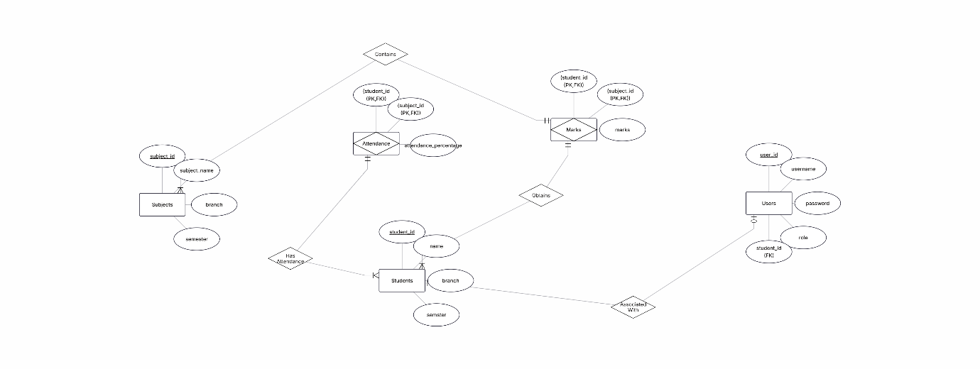
• The database schema is normalized to reduce redundancy.
• Composite keys are used in Marks and Attendance to avoid duplicate records.
• Referential integrity is maintained using foreign key constraints.
• ENUM is used in Users table for role management (admin, student).

Database Schema Design
The database schema of the Student Performance Analytics System is designed using relational database principles to ensure efficient data storage, integrity, and consistency. The schema consists of five main tables: Students, Subjects, Users, Marks, and Attendance. Each table is designed with appropriate attributes, primary keys, and foreign keys to maintain relationships between entities.
1. Students Table
The Students table stores basic information about students such as their name, branch, and semester. Each student is uniquely identified by student_id.
Attributes:
• student_id (Primary Key)
• name
• branch
• semester
SQL Query:
CREATE TABLE students (
student_id INT AUTO_INCREMENT PRIMARY KEY,
name VARCHAR(50) NOT NULL,
branch VARCHAR(50),
semester INT
);
2. Subjects Table
The Subjects table contains details about subjects offered in different branches and semesters. Each subject is uniquely identified by subject_id.
Attributes:
• subject_id (Primary Key)
• subject_name
• branch
• semester
SQL Query:
CREATE TABLE subjects (
subject_id INT AUTO_INCREMENT PRIMARY KEY,
subject_name VARCHAR(50) NOT NULL,
branch VARCHAR(50),
semester INT
);
3. Users Table
The Users table is used for authentication and role management. It stores login credentials and user roles. Each user is uniquely identified by user_id. The student_id acts as a foreign key linking users to students.
Attributes:
• user_id (Primary Key)
• username (Unique Key)
• password
• role (admin / student)
• student_id (Foreign Key)
SQL Query:
CREATE TABLE users (
user_id INT AUTO_INCREMENT PRIMARY KEY,
username VARCHAR(50) UNIQUE NOT NULL,
password VARCHAR(100) NOT NULL,
role ENUM('admin', 'student') NOT NULL,
student_id INT,
FOREIGN KEY (student_id) REFERENCES students(student_id)
);
4. Marks Table
The Marks table stores the academic performance of students in different subjects. It represents a many-to-many relationship between Students and Subjects. A composite primary key (student_id, subject_id) is used to ensure that each student has only one record per subject.
Attributes:
• student_id (Primary Key, Foreign Key)
• subject_id (Primary Key, Foreign Key)
• marks
SQL Query:
CREATE TABLE marks (
student_id INT,
subject_id INT,
marks INT,
PRIMARY KEY (student_id, subject_id),
FOREIGN KEY (student_id) REFERENCES students(student_id),
FOREIGN KEY (subject_id) REFERENCES subjects(subject_id)
);
5. Attendance Table
The Attendance table stores attendance details of students for each subject. Similar to the Marks table, it uses a composite primary key (student_id, subject_id) and maintains relationships through foreign keys.
Attributes:
• student_id (Primary Key, Foreign Key)
• subject_id (Primary Key, Foreign Key)
• attendance_percentage
SQL Query:
CREATE TABLE attendance (
student_id INT,
subject_id INT,
attendance_percentage INT,
PRIMARY KEY (student_id, subject_id),
FOREIGN KEY (student_id) REFERENCES students(student_id),
FOREIGN KEY (subject_id) REFERENCES subjects(subject_id)
);
Schema Characteristics
The database schema is designed following normalization principles to eliminate redundancy and ensure efficient data organization. Relationships between tables are established using foreign keys, which maintain referential integrity. Composite keys are used in the Marks and Attendance tables to avoid duplicate entries.
The schema supports efficient querying and data analysis, making it suitable for implementing performance analytics and machine learning-based insights.
Overall, the database design provides a strong foundation for the system, enabling reliable data storage, easy retrieval, and scalability for future enhancements.

SQL Queries
SQL (Structured Query Language) is a fundamental component of the Student Performance Analytics System, as it is used to manage and manipulate data stored in the relational database. Although users interact with the system through a graphical front-end interface, all operations such as data insertion, updating, deletion, and retrieval are internally executed using SQL queries in the backend.
The system makes use of different categories of SQL queries, including Data Definition Language (DDL), Data Manipulation Language (DML), and Data Query Language (DQL), to ensure efficient database operations and data analysis.
DDL (Data Definition Language)
DDL queries are used to define and structure the database schema. These queries are responsible for creating tables and specifying constraints such as primary keys, foreign keys, and unique constraints. Proper use of DDL ensures that the database is well-organized and maintains data integrity.
For example, the Students table is created using the following query:
CREATE TABLE students (
student_id INT AUTO_INCREMENT PRIMARY KEY,
name VARCHAR(50) NOT NULL,
branch VARCHAR(50),
semester INT
);
Similar DDL queries are used to create other tables such as Subjects, Users, Marks, and Attendance, each with appropriate relationships and constraints.
DML (Data Manipulation Language)
DML queries are used to modify the data stored in the database. These include operations such as inserting new records, updating existing data, and deleting unwanted records. In this system, most DML operations are triggered through the front-end interface; however, they are executed in the backend using SQL queries.
For example, inserting a new student record:
INSERT INTO students (name, branch, semester)
VALUES ('Rahul', 'CSE', 3);
Updating student information:
UPDATE students
SET branch = 'AIML'
WHERE student_id = 1;
Deleting a student record:
DELETE FROM students
WHERE student_id = 5;
These operations ensure that the database remains up-to-date and accurately reflects the current state of the system.
DQL (Data Query Language)
DQL queries are used to retrieve data from the database. The SELECT statement is the most commonly used command for fetching data and generating reports. These queries play a crucial role in analyzing student performance.
A simple query to display all student records:
SELECT * FROM students;
To perform more advanced analysis, JOIN queries are used to combine data from multiple tables. This allows the system to display meaningful information such as student performance across different subjects:
SELECT s.name, sub.subject_name, m.marks
FROM students s
JOIN marks m ON s.student_id = m.student_id
JOIN subjects sub ON m.subject_id = sub.subject_id;
Aggregate functions are also used to perform calculations and generate insights. For example, calculating the average marks of each student:
SELECT s.name, AVG(m.marks) AS average_marks
FROM students s
JOIN marks m ON s.student_id = m.student_id
GROUP BY s.student_id;
Such queries help in identifying performance trends and evaluating student progress.

System Implementation
The Student Performance Analytics System is implemented as a full-stack application that integrates front-end, backend, and database components to provide efficient data management and analysis. The system ensures smooth interaction between users and the database while maintaining data integrity, scalability, and performance.
The front-end of the system is developed using web technologies such as HTML, CSS, and JavaScript. It provides an interactive and user-friendly interface that allows users to perform operations such as adding student details, managing subjects, entering marks, and viewing attendance. The interface is designed to be simple, responsive, and easy to navigate.
The backend is responsible for handling the core logic of the application. It acts as a bridge between the front-end and the database. Whenever a user performs an action, the backend processes the request, validates the data, and executes the required operations on the database. It ensures that only valid and consistent data is stored.
The system uses a relational database (MySQL) to store structured data. It consists of tables such as Students, Subjects, Users, Marks, and Attendance. These tables are connected using primary and foreign keys, ensuring referential integrity. The database is normalized to eliminate redundancy and improve efficiency.
The system follows a modular design approach, where functionalities such as student management, subject management, marks handling, and attendance tracking are handled in separate modules. This improves maintainability and scalability of the application.
Working of the System
The working of the Student Performance Analytics System follows a structured flow of operations from user interaction to data processing and output generation.
- User Interaction
The system begins with user interaction through the front-end interface. Users (admin or student) access the system through a login page. Based on their role, they are redirected to the appropriate dashboard.
- Authentication and Authorization
User credentials entered on the login page are verified using the Users table in the database. The system checks the username, password, and role to grant access. Admin users are given full control, while student users have limited access.
- Data Entry and Management
The admin can add, update, or delete student records, subjects, marks, and attendance using forms provided in the interface. These inputs are sent to the backend, where they are validated and then stored in the database.
- Database Processing
The backend communicates with the database to perform operations such as inserting new records, updating existing data, or retrieving information. SQL queries are executed to maintain and manage the data efficiently.
- Data Retrieval and Analysis
When a user requests information, such as viewing student performance, the system retrieves data from multiple tables using queries (including JOIN operations). The data is then processed and organized for display.
- Output Generation
The processed data is sent back to the front-end, where it is displayed in the form of tables or reports. Users can view marks, attendance, and performance details easily.
- Analytical Capability
The system can analyze student data to identify trends and performance levels. It can be extended using machine learning techniques to predict student outcomes and classify students based on their performance.
This workflow ensures that the system operates efficiently, providing accurate and real-time information to users.
The implementation ensures efficient data handling, smooth user interaction, and reliable performance. The system is tested for various operations such as data insertion, updating, deletion, and retrieval to ensure correctness.
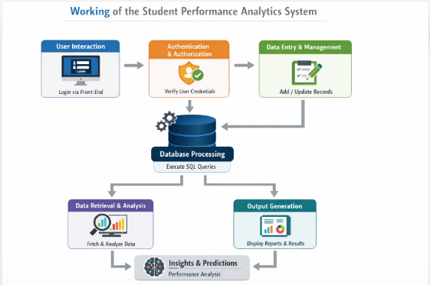

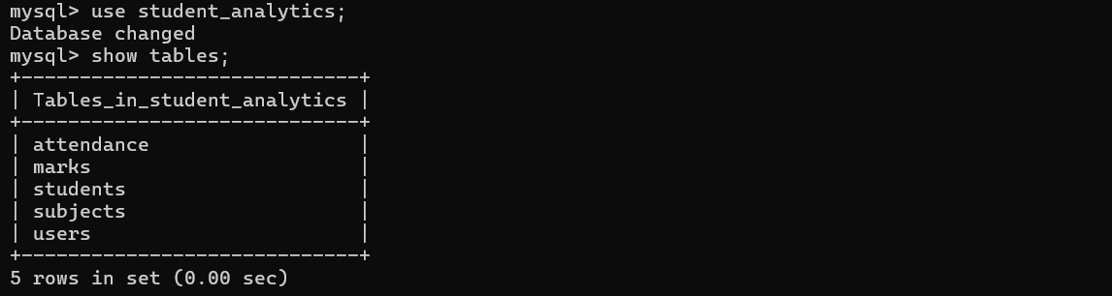
Screenshots
Fig.1 List of Tables in database
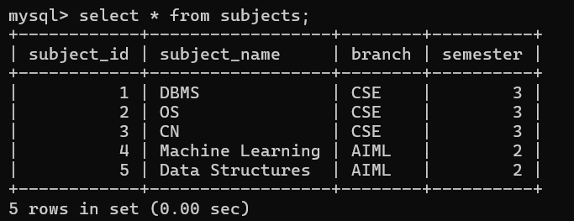
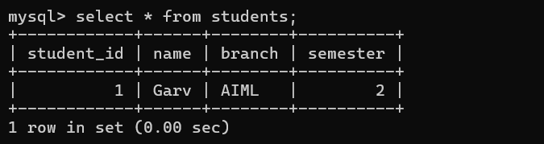
Fig.2 Subject Table
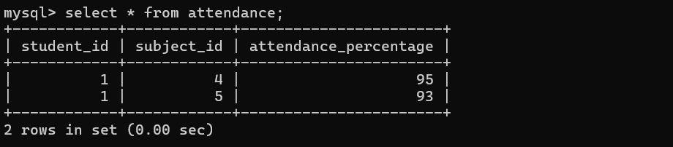
Fig.3 Student Table
Fig.4 Attendance Table
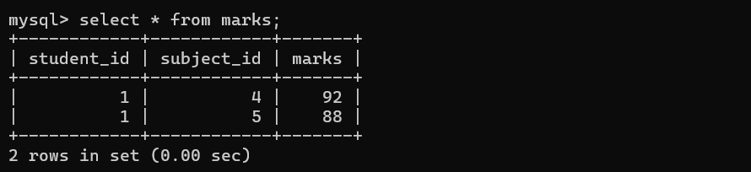
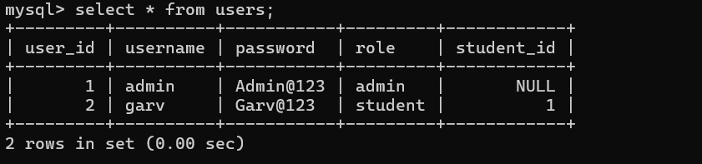
Fig.5 Marks Table
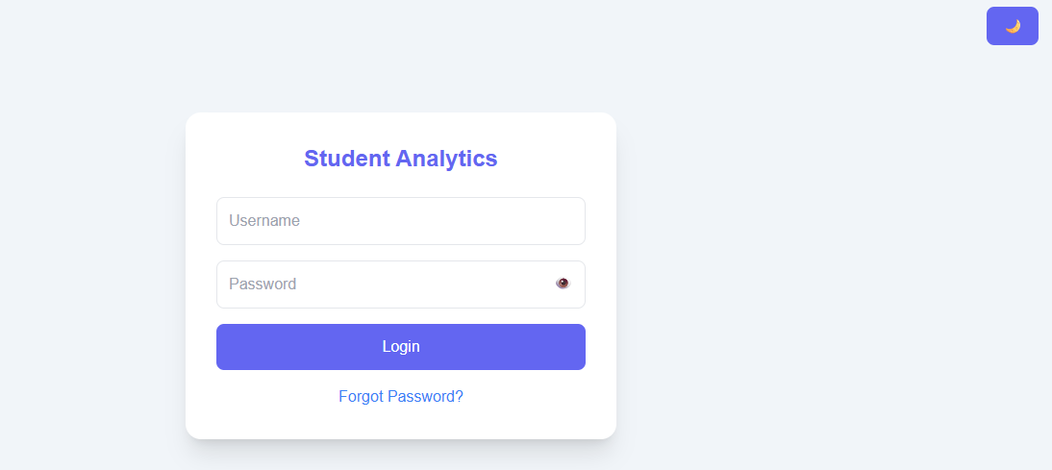
Fig.6 Users Table
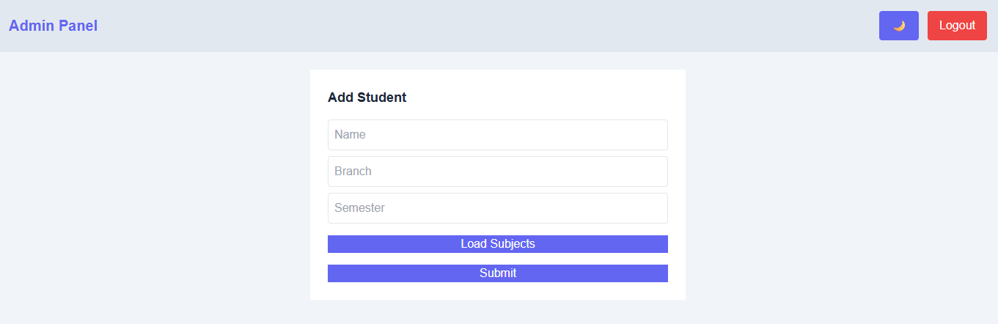
Fig.7 Login Page (For Both Admin and Student)
Fig.8 Admin Panel UI
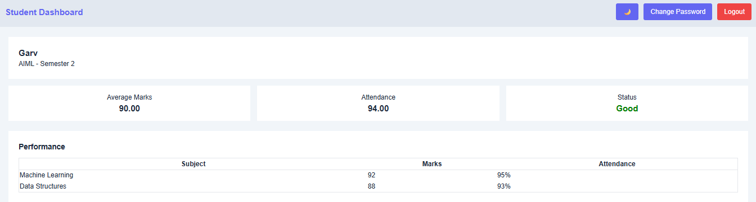
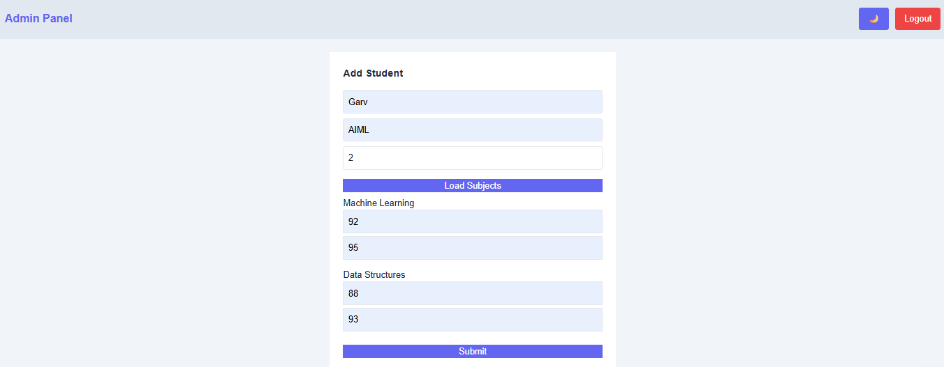
Fig.9 Adding Data from Admin Panel
Fig.10 Student Dashboard

Results
The Student Performance Analytics System successfully demonstrates the effective management and analysis of student data using a full-stack application integrated with a relational database. The system is capable of storing, retrieving, and processing data related to students, subjects, marks, and attendance in an organized and efficient manner.
The implementation of the system allows administrators to perform various operations such as adding new students, managing subject details, entering marks, and recording attendance. These operations are executed smoothly through a user-friendly interface, ensuring ease of use and accuracy.
One of the key outcomes of the system is the ability to retrieve and display student performance data efficiently. By using SQL queries, especially JOIN operations, the system can combine data from multiple tables and present meaningful information such as subject-wise marks and overall student performance.
The system also enables basic performance analysis through the use of aggregate functions. For example, average marks of students can be calculated, allowing identification of high-performing and low-performing students. This helps in understanding academic trends and evaluating student progress.
Additionally, the system ensures data integrity through the use of primary and foreign keys, preventing inconsistencies and duplication of records. The modular design of the system allows different functionalities to operate independently, improving maintainability and scalability.
Although advanced machine learning techniques are not fully implemented, the system provides a strong foundation for future enhancements in predictive analysis. The current implementation successfully demonstrates how data can be transformed into useful insights using database queries.
Overall, the system achieves its objective of providing an efficient platform for managing and analyzing student performance data. It improves the efficiency of data handling, reduces manual effort, and supports better decision-making in educational institutions.

Conclusion
The Student Performance Analytics System is a comprehensive solution designed to manage and analyze student academic data efficiently. The project successfully integrates front-end, backend, and database components to create a functional full-stack application.
The system effectively demonstrates the application of database management concepts such as schema design, normalization, primary and foreign keys, and SQL queries. It provides a structured approach to storing and retrieving student data, ensuring accuracy and consistency.
Through the implementation of various modules, the system allows administrators to manage student records, subjects, marks, and attendance with ease. The use of SQL queries enables efficient data processing and analysis, allowing users to gain meaningful insights into student performance.
Although the current implementation focuses on data management and analysis using SQL queries, it is designed to support future integration of machine learning techniques for advanced prediction and classification.
The project also highlights the importance of data-driven decision-making in the field of education. By transforming raw data into useful information, the system helps educators identify trends, evaluate performance, and take appropriate actions to improve academic outcomes.
In conclusion, the project successfully meets its objectives and provides a practical solution for student performance analysis. It demonstrates the effective use of modern technologies and lays the foundation for further enhancements using machine learning and advanced analytics.

