CrowdVision: Custom CNN-Based Face Detection,
Crowd Counting and Face Recognition
A Software Engineering Approach
Mini Project Report submitted in the partial fulfilment of
Bachelor of Technology (B.Tech)
in
Computer Engineering
Course: Software Engineering
by
Gauransh Bhartia (B134)
Garv Agrawal (B156)
Adarsh Yadav (B189)

Under the supervision of
Prof. Prashasti Kanikar
(Department of Computer Engineering, MPSTME)

SVKM's NMIMS University
(Deemed-to-be University)
MUKESH PATEL SCHOOL OF TECHNOLOGY MANAGEMENT & ENGINEERING (MPSTME)
Vile Parle (W), Mumbai-56
Academic Year 2026–27

INDEX
Sr. No. | Contents | Page No.
1 | Project Introduction and Authors | 3
2 | Problem Statement, Objectives and Scope | 4
3 | Software Requirements Specification (SRS) | 5
4 | Software Process Model, Estimation and Risks | 6
5 | System Architecture and Design Diagrams | 7
6 | Implementation | 10
7 | Testing and Results | 11
8 | Screenshots | 12
9 | Conclusion and Future Scope | 14
10 | References | 14

List of figures
Fig. 1 System architecture (4 layers); Fig. 2 Use case diagram; Fig. 3 Data flow diagram (Level 1); Fig. 4 Class diagram; Fig. 5 Sequence diagram (one frame); Fig. 6 Web console: live detection; Fig. 7 Web console: face recognition; Fig. 8 Web console: session dashboard; Fig. 9 Recognition result; Fig. 10 Evaluation scenes; Fig. 11 Automated test run (17/17 passed).

1. Project Introduction and Authors

1.1 Introduction
Counting people and knowing who is present are everyday needs in classrooms, labs, events and offices. Doing it by hand is slow and error-prone, and most automatic tools depend on large ready-made models (such as YOLO) or cloud services.
CrowdVision is a software product that watches a camera, finds every face, counts the people present, raises an alert when a room is over capacity and recognises enrolled people by name. Both neural networks inside it, CrowdVisionNet (detection, 122,774 parameters) and RecogNet (recognition), were designed and trained from scratch by the team, with no YOLO or pretrained weights. It runs in real time on an ordinary laptop CPU, through a desktop app and a browser-based web console.
This report presents CrowdVision from a Software Engineering point of view. The CNN is one module of a larger system that was built through the full SDLC: requirements (SRS), an iterative process model, effort estimation, risk management, layered design with UML diagrams, modular implementation, testing at four levels, a defect log and maintenance planning.

1.2 Authors
Sr. No. | Name | Roll No. | Program
1 | Gauransh Bhartia | B134 | B.Tech Computer Engineering
2 | Garv Agrawal | B156 | B.Tech Computer Engineering
3 | Adarsh Yadav | B189 | B.Tech Computer Engineering

Project mentor: Prof. Prashasti Kanikar, Department of Computer Engineering, MPSTME, NMIMS.

1.3 Tools and technologies
Area | Used
Languages | Python 3.10+ (backend, models); HTML, CSS, JavaScript (web console)
Libraries | PyTorch (basic layers only), OpenCV (camera and drawing only), NumPy, Pillow
Datasets | LFW (13,233 face photos), Caltech-101 (7,807 non-face photos)
SE tools | Git and GitHub (version control), pytest (automated testing), VS Code (IDE), draw.io-style UML diagrams

2. Problem Statement, Objectives and Scope

2.1 Problem statement
To design, build and test a software system that, from a live camera, video or photo, detects every visible face, counts the people in real time, warns when a capacity is exceeded and identifies enrolled people, using CNNs the team trains from scratch, running offline on a normal laptop CPU, and developed with a disciplined software engineering process.
Our first prototype showed why process matters: trained on 21 images it reached 100% training accuracy but, on test scenes, only F1 67.9% with an average count error of 2.18 people. Measurable requirements, iterative testing and defect tracking turned it into a reliable product.

2.2 Objectives
- Write an SRS with 12 functional and 10 measurable non-functional requirements (IEEE 830 style).
- Follow an iterative and incremental process model, testing at the end of every iteration.
- Design a layered, modular architecture and document it with use case, DFD, class and sequence diagrams.
- Build a fully convolutional CNN that meets precision and recall ≥ 90% and a count error ≤ 0.5 people per image.
- Deliver a desktop app and a web console with counting, capacity alert, zone, logs, enrolment and recognition.
- Verify and validate the system with unit, integration, system and acceptance tests and keep a defect log.
- Plan the project with COCOMO effort estimation and a risk register.

2.3 Scope
In scope | Out of scope
Face detection, counting and recognition from webcam, video or photo | People whose faces are not visible
Real-time CPU use on a laptop (Windows / Linux) | GPU servers, mobile apps, cloud hosting
Capacity alert, zone, screenshots, recording, CSV logs, attendance | Very dense crowds of hundreds of people
Small groups such as a class or lab | Large identity databases or surveillance
Local web console bound to the same machine | User accounts or storing faces online

Stakeholders: the operator (faculty, lab or event staff) who runs the system; the people being counted or recognised; and the developers who maintain it.
Limitations: the detector is trained mainly on frontal faces, so strong side profiles or faces under about 30 px can be missed; the evaluation scenes are synthetic composites.

3. Software Requirements Specification (SRS)
Requirements were gathered from the problem statement, mentor discussions and testing of the first prototype. Each has an ID and, where possible, a measurable target, so it can be verified by a test (Section 7).

3.1 Functional requirements
ID | Requirement | Priority
FR-01 | Read frames from a webcam, a video file or an image. | High
FR-02 | Detect every visible face and draw one box per face. | High
FR-03 | Display the current people count, peak count and frames per second. | High
FR-04 | Raise a visible alert when the count exceeds a user-set capacity. | High
FR-05 | Let the user draw a zone and show the count inside it. | Medium
FR-06 | Log the count with a timestamp and export it as CSV. | Medium
FR-07 | Save screenshots and record video. | Medium
FR-08 | Enrol a person with the webcam (about 60 photos). | High
FR-09 | Train the recognition model from the interface. | High
FR-10 | Show the name of each enrolled person, or "Unknown". | High
FR-11 | Record each person's first-seen and last-seen times (attendance). | Medium
FR-12 | Change the confidence threshold and capacity while running. | Medium

3.2 Non-functional requirements
ID | Type | Requirement | Measurable target
NFR-01 | Accuracy | Detected boxes should be real faces | Precision ≥ 90% on unseen scenes
NFR-02 | Accuracy | Real faces should be found | Recall ≥ 90% on unseen scenes
NFR-03 | Accuracy | Counts close to the truth | Count error ≤ 0.5 people per image
NFR-04 | Performance | Live video on a laptop CPU | ≥ 5 frames per second at 640 px
NFR-05 | Generalisation | Works on people never seen in training | Test split by person
NFR-06 | Portability | Windows and Linux, Python 3.10+ | One pip install -r requirements.txt
NFR-07 | Usability | First-time user can start quickly | One command; buttons and on-screen help
NFR-08 | Maintainability | Modules change independently | Layered design + automated tests
NFR-09 | Privacy | No images leave the computer | Offline; server bound to localhost
NFR-10 | Independence | No YOLO or pretrained weights | All weights trained from scratch

4. Software Process Model, Estimation and Risks

4.1 Process model: iterative and incremental
We chose an iterative and incremental model, close to Boehm's spiral model, instead of waterfall. The behaviour of an ML component cannot be fully specified in advance; it must be measured and improved. Each iteration ended with testing, and the defects found defined the next iteration.
Iteration | What we built | Testing showed | Next step
1. Prototype | Sliding-window CNN, 21 images | 100% train, 75% validation; duplicate boxes; slow | New dataset pipeline
2. Data + model | 166k crops, fully convolutional CNN | 99.87% crop accuracy; many false boxes | Hard-negative mining
3. Robust detection | Mining, edge-face training, cluster merging | Precision 57% → 96%, recall 83% → 99% | Tracker + recognition
4. Product | Tracker, RecogNet, desktop + web UI, tests | 17/17 tests pass; all accuracy NFRs met | Maintenance

4.2 Effort estimation (Basic COCOMO, organic mode)
Size: about 2.88 KLOC (1,955 lines of Python, 840 lines of web code, 89 lines of tests). Organic mode is used because the team is small and the requirements are flexible.
- Effort E = 2.4 × (KLOC)^1.05 = 2.4 × 2.884^1.05 ≈ 7.3 person-months
- Development time D = 2.5 × E^0.38 = 2.5 × 7.3^0.38 ≈ 5.3 months
- Average staff P = E / D = 7.3 / 5.3 ≈ 1.4 people
COCOMO assumes all code is written by hand. We reused libraries (PyTorch, OpenCV), so this is an upper bound.

4.3 Risk management
Risk | Prob. | Impact | Mitigation | Status
Too little training data; model overfits | High | High | Public datasets, augmentation, split by person | Resolved
Duplicate or wrong boxes inflate the count | High | High | Box regression, cluster merging, nested-box rule, tracker | Resolved
Too slow on a CPU | Med | High | Fully convolutional design, --width option | Resolved
False detections in the demo room | Med | Med | Hard-negative mining, collect_backgrounds.py | Mitigated
Privacy of face data | Med | High | Offline, localhost only; faces excluded from Git | Mitigated
Library / OpenCV GUI incompatibility | Med | Low | Pinned requirements; documented fix | Resolved

5. System Architecture and Design Diagrams

5.1 Layered architecture
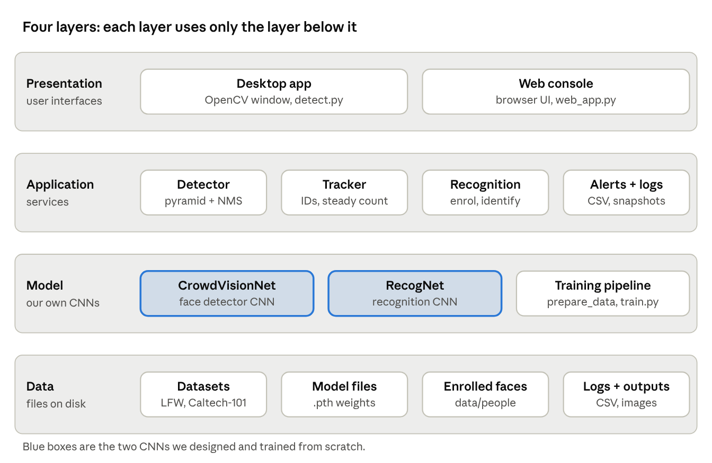
Fig. 1: System architecture: Presentation, Application, Model and Data layers
- Presentation: desktop OpenCV window (`detect.py`, `face_recognition_app.py`) and web console (`web/index.html`).
- Application: Engine (`web_app.py`), IoU tracker, alerts, counting zone, logging.
- Model: CrowdVisionNet (`model.py`, `detector.py`) and RecogNet.
- Data: datasets, trained weights (.pth), enrolled faces, CSV logs.

5.2 Design principles applied
- Modularity: 10 modules, each with one job.
- Low coupling: the interface only calls `detect(frame)` and receives boxes; it does not know how the CNN works. The web console was added without changing the model.
- High cohesion: all box-merging logic lives in `detector.py`, so the biggest accuracy fix (defect D-03) touched one file.
- Separation of concerns: data preparation, training, inference and UI are separate scripts, which avoids hidden technical debt in ML systems.
CNN design (CrowdVisionNet): 48×48 input → Conv 16 → Conv 32 → Conv 64 (each 3×3 + BatchNorm + ReLU + MaxPool) → Conv 4×4, 96 filters → two 1×1 heads (face/non-face, box offsets). With no Linear layers it scores a whole frame in one pass. Detection pipeline: image pyramid → CNN → threshold 0.99 → box refinement → cluster merge with voting → nested-box rule → tracker (median count over 15 frames).

5.3 Use case diagram
The Operator starts detection, views the count, sets capacity, draws a zone, enrols people, trains the recogniser and exports logs. The Enrolled person takes part in enrolment and recognition.
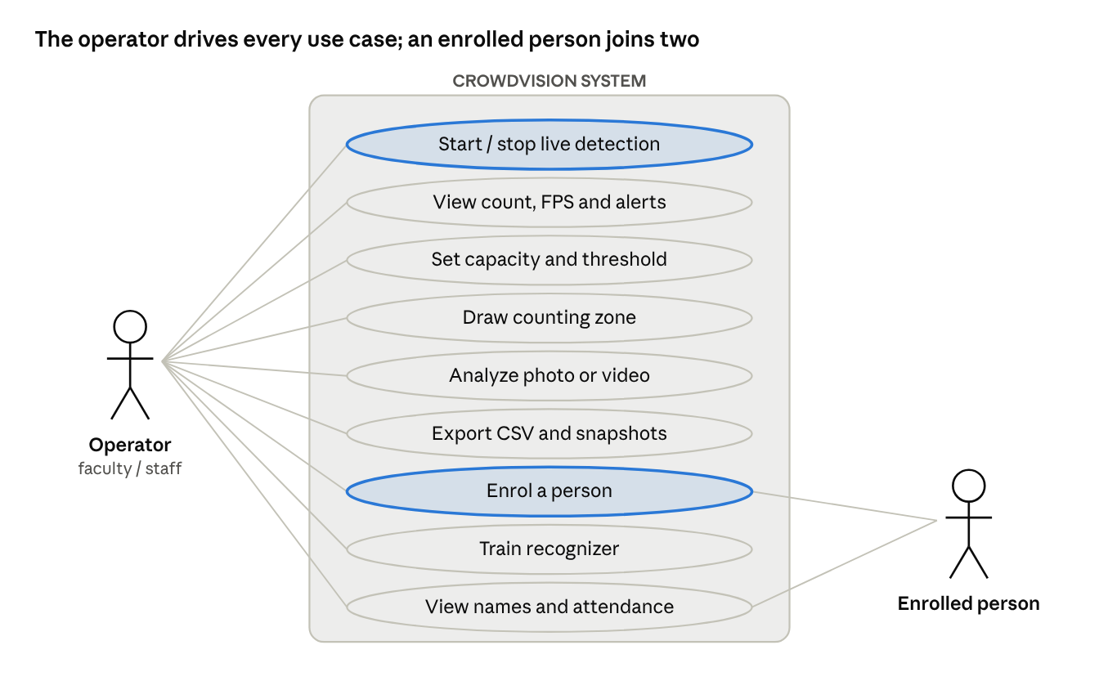
Fig. 2: Use case diagram

5.4 Data flow diagram (Level 1)
Frames flow from the camera through capture (1.0), detection (2.0), tracking (3.0), recognition (4.0) and display (5.0); enrolment and training (6.0) write to the data stores D1 models, D2 enrolled faces and D3 logs.
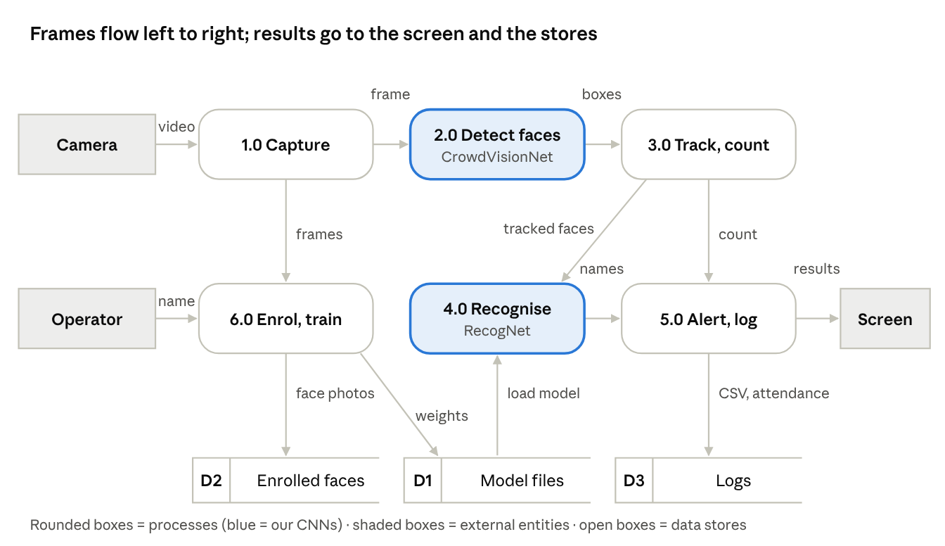
Fig. 3: Data flow diagram, Level 1

5.5 Class diagram
Engine coordinates the system. FaceDetector owns CrowdVisionNet and Recognizer owns RecogNet (composition); FaceTracker keeps one Track per person; the web Handler calls Engine.
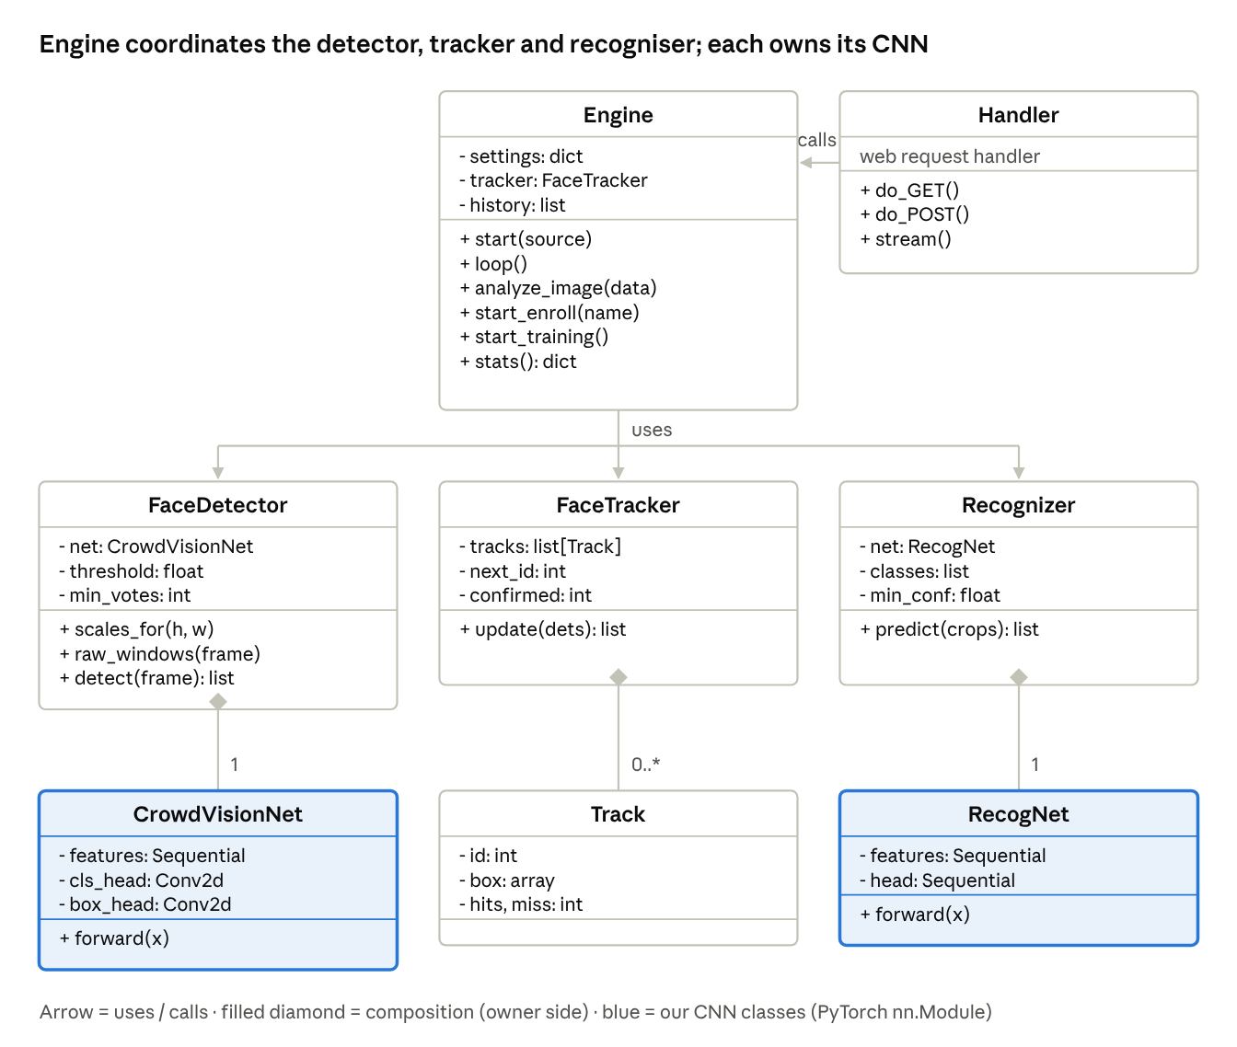
Fig. 4: Class diagram

5.6 Sequence diagram
For each frame, Engine reads the camera, calls detect(frame), updates the tracker, calls predict for each face, draws the result and checks the capacity alert.
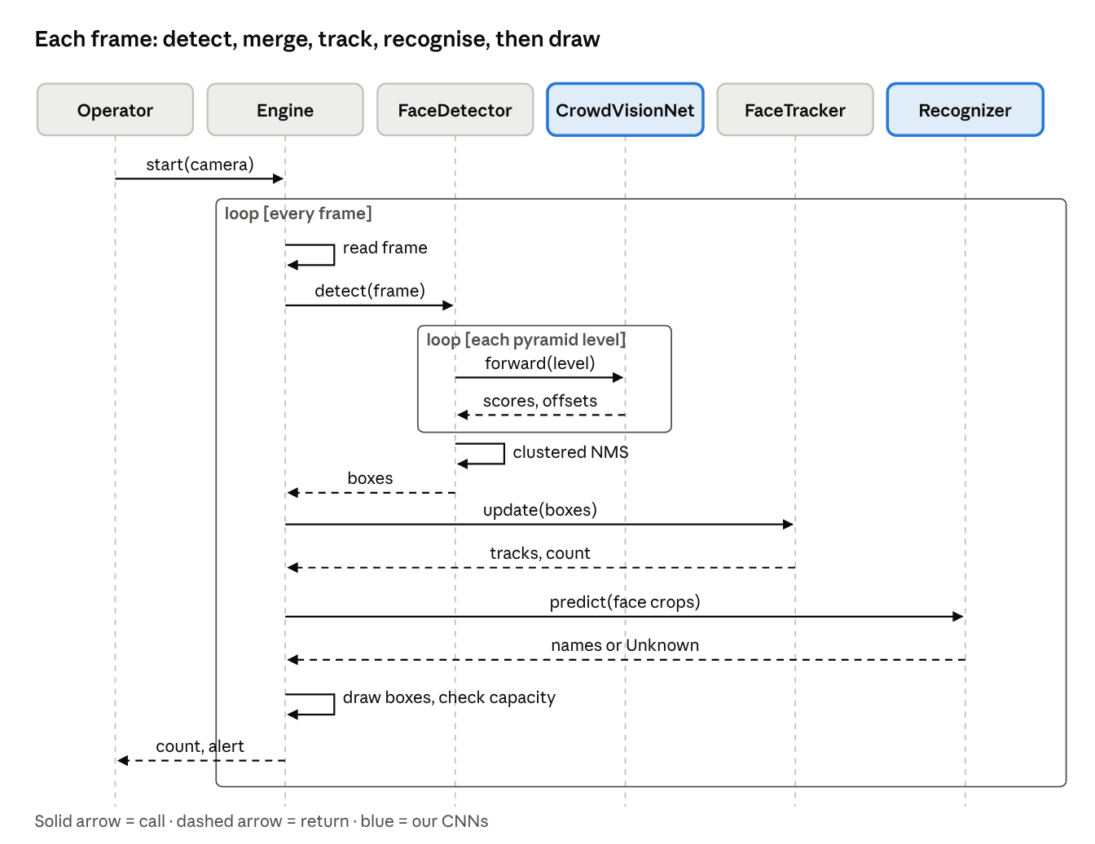
Fig. 5: Sequence diagram for processing one frame

6. Implementation
Module | Responsibility | Requirements
model.py | CrowdVisionNet architecture | FR-02, NFR-10
download_datasets.py, prepare_data.py | Download data; build ~166k crops, split by person | NFR-05
train.py | Training, hard-negative mining, metrics, plots | NFR-01, 02
detector.py | Pyramid inference, box refinement, cluster merge | FR-02, NFR-01..04
detect.py | Desktop app: tracker, zone, alert, screenshots, recording, CSV | FR-01..07, 12
face_recognition_app.py | Enrol, train RecogNet, recognise, attendance | FR-08..11
web_app.py, web/index.html | Web console: live feed, analyser, recognition, dashboard | FR-01..12, NFR-07, 09
evaluate.py | System test on 300 unseen scenes | NFR-01..03
tests/test_crowdvision.py | 17 automated unit and integration tests | NFR-08
requirements.txt, README.md, .gitignore | Configuration, setup guide, privacy rules for Git | NFR-06, 07, 09

6.1 Version control and configuration
The code is kept in Git and GitHub. `requirements.txt` pins the dependencies (NFR-06) and `.gitignore` keeps datasets and enrolled face photos out of the repository (NFR-09). Data preparation uses a fixed random seed, so every build of the training set is reproducible (checked by test UT-12).

6.2 How to run
pip install -r requirements.txt
python detect.py # desktop live demo
python face_recognition_app.py # enrol / train / recognise
python web_app.py # web console
python -m pytest tests -v # 17 automated tests

6.3 Maintenance plan
Type | In CrowdVision
Corrective | Each bug from the defect log becomes a new automated test before it is fixed
Adaptive | Retrain for a new room with collect_backgrounds.py; adapt to new library versions
Perfective | New features added without touching the model (web console, recognition)
Preventive | Run the automated tests after every change (regression testing)

7. Testing and Results
Testing was done at four levels, each with a different purpose: unit and integration tests (white-box, automated with pytest), system testing against the NFRs, and acceptance testing against the FRs (black-box).

7.1 Unit and integration tests (17 of 17 pass)
ID | What is tested | Expected | ID | What is tested | Expected
UT-01 | CNN output, one crop | 2 + 4 values | UT-10 | Tracker keeps ID | Same ID
UT-02 | CNN output, full frame | 55×75 map | UT-11 | Crowd levels | LOW/HIGH/OVER
UT-03 | Parameter count | 122,774 | UT-12 | Split is reproducible | Same split
UT-04 | Frame = sliding window | Equal | UT-13 | Face crop at edge | No error
UT-05 | IoU values | 1 / 0 / 1⁄3 | IT-01 | Blank frame | 0 faces
UT-06 | NMS removes duplicate | 2 of 3 kept | IT-02 | Unseen person photo | 1 face found
UT-07 | Cluster merge votes | 1 box, 2 votes | IT-03 | Trained model loads | Ready
UT-08 | Nested-box rule | Small box kept | IT-04 | Recogniser output | Valid name
UT-09 | Tracker needs 2 hits | Shown at frame 2

7.2 System testing: NFR verification
Requirement | Target | Measured (300 unseen scenes, 1,438 faces) | Result
NFR-01 Precision | ≥ 90% | 96.1% (first prototype: 57.3%) | Met
NFR-02 Recall | ≥ 90% | 99.0% (first prototype: 83.3%) | Met
NFR-03 Count error | ≤ 0.5 | 0.23 people per image; 82.3% of images exact | Met
NFR-04 Speed | ≥ 5 FPS | about 77 ms per frame (≈ 13 FPS), 2-core CPU, 60 px min face | Met
NFR-05 Generalisation | Unseen people | 99.87% crop accuracy (P 99.87%, R 99.48%, F1 99.67%) | Met
NFR-09 / 10 | Offline; from scratch | Server on 127.0.0.1; all weights trained by us | Met

7.3 Acceptance testing
TC | Req. | Test | Result
TC-01/02 | FR-01, 02 | Webcam and video file show one box per face | Pass
TC-03/04 | FR-03 | Dashboard updates; photo analyser returns count | Pass
TC-05 | FR-07 | Save snapshot | Pass
TC-06/07 | FR-09, 10 | Train recogniser; names or "Unknown" shown | Pass
TC-08 to 12 | FR-04, 05, 06, 08, 11, 12 | Capacity alert, zone, CSV export, enrolment, threshold slider | To verify in live demo

7.4 Defect log
ID | Defect | Found by | Fix
D-01 | 100% train vs 75% validation accuracy | Validation test | New 166k-crop dataset, augmentation
D-02 | Several boxes on one face | Live test | Box regression, clustered NMS
D-03 | Big stretched boxes; precision 57% | System test | Size-aware merging + nested-box rule
D-04 | Face at frame edge not detected | Manual test | Frame padding + edge-cut training
D-05 | One person counted as 61 unique faces | Acceptance test | Count only after 2 consecutive hits
D-06 | Fine-tuning ran out of memory | Training run | Cap at 40,000 hard negatives; --resume
D-07 | Window failed to open on Windows | Acceptance test | Reinstall GUI OpenCV; documented in README

8. Screenshots
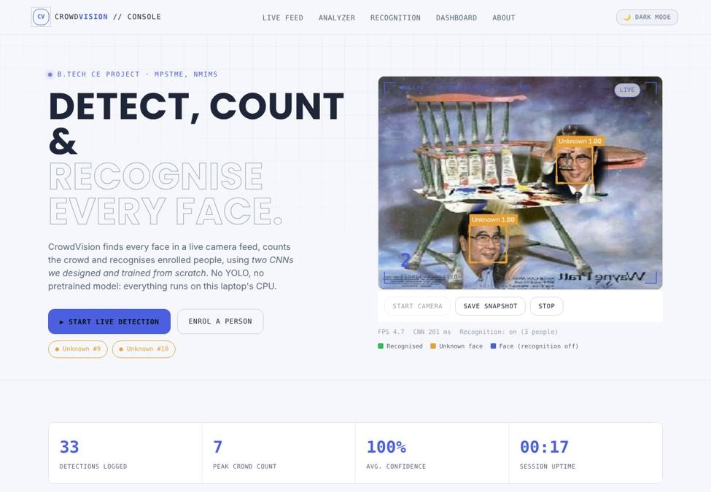
Fig. 6: Web console: live detection with face count, FPS and session statistics
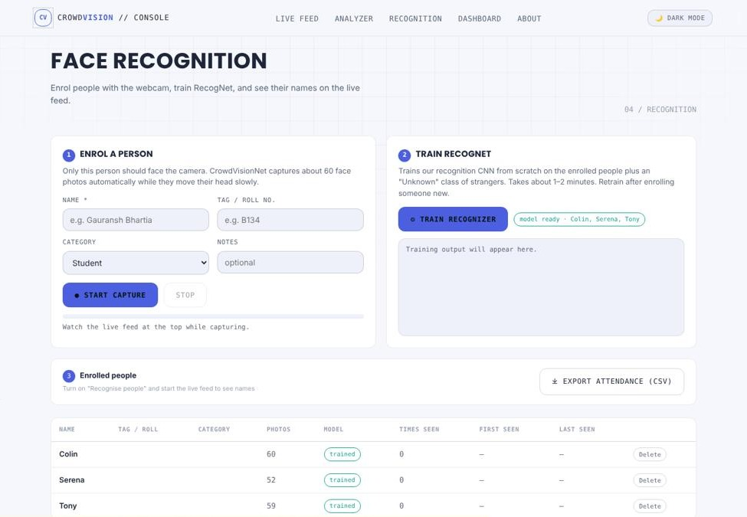
Fig. 7: Web console: enrol a person, train RecogNet and list enrolled people

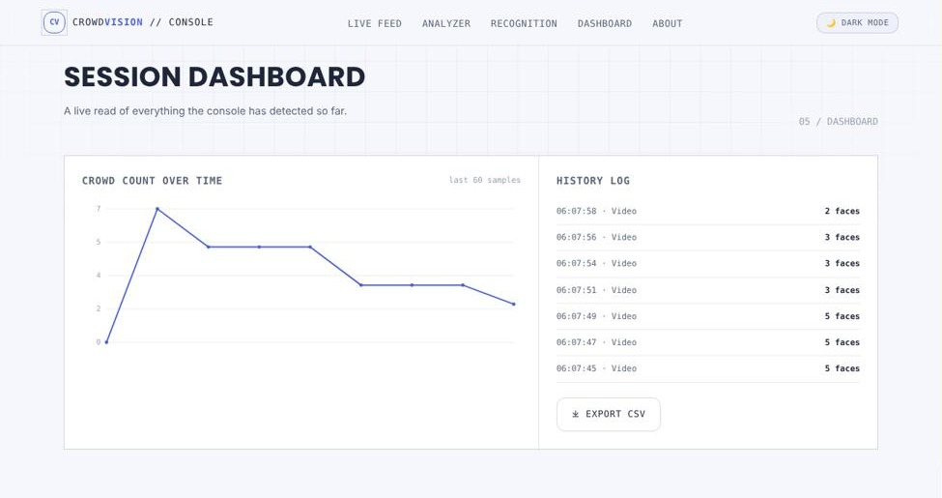
Fig. 8: Web console: session dashboard with crowd count over time and history log
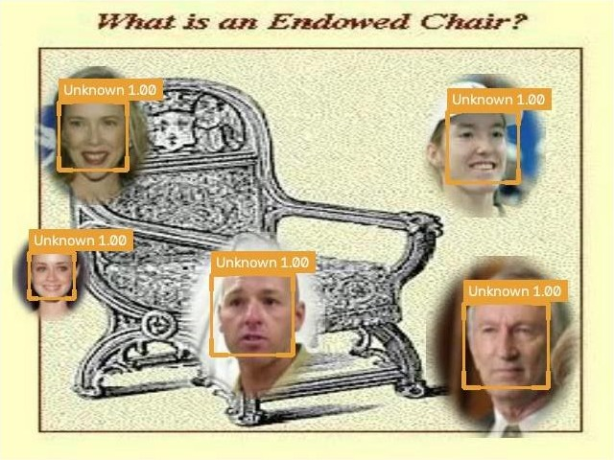
Fig. 9: Recognition result: people who are not enrolled are labelled "Unknown"
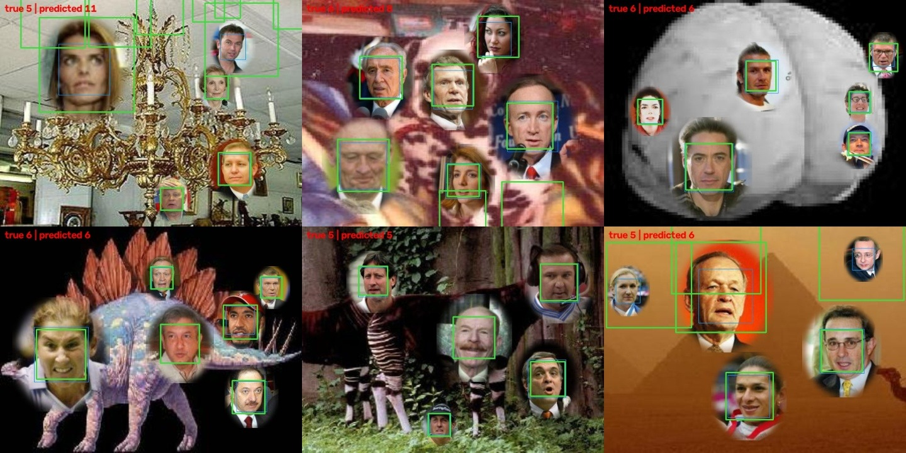
Fig. 10: System test on unseen scenes (blue = ground truth, green = prediction)
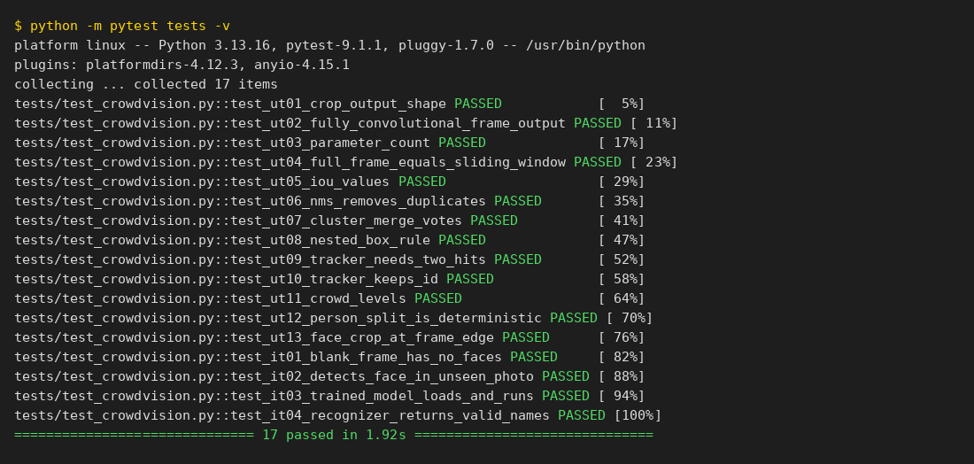
Fig. 11: Automated test run: 17 of 17 tests passed (pytest)

9. Conclusion and Future Scope
CrowdVision meets all its accuracy and performance requirements: 96.1% precision, 99.0% recall and a count error of 0.23 people per image, in real time on a laptop CPU, using CNNs designed and trained from scratch. The main lesson is that the biggest quality gains came from software engineering, not from a bigger model. Measurable NFRs made progress visible, testing at several levels found different defects (system testing found D-03, acceptance testing found D-05 and D-07), and the low-coupling design meant the largest fix touched only one module. The iterative process took F1 from 67.9% to 97.5%.
Future scope: train on more side-profile and low-light faces; add density-map counting for very dense crowds; export the model to ONNX for a Raspberry Pi or a phone; add multi-camera support with a central dashboard; set up continuous integration so the tests run on every GitHub push.

10. References
[1] W. W. Royce, "Managing the Development of Large Software Systems," Proc. IEEE WESCON, 1970, pp. 1–9.
[2] B. W. Boehm, "A Spiral Model of Software Development and Enhancement," IEEE Computer, vol. 21, no. 5, pp. 61–72, 1988.
[3] B. W. Boehm, Software Engineering Economics. Englewood Cliffs, NJ: Prentice-Hall, 1981.
[4] IEEE Std 830-1998, IEEE Recommended Practice for Software Requirements Specifications, IEEE, 1998.
[5] D. Sculley et al., "Hidden Technical Debt in Machine Learning Systems," Advances in NeurIPS 28, 2015, pp. 2503–2511.
[6] S. Amershi et al., "Software Engineering for Machine Learning: A Case Study," Proc. IEEE/ACM ICSE-SEIP, 2019, pp. 291–300.
[7] E. Breck, S. Cai, E. Nielsen, M. Salib and D. Sculley, "The ML Test Score: A Rubric for ML Production Readiness and Technical Debt Reduction," Proc. IEEE Big Data, 2017, pp. 1123–1132.
[8] J. M. Zhang, M. Harman, L. Ma and Y. Liu, "Machine Learning Testing: Survey, Landscapes and Horizons," IEEE Trans. Software Engineering, vol. 48, no. 1, pp. 1–36, 2022.
[9] A. Bochkovskiy, C.-Y. Wang and H.-Y. M. Liao, "YOLOv4: Optimal Speed and Accuracy of Object Detection," arXiv:2004.10934, 2020.
[10] Y. Li, X. Zhang and D. Chen, "CSRNet: Dilated Convolutional Neural Networks for Understanding the Highly Congested Scenes," Proc. IEEE CVPR, 2018, pp. 1091–1100.
[11] L. Boominathan, S. S. S. Kruthiventi and R. V. Babu, "CrowdNet: A Deep Convolutional Network for Dense Crowd Counting," Proc. ACM Multimedia, 2016, pp. 640–644.
[12] G. B. Huang, M. Ramesh, T. Berg and E. Learned-Miller, "Labeled Faces in the Wild," Univ. of Massachusetts, Amherst, Tech. Rep. 07-49, 2007.

