Name: Garvit Joshi Section: KM088
Roll No.: 51 Subject: INT 219
Registration No.:11808472

Set-C
Q1. Create an HTML form for booking appointment with doctor. Perform JavaScript validation on all fields. The user must be alerted each time a field is left blank. Also add a relevant full background image to the body. [10]
Code:
Index.html
style1.css
Screenshot:
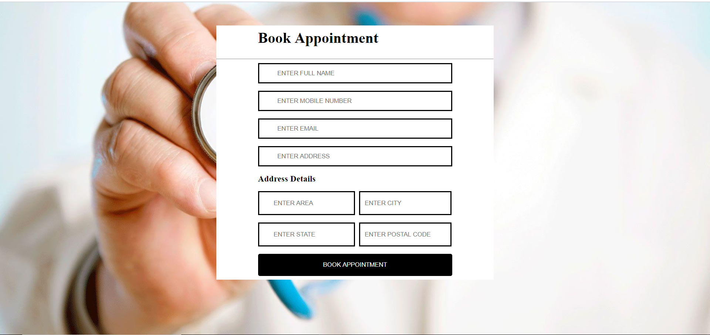
Q2. Using external CSS, design a responsive web page using media query for a hospital. Also include a relevant full background image, a menu bar and few images along with description related to hospitals or equipment in order to depict the theme of the web page.
Code:
Index.html
<!DOCTYPE html>
<html>
<head>
<title>Assingment1</title>
<link rel="stylesheet" type="text/css" href="index1.css">
<script src="https://kit.fontawesome.com/5d5dfc09c0.js" crossorigin="anonymous"></script>
<link href="https://fonts.googleapis.com/css2?family=Raleway:wght@300&display=swap" rel="stylesheet">
<meta name="viewport" content="width=device-width, initial-scale=1">
</head>
<body class="body1">
<header class="head1">
<nav class="nav1">
<span id="span1">Home</span>
<span id="span1">About</span>
<a href="#p2" style="text-decoration: none;"><span id="span1">Contact</span></a>
<select id="select1">
<option>Service</option>
<option>primary care</option>
<option>mental health </option>
<option>drug treatment</option>
<option>dental services</option>
<option>heart dieases</option>
</select>

</nav>
<hr>
</header>
<main class="class1">
<section class="sec1">

<div class="place-wrapper">
<img id="image1" src=https://images.unsplash.com/photo-1512678080530-7760d81faba6?ixlib=rb-1.2.1&ixid=eyJhcHBfaWQiOjEyMDd9 alt="hospital bed near couch" >
<br>
<p id="p5"> hospital bed near couch</p>
<p id="p6">A hospital bed or hospital cot is a bed specially designed for hospitalized patients or others in need of some form of health care. These beds have special features both for the comfort and well-being of the patient and for the convenience of health care workers.</p>
</div>
<div class="place-wrapper">

<img id="image1"src="https://static01.nyt.com/images/2020/03/17/business/00VIRUS-VENTILATORS-01/00VIRUS-VENTILATORS-01-mediumSquareAt3X.jpg" alt="00VIRUS-VENTILATORS-01" >
<br>
<p id="p5"> Ventilator</p>
<p id="p6">A ventilator is a machine that provides mechanical ventilation by moving breathable air into and out of the lungs, to deliver breaths to a patient who is physically unable to breathe, or breathing insufficiently</p>
</div>
<div class="place-wrapper">
<img id="image1" src="https://www.hospitalmanagement.net/wp-content/uploads/sites/13/2017/10/1-main-1.jpg" alt="MRI Machine" >
<p id="p5"> MRI Machine</p>
<p id="p6">Search ResultsFeatured snippet from the web Magnetic Resonance Imaging (MRI) is a medical test that is used to make pictures of organs and structures inside the body using a magnetic field and pulses of radio wave energy. MRI gives different information about body structures that can be seen with an X-ray, ultrasound, or CT scan (computed tomography)</p>
</div>

<div class="place-wrapper"><img id="image1" src="https://media.istockphoto.com/photos/black-stethoscope-on-blue-background-picture-id1179610553?k=6&m=1179610553&s=612x612&w=0&h=v6Wj8AcJx6YppS-ulxEx_g4dihKHCFQv3qEht7aLIOE=" alt="Stethoscope" >
<p id="p5"> Stethoscope</p>
<p id="p6">The stethoscope allows the practitioner to assess a patient's cardiac, respiratory and intestinal state and is an integral tool in professional nursing practice. It is used to listen (auscultation) to the body's sounds during a physical examination and assessment</p>
</div>
<div class="place-wrapper">
<img id="image1"src="https://upload.wikimedia.org/wikipedia/commons/thumb/0/0a/Xraymachine.JPG/1200px-Xraymachine.JPG" alt="Radiography" >
<p id="p5">Radiography</p>
<p id="p6">X-ray, or radiography, is used to diagnose fractured bones, detect injury or infection, or to locate foreign objects in soft tissue. Some x-ray exams employ an iodine-based contrast material to clarify the visibility of specific organs like the heart, lungs, blood vessels or tissues</p>
</div>
<div class="place-wrapper">
<img id="image1" src="https://image.made-in-china.com/2f0j00zSUtAIvnYRru/Medical-Xray-Machine-for-Sale-X-Ray-Machines-X-ray-Digital-Equipment.jpg" alt="X-ray" >
<p id="p5">X-ray machine</p>
<p id="p6">X-rays are highly penetrating, ionizing radiation, therefore X-ray machines are used to take pictures of dense tissues such as bones and teeth. This is because bones absorb the radiation more than the less dense soft tissue. X-rays from a source pass through the body and onto a photographic cassette</p>
</div>

<div class="place-wrapper">
<img id="image1" src="https://s3-eu-west-1.amazonaws.com/wbm.thumbnail/dissolve/1200/851840.jpg" alt="operation threater" >
<p id="p5"> Operation theater</p>
<p id="p6">An operating theater (also known as an operating room (OR), operating suite, or operation suite) is a facility within a hospital where surgical operations are carried out in an aseptic environment. ... There are only two old-style operating theaters left, both of which are preserved as part of museums.</p>

</div>
<div class="place-wrapper">
<img id="image1" src="https://3.imimg.com/data3/NW/TD/MY-174437/opd-500x500.jpg" alt="opd" >
<p id="p5"> Outpatient Department(OPD)</p>
<p id="p6">Definition OPD is defined as a part of the hospital with allotted physical facilities and medical and other staffs, with regularly scheduled hours, to provide care for patients who are not registered as inpatients. A hospital department where patients receive diagnosis and/ or treatment but do not stay overnight</p>
</div>
<div class="place-wrapper">
<img id="image1" src="https://goldencarehospital.com/wp-content/uploads/2016/03/Physio-1024x681.jpg" alt="physiotherapy department" >
<p id="p5">physiotherapy department</p>
<p id="p6">Physiotherapy is treatment to restore, maintain, and make the most of a patient's mobility, function, and well-being. Physiotherapy helps through physical rehabilitation, injury prevention, and health and fitness. Physiotherapists get you involved in your own recovery.</p>
</div>

</section>
</main>

<footer class="foot1">
<p id="p2"> Contact us </p>

<a href="https://m.facebook.com/profile.php?lst=100009274090199%3A100009274090199%3A1598705447"><i id="facebook" class="fab fa-facebook-f"></i></a>
<a href="https://twitter.com/garvit__joshi" style="text-decoration: none;"><i id="twitter" class="fab fa-twitter"></i></a>

<a href=" mailto:garvitjoshi9@gmail.com" style="text-decoration: none"> <i id="mail" class="fas fa-envelope"></i></a>
<p id="p1">&copy; Copyright 2020 Garvit Joshi.</p>
</footer>

</body>
</html>

Index.css:
.body1{
background-image:url(https://images.unsplash.com/photo-1519494026892-80bbd2d6fd0d?ixlib=rb-1.2.1&q=80&fm=jpg&crop=entropy&cs=tinysrgb&w=1080&fit=max&ixid=eyJhcHBfaWQiOjEyMDd9);
background-repeat: no-repeat;
background-size: cover;
background-image-opacity:0.2;
color:black;
margin: 0px;
font-family: 'Raleway', sans-serif;

}
.head1{
background-color:white;
color:rgba(0,0,0, 0.8);
}
.nav1{
padding: 16px;

}
#span1{
padding: 16px;
font-size: 22px;
cursor:pointer;
color:rgba(0,0,0, 0.8);

}
#select1{
background-color:white ;
color:rgba(0,0,0, 0.9);
font-size: 22px;
border:0px;
cursor: pointer;
opacity: 1;

font-family: 'Raleway', sans-serif;
}

#span2{
float: right;
padding-right:16px;
font-size: 22px;
color:rgba(0,0,0, 0.9) ;
}

/*#lain:focus:required{
background-color: lightcoral;
}*/

.foot1{
background-color:#98599B;
height: 150px;
}
#p1{
margin: 15px;
padding-top:15px;
}
#facebook{

color: blue;
font-size: 32px;
opacity: 1;
padding-left:10px;
}
#p2{

font-size: 20px;
margin-top: 0px;
padding: 10px;
padding-top: 10px;
padding-bottom: 0px;
color: rgba(0,0,0, 0.9);

}
#p5{
text-align: center;
font-size: 22px;
font-weight: bold;
}
#p6:hover{
cursor: pointer;
font-size: 20px;
font-weight: bold;

}
#twitter{

color: #15D0F3 ;
font-size: 30px;
opacity: 1;
padding-left:10px;
display: inline;
}
#mail{

color: #1391EC ;
font-size: 30px;
opacity: 1;
padding-left:10px;
display: inline;
}

#tab1{
margin-right: auto;
margin-left: auto;

}
#de1{

padding: 20px;

}
#image1{
width: 100%;
height: 300px;

border:2px solid black;
margin-left:5px;
margin-right: 5px;
border-radius:15px;

}
#image1:hover{
background-color: blue;
cursor: pointer;
}
.place-wrapper{
display: inline-block;
width: 30%;
box-sizing: border-box;
vertical-align: top;
margin: 5px;
margin-right: 15px;
margin-left: 25px;

}

@media screen and (max-width:1276px ){

.place-wrapper{
display: block;
width: 90%;
margin-left:38px;
}

.head1{
background-color:white;
color:rgba(0,0,0, 0.8);
text-align:center;
display:block;

}
#span1{
font-size: 22px;
}
#select1{

font-size: 22px;

}
}

@media screen and (max-width:992px ){

.place-wrapper{
display: block;
width: 95%;
margin-left:15px;
}

.head1{
background-color:white;
color:rgba(0,0,0, 0.8);
text-align:center;
display:block;

}
#span1{
font-size: 22px;
}
#select1{

font-size: 22px;

}
}

@media screen and (max-width:786px) {

.place-wrapper{
display: block;
width: 85%;
margin-left:45px;

}

.head1{
background-color:white;
color:rgba(0,0,0, 0.8);
text-align:center;
display:block;

}
#span1{
font-size: 22px;
}
#select1{

font-size: 22px;

}

@media screen and (max-width:600px ){

.place-wrapper{
display: block;
width: 90%;
margin-left:15px;
}

.head1{
background-color:white;
color:rgba(0,0,0, 0.8);
text-align:center;
display:block;

}
#span1{
font-size: 10px;
}
#select1{

font-size: 10px;

}
}

Screenshots:
In Laptop:
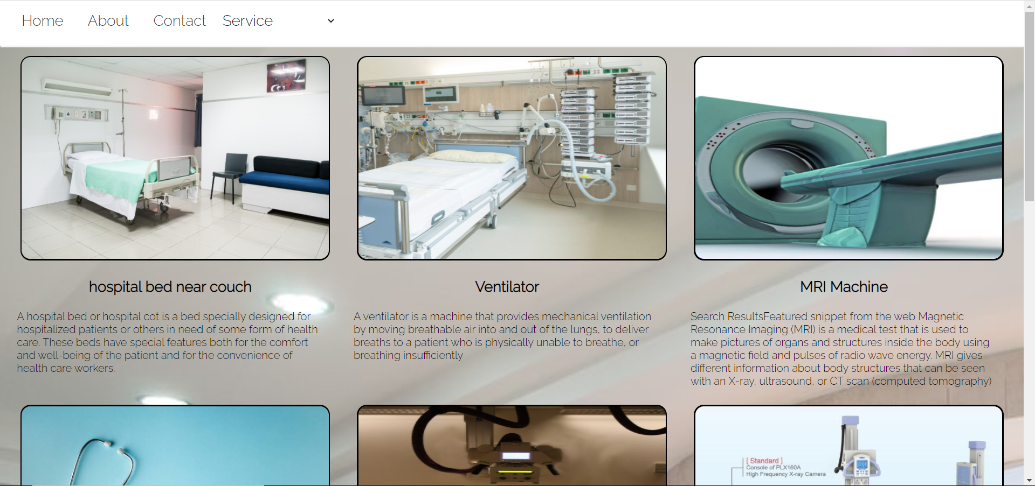
In Mobile Devices:
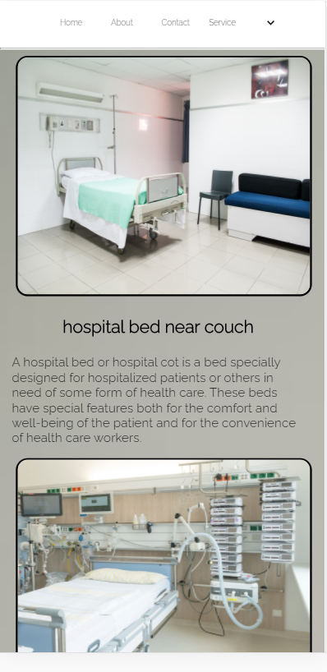

Q3. (a) When the user hovers the cursor over the row of the table, a function is triggered that changes the background color of the row. Complete the following code:
Code:
<html>
<head><title></title></head>
<body>
<table border=2>
<tr onmouseover="ChangeBackgroundColor(this)" onmouseout="RestoreBackgroundColor(this)">
<th>Name</th>
<th>Regno</th>
</tr>
<tr onmouseover="ChangeBackgroundColor(this)" onmouseout="RestoreBackgroundColor(this)">
<td>Ram</td>
<td>2000</td>
</tr>
<tr onmouseover="ChangeBackgroundColor(this)" onmouseout="RestoreBackgroundColor(this)">
<td>Sham</td>
<td>3000</td>
</tr>
</table>
<script type="text/javascript" >

var TableBackgroundNormalColor = "#ffffff";
var TableBackgroundMouseoverColor = "#FF0000";

// These two functions need no customization.
function ChangeBackgroundColor(row) {
row.style.backgroundColor = TableBackgroundMouseoverColor;
}

function RestoreBackgroundColor(row) {
row.style.backgroundColor = TableBackgroundNormalColor;
}
</script>
</body>
</html>

Screenshots:
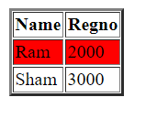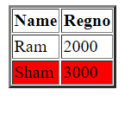
Q3. (b) Write a JavaScript program to print the grades of the students according to the given conditions
marks>90, print grade A
marks>=60 and marks<90, print grade B
marks>=40 and marks<60, print grade C
marks<40, print fail
Code:
<html>
<body>
<script>

var msg = 'Enter the percentage of student:';

var marks = prompt(msg);
if(marks>=90)
{
document.write('Grade -> A');}
else if(marks>=60 && marks<90)
{
document.write('Grade -> B');}
else if(marks>=40 && marks<60)
{
document.write('Grade -> C');}
else if(marks>60 && marks<=70)
{
document.write('Grade - C');}
else if(marks<40){

document.write('FAILED');}

</script>
</body>
</html>

Screenshots:
