JAVA

FAT

LAB

**NAME:** Rohin Srivastava

**REGISTRATION NUMBER:** 19BIT0177

1.

CODE:

**package** jva;

**import** java.io.*;

**public** **class** xbbd{

**public** **static** **void** main(String[] args) **throws** IOException

{

BufferedReader input = **new** BufferedReader (**new** InputStreamReader(System.***in***));

**try** {

FileWriter writer = **new** FileWriter("file.txt");

**boolean** l=**true**;

**while**(l) {

System.***out***.print("Enter 1 to Write inside the file OR\nEnter 2 to read the contents of the file\nEnter Number: ");

**int** c= Integer.*parseInt*(input.readLine());

**switch**(c) {

**case** 1:

System.***out***.println("Enter the content1:");

String str = input.readLine();

writer.write(str);

writer.close();

**break**;

**case** 2:

File file = **new** File("file.txt");

BufferedReader buffer = **new** BufferedReader(**new** FileReader(file));

String st;

**while** ((st = buffer.readLine()) != **null**)

System.***out***.println(st);

**break**;

**default**:

System.***out***.println("Wrong Choice!!");

}

System.***out***.println("Enter false to exit OR true to continue");

l = Boolean.*parseBoolean*(input.readLine());

}

}

**catch** (IOException e) {

System.***out***.println("An error occurred.");

e.printStackTrace();

}

}}

OUTPUT:

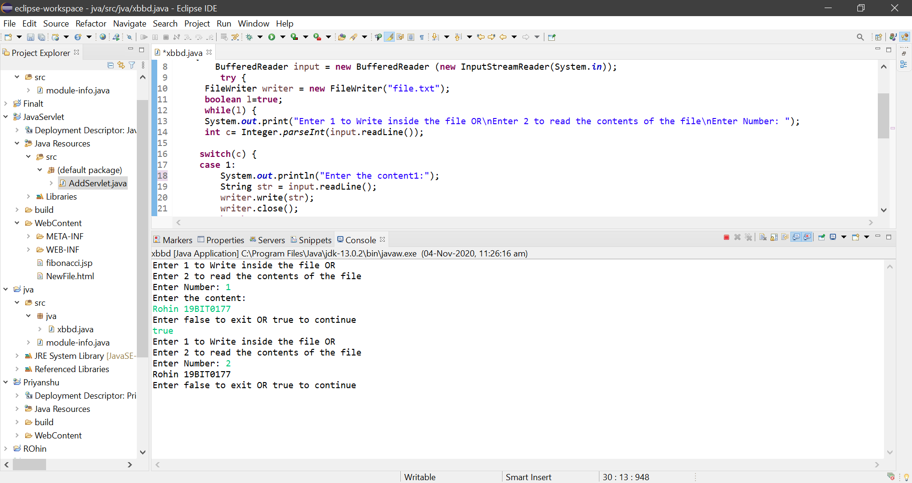

2.

CODE:

HTML CODE:

<%!

int n;

String str;

int fibo(int n) {

if(n<2)

return n;

else

return fibo(n-1) + fibo(n-2);

}

%>

<b>Fibonacci series: </b><br>

<%

str = request.getParameter("val");

n = Integer.parseInt(str);

for(int i=0; i<=n; i++) {

out.print(fibo(i) + " ");

}

%>

JSP CODE:

<%@ page language=*"java"* contentType=*"text/html; charset=ISO-8859-1"*

pageEncoding=*"ISO-8859-1"*%>

<!DOCTYPE html>

<html>

<head>

<body>

<%!

**int** n;

String str;

**int** fibo(**int** n) {

**if**(n<2)

**return** n;

**else**

**return** fibo(n-1) + fibo(n-2);

}

%>

<b>Fibonacci series: </b><br>

<%

str = request.getParameter("n");

n = Integer.parseInt(str);

**for**(**int** i=0; i<=n; i++) {

out.print(fibo(i) + " ");

}

%>

</body>

</html>

OUTPUT:

