**DEPARTMENT OF COMPUTER ENGINEERING**

**GRAPHIC ERA DEEMED UNIVERSITY**

**DEHRADUN**

**2021-2022**

GROCERY DELIVERY APPLICATION USING FULL STACK WEB DEVELOPMENT

**PROJECT REPORT**

Submitted in fulfilment of the requirement for the III semester

**Bachelor of Technology**

**SUBMITTED BY:**

Garvit Jain

Univ. Roll No – 2017327

Enrollment No – GE202017327

**Under the Guidance of:**

**Ms. Parul Madan**



***CERTIFICATE***

This to certify that the mini project report entitled “Grocery Delivery Application Using Full Stack Web Development” being submitted by **Garvit Jain** (2017327) in partial fulfilment of the requirements for the award of the degree of Bachelor of Technology in Computer Engineering, Graphic era Deemed to be University, Dehradun during the academic year 2021-2022. This is a genuine document of my work finished under the Supervision of Ms. Parul Madan. It is certified that all corrections/suggestions indicated for the internal assessment have been incorporated. The project has been approved as it satisfies the academic requirements associated with the degree mentioned.

________________

Signature

ACKNOWLEDGMENT

I would like to take this opportunity to express my gratitude to entire faculty at Department of Computer Science and Information Technology, Graphic Era Deemed to be University, Dehradun who evaluated the project from time to time and gave me valuable suggestions as to how to improve the project.

I am highly indebted to Graphic Era University for providing me the required infrastructure and facilities to accomplish the given

I am grateful to **Ms. Parul Madan** Graphic Era Deemed to be University, Dehradun; for her supervision, encouragement, inspiration and guidance. Working under him is being an enriched experience.

In all, I found congenial work environment in Graphic Era University, Dehradun and this project completion will mark a new beginning for me in the coming days.

Garvit Jain

Roll no – 2017327

CONTENTS

* Abstract
* Problem Statement
* Requirements
* Motivation
* Introduction
* Methodology
* Overview of Website
* Conclusion
* Bibliography

ABSTRACT

A Grocery Online Store accepts all orders for items offered by that store to its customers along with all the offers going on its items so that customers can choose the best item according to their needs. The website displays all the items that a store wants to sell.

Through this website customers are able to purchase all their daily need items which they buy on monthly or daily basis regularly by adding those items to their cart and placing the order by giving relevant details for the delivery of items by confirming the amount to be paid.

It provides a convenient option for the sellers also by providing them option to keep a check on the stock of products, demands of various products, all the acquired customers, the payments received and obviously the details of all the orders placed; and thus providing a large variety of products for its customers to choose from by offering them the best deals on them.

PROBLEM STATEMENT

The project was to design a website to purchase grocery items using full stack development.

REQUIREMENTS

Languages Required:

1. HTML (Hypertext Markup Language) – It is used to structure the website, headings etc.
2. CSS (Cascading Style Sheet) – For adding style to the layout, colours and design to the website.
3. JavaScript – For building the logical operations required for the functioning of the website.
4. PHP – It is required for back end development in the website and accessing the database.
5. MySql – It is used as a database required to store the information of customers, stock, order summaries and payment details etc.

MOTIVATION

We all have seen in our houses that monthly a list is being made for the grocery items and then either we go to any local grocery shop and purchase the items or we select each item one by one by searching it on other grocery websites. I was motivated to design this website so as to provide a checklist to the customers of all the items in the store so that they don’t need to make any list before and all the products marked will be added to their cart making its time efficient also. With this motivation it helped me to start learning basic languages required as mentioned above for designing my own website.

INTRODUCTION

A few years back, for grocery shopping people were only dependent on their local grocery stores which earned a good margin due to customers dependency and also all the grocery shop owners competed among themselves only.

After the online revolution of grocery stores big players who were in retail have taken their stores online and along with that many other websites have also been hosted to provide customers. I have also created a website with basic user interface so that one who don’t know much about working of websites much can also use this website with ease and can select the required items according to their needs. The website I have made is still a prototype as it was my first time building a website on my own using various languages and also by learning to use them efficiently to bring user a good experience using this website.

Any user just need to sign in or sign up on the website and start ordering on it with all the offers going on at that moment of the items and can get the items home delivered for free of cost at their doorstep making it time efficient and energy efficient for users.

METHODOLOGY

In my website I have designed web pages regarding each need of the website like for grocery items like vegetables, fruits, dairy items, bakery etc a web page for each is created with cards representing the products available under that section with its name and price along with an option to add it to the cart. After creating web pages for all the major categories in which items can be divided into, all these web pages are hyperlinked to each other and to the home page.

CSS is used to make the website look good in design by dividing the layout of the website into blocks so that header, dropdown menus, headings, advertisements, dividing the body into two blocks for navigating the website and one with all the items in that category.

After that major pages like the home page, offers, orders, payments, contact us and sign up page is developed and linked with all other web pages already created. PHP is used as a backend programming language in this website so as to create a database consisting of tables for personal details of the customers, the stock of products left, new stock arrived, orders received, payment details which can be accessed by the administrator.

OVERVIEW OF WEBSITE

The website opens with the home page consisting of on going offers, the coming offers with option to sign up and also option to navigate to various categories of products from it.

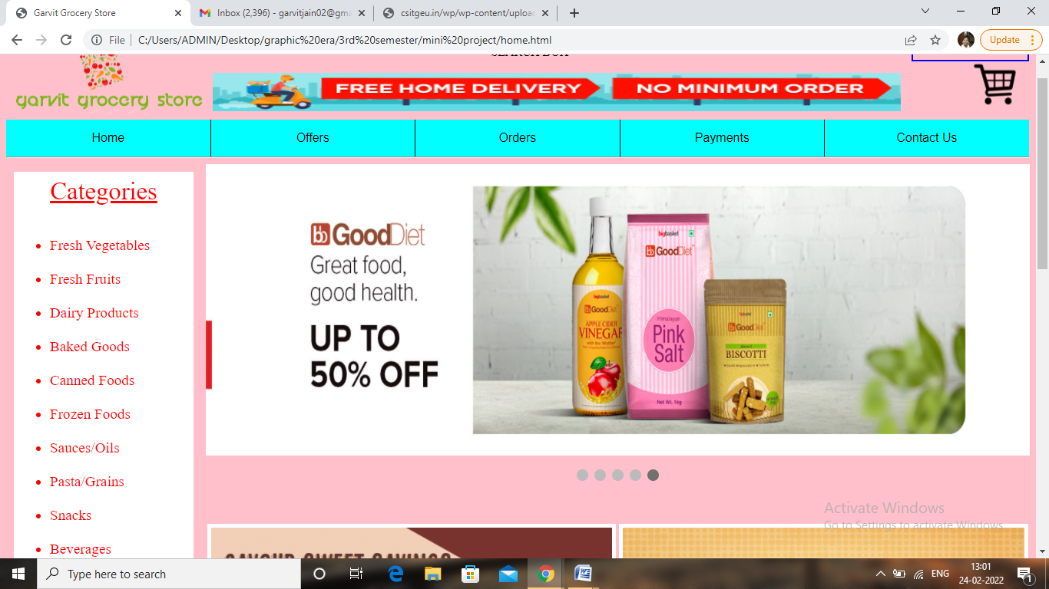

Various categories can be accessed from here through which items available ca be selected and added to the cart.

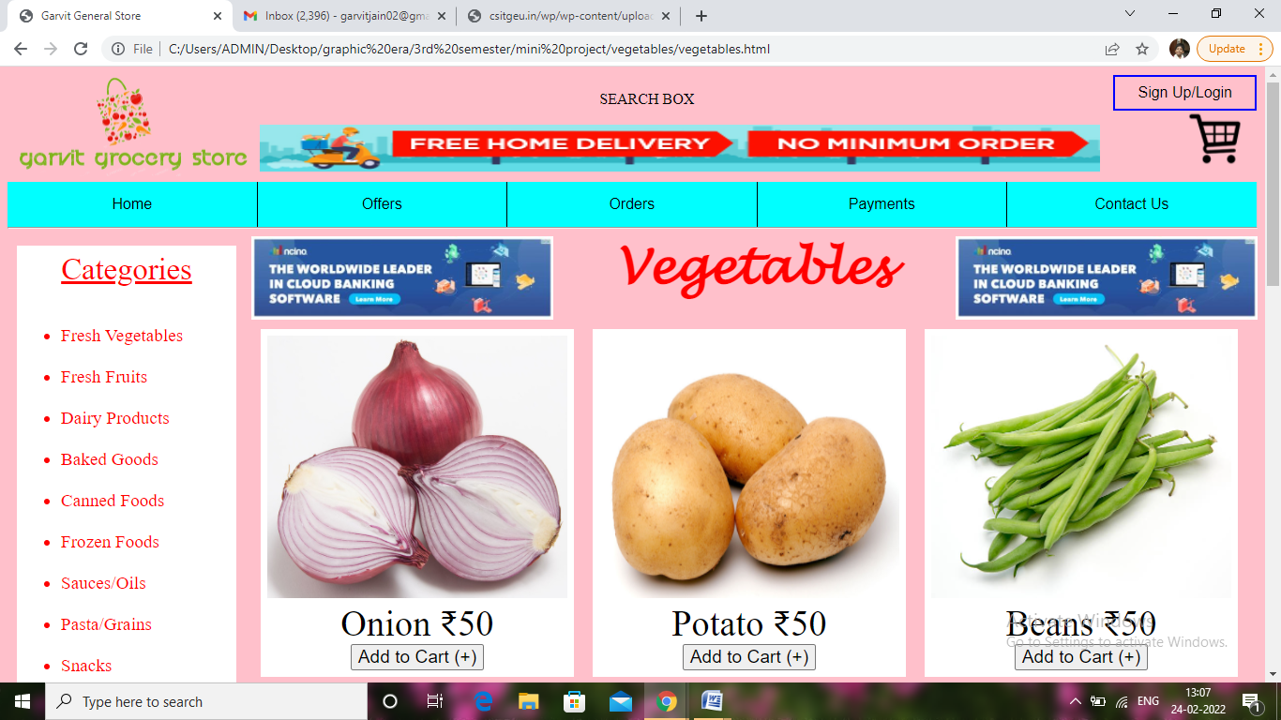

Like this each category defined here would have different product cards available in the stock in that category which users can purchase by adding it to their cart and their cart can be displayed at the top right corner.

Some other major pages like offers, orders and payments page show details only upon sign up for each customer individually based on their order history; contact us page can be viewed as:

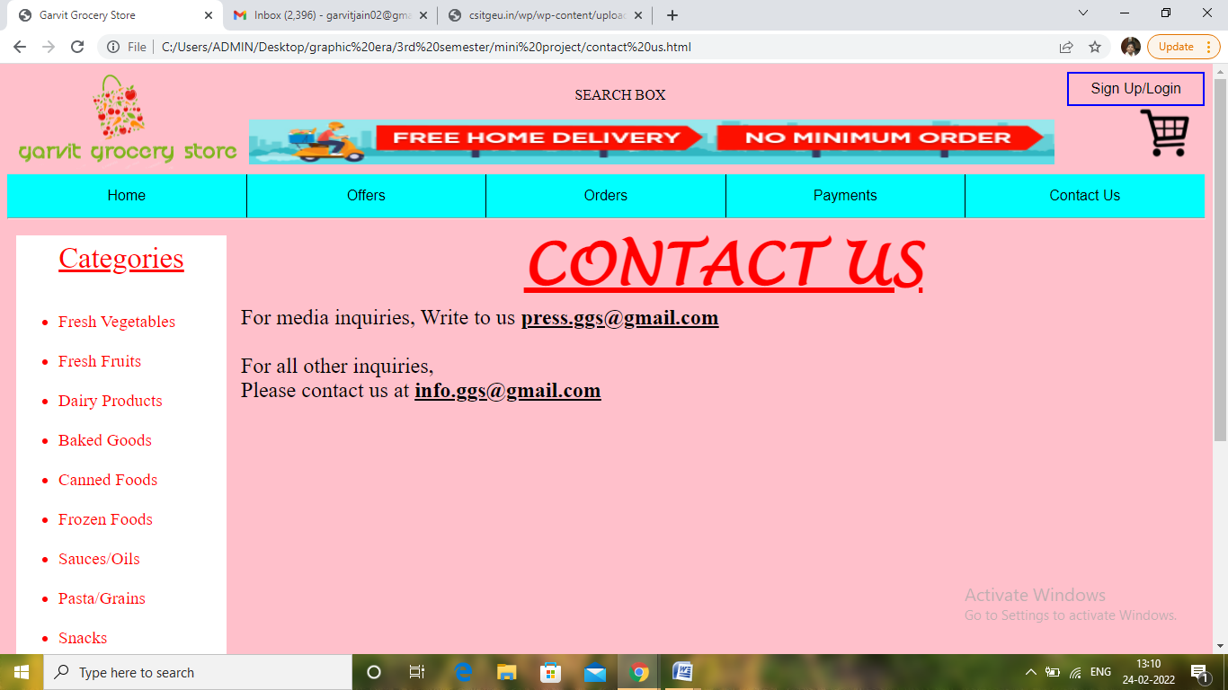

Once a person sign up and create a profile, then orders can be placed on the website.

CONCLUSION

The completion of the project went quite well, I learned a lot about the functioning of grocery stores, types of data they require to maintain for its functioning, to keep a large variety of products for its customers to keep them promising for best deals they could offer. I also learnt how to manage and develop a website, what all knowledge is required for building a website, the various effects that can be given to the website for making it more designed and to provide a good user experience. While developing the grocery app I also leant the uses of HTML, CSS, PHP, JavaScript and MySql and their requirement for the website.

Overall working on this project was great fun as I came up with great piece of knowledge and understanding of the topic web development and functionality of grocery stores.

BIBLIOGRAPHY

Following websites were referred for the completion of this project:

* <https://www.google.co.in/>
* <https://www.w3schools.com/>
* <https://codepen.io/>
* <https://www.youtube.com/>