**Mini Project Report on**



**Library Management System**



**Submitted in partial fulfillment of the requirement for the award of the degree of**

**BACHELOR OF TECHNOLOGY**

**IN**

**COMPUTER SCIENCE & ENGINEERING**

**Submitted by:**

**Student Name :**  **University Roll No. :**

**Garvit Jain 2017327**

***Under the Mentorship of***

**Ms. Meenakshi Maindola**

**Designation**

**ASST.PROFESSOR**



**Department of Computer Science and Engineering**

**Graphic Era (Deemed to be University)**

**Dehradun, Uttarakhand**

**January 2023**

GEU logo

**CANDIDATE’S DECLARATION**

I hereby certify that the work which is being presented in the project report entitled **“LIBRARY MANAGEMENT SYSTEM”** in partial fulfillment of the requirements for the award of the Degree of Bachelor of Technology in Computer Science and Engineeringof the Graphic Era (Deemed to be University), Dehradun shall be carried out by the under the mentorship of **MS. MEENAKSHI MAINDOLA, ASST. PROFESSOR**, Department of Computer Science and Engineering, Graphic Era (Deemed to be University), Dehradun.

Name: **GARVIT JAIN**  University Roll no: **2017327**

**Table of Contents**

| **Chapter No.** | **Description** | **Page No.** |
| --- | --- | --- |
| Chapter 1 | Introduction | 1-2 |
| Chapter 2 | Literature Survey | 3 |
| Chapter 3 | Methodology | 4-6 |
| Chapter 4 | Result and Discussion | 7-8 |
| Chapter 5 | Conclusion and Future Work | 9 |
| Chapter 6 | References | 10 |

**Chapter 1**

**Introduction**

A Library Management System manages and stores books information electronically. The system helps both students and library manager (Admin) to keep a constant track of all the books available in the library. It allows both the admin and the students to search for the desired books.

* 1. **Abstract**

A Library Management System is a system that is used to maintain the records of the library. It contains options for various tasks like the number of available books, the number of books issued, the number of books to return or renew.

It helps to maintain a database that is useful to enter new books and records of books borrowed by the members or students from the library with their respective period of issue along with the return dates as well. It allows maintenance of these resources in a more operative manner that will help to save the time and it also becomes convenient for the librarian to manage the process of books allocation.

* 1. **Motivation**

It is seen that it becomes very necessary for institutions to keep a continuous track of the books issued and returned and even calculate fine. This task is often carried out manually at various libraries of many institutions. This task if carried out manually will be tedious and includes chances of mistakes. These errors are avoided by allowing the system to keep track of information such as issue date, last date to return the book and even fine information and thus there is no need to keep manual track of this information which thereby avoids chances of mistakes.

This Library Management System will be an automated one with an easy interface and open source design so that the libraries can be managed more efficiently: the users would be able to search up the book check its availability, the admin department will be able to keep the track of the status of each user including their details and books they have issued.

It will reduce the manual work done by the librarian to maintain the records of the library. Thus this system reduces manual work to a great extent allows smooth flow of library activities by removing the chances of errors in record handling details.

* 1. **Problem Statement**

The problem statement for this project was to design a Library Management System. This system should have an easy frontend interface for the user with its connectivity to the database and handle the various tasks and queries of the library in an efficient and automated environment.

* 1. **Requirements**

The resources and languages that are required to be learnt for the development of this project on Library Management System are:

1. Java – Basic knowledge of java language and its classes and libraries with their implementation.
2. Java Swing GUI – A perfect knowledge of Java AWT and Swing should be learnt for development of frontend for the project.
3. Oracle Database – Tables containing records of users, books, issue and return details etc are to be managed in RDBMS provided by Oracle.
4. SQL – Structured Query Language is used to access database and update or retrieve the records from it.

**Chapter 2**

**Literature Survey**

* Papers : International Journal of Research Publication and Reviews Published Year : February 2022 Topic : Library Management System – A Survey[1]
* Papers : International Research Journal of Engineering and Technology Published Year : March 2020 Topic : Library Management System[2]
* Papers : Libaray Philosophy and Practice (e-journal) Published Year : 2019 Topic : Library Management System with topic learning and its adaptability to open and distance learning libraries[3]

As the economic growth increased, people have higher aspiration to excel in education and work through better access to information and knowledge. Technologies for building user-centered digital library environments and making computer user interactions more intelligent should be explored.

A Library Management System has been designed to automate, manage and look after the overall processing of a library for which continuous efforts are being made to improve the existing library management systems, such as centralized database, user identification and authentication via login into their respective accounts and reporting web based module etc with an aim to simplify the library process and perform its tasks more efficiently to save time and cost.

The need for and efficient Library Management System came into picture when there was a boom in print media and a lot of articles and journals were being printed and the only major source of information used to be these books which showed the need to manage the processes of a library in a proper manner to avoid errors and prevent losses due to mishandling of records. From then various library management systems have been developed in both manual and electronically to ease this process.

**Chapter 3**

**Methodology**

The methodology followed for the development of this Library Management System project is:

* 1. **Database**

There are two major procedures that were required to access the database via Java programming language i.e. first to install jdbc drivers and set connectivity of database with Java and secondly to prepare a database schema and interlink the tables.

* + 1. **Database Connection**

To connect the oracle database to the Java application, we need following requirements:

1. **Driver class:**The driver class for the oracle database is **oracle.jdbc.driver.OracleDriver**.
2. **Connection URL:**The connection URL for the oracle database is **jdbc:oracle:thin:@localhost:1521:xe** where jdbc is the API, oracle is the database, thin is the driver, localhost is the server name on which oracle is running, we may also use IP address, 1521 is the port number and XE is the Oracle service name.
3. **Username:**The default username for the oracle database is **system**.
4. **Password:**It is the password given by the user at the time of installing the oracle database.[4]

To connect java application with the Oracle database ojdbc5.jar and ojdbc6.jar files are required to be loaded and the classpath should be set for this in environment variables.

* + 1. **Database Design**

The schema designed for the database for this library management system is explained below with all the tables required along with their schema and their use in the system.

1. **Admins** ("aid" number(5,0) primary key, "username" varchar2(20) unique, "password" varchar2(20), "name" varchar2(30), "phone" number(10,0))

This table is made to store the details of all the admins that have access rights to the Library Management System and only and admin can issue a book, return a book, add users or add books in the database.

1. **Books** ("bid" number(5,0) primary key, "bookname" varchar2(50), "price" number (4,0), "genre" varchar 2(20))

This table stores the information of all the books that are currently stored in the library and the database for the same is maintained

1. **Issued** ("sid" number(5,0), "bid" number (5,0))

This table is used to store the information of all the books that are currently being issued to users along with the user id to maintain the records about which book is issued to which student or user.

1. **Students** ("sid" number (5,0), "username" varchar2(20), "password" varchar 2(20), "name" varchar2(30), "phone" number(10,0))

This table is maintained to store all the details of all the users (students in this case) who are registered in the database of the library and these users can issue books through admin. These students can look upon the available books in the library and the books issued by them by logging into their account.

1. **Issued_Details** ("iid" number (5,0), "bid" number(5,0), "sid" number (5,0), "issuedate" date, "returndate" date, "period" number (3,0), "fine" number (4,0))

This table stores the information of all the transactions of all the books issued to which user with their issue date, return date, issued ids and fines if the return period is exceeded.

* 1. **User Interface**

The user interface for the application is designed using Netbeans software which makes it easy to design the frontend interface of the application and an auto-generated code is being written into our java file for the frontend designed using the tools offered by the Netbeans software. All the tools offered by the Netbeans are shown below along with the properties that can be modified of each Java Swing GUI element. Swing is a GUI widget toolkit for Java. It is part of Oracle's Java Foundation Classes – an API for providing a graphical user interface for Java programs. Swing was developed to provide a more sophisticated set of GUI components than the earlier Abstract Window Toolkit. The Major java swing and awt tools used for the development of this application are:

* **JFrame** - JFrame is a top-level container that provides a window on the screen. A frame is actually a base window on which other components rely, namely the menu bar, panels, labels, text fields, buttons, etc.
* **JLabel -** The object of JLabel class is a component for placing text in a container. It is used to display a single line of read only text. The text can be changed by an application but a user cannot edit it directly. It is also used to set the background icon of the application.
* **JButton -** The JButton class is used to create a labeled button that has platform independent implementation. The application result in some action when the button is pushed.

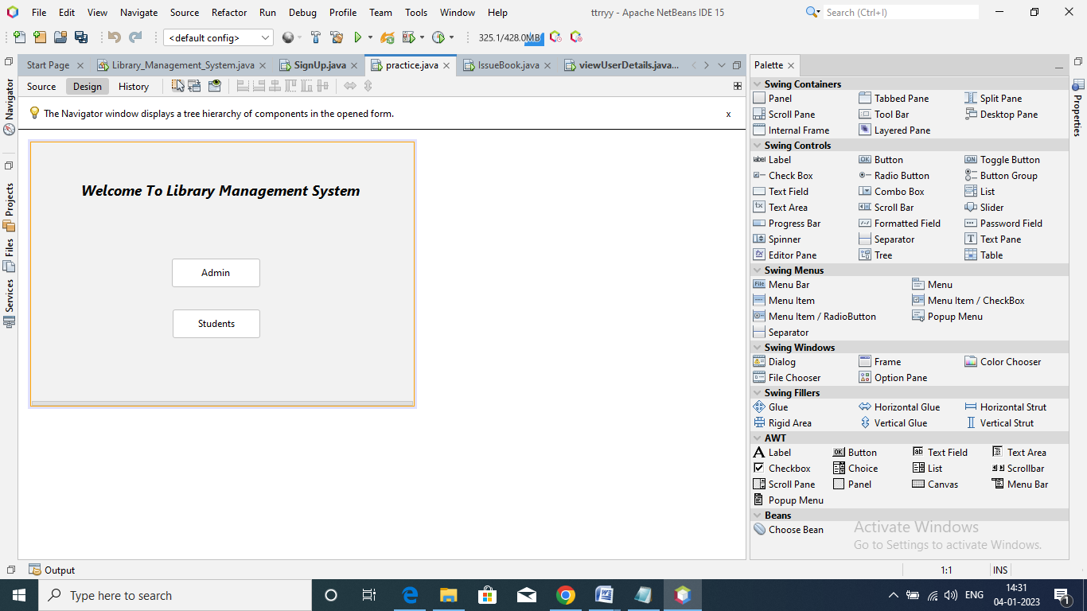 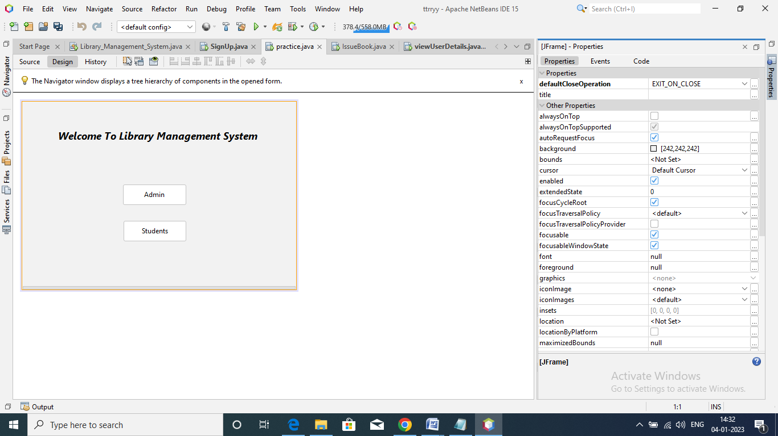

Fig. 3.1 Fig. 3.2

Java Swing Components Properties of JFrame

* **JTextField** - The object of a JTextField class is a text component that allows the editing of a single line text. It inherits JTextComponent class. It is used to get input of various text fields like passwords or while adding users and books, and inputting data for issuing a book or to return a book.
* **JPasswordField -** The object of a JPasswordField class is a text component specialized for password entry. It allows the editing of a single line of text. It inherits JTextField class. This is used to get password while login authentication.
* **JTabel -** The JTable class is used to display data in tabular form. It is composed of rows and columns. It is used to display all the details of the users, available books, issued books, total books etc.

**Chapter 4**

**Result and Discussion**

The Resultant application that has been made can be visualized as: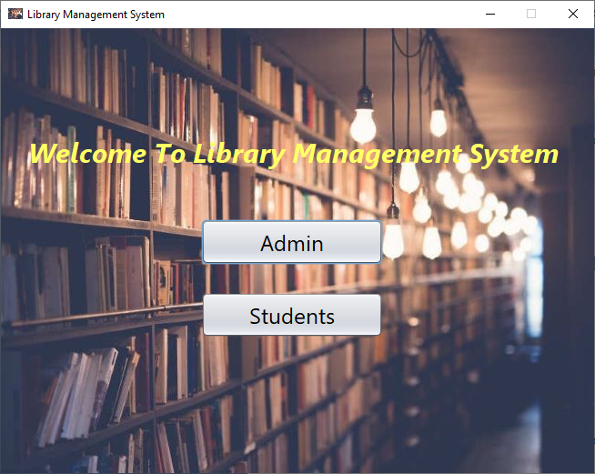

Fig 4.1

The users can distinguish themselves as admin or user (student in this case as it is being considered for a library in an educational institution) and can login with their login credentials accordingly.

After getting access into the system all the tasks and processes that are performed in a library can be done be the admin like viewing total books available in the library, total books that are currently being issued, total available books in the library which further can be issued by other users, viewing all the users that are currently registered in the library, issuing a book to any user, returning a book in the library, adding new books in the database of the library which are recently being bought or adding new users along with all their details and username and password; similarly users can also perform various tasks like viewing all the available books that he/she can issue or viewing all the books that are currently being issued by that user from the library and need to be returned back.

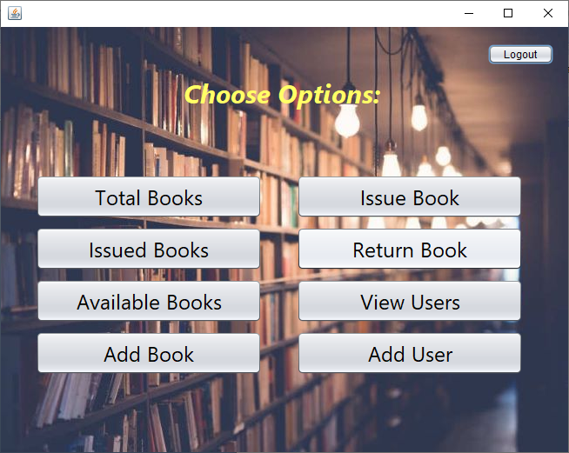

Fig 4.2 (Admin Options)

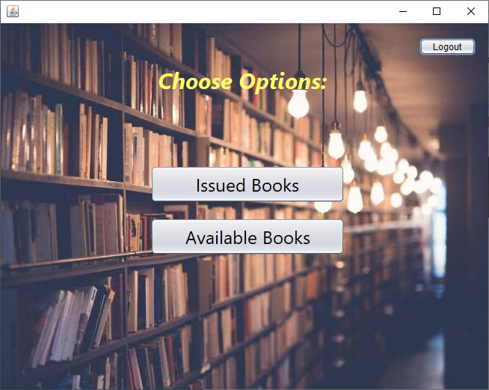 Fig 4.3 (User Options)

**Chapter 5**

**Conclusion and Future Work**

The website provides a computerized version of library management system which will benefit the students as well as the staff of the library. It makes entire process online where students can search books and can do book transactions. It also has a facility for student where student can login and can see status of books issued and can look all other books that are available in the library and can issue them through admin.

There is a future scope of this facility that many more features such as there will be a teacher login page where they can upload or put on the server online lecture video tutorials for online distance learning which is getting popularized after covid all over the world, a feature of group chat where students can discuss various issues of various subjects can be added to this thus making it more interactive, more user friendly and project which fulfills each user needs in the best possible way.

**Chapter 6**

**References**

[1] <https://ijrpr.com/uploads/V3ISSUE2/ijrpr2580--library-management-systems-%E2%80%93-a-survey.pdf>

[2] <https://www.irjet.net/archives/V7/i3/IRJET-V7I3109.pdf>

[3] <https://digitalcommons.unl.edu/cgi/viewcontent.cgi?article=6414&context=libphilprac>

[4] <https://www.javatpoint.com/example-to-connect-to-the-oracle-database>