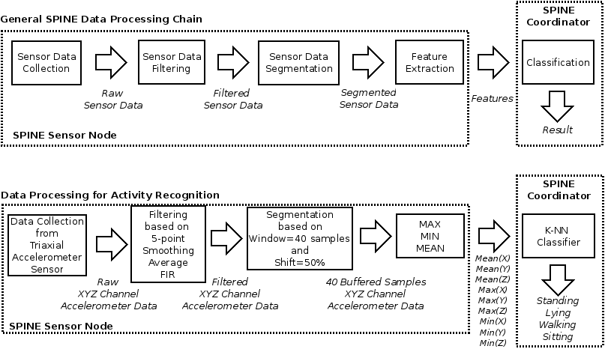

A wireless sensor network (WSN) (sometimes called a wireless sensor and actor network [[1]](https://scholar.google.co.uk/scholar?oi=bibs&cluster=11960246589498210561&btnI=1&hl=en)(WSAN)[[1]](https://en.wikipedia.org/wiki/Wireless_sensor_network#cite_note-1)) are spatially distributed [autonomous](https://en.wikipedia.org/wiki/Autonomous) [sensors](https://en.wikipedia.org/wiki/Sensor) to *monitor* physical or environmental conditions,[[2]](https://en.wikipedia.org/wiki/Wireless_sensor_network" \l "cite_note-2)such as [temperature](https://en.wikipedia.org/wiki/Temperature), [sound](https://en.wikipedia.org/wiki/Sound), [pressure](https://en.wikipedia.org/wiki/Pressure), etc. and to cooperatively pass their data through the network to a main location. The more modern networks are bi-directional, also enabling *control* of sensor activity. The development of wireless sensor networks was motivated by military applications such as battlefield surveillance; today such networks are used in many industrial and consumer applications, such as industrial process monitoring and control, machine health monitoring, and so on.