Synopsis

Title of proposed mini project: Automatic Doorbell with object detection

1. Name of Student :Garvit Singh
2. University Roll No. :2200910310072
3. Branch :Electronics and Communication
4. Proposed Topic : Automatic Doorbell with object

detection

1. Submited By :Garvit Singh

Introduction

Doorbells are usual signaling devices used to alert the person inside the building to open the door as someone has arrived. Classic doorbells can be seen in every house now a days, which uses simple button and when that button is pressed the bell rings. The doorbell which we are going to make is different from that. We will make a doorbell which is automatic, i.e. it will detect someone in front of it and then it will ring. We will be using a very simple circuit to implement this project. This project can be really beneficial because it’s not always the case that a person can reach the doorbell, so it would be nice if it rings automatically after detecting the person. Also, there is a flexibility that you can adjust the distance according to you by doing some changes in the code you are using to drive the doorbell.

We will be using [ultrasonic sensor](https://www.electricaltechnology.org/2018/11/types-sensors-applications.html#ultrasonic-sensor) to detect the person and then give the alert using a buzzer. As we know that ultrasonic sensors are used for distance measurement without physical contact for small distances. So it’s the best thing to use ultrasonic sensor for detecting object.

We’ve prototyped the touchless bell push using Arduino, which means the code can be ported to any Arduino-compatible platform.

Objectives

1. Develop a system that can accurately detect the presence of approaching individuals or objects using ultrasonic sensors
2. Provide users with the ability to customize and configure the system based on their preferences, allowing for adjustable sensitivity levels and response behaviors
3. Strive for a high level of reliability and accuracy in object detection to minimize false positives and negatives, ensuring the system's effectiveness in real-world scenarios

Why Needed ?

1. Enhanced Security: The system provides an additional layer of security by detecting approaching individuals or objects. This is particularly beneficial in situations where occupants want to be aware of who is approaching their door before answering
2. Convenience and Automation: The automatic doorbell eliminates the need for occupants to manually check or open the door when someone is approaching. This adds a level of convenience, especially in situations where hands-free or immediate response is desired
3. Accessibility for Diverse Users: The automated response of the doorbell benefits users with mobility challenges, providing an accessible solution that doesn't require physical interaction with the doorbell

Component Required

1. Arduino UNO x1
2. HC- SR04 ultrasonic sensor x1
3. Buzzer x1
4. LED x1
5. Jumpers wires
6. Connecting wires

Circuit Diagram

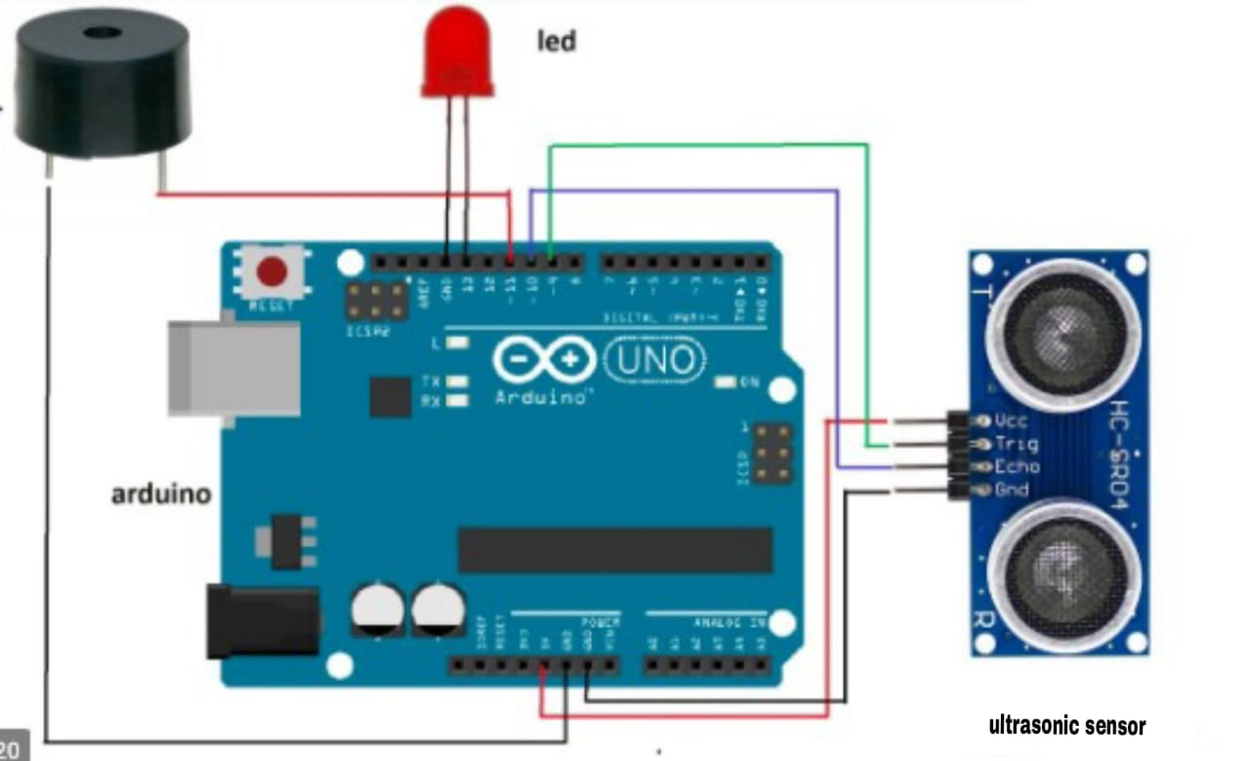

Literature Review

The literature review for the "Automatic Doorbell with Object Detection By Arduino, Ultrasonic Sensor, Breadboard" project reveals a landscape marked by a blend of smart home technologies, sensor applications, and Arduino-based projects. Existing studies highlight the growing interest in enhancing traditional doorbell systems through object detection mechanisms. Research in smart homes emphasizes the importance of security and automation, aligning with the objectives of this project. Various sensor technologies, particularly ultrasonic sensors, have been extensively utilized in object detection applications, showcasing their versatility and reliability.

Arduino microcontrollers emerge as popular choices in similar projects, owing to their open-source nature and ease of programming. These studies demonstrate how Arduino platforms facilitate the integration of sensors, enabling intelligent decision-making processes in response to detected objects. Furthermore, the literature underscores the need for customizable and adaptable systems, aligning with the project's goal of allowing users to tailor the doorbell's sensitivity and responses

Methodology/Planning of Work

The methodology for the "Automatic Doorbell with Object Detection By Arduino, Ultrasonic Sensor, Breadboard" project involves a systematic approach to design, implementation, and testing. The project will commence with a thorough analysis of sensor technologies and Arduino microcontroller capabilities through a comprehensive literature review. Following this, the specific requirements for object detection in the context of a doorbell system will be defined

The planning of work involves the step-by-step development of the system. First, the Arduino microcontroller will be programmed to interface with ultrasonic sensors, interpreting their data for object detection. The system's architecture will be designed, detailing the connections between components such as the Arduino, ultrasonic sensors, and the breadboard

Expected Outcome

The expected outcome is an intelligent Automatic Doorbell with Object Detection, utilizing Arduino, ultrasonic sensors, and a breadboard. The system will accurately detect approaching objects, trigger automated responses, and provide a customizable, user-friendly solution that enhances security and convenience in residential or commercial settings

Sign : Garvit singh