Towards speed up search of matches in distributed suffix tree

Authors Name/s per 1st Affiliation (Author)
line 1 (of Affiliation): dept. name of organization
line 2: name of organization, acronyms acceptable
line 3: City, Country
line 4: e-mail address if desired
Authors Name/s per 2nd Affiliation (Author)
line 1 (of Affiliation): dept. name of organization
line 2: name of organization, acronyms acceptable
line 3: City, Country
line 4: e-mail address if desired

Abstract—Maximal Exact Matches (MEM) are substrings that are found in a reference sequence and a query sequence. They are exact and maximal that is they cannot be extended in left or right direction without incurring a mismatch. The computation of MEMs in large sequences is a heavy and repetitive task, so that it is a fair chance of being parallelized and executed this search in clusters and multicore architectures. This paper resembles a first approach to find MEMs in genomic sequences in a somehow distributed way. This approach is based on the current tool for genome alignment tool, MUMmer, which is able of find MEMs but it lacks of handling sequences that do not fit in main memory when they are put in its data structure.
Maximal Exact Matches; Suffix tree; Distributed Suffix tree; Genome Alignment.

Introduction
Given a text t of length n and a string s of length m of an alphabet Σ, the problem of string matching is to find all occurrences of the string s in text t. Although the main problem is well studied, recent advances in research genomics and new developments in processor architectures introduces new challenges in the area. Bioinformatics applications are those that give motivation for the investigation of the search variable-length strings in a string.
The suffix tree is a data structure that allows the search for exact matches variable length in linear time. However the requirements of space needed to store the suffix tree in main memory make a non-viable structure when the suffix tree to be stored exceeds the available memory.
Additionally, the reason for using a tree suffix is that the search for exact matches of variable length in a tree suffixes is done in linear time.
Thus the goal is to accelerate the efficient search for maximal exact matches and considering the use of computing resources and memory. The considerations that are taken into account are the size of the reference string (on which searching is performed) and the length of the match to find.

MUMmer
MUMmer is an application for sequence alignment based on a heuristic. This heuristic lies that the sequences to align are very close related, i.e., share common sequence regions together.
The goal of MUMmer is to find all those substrings that are common to both sequences reference R, and query Q, and maximal. There are two kinds of matches used by MUMmer: MEM and MUM that are described above.

MEM
A MEM (Maximal Exact Match) is a substring which is common two reference and query sequence, it is longer than a minimal length d and it cannot be extended to both extremes without incurring a mismatch.
Identify applicable sponsor/s here. If no sponsors, delete this text box. (sponsors)

MUM
A MUM is a particular case of a MEM that is those MEMs that are unique in both reference and query sequences.

Searching for matches
In order to find a match of maximal length inside a string there are several approaches. Two of these known solutions are based in suffix array and suffix tree respectively. Both structures extract every suffix of a given reference string and use an index in order to identify where a matching is located in the reference string.

Suffix array
A suffix array provides a lexicographically ordered list of all the suffixes of a string. The search of a string inside a suffix array is carried out by using a binary search. If the element at position i in the suffix array is j, it means that T_{j}, the suffix starting at position j in T is the i-th smallest suffix of T.

Suffix tree
A suffix tree represents the set of all suffixes of a string. The suffix tree provides a more compact representation of the suffixes. To find a string inside a suffix tree, it has to traversal the suffix tree from the root searching for a common path between the string and the suffix stored in the tree. If the match is found inside a leaf node then there is the only one match. If the match is found in a node then the position of the matches are located at the end of the common path of the leaf nodes.
To find a MUM in a suffix tree it is only necessary to verify that the substring of the subject sequence is long enough, that it is unique in the subject sequence and that the match is also left maximal. This is done as follows:
- Is substring of length at least minimum match length?
- Does match correspond to a leaf edge? Then the string represented by the location is unique in the subject sequence.
- Is the substring left maximal? This is true if one of the following conditions hold:
- The suffix of the query currently considered is the first suffix, or
- The string represented by match is a prefix of the subject string, or
- The characters immediately to the left of the matching strings in the reference sequence and the query sequence are different.
If all conditions 1-3 are true, then the match is considered a MUM-candidate.

Suffix tree: a data structure
There are several approaches to represent a logical suffix tree in real computers. The efficiency of every approach depends of how much space the need and how easy they are to get information from them.
The implementation of the suffix tree in MUMmer is as follows:
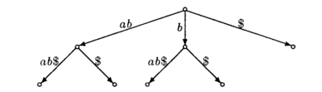
Figure 1
The representation of a suffix tree, see Figure 1, in memory is implemented with a linked list that allows saving memory. This representation is shown in Figure 2.
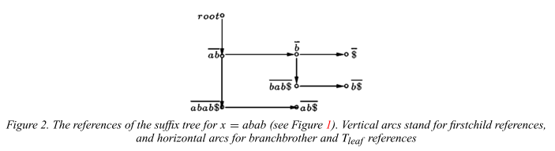

Figure 2
The suffix tree uses two tables for the leaves and branches, as shown in Table I:
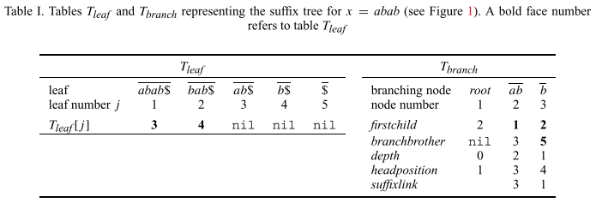
In order to save memory some redundancy is used so that small and large nodes are defined as shown in Table II.
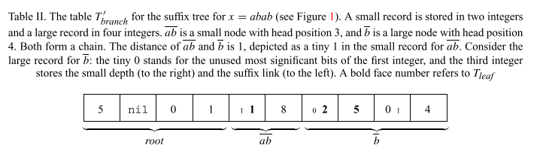
If a computer with 64 bit architecture is used, then the space used to store a DNA sequence in a suffix tree is as follows 16*n where n is the length of the sequence to store.

Distributed suffix tree
To improve the search of matches in suffix tree a novel approach is proposed. The use of a distributed suffix tree may allow executing the search for matches in multicore architectures and clusters.
Our first approach is to split horizontally the suffix tree. If a suffix tree were divided within a defined depth level that could be replaced with a more compact data structure, this compact data structure would allow saving space and speed up the initial search of matches for a fixed size of prefixes.
To define the appropriate length to split a suffix tree horizontally some tests were carried out.
In Figure 3 it is shown the search for matches for a minimum length of 4.
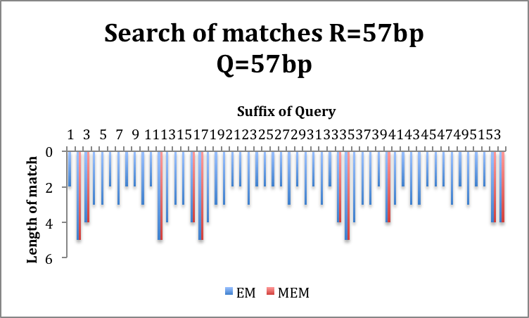
Figure 3
The minimum length for a match is a first approach to decide where to split a suffix tree, as it is shown in Figure 4.
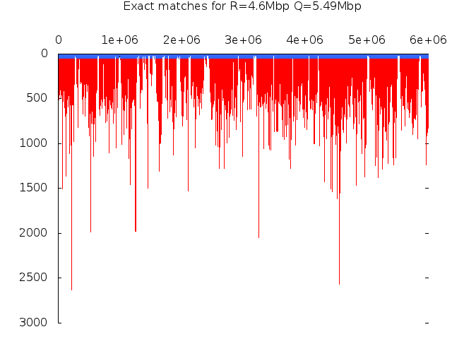
Figure 4

