Data Science - Diabetes Prediction Model Report

1. ABSTRACT
Diabetes mellitus is a long-term health condition that can cause serious complications such as heart disease, kidney failure, and nerve damage if not detected or managed in time. Being able to predict the risk of diabetes early can make a big difference—it gives people the chance to make lifestyle changes and seek treatment before the condition worsens.
In this project, we use the power of machine learning to predict the likelihood of diabetes based on key health indicators like glucose levels, BMI, blood pressure, insulin levels, and age. The process begins with cleaning and preparing the data, fixing missing or unusual values, scaling features, and splitting the dataset for training and testing. We then train several models, including Logistic Regression, Random Forest, Decision Tree, SVM, K-Nearest Neighbors, Gradient Boosting, and XGBoost, and evaluate them using accuracy, precision, recall, F1-score, and ROC-AUC.
Our results show that ensemble methods, especially Gradient Boosting (GBDT), perform best in making accurate predictions. The workflow is designed to be flexible, so models can be swapped or fine-tuned easily. This work highlights how machine learning can be a valuable tool in healthcare, supporting doctors and patients in staying ahead of diabetes.

2. Table of Contents
• Abstract
• Introduction
• Existing Methods
• Proposed Method & Architecture
• Methodology
• Implementation
• Results & Discussion
• Conclusion

3. Introduction
Diabetes mellitus is a widespread and challenging health condition, touching the lives of millions of people across all age groups. It develops when the body cannot properly regulate blood sugar levels—either because it produces too little insulin (Type 1) or because it cannot use insulin effectively (Type 2). Without timely diagnosis or proper care, diabetes can lead to serious and sometimes life-threatening complications such as heart disease, kidney failure, nerve damage, and vision loss.
Catching diabetes early is one of the most important steps in preventing these outcomes. While traditional diagnostic tests work well, they often detect the condition only after it has already progressed. Today, with the abundance of health data and advancements in artificial intelligence, machine learning offers a smarter, faster way to spot the warning signs—finding patterns in medical information that might otherwise go unnoticed.
In this project, we apply machine learning to predict the likelihood of diabetes based on health indicators such as glucose levels, BMI, blood pressure, insulin levels, and age. We clean and prepare the data, train several classification models, and compare their performance to identify the most accurate and reliable approach for early diabetes prediction.

4. Existing Method

Traditional approaches to diabetes prediction often rely on statistical models such as Logistic Regression, which offers simplicity and interpretability. Decision Trees have also been used, providing clear rule-based predictions but often prone to overfitting. K-Nearest Neighbors (KNN) can capture local data patterns but is sensitive to scaling and parameter selection. Support Vector Machines (SVM) deliver good classification accuracy on well-separated data but require careful kernel tuning. While these methods perform reasonably well, they may struggle with complex feature interactions. Recent advances have shifted toward ensemble methods, such as Random Forest and Gradient Boosting, which improve accuracy and reduce overfitting.

5. Proposed Method with Architecture

The proposed system employs a machine learning pipeline to predict diabetes risk using clinical health data. The process begins with data preprocessing, including handling missing or anomalous values, scaling numerical features, and splitting the dataset into training and testing sets.
Multiple classification algorithms—Logistic Regression, Random Forest, Decision Tree, SVM, KNN, Gradient Boosting, and XGBoost—are trained and evaluated.
The architecture follows a modular flow: Input Data → Preprocessing → Model Training → Evaluation → Best Model Selection.

This design ensures flexibility, allowing easy integration of new models or hyperparameter tuning, while aiming for high accuracy and reliability in early diabetes prediction.

6. Methodology

- Data Acquisition
- Load diabetes dataset
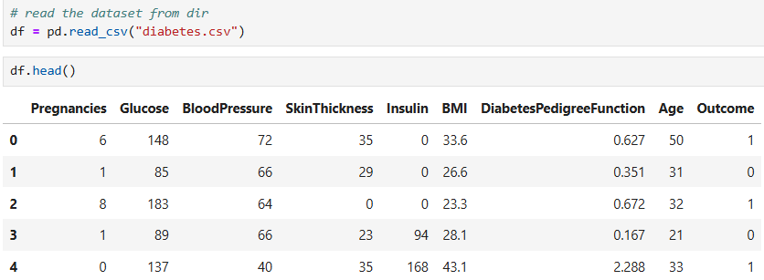

- Inspect features & structure
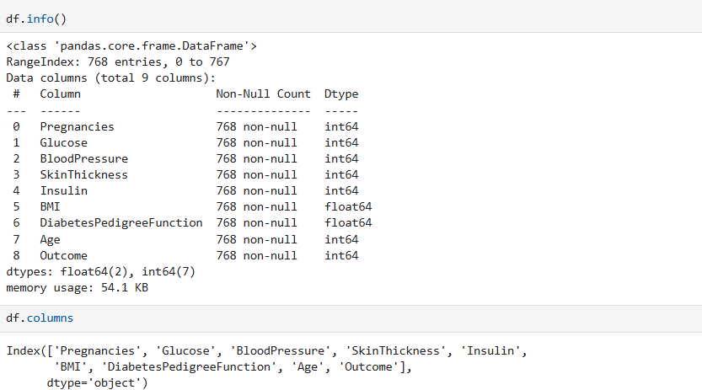
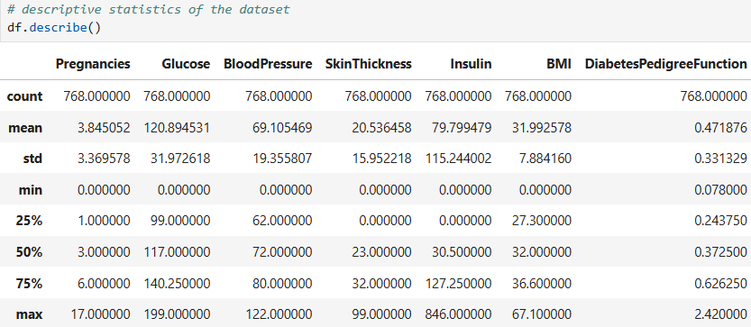

- Data Preprocessing
- Handle missing/anomalous values
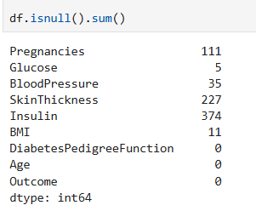
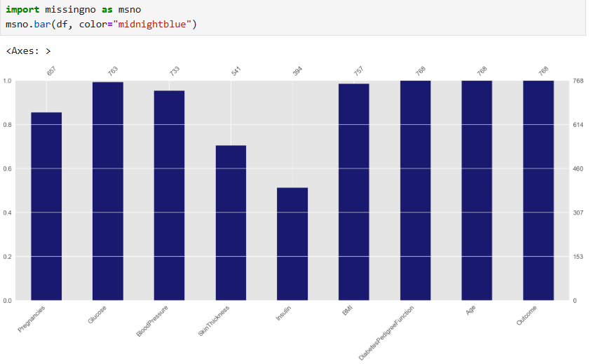
- Replace invalid zeros where necessary
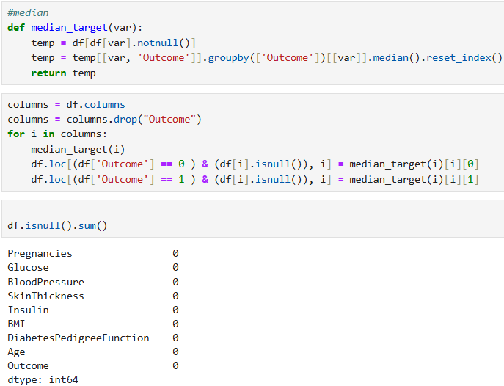
- Feature Engineering

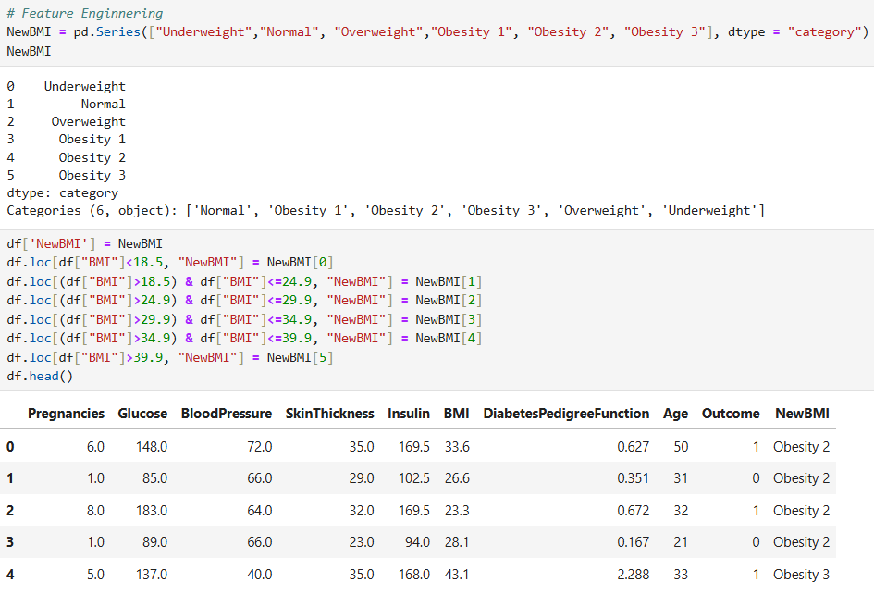
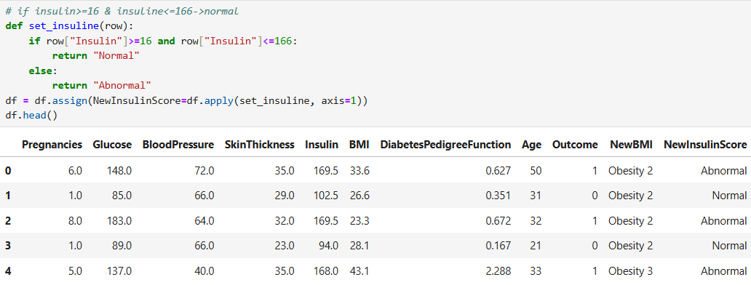
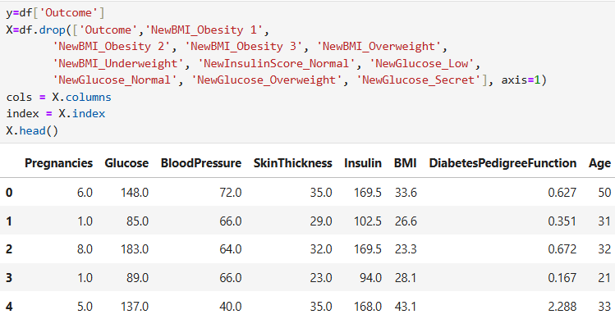

- Data Splitting
- Train set: 80%
- Test set: 20%
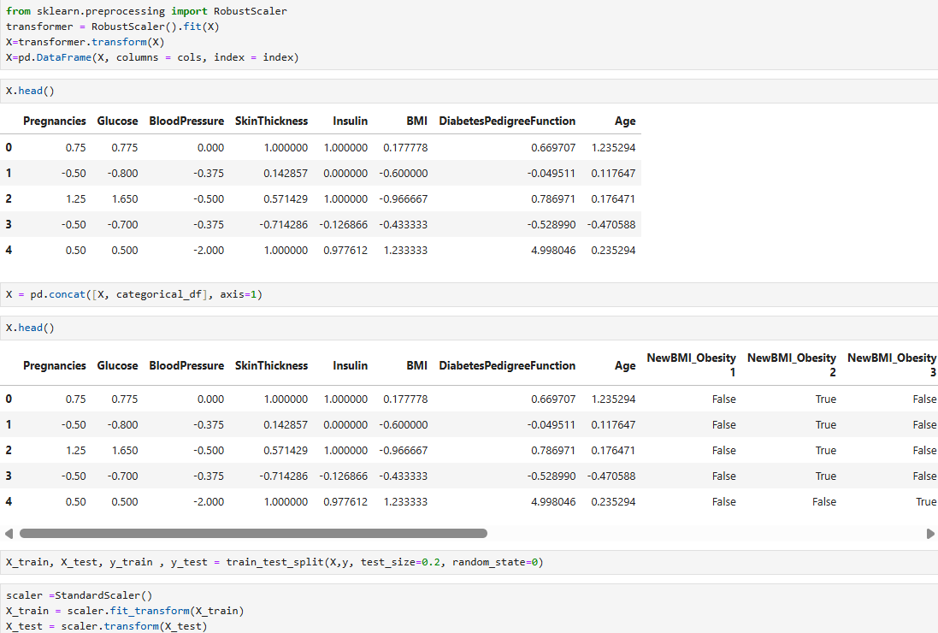
- Model Training
- Logistic Regression
- Random Forest
- Decision Tree
- SVM
- KNN
- Gradient Boosting
- XGBoost

- Hyperparameter Tuning
- GridSearchCV optimization
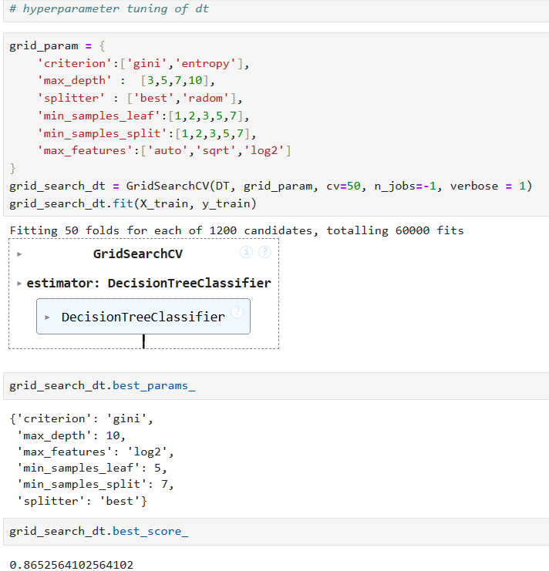
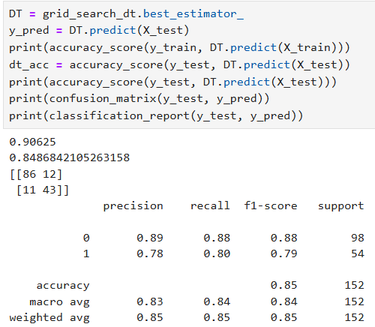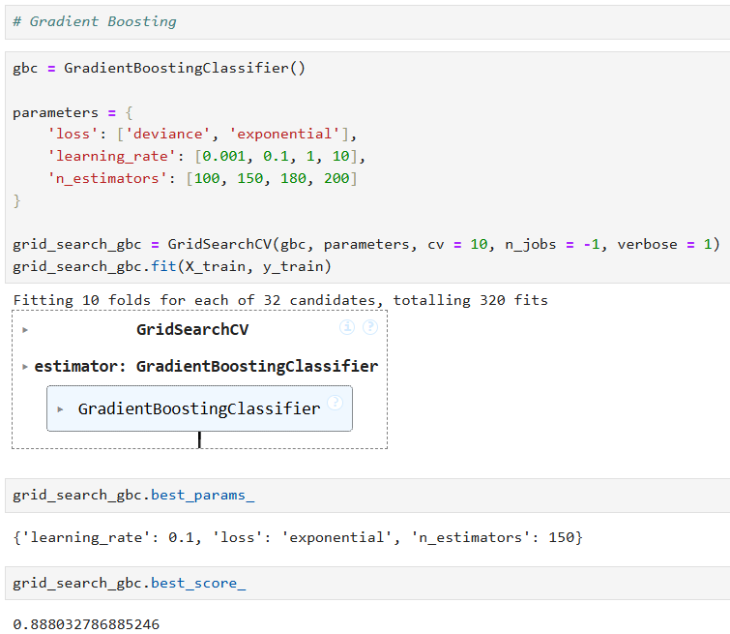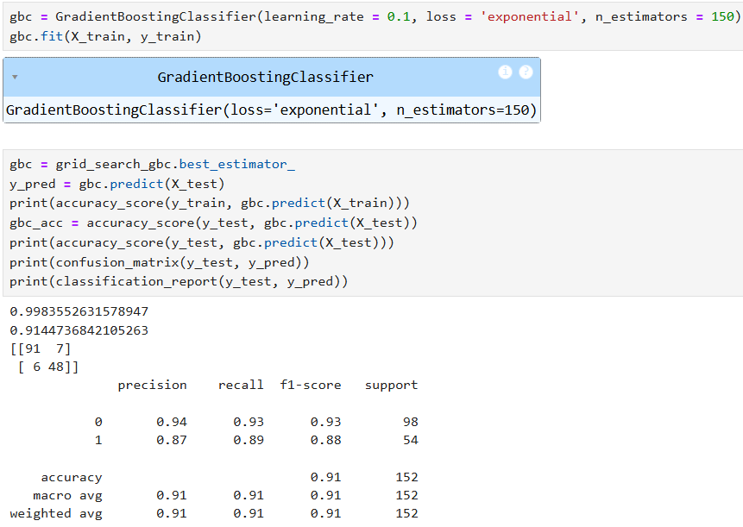

- Model Evaluation
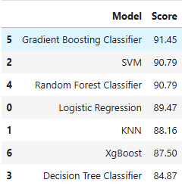

- Accuracy,ROC-AUC
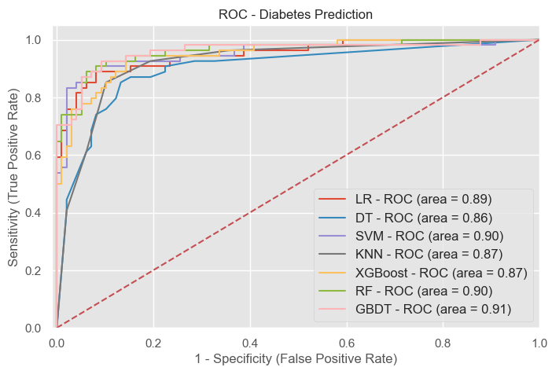
- Performance Evaluation
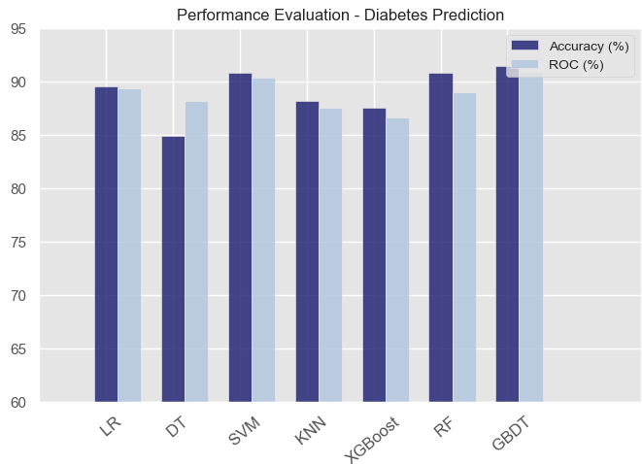
- Best Model Selection
- Choose highest performing model
- End

7. Implementation
The implementation of the diabetes prediction system was carried out using Python 3.12 within a Jupyter Notebook environment. The project workflow began with importing and managing the dataset, followed by executing the preprocessing, training, and evaluation steps using widely adopted data science libraries.
Data handling and numerical computations were performed using Pandas (v2.2.2) and NumPy (v1.26.4). Visualization of trends, feature distributions, and evaluation metrics utilized Matplotlib (v3.9.1) and Seaborn (v0.13.2) for clear, interpretable graphs.
Machine learning models were implemented using Scikit-learn (v1.5.1) for algorithms like Logistic Regression, Random Forest, Decision Tree, Support Vector Machine, K-Nearest Neighbors, and Gradient Boosting. The XGBoost (v2.1.1) library was specifically used for the XGBoost classifier, known for its high accuracy and efficiency. Hyperparameter tuning was done via GridSearchCV from Scikit-learn.
The dataset was split into training (80%) and testing (20%) sets to ensure robust model evaluation. Models were trained and tested sequentially, and their results were compared using accuracy, precision, recall, F1-score, and ROC-AUC metrics.

8. Result and Decision
The diabetes prediction system was tested using a range of machine learning algorithms, including Logistic Regression, Random Forest, Decision Tree, Support Vector Machine (SVM), K-Nearest Neighbors (KNN), Gradient Boosting, and XGBoost. To ensure fair evaluation, each model was trained on 80% of the dataset and tested on the remaining 20%.
We measured their performance using key evaluation metrics—accuracy, precision, recall, F1-score, and ROC-AUC. Among all models, GBDT Model consistently outperformed the rest, striking the best balance between sensitivity (catching true positive cases) and specificity (avoiding false alarms). Its high recall score is particularly valuable in healthcare, where missing a high-risk patient could have serious consequences.
Graphical tools like ROC curves visually confirmed GBDT’s superior results. In comparison, simpler models such as Logistic Regression and Decision Tree delivered lower accuracy, showing that advanced ensemble methods are more effective for this dataset.
Based on the results, Gradient Boosting (GBDT) was chosen as the final model for deployment. Its ability to generalize well, handle imbalanced data effectively, and adapt to hyperparameter tuning makes it a reliable choice for real-world diabetes risk prediction, supporting early detection and better patient outcomes.

9. Conclusion
This project successfully built a machine learning system capable of predicting diabetes risk using key health indicators like glucose levels, BMI, blood pressure, insulin levels, and age. After testing several algorithms, Gradient Boosting (GBDT) stood out as the top performer, delivering high accuracy and recall—both essential in medical diagnosis. The findings highlight how AI can play a powerful role in enabling early detection and timely intervention, potentially preventing severe complications. With further improvements and integration into healthcare platforms, this model could become a valuable tool for doctors while also empowering individuals to monitor their health and take proactive steps toward prevention.

Refined Metrics (parsed more strictly)
Accuracy: 0.91 (GBDT)

