**Details about the execution**

* You will be prompted to select the agent
* 1->simple minimax, 2-> minimax with pruning.
* 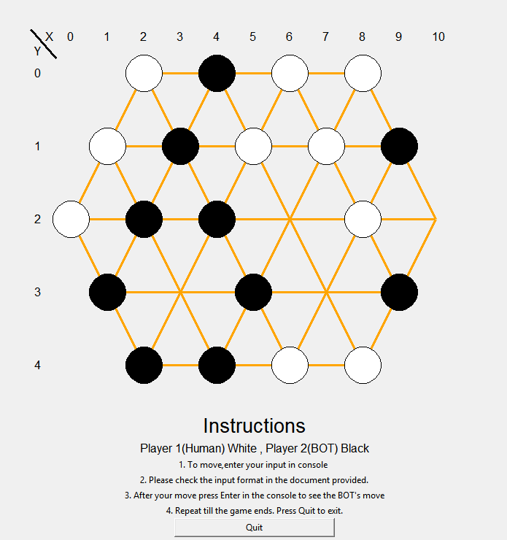After that the randomly generated board will be displayed in the cmd and the gui.

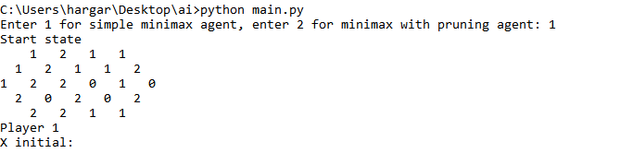

* Enter the initial coordinates of the white piece you want to move
* 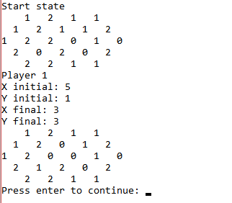In case your input is invalid it will ask you to re-enter.
* Then input the final coordinates.
* The move will execute and wait for you to press enter.

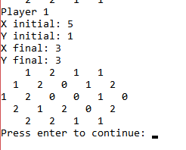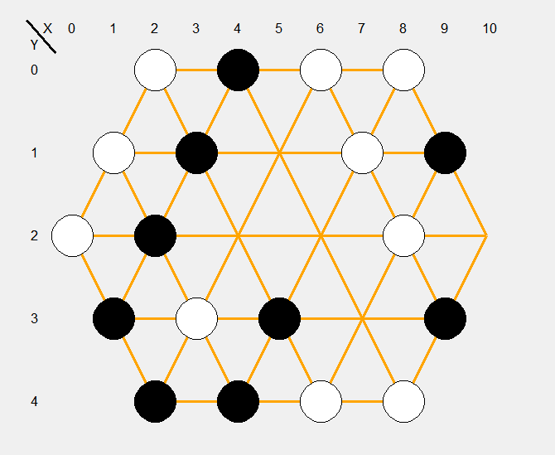

* 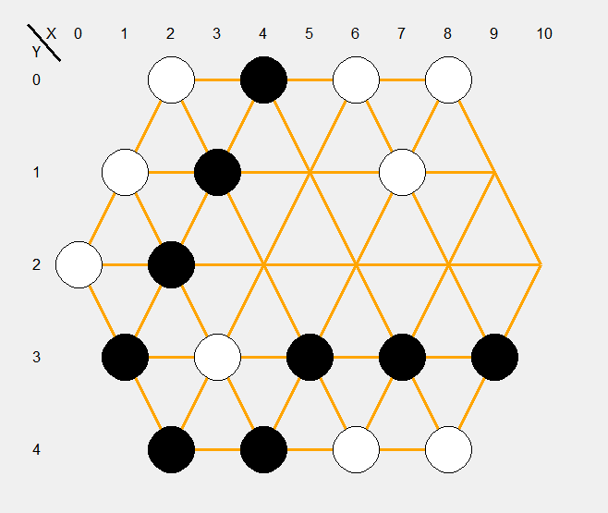After you press enter the bot will execute its move and show it in the cmd and the gui.
* And will prompt you to enter the next move again.
* The game ends when one player looses and the game terminates.
* Press quit to exit the program.

Details about the functions have been commented.