Artificial Intelligence (Assignment 1)

ID: 2015B4A70551P

Name: Garv Sachdeva

There are 4 python files and 1 bat file:

function2.py : contains BFS DFS and some helper funtions

generate2.py: to generate the initial random state

GUI2.py: to print the configurations using turtles

driver.py: executes all the functions

run.bat: executes the driver file

DFS has been implemented using stack. BFS uses a queue.

If we consider only getting 1 possible solution DFS works way faster than BFS.

If we want to find every possible final configuration, performance of BFS and DFS are comparable.

The path cost between two valid states is the difference between the no of matchsticks.

In this code I do not need to check for dangling edges since my code only jumps from 1 valid state to another.

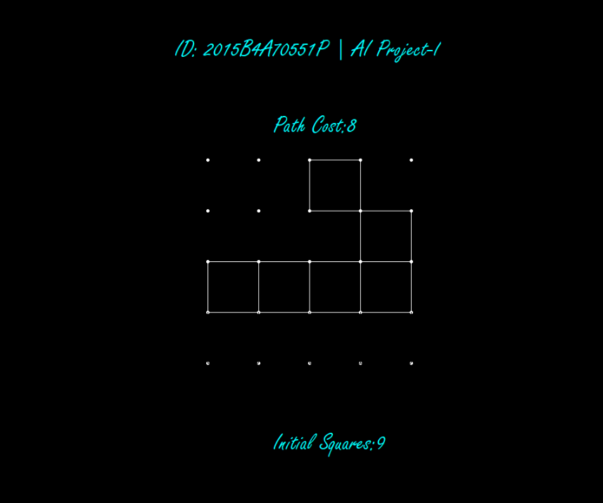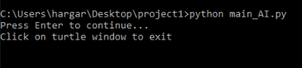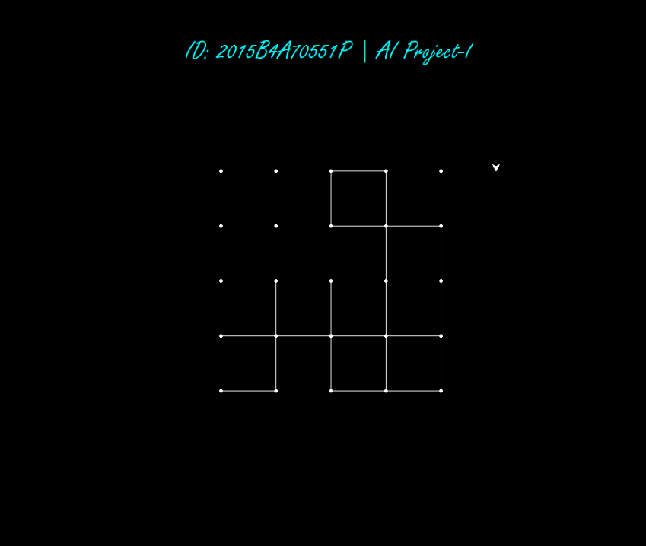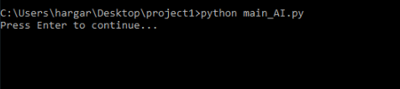

**WORKING**​ :

Given screenshot shows a randomly generated configuration and the final configuration.

1. To change the percentage of squares generated randomly you may change value in line no 13 of driver file.
2. To change the no of squares in the final state you may change value in line no 15 of driver file.
3. Kindly note that you may give any value from 0 to16 as the no of squares in the final state.
4. To switch between BFS and DFS you may comment or uncomment lines no. 19 and 22 in the driver.
5. After executing the driver file (manually or by using the .bat file) the initial state will print.
6. To see the output state kindly press Enter in the cmd window.
7. **Note:** If the turtle window hangs kindly comment line no 39 of the driver file.
8. After pressing enter unnecessary edges will get deleted.
9. And the no of matchsticks removed(path cost) to get to the final state will show.
10. To exit the execution kindly click anywhere on the turtles window.
11. To test for a custom input uncomment line 16 and 17 in driver and comment 19 and 20.