PHASE 3 REPORT

Smartphone Sensor Data Analysis and Prediction of Usage Pattern and Overheating using Machine Learning

Problem Id: 24
Section P | G2
Team member 1 (Team Lead)  (Last Name, name, Student ID, University Roll No., email, picture):  Team member 2  (Last Name, name: student ID:, University Roll No email, picture):  Team member 3  (Last Name, name: student ID: , University Roll No email, picture): | Bajaj,Shivansh:2510370470;2028849  2510370470@geu.ac.in  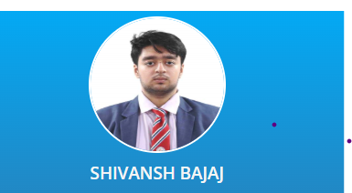  Sharma, Garv : 2510370052,2028716  2510370052@geu.ac.in    Jain,Ketan : 25101281877; 2028743;  25101281877@geu.ac.in  

Problem Description
This phase focuses on training and evaluation of machine learning models for smartphone usage prediction and overheating detection.

Machine Learning Models Used
- Logistic Regression
Used for classification of smartphone usage patterns and overheating prediction.
- K-Nearest Neighbors (KNN) Classifier
- Used for classifying data points based on nearest neighbors.
- Decision Tree Classifier
  - Used for rule-based classification and prediction.
- Random Forest Classifier
  - Ensemble model using multiple decision trees for higher accuracy.
- Gradient Boosting Classifier
  - Boosting algorithm used to improve prediction performance.
- AdaBoost Classifier
  - Adaptive boosting model for improving weak learners.
- Extra Trees Classifier
  - Ensemble learning method similar to Random Forest with randomized trees.
- Voting Classifier
  - Combines predictions of multiple models for better performance.
- Support Vector Classifier (SVC)
  - Used for classification with optimal hyperplane separation.
- Gaussian Naive Bayes
- Probabilistic classification algorithm based on Bayes theorem.
- MLP Classifier (Neural Network)
- Multi-layer perceptron neural network for advanced classification tasks.

Other ML/Data Processing Techniques used in the project:
- StandardScaler → Feature scaling
- PCA (Principal Component Analysis) → Dimensionality reduction
- SelectKBest with f_classif → Feature selection
- MultiOutputClassifier → Multi-target prediction
- Train-Test Split → Dataset splitting
- Cross Validation → Model validation
- GridSearchCV → Hyperparameter tuning

Final Architecture
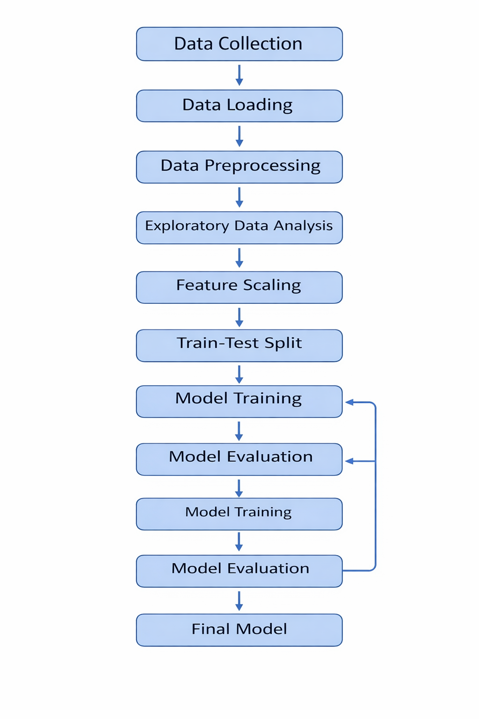
1. Data Collection – The dataset containing smartphone sensor readings was collected and stored in CSV format.
2. Data Loading – The dataset is loaded into Python using the Pandas library for further analysis.
3. Data Preprocessing – Missing values are handled using mean and median replacement. Duplicate entries are removed.
4. Exploratory Data Analysis – Histograms, scatter plots, and heatmaps are used to understand relationships between variables.
5. Feature Scaling – StandardScaler is applied to normalize numerical features.
6. Train-Test Split – The dataset is divided into training and testing sets.
7. Model Training – Logistic Regression and Random Forest algorithms are used.
8. Model Evaluation – The trained models are evaluated using classification metrics.

Model Training Process
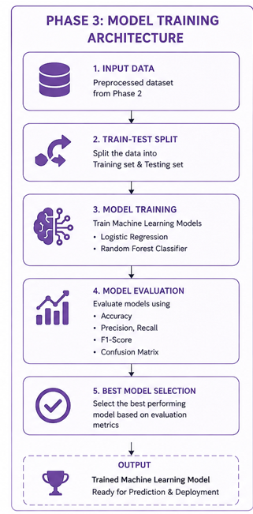

Evaluation Metrics
• Accuracy
• Precision
• Recall
• F1 Score

Health Impact ANALYSIS

Usage Pattern | Possible Health Issue
High screen time | Eye strain, headaches
Late night usage | Sleep disorders
Excess gaming | Addiction, anxiety
Low movement | Obesity, poor fitness

Results and Visualizations

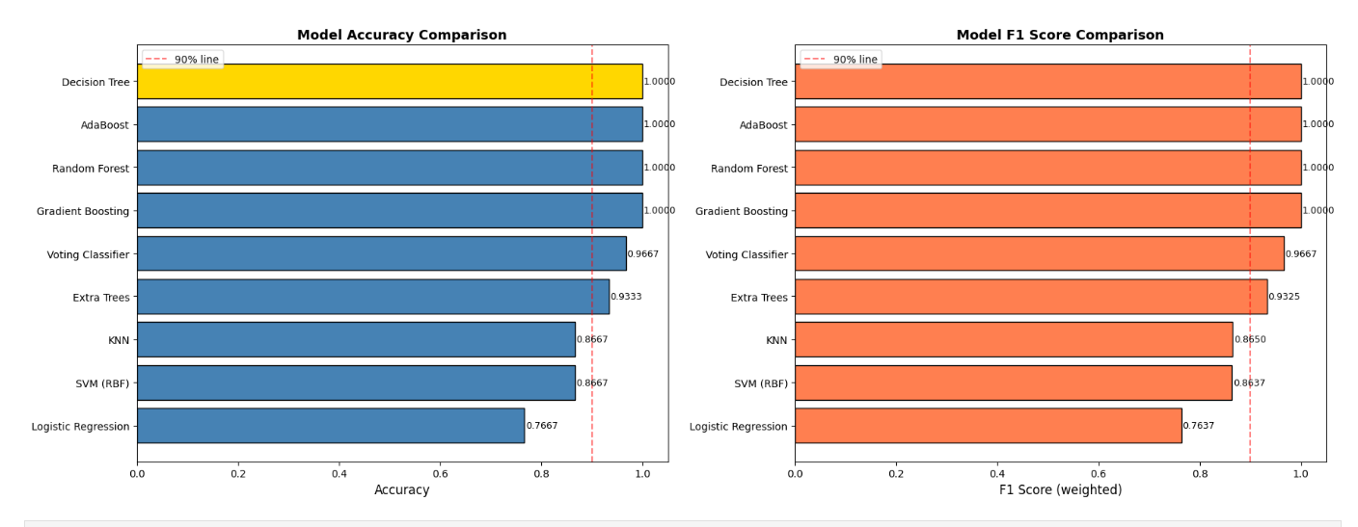

Future Scope
Although the project achieved satisfactory results, several improvements and advanced features can be implemented in the future to make the system more intelligent, scalable, and practical for real-world deployment.

1. Real-Time Smartphone Monitoring
The current project works on a prepared dataset. In future, real-time smartphone sensor data can be collected directly from mobile devices using Android or iOS applications. This would allow live monitoring of device performance and overheating conditions.

2. Deep Learning Integration
Advanced Deep Learning models such as:
- Artificial Neural Networks (ANN)
- Convolutional Neural Networks (CNN)
- Long Short-Term Memory Networks (LSTM)
can be implemented to improve prediction accuracy and capture complex sensor behavior patterns more effectively.

3. Mobile Application Development
A dedicated mobile application can be developed that:
- Continuously monitors smartphone health
- Predicts overheating risks
- Sends warning notifications to users
- Provides personalized usage recommendations
This would make the system more user-friendly and practical.

4. Cloud-Based Data Processing
Cloud integration can help store and analyze large amounts of smartphone sensor data from multiple users. Technologies such as:
- Google Firebase
- AWS
- Microsoft Azure
can be used for scalable cloud analytics and remote monitoring.

5. Personalized Health Recommendations
The system can be enhanced to provide customized health suggestions based on user behavior patterns, such as:
- Reducing screen time
- Improving sleep schedules
- Limiting excessive gaming
- Encouraging physical activity

6. Integration with IoT and Wearable Devices
Future versions may integrate smartwatch and wearable sensor data to perform more accurate health and activity analysis.

7. Cybersecurity and Privacy Enhancement
Since smartphone data is sensitive, future systems can include:
- Secure authentication
- Data encryption
- Privacy-preserving machine learning techniques
to ensure user data protection.

8. Automatic Model Optimization
Hyperparameter tuning and AutoML techniques can be integrated to automatically select the best machine learning model and improve overall system performance.

9. Multi-Device Compatibility
The project can be extended to analyze data from:
- Tablets
- Smartwatches
- Laptops
- IoT devices
for broader device analytics.

10. Smart Recommendation System
An intelligent recommendation engine can be added to suggest:
- Battery optimization tips
- Performance improvements
- App usage control
- Device cooling strategies

Conclusion
The project titled “Smartphone Sensor Data Analysis and Prediction of Usage Pattern and Overheating using Machine Learning” successfully demonstrates the practical implementation of Artificial Intelligence and Machine Learning techniques in analyzing smartphone sensor data. The system was designed to collect, preprocess, analyze, and predict smartphone behavior using multiple machine learning algorithms.
During the implementation process, smartphone sensor parameters such as CPU usage, battery consumption, temperature, RAM utilization, screen time, and application activity were analyzed to understand device performance and user behavior patterns. Data preprocessing techniques including missing value handling, duplicate removal, feature scaling, and feature selection helped improve the quality and reliability of the dataset.
Exploratory Data Analysis (EDA) provided meaningful insights into the relationship between different smartphone parameters. Heatmaps, histograms, scatter plots, and correlation analysis helped identify important patterns related to overheating conditions and excessive smartphone usage.
Several machine learning models such as Logistic Regression, Random Forest, Decision Tree, KNN, Support Vector Machine, Gradient Boosting, AdaBoost, Extra Trees Classifier, and Neural Networks were implemented and evaluated. The models successfully predicted smartphone usage patterns and overheating risks with good accuracy and performance metrics. Ensemble models such as Random Forest and Voting Classifier produced more reliable and stable predictions compared to individual models.
The project also extended beyond device performance analysis by incorporating user-centric insights such as:
- Usage purpose prediction
- Age group classification
- Health risk identification due to excessive smartphone usage
The system highlights how machine learning can be used not only for technical device monitoring but also for understanding digital behavior and promoting healthier smartphone usage habits.
Overall, the project successfully achieved its objectives and demonstrated the real-world application of machine learning in smartphone analytics, predictive monitoring, and intelligent decision-making systems.

- Platform Required:
• Python
• Jupyter Notebook
• Anaconda / Python IDE
• Libraries: Pandas, NumPy, Matplotlib, Seaborn, Scikit-learn

- Books and Link Sources:
Books:
1. Hands-On Machine Learning with Scikit-Learn, Keras & TensorFlow – Aurélien Géron
2. Python for Data Analysis – Wes McKinney

Online Datasets:
1.Human Activity Recognition Dataset
https://archive.ics.uci.edu/ml/datasets/human+activity+recognition+using+smartphones
Real smartphone accelerometer and gyroscope dataset used for activity classification.

2. MotionSense Dataset
https://github.com/mmalekzadeh/motion-sense
iPhone sensor dataset capturing motion patterns like walking, sitting, and jogging.

3. WISDM Smartphone Dataset
https://www.cis.fordham.edu/wisdm/dataset.php
Dataset containing smartphone sensor data for human activity recognition using accelerometer signals.

4. MobiAct Dataset
https://bmi.hmu.gr/the-mobifall-and-mobiact-datasets-2/
Smartphone-based dataset including normal activities and abnormal movements like falls.

5. ExtraSensory Dataset
http://extrasensory.ucsd.edu/
Multimodal smartphone sensor dataset with detailed context and user activity labels.

6. Kaggle Smartphone Usage Datasets
https://www.kaggle.com/datasets
Collection of datasets containing mobile usage patterns, app activity, and user behavior.
Online Resources:
1. https://scikit-learn.org
2. https://pandas.pydata.org
3. https://www.kaggle.com
4. https://matplotlib.org

