電通二乙微處理器實驗 實驗結報

實驗名稱 | LAB 01 - Blink
組別 | 21 | 組員 | 04050325陳宇亮 / 04050902周芷琪

https://github.com/gary07456/04050325

- 實驗目的
Arduino 介紹
- 實驗步驟
用circuits模擬電路圖
- 程式碼
// Pin 13 has an LED connected on most Arduino boards.
// give it a name:
int led = 13;
// the setup routine runs once when you press reset:
void setup() {
// initialize the digital pin as an output.
pinMode(led, OUTPUT);
}
// the loop routine runs over and over again forever:
void loop() {
digitalWrite(led, HIGH); // turn the LED on (HIGH is the voltage level)
delay(1000); // wait for a second
digitalWrite(led, LOW); // turn the LED off by making the voltage LOW
delay(1000); // wait for a second
}

- 實驗結果及分析
改了delay的數字之後 燈泡亮的速度真的變慢了耶 !!!

- 心得討論

電路圖真好玩

- 修正電路圖
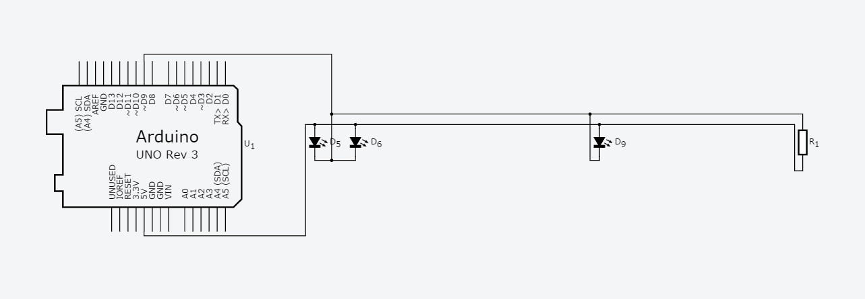
- 修正程式碼

// Pin 13 has an LED connected on most Arduino boards.
// give it a name:
int led = 13;
// the setup routine runs once when you press reset:
void setup() {
// initialize the digital pin as an output.
pinMode(led, OUTPUT);
}
// the loop routine runs over and over again forever:
void loop() {
digitalWrite(led, HIGH); // turn the LED on (HIGH is the voltage level)
delay(2000); // wait for a second
digitalWrite(led, LOW); // turn the LED off by making the voltage LOW
delay(2000); // wait for a second
}

