movl $1, %eax

movl $10, %ebx

addl %ebx, %eax

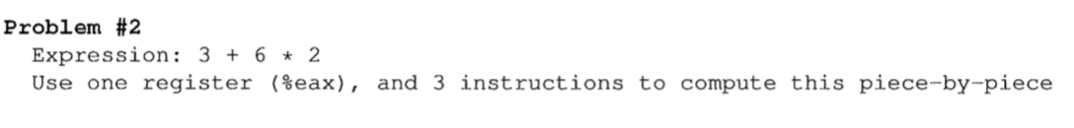

movl $6, %eax

imull %2, %eax

addl %3, %eax

|  |  |
| --- | --- |
|  | [ %edx 0 ]  [ %eax 7 ]  [ %ebx 3 ]  7 / 3 = 2….1 -> [ %eax quatint 2 ] [ %edx remainder 1 ]  [ %ecx 2 ]  [ %edx 0 ]  [ %eax 9 ]  [ %ebx 2 ]  9/ 2 = 4….1 -> [ %eax quatint 4 ] [ %edx remainder 1 ]  [ %eax 1 ]  2 + 1 = 3 -> [ %ecx 3 ] |

|  |  |
| --- | --- |
|  | 100  AB  108  FF  ~~104~~ AB  11  ~~264~~ 108->13 (decimal to hex)  FF  11 |

|  |  |
| --- | --- |
|  | addl $4, %esp  movl, $10, (%esp)  pushl $10 |

addl $4, %esp

movl $10, (%esp) / pushl $10

movl (%esp), %ecx / popl %ecx

addl $5, %ecx

movl ~~(~~%ecx~~)~~, %eax

subl $4, %esp