|  |
| --- |
|  |
| The Specification |
| [Type the document subtitle] |
|  |
| **[Your Name]** |
| **[Pick the date]** |

[Type the abstract of the document here. The abstract is typically a short summary of the contents of the document. Type the abstract of the document here. The abstract is typically a short summary of the contents of the document.]

Table of Contents

[To update the table of contents, right click the message below and select Update Field (F9 on PC, ⌥⌘U on Mac).]

**No table of contents entries found.**

1. Pages
   1. Page Tree

Server  
 Kamel 3.1.1  
 1 Login  
 2.1 Dashboard - TestStation Status  
 2.2 Dashboard - PO Status  
 2.3 Dashboard - SPC  
 3.1 Work Order Management － Testing  
 3.2 Work Order Management － Packaging  
 4.1 Quality traceability － VNA  
 4.1.1 Quality traceability － VNA - Report  
 4.2 Quality traceability － PIM  
 4.2.1 Quality traceability - PIM - Report  
 4.3 Quality traceability - Report - index  
 4.3.1 Quality traceability - Report - Details  
 5.1 System User - Group  
 5.1.1 System User - Group － Add  
 5.1.2 System User - Group － Edit  
 5.2 System User - User  
 5.2.1 System User - User － Add  
 5.2.2 System User - User － Edit  
 New Page 1  
 6.1 Testing Management - ProductType  
 6.1.1 Testing Management - ProductType - Add  
 6.1.2 Testing Management - ProductType - Edit  
 6.2 Testing Management - TestItem  
 6.2.1 Testing Management - TestItem - Add  
 6.2.2 Testing Management - TestItem - Edit  
 6.3 Testing Management - TestStation  
 6.3.1 Testing Management - TestStation - Add  
 6.3.2 Testing Management - TestStation - Edit  
 6.4 Testing Management - TestEquipment  
 6.4.1 Testing Management - TestStation - Add  
 6.4.2 Testing Management - TestStation - Edit  
 6.5 Testing Management - Authorization  
 6.5.1 Testing Management - Authorization - Add  
 6.5.2 Testing Management - Authorization - Edit  
 6.6 Testing Management - Department  
 6.6.1 Testing Management - Department - Add  
 6.6.2 Testing Management - Department - Edit  
 6.7 Testing Management - Tester  
 6.7.1 Testing Management - Tester - Add  
 6.7.2 Testing Management - Tester - Edit  
 6.8 Testing Management - TestConfig  
 6.8.1 Testing Management - TestConfig - Add  
 6.8.2 Testing Management - TestConfig - state_file  
 7.1 File Management - View  
 7.2 File Management - Add  
 7.3 File Management - Edit  
 Kamel Data Structure  
 Kamel Data Structure (Ref)  
 WebService  
 －－－－－8 Packaging  
 －－－－－Lowen - customer info  
 －－－－－－Testing Management - ProductParaM  
Packaging Application  
 1. Packaging Application Basic V1.0 - Login  
 2. Packaging Application Basic V1.0 － 1  
 3. Packaging Application Basic V1.0 - 2

* 1. Server
  2. Kamel 3.1.1
     1. User Interface

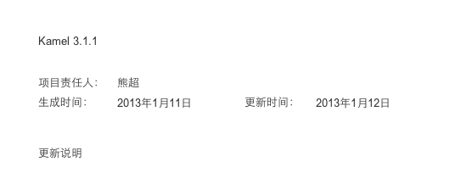

* 1. 1 Login
     1. User Interface

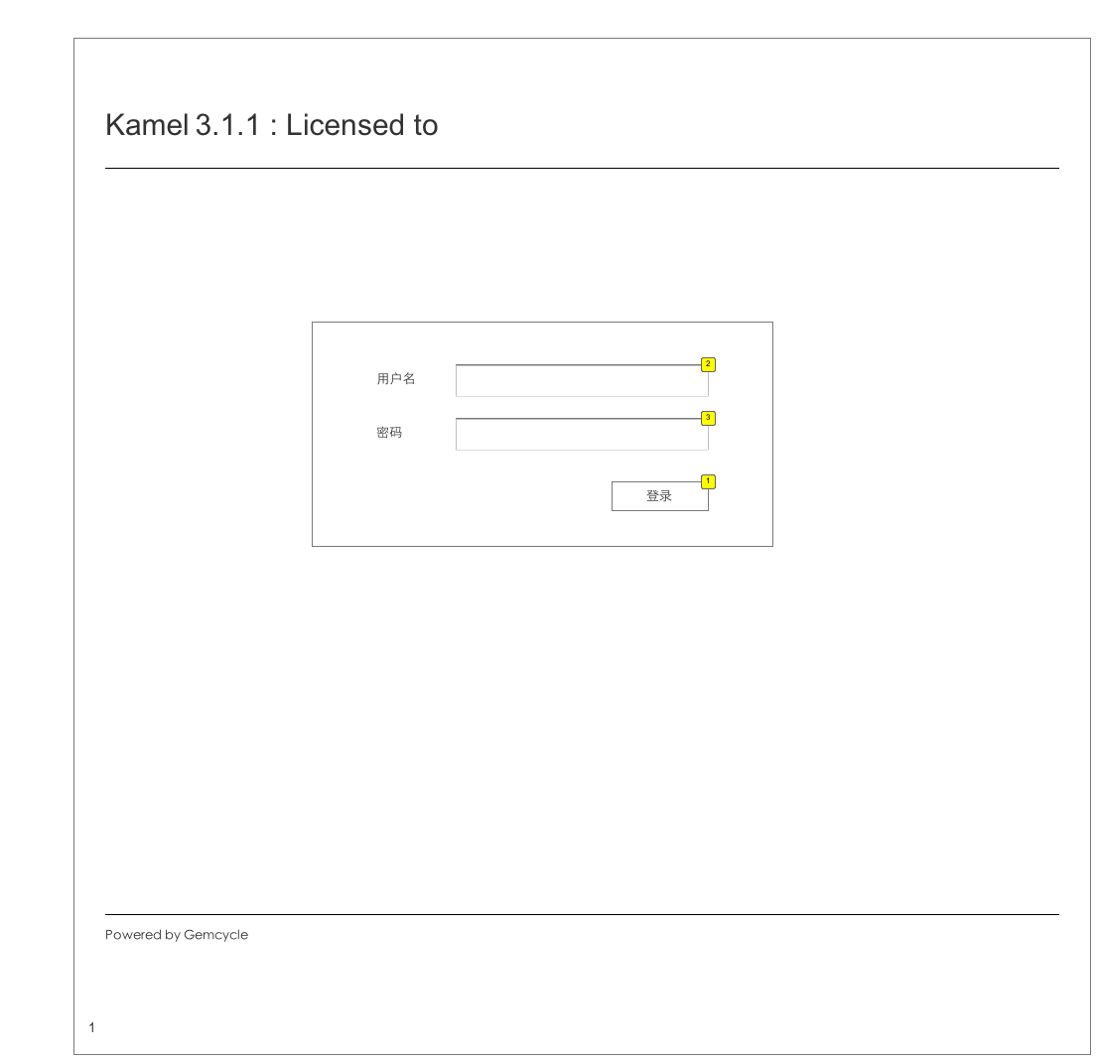

* + 1. Widget Table

| Footnote | Description | Version |
| --- | --- | --- |
| 1 | system_user表 1. 用户名、密码正确，登录系统，进入“生产看板”页面 2. 用户名、密码错误，提示“用户名或密码不正确，请检查！” | ver1-0 |
| 2 | 只允许英文字母、数字 | ver1-0 |
| 3 | 只允许英文字母、数字 | ver1-0 |

* 1. 2.1 Dashboard - TestStation Status
     1. User Interface

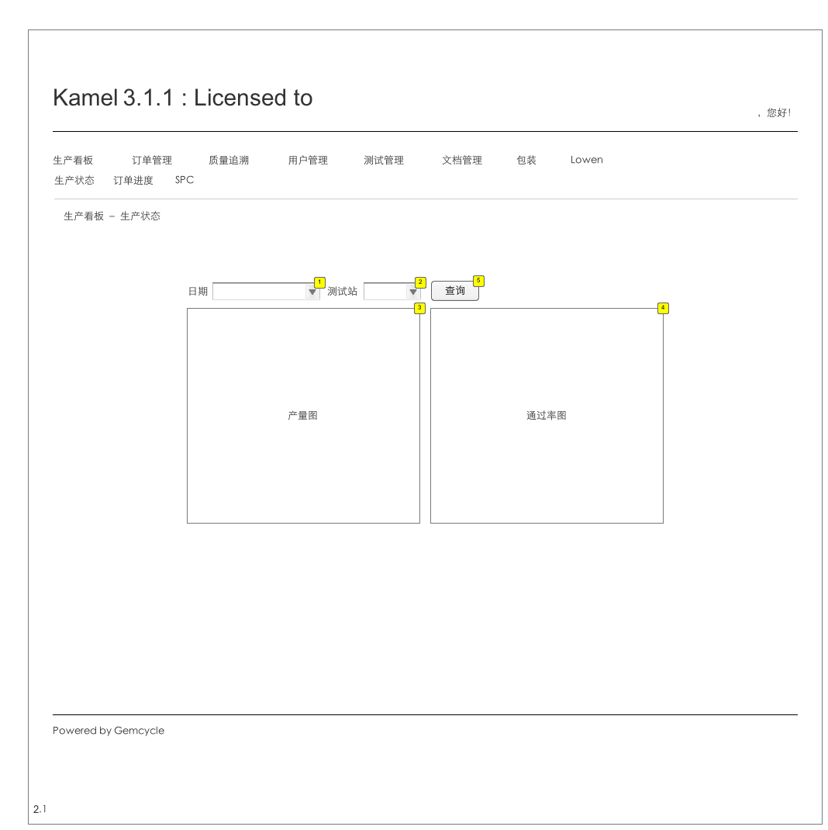

* + 1. Widget Table

| Footnote | Description | Version |
| --- | --- | --- |
| 1 | 日历格式 | ver1-0 |
| 2 | test_station | VER1-0 |
| 3 | 计算单位小时内所有测试站，或某一个测试站，测试过产品的数量。 计算product_test_info.testtime每一个小时内, product_test_info.id的数量，或者符合product_test_info.test_station的数量。  柱状图  x: 24小时制，0-23 y：单位小时内测试数量 |  |
| 4 | 计算单位时间内product_test_info.result=1的数量／总测试数量，或者某测试站product_test_info.result=1的数量／该测试站tai时间内测试的总数量。  折线图  x：24小时制，0-23 y：单位小时内pass数量／总数量 | ver1-0 |
| 5 |  | 点击开始依据条件开始计算，刷新下图， |

* 1. 2.2 Dashboard - PO Status
     1. User Interface

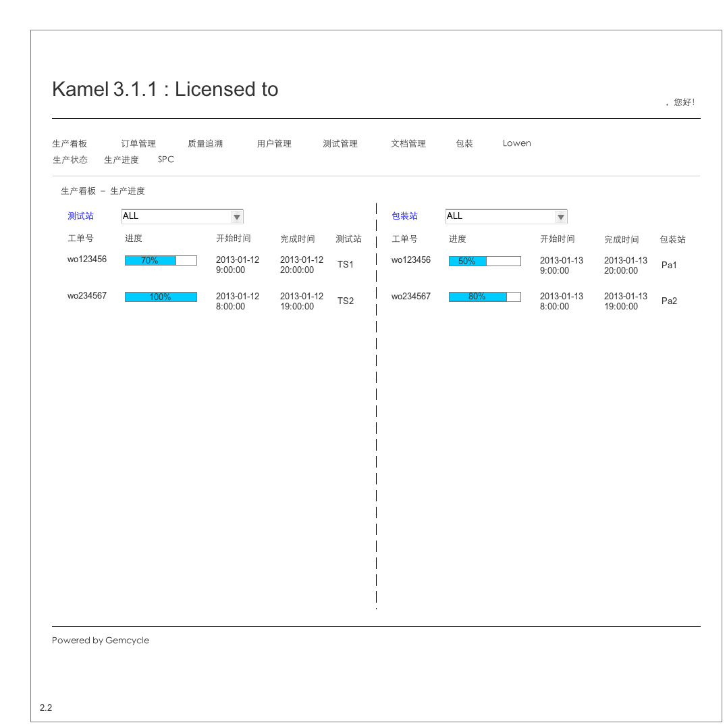

* 1. 2.3 Dashboard - SPC
     1. User Interface

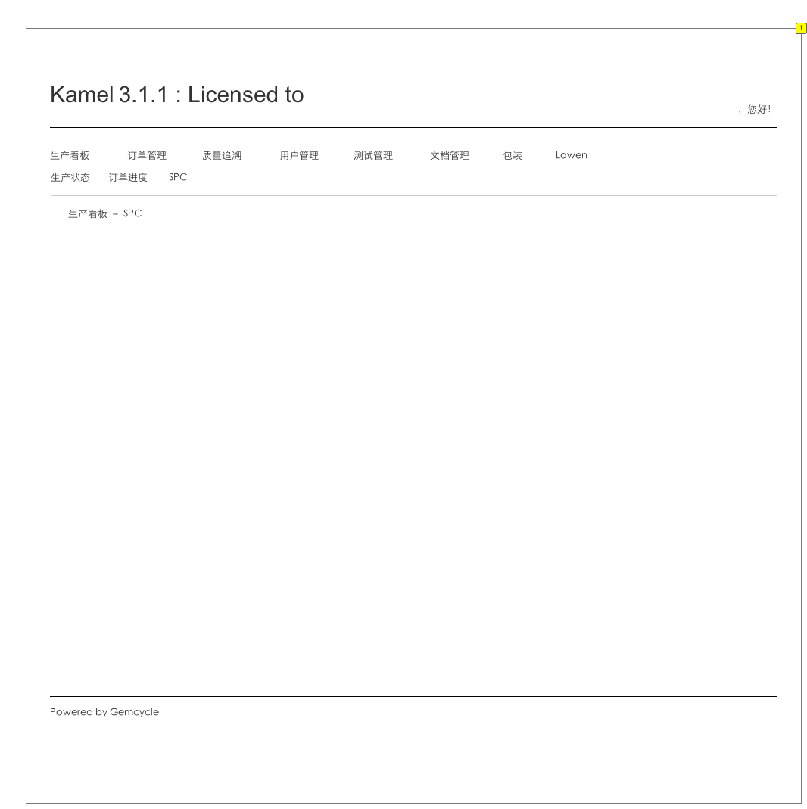

* + 1. Widget Table

| Footnote | Version |
| --- | --- |
| 1 | verX |

* 1. 3.1 Work Order Management － Testing
     1. User Interface

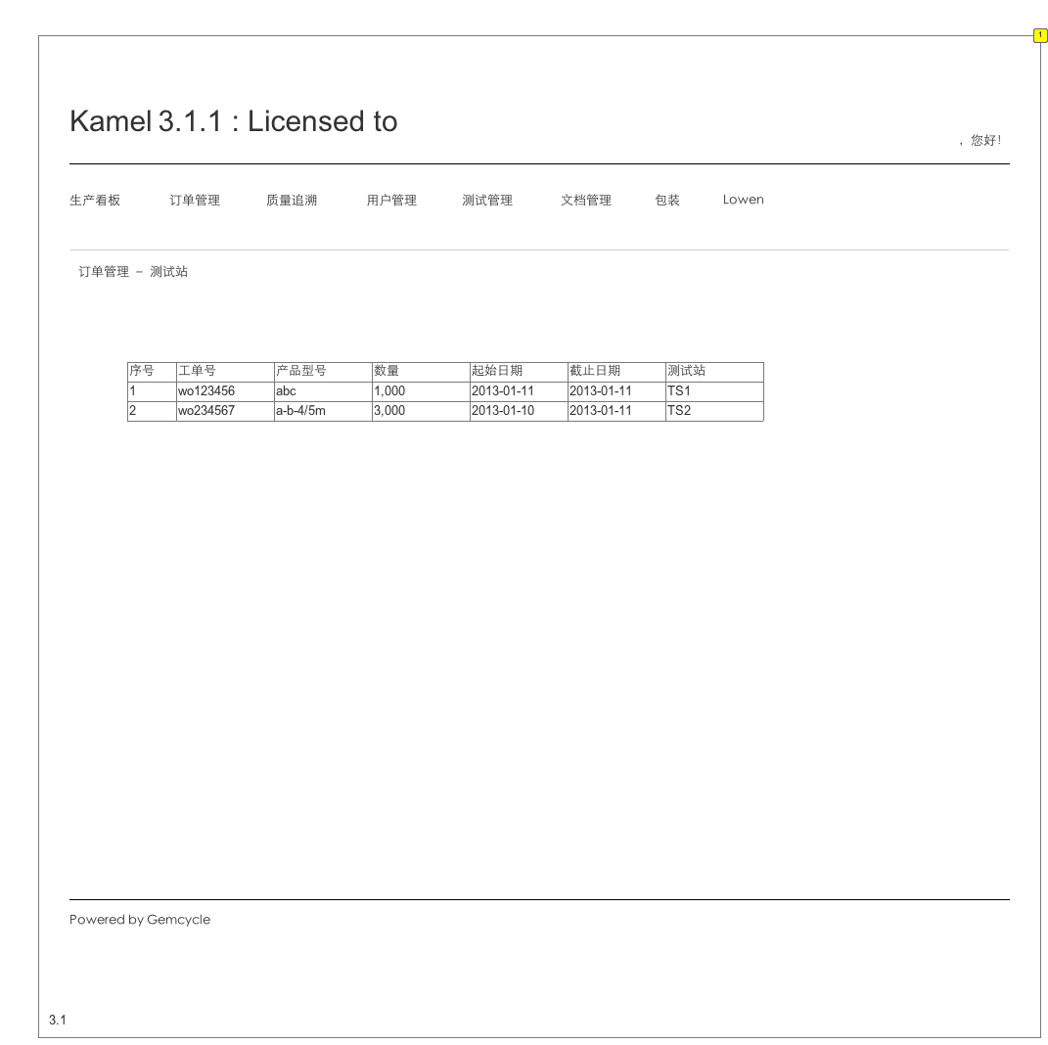

* + 1. Widget Table

| Footnote | Version |
| --- | --- |
| 1 | ver2-0 |

* 1. 3.2 Work Order Management － Packaging
     1. User Interface

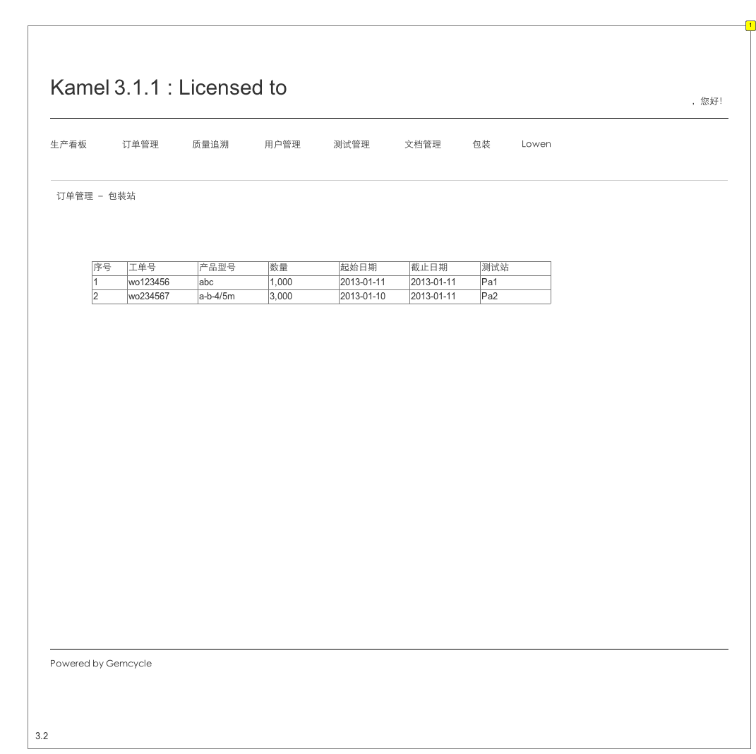

* + 1. Widget Table

| Footnote | Version |
| --- | --- |
| 1 | ver2-0 |

* 1. 4.1 Quality traceability － VNA
     1. User Interface

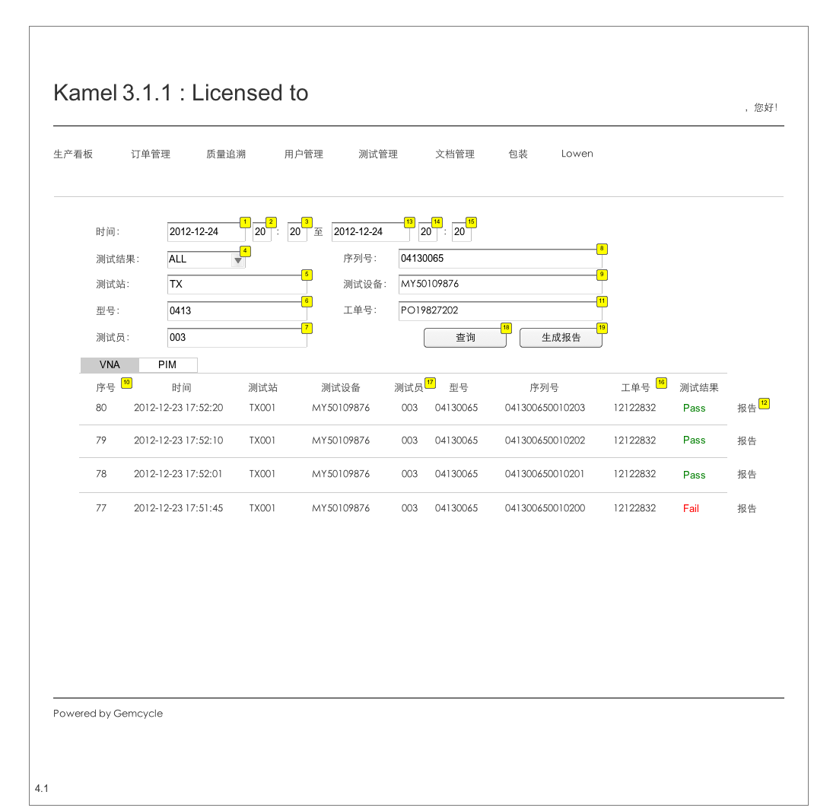

* + 1. Widget Table

| Footnote | Description | Version |
| --- | --- | --- |
| 1 | 日历形式选择日期。默认值1900-01－01。不显示。 | ver1-0 |
| 2 | 下拉菜单选择，0-23。默认选择00。不显示。 | ver1-0 |
| 3 | 下拉菜单选择，0-59，默认选择00。不显示。 | ver1-0 |
| 4 | PASS, FAIL, ALL。默认选择ALL。 | ver1-0 |
| 5 | 模糊搜索。product_test_info.test_station, test_station.name | ver1-0 |
| 6 | 模糊搜索。product_test_info.product_type, product_type | VER1-0 |
| 7 | 模糊搜索。product_test_info.tester, tester | ver1-0 |
| 8 | 模糊搜索。product_test_info.sn | VER1-0 |
| 9 | 模糊搜索。product_test_info.equipmentSN | VER1-0 |
| 10 | 记录序号，显示时倒序排列，时间近的排在前面。 |  |
| 11 |  | ver2-0 |
| 12 | 生成页面4.1 | VER1-0 |
| 13 | 日历形式选择日期。默认选择2999-01－01。不显示。 | ver1-0 |
| 14 | 下拉菜单选择，0-23。默认选择00。不显示。 |  |
| 15 | 下拉菜单选择，0-59，默认选择00。不显示。 |  |
| 16 |  | ver2-0 |
| 17 | 显示tester.name |  |
| 18 | 查询并显示符合条件的结果 | ver1-0 |
| 19 | 生成查询得到结果的报告。4.3 | ver1-0 |

* 1. 4.1.1 Quality traceability － VNA - Report
     1. User Interface

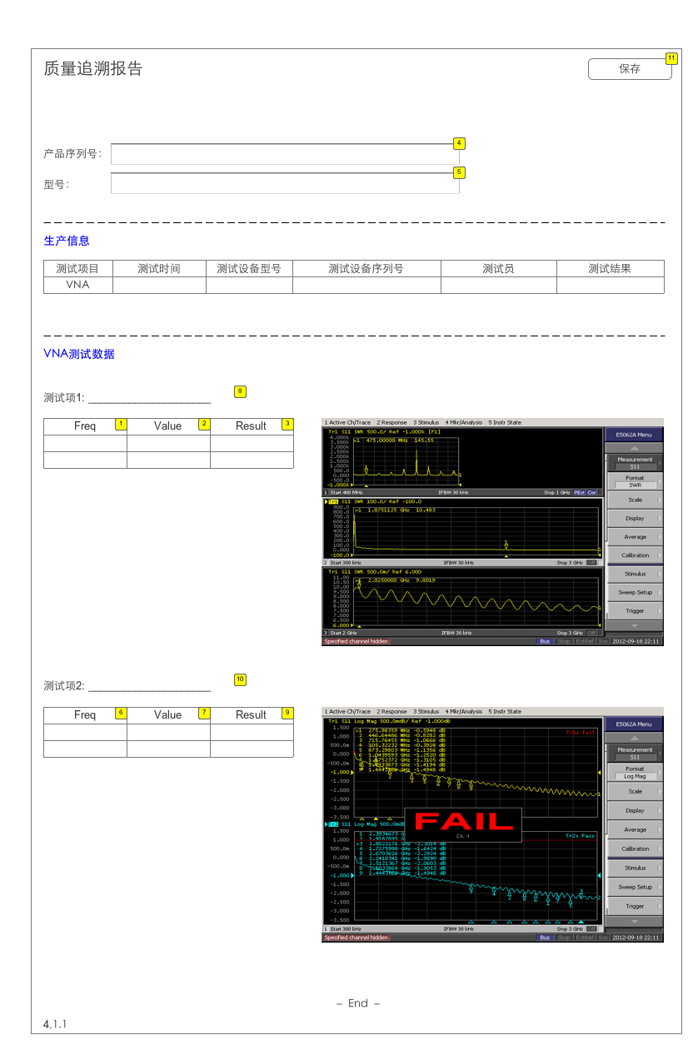

* + 1. Widget Table

| Footnote | Description | Version |
| --- | --- | --- |
| 1 | x值 | VER1-0 |
| 2 | y值 | VER1-0 |
| 3 | 测试结果，PASS or Fail |  |
| 4 | 产品序列号 | VER1-0 |
| 5 | 产品型号 | VER1-0 |
| 6 | x值 | VER1-0 |
| 7 | y值 | VER1-0 |
| 8 | 显示测试项名称 | VER1-0 |
| 9 | 测试结果，PASS or Fail |  |
| 10 | 显示测试项名称 | VER1-0 |
| 11 | 保存为pdf文件 | ver1-0 |

* 1. 4.2 Quality traceability － PIM
     1. User Interface

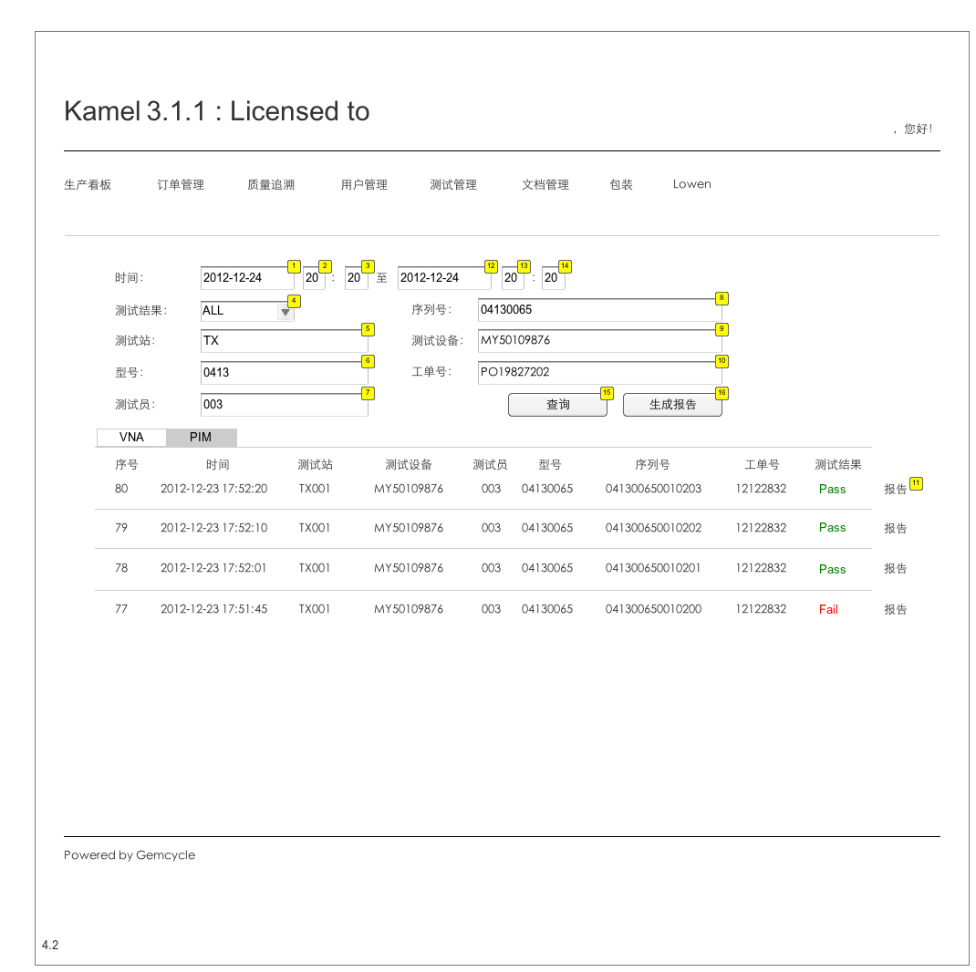

* + 1. Widget Table

| Footnote | Description | Version |
| --- | --- | --- |
| 1 | 日历形式选择日期。默认值1900-01－01。不显示。 | ver1-0 |
| 2 | 下拉菜单选择，0-23。默认选择00。不显示。 | ver1-0 |
| 3 | 下拉菜单选择，0-59，默认选择00。不显示。 | ver1-0 |
| 4 | PASS, FAIL, ALL。默认选择ALL。 | VER1-0 |
| 5 | 模糊搜索 | VER1-0 |
| 6 | 模糊搜索 | VER1-0 |
| 7 | 模糊搜索 | VER1-0 |
| 8 | 模糊搜索 | VER1-0 |
| 9 | 模糊搜索 | VER1-0 |
| 10 | 模糊搜索 | VER1-0 |
| 11 | 生成页面4.1 | VER1-0 |
| 12 | 日历形式选择日期。默认选择2999-01－01。不显示。 | ver1-0 |
| 13 | 下拉菜单选择，0-23。默认选择00。不显示。 |  |
| 14 | 下拉菜单选择，0-59，默认选择00。不显示。 |  |
| 15 | 查询并显示符合条件的结果 | ver1-0 |
| 16 | 生成查询得到结果的报告。4.3 | ver1-0 |

* 1. 4.2.1 Quality traceability - PIM - Report
     1. User Interface

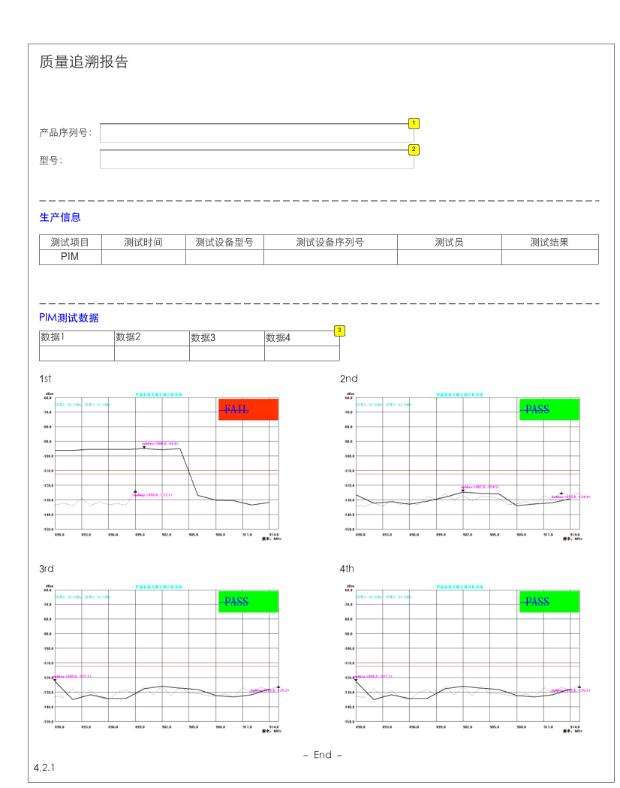

* + 1. Widget Table

| Footnote | Description | Version |
| --- | --- | --- |
| 1 | 产品序列号 | VER1-0 |
| 2 | 产品型号 | VER1-0 |
| 3 | 显示每一组测试数据最大值 | VER1-0 |

* 1. 4.3 Quality traceability - Report - index
     1. User Interface

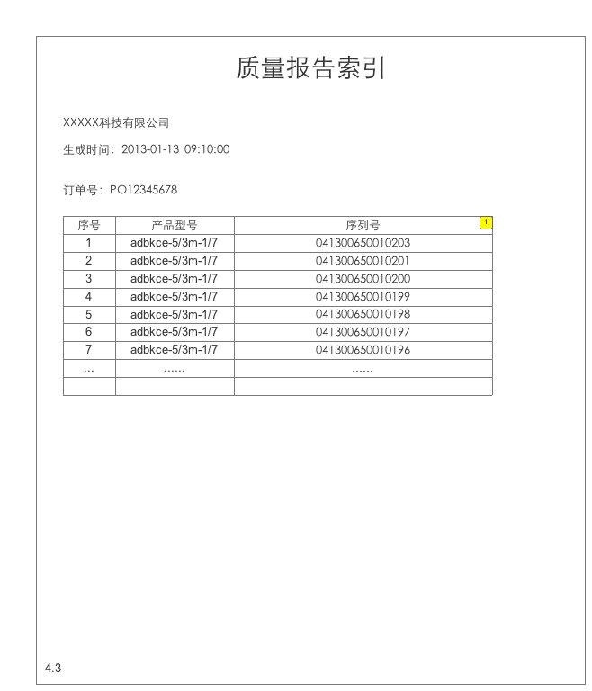

* + 1. Widget Table

| Footnote | Description | Version |
| --- | --- | --- |
| 1 | 打开4.3.1 | ver1-0 |

* 1. 4.3.1 Quality traceability - Report - Details
     1. User Interface

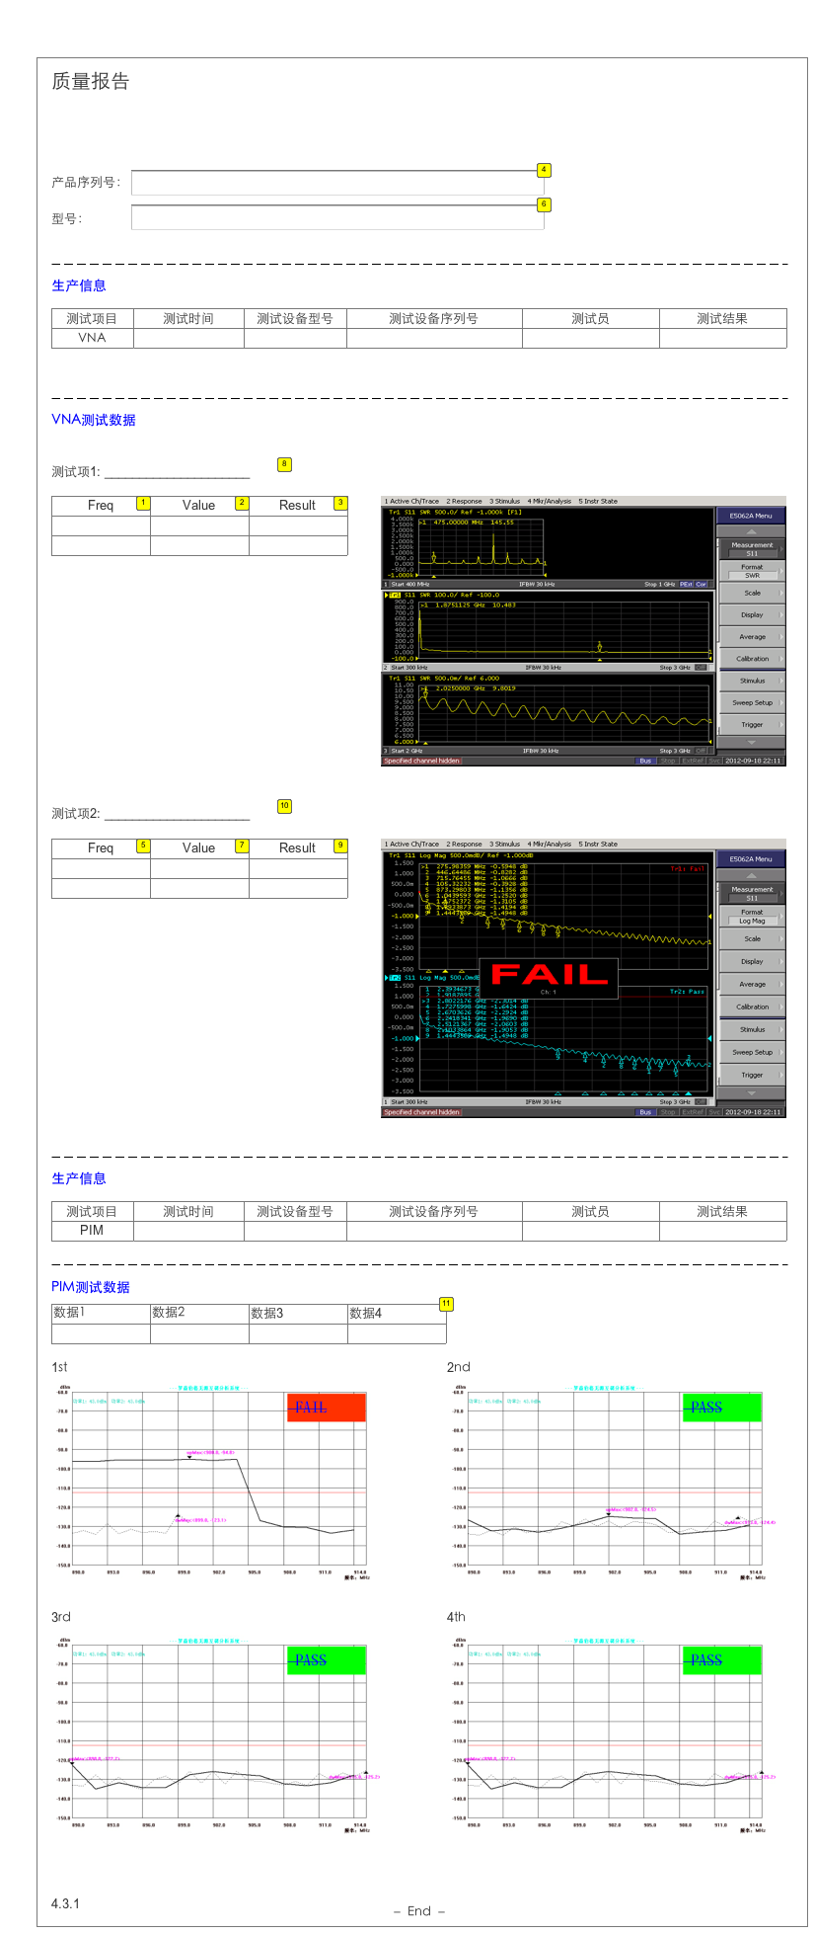

* + 1. Widget Table

| Footnote | Description | Version |
| --- | --- | --- |
| 1 | x值 | VER1-0 |
| 2 | y值 | VER1-0 |
| 3 | 测试结果，PASS or Fail |  |
| 4 | 产品序列号 | VER1-0 |
| 5 | x值 | VER1-0 |
| 6 | 产品型号 | VER1-0 |
| 7 | y值 | VER1-0 |
| 8 | 显示测试项名称 | VER1-0 |
| 9 | 测试结果，PASS or Fail |  |
| 10 | 显示测试项名称 | VER1-0 |
| 11 | 显示每一组测试数据最大值 | VER1-0 |

* 1. 5.1 System User - Group
     1. User Interface

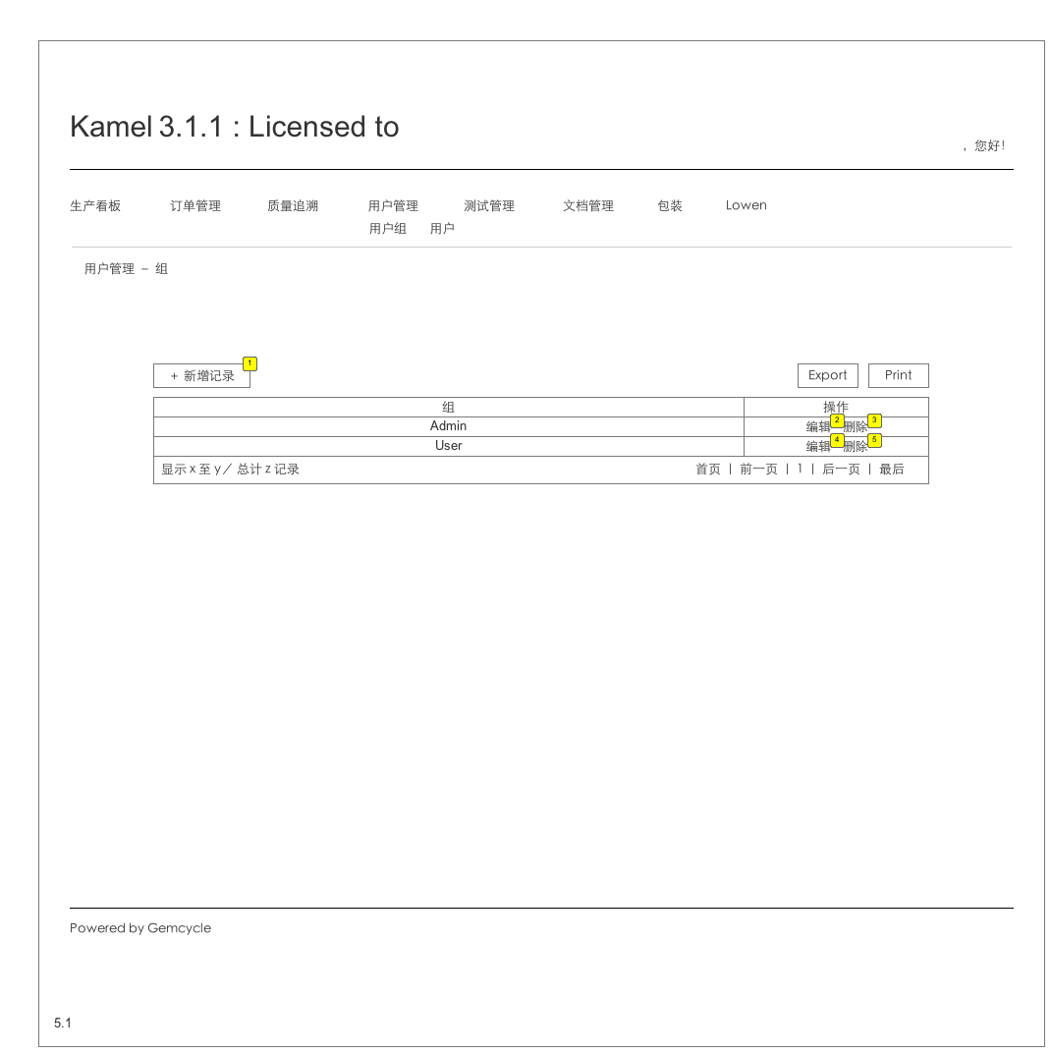

* + 1. Widget Table

| Footnote | Description | Version |
| --- | --- | --- |
| 1 | 转到5.1.1 | VER1-0 |
| 2 | 转到5.1.2 | VER1-0 |
| 3 | 删除本条记录，删除前提示用户是否确定要删除。 | VER1-0 |
| 4 | 转到5.1.2 | VER1-0 |
| 5 | 删除本条记录，删除前提示用户是否确定要删除。 | VER1-0 |

* 1. 5.1.1 System User - Group － Add
     1. User Interface

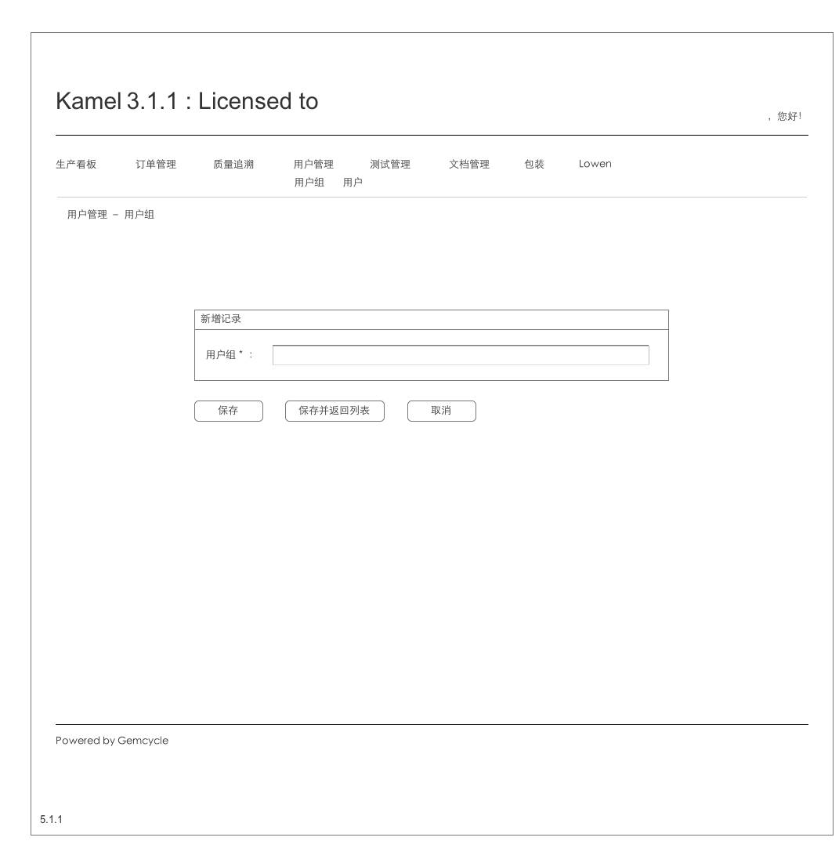

* 1. 5.1.2 System User - Group － Edit
     1. User Interface

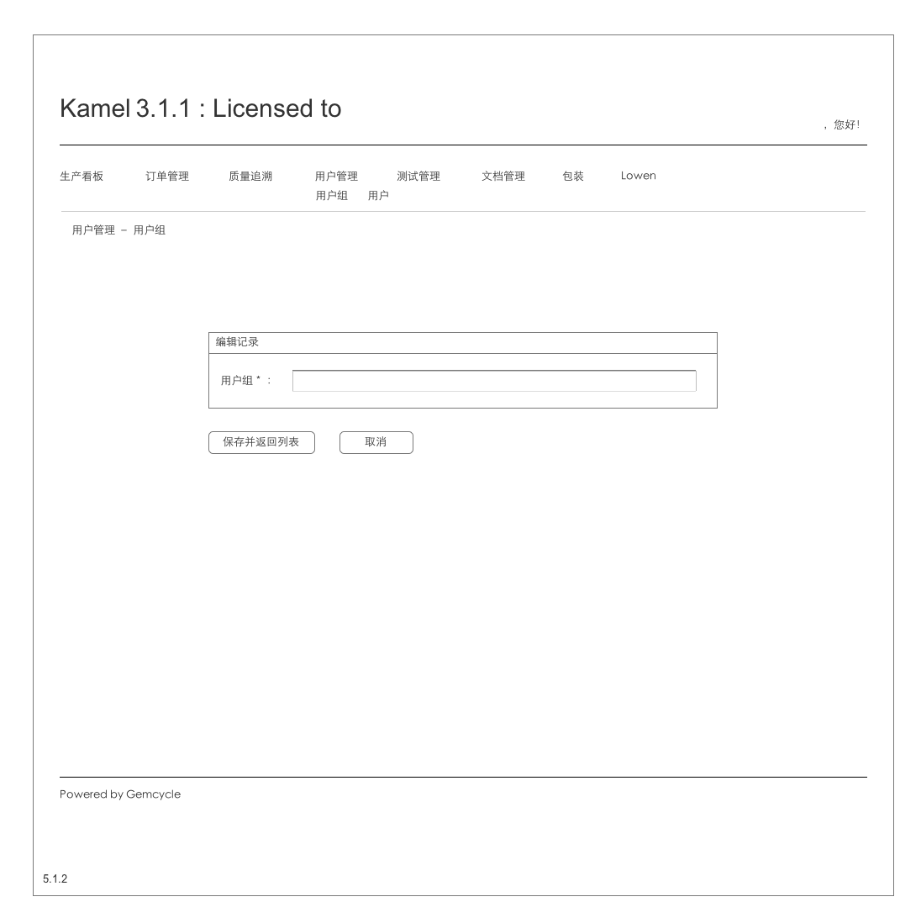

* 1. 5.2 System User - User
     1. User Interface

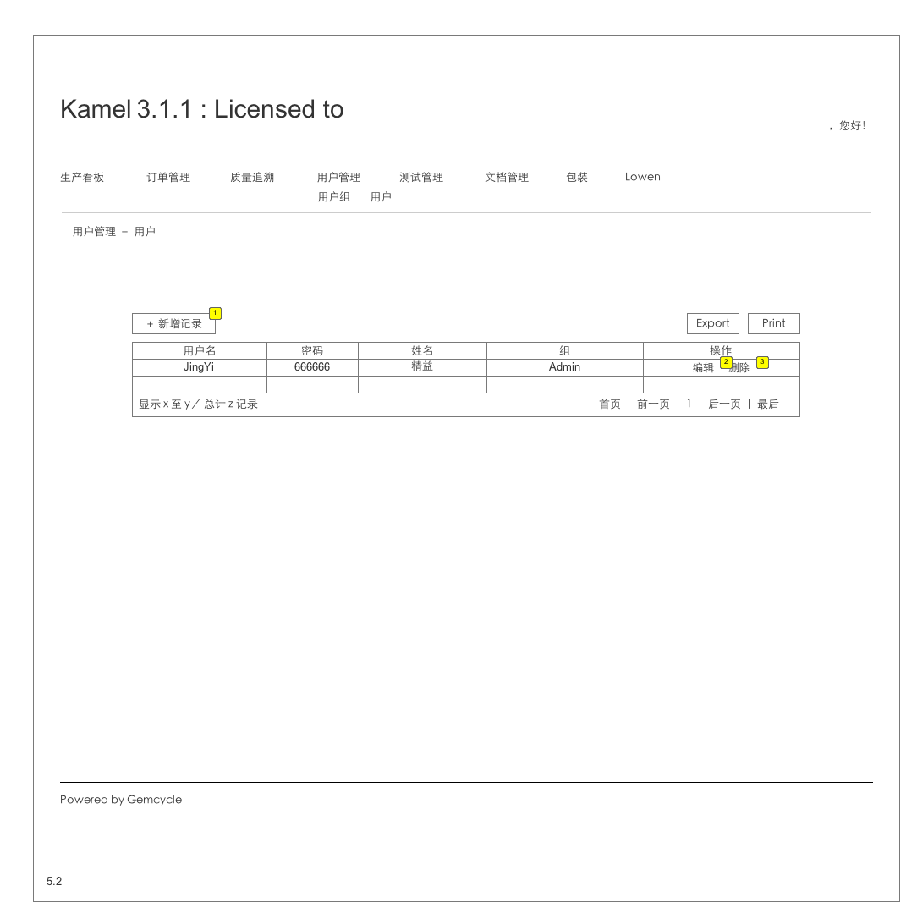

* + 1. Widget Table

| Footnote | Description | Version |
| --- | --- | --- |
| 1 | 转到5.2.1 | VER1-0 |
| 2 | 转到5.2.2 |  |
| 3 | 从SYSTEM_USER中删除该条记录。 | ver1-0 |

* 1. 5.2.1 System User - User － Add
     1. User Interface

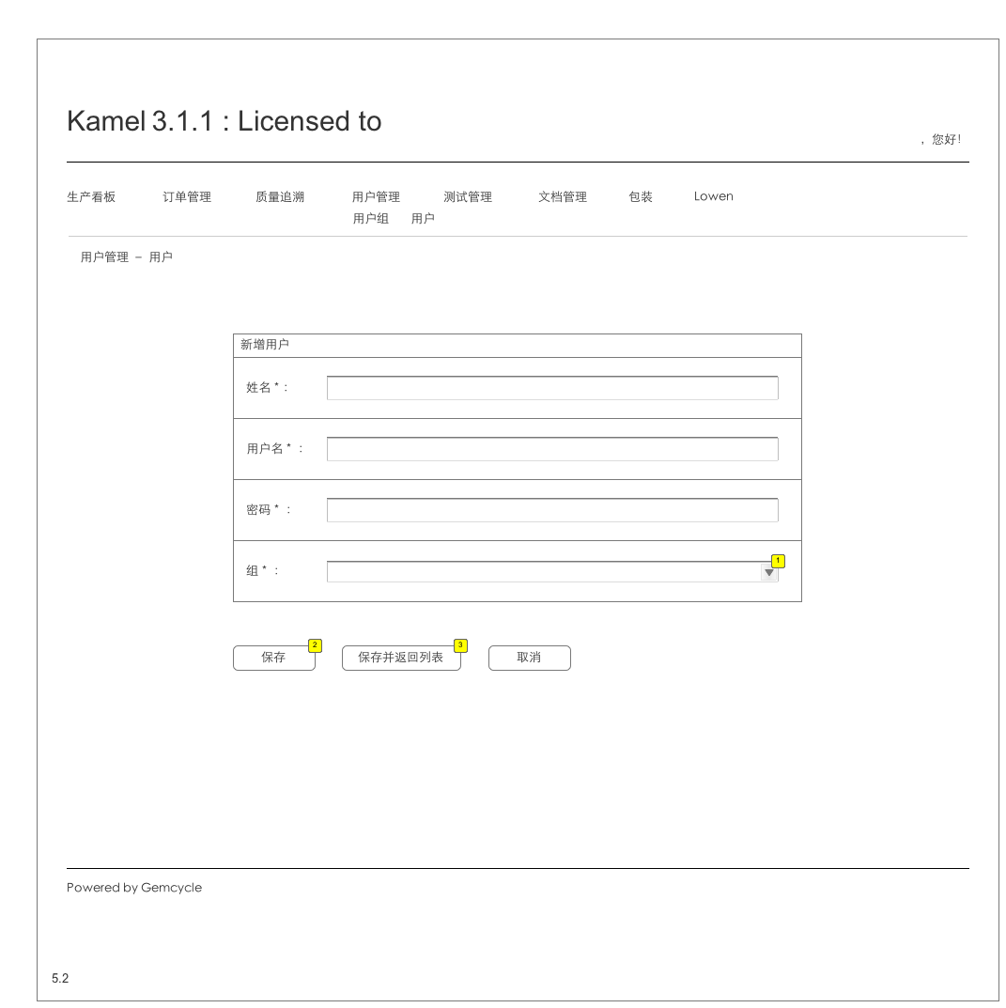

* + 1. Widget Table

| Footnote | Description | Version |
| --- | --- | --- |
| 1 | 读取USER_GROUP | ver1-0 |
| 2 | 插入表SYSTEM_USER，清空输入框，等待新的输入。 | ver1-0 |
| 3 | 插入SYSTEM_USER，返回5.2 |  |

* 1. 5.2.2 System User - User － Edit
     1. User Interface

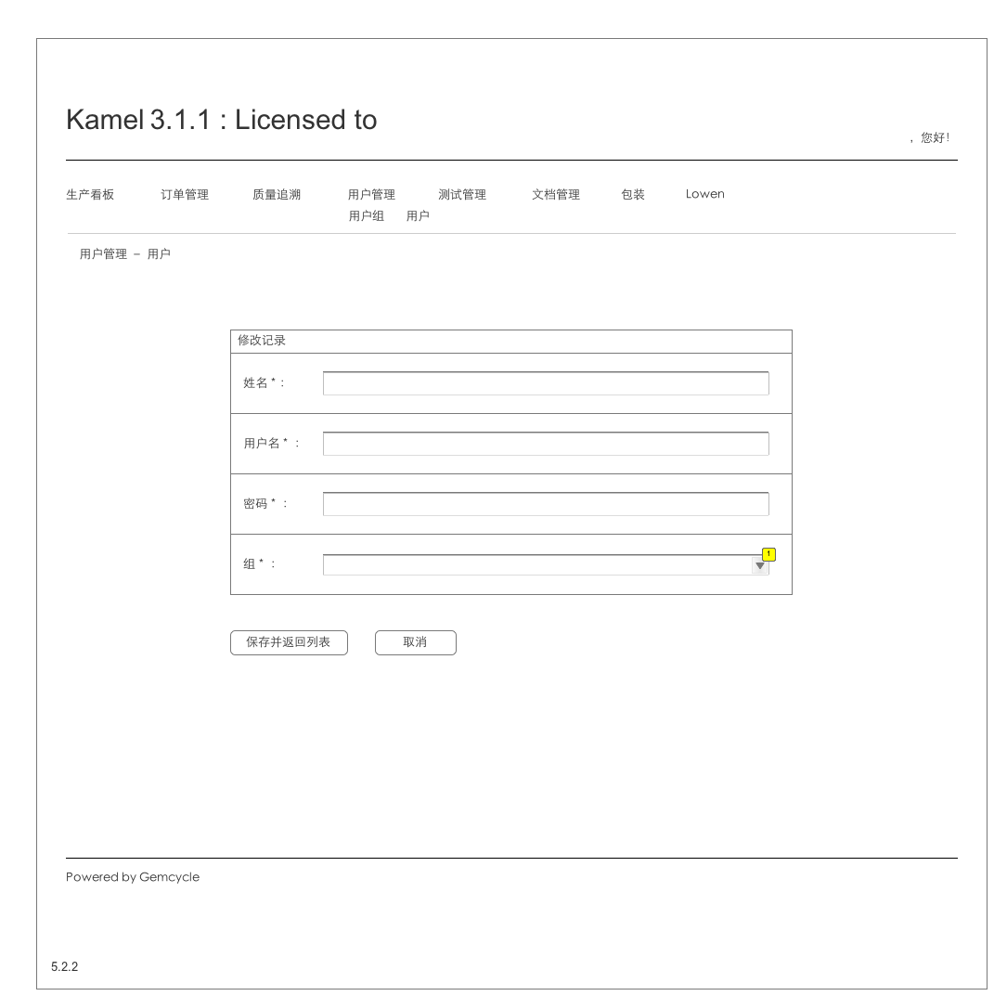

* + 1. Widget Table

| Footnote | Description | Version |
| --- | --- | --- |
| 1 | 读取USER_GROUP | ver1-0 |

* 1. New Page 1
  2. 6.1 Testing Management - ProductType
     1. User Interface

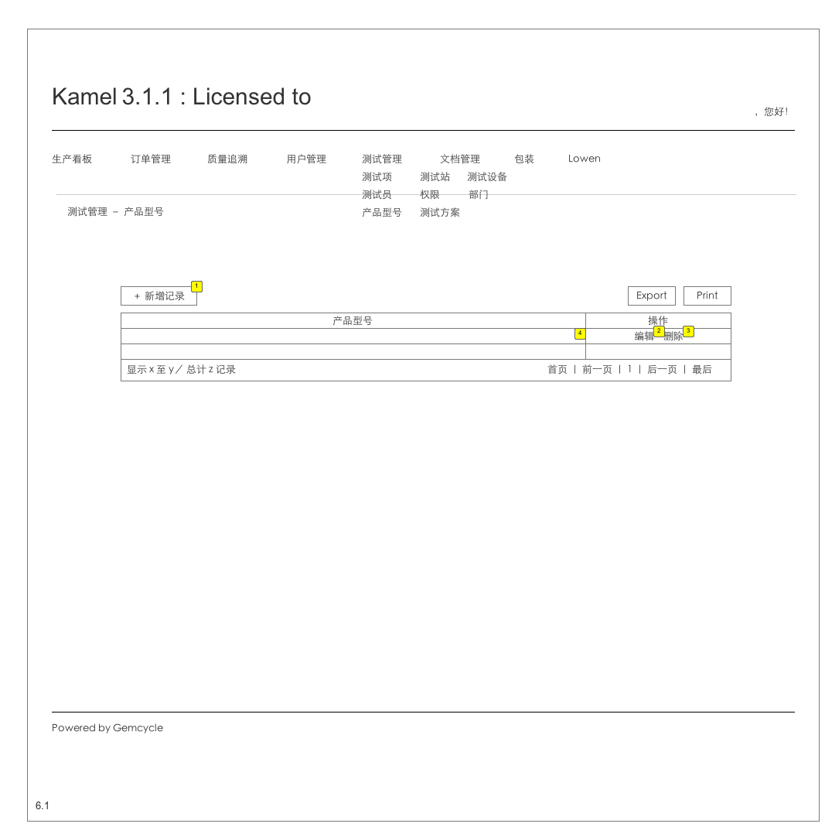

* + 1. Widget Table

| Footnote | Description | Version |
| --- | --- | --- |
| 1 | 转到6.1.1 | VER1-0 |
| 2 | 转6.1.2 | VER1-0 |
| 3 | 删除本条记录，删除前提示用户是否确定要删除。 | VER1-0 |
| 4 | 字符串，product_type表 | ver1-0 |

* 1. 6.1.1 Testing Management - ProductType - Add
     1. User Interface

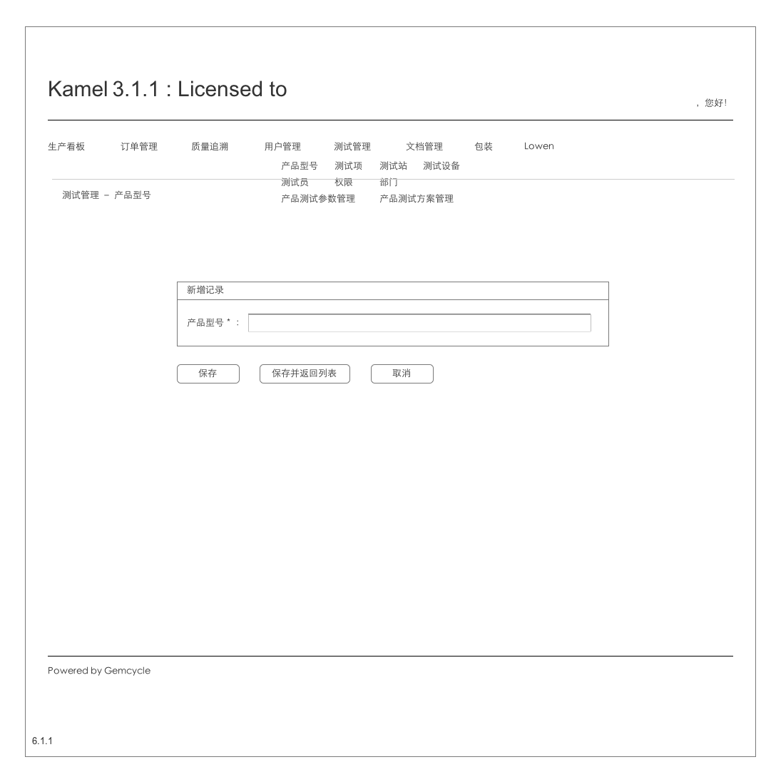

* 1. 6.1.2 Testing Management - ProductType - Edit
     1. User Interface

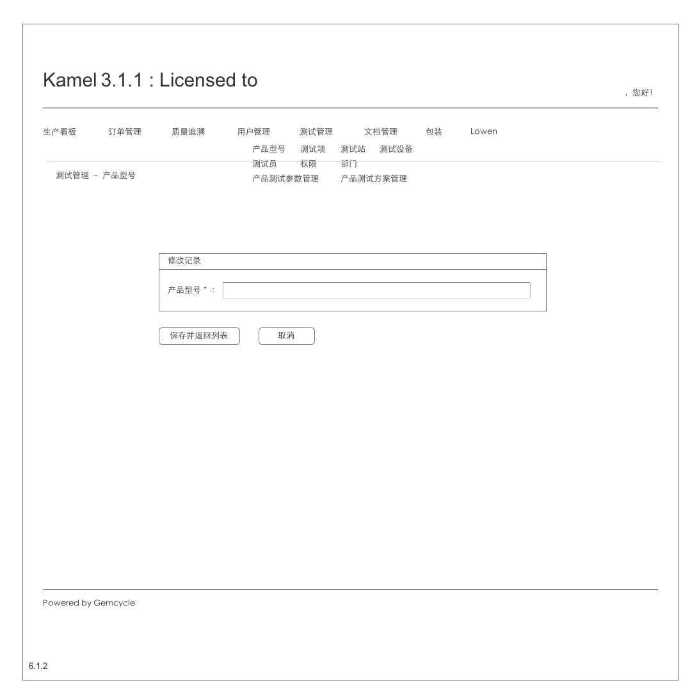

* 1. 6.2 Testing Management - TestItem
     1. User Interface

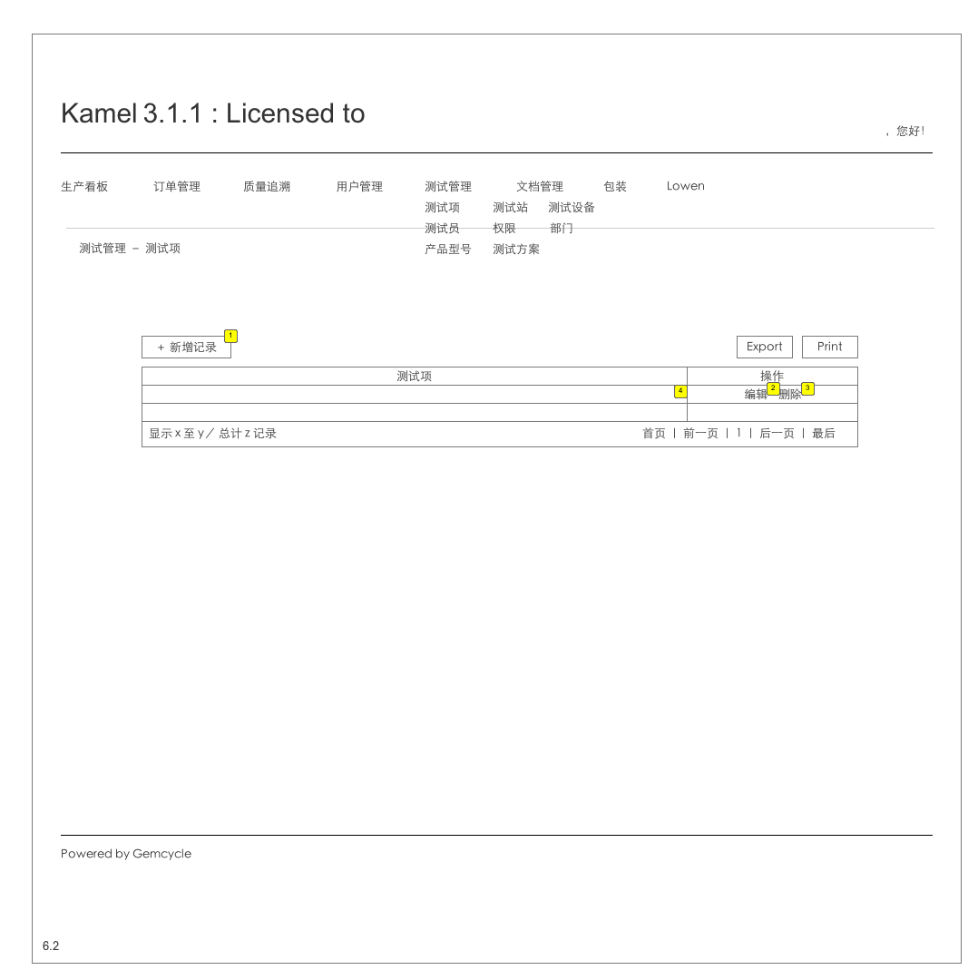

* + 1. Widget Table

| Footnote | Description | Version |
| --- | --- | --- |
| 1 | 转到6.2.1 | VER1-0 |
| 2 | 转6.2.2 | VER1-0 |
| 3 | 删除本条记录，删除前提示用户是否确定要删除。 | VER1-0 |
| 4 | 字符串，test_item表 | ver1-0 |

* 1. 6.2.1 Testing Management - TestItem - Add
     1. User Interface

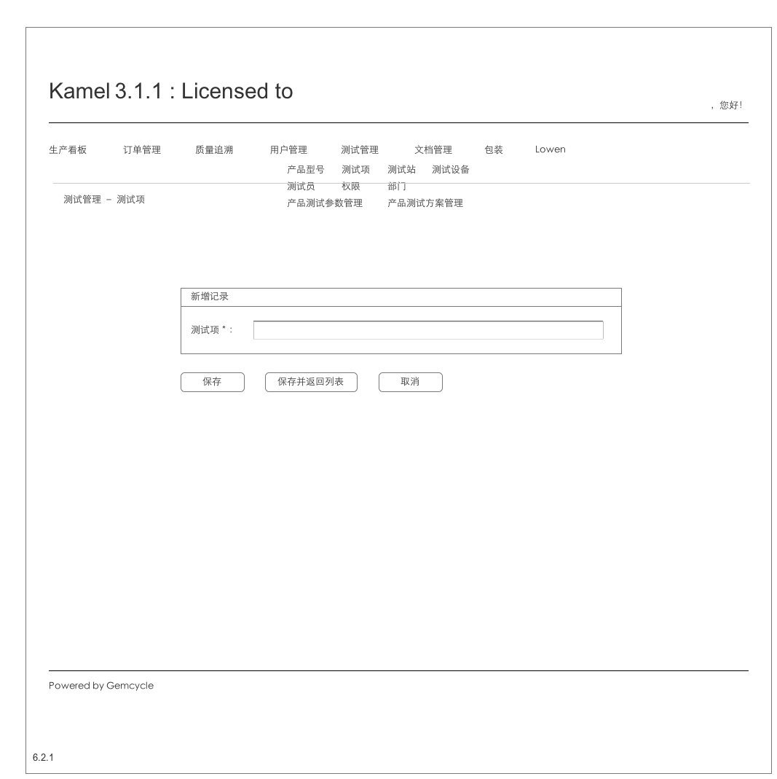

* 1. 6.2.2 Testing Management - TestItem - Edit
     1. User Interface

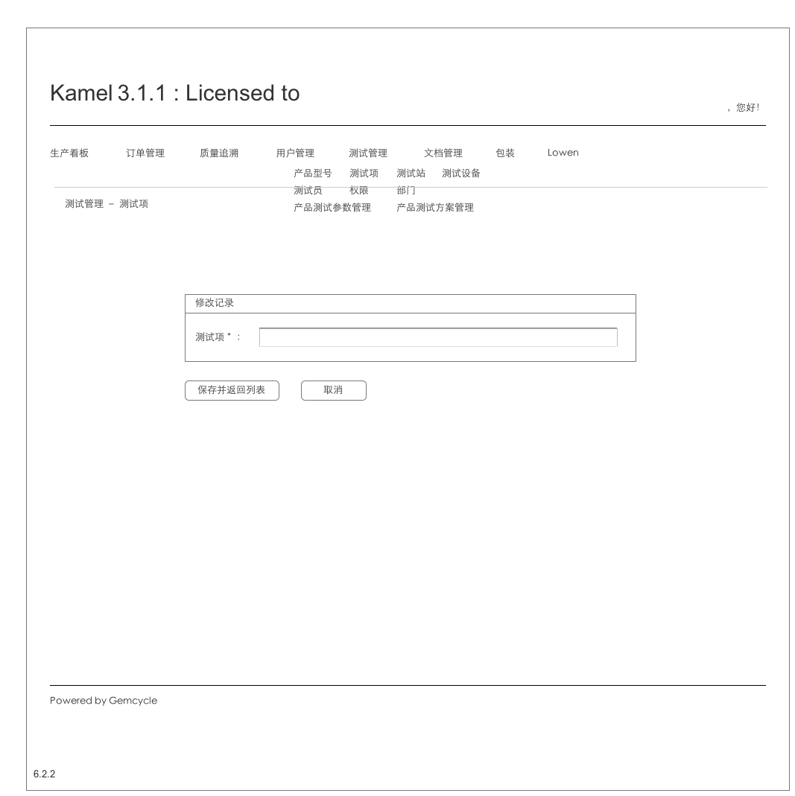

* 1. 6.3 Testing Management - TestStation
     1. User Interface

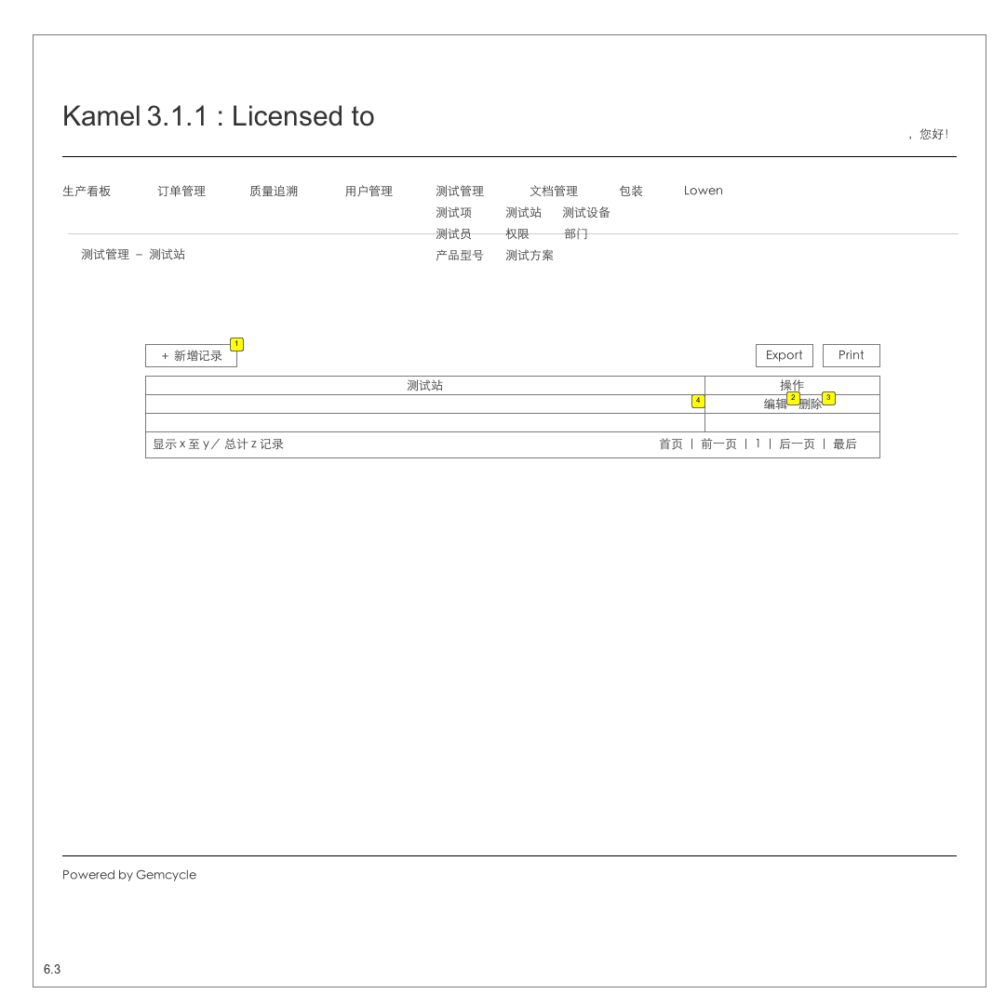

* + 1. Widget Table

| Footnote | Description | Version |
| --- | --- | --- |
| 1 | 转到6.3.1 | VER1-0 |
| 2 | 转6.3.2 | VER1-0 |
| 3 | 删除本条记录，删除前提示用户是否确定要删除。 | VER1-0 |
| 4 | 字符串，test_station表 | ver1-0 |

* 1. 6.3.1 Testing Management - TestStation - Add
     1. User Interface

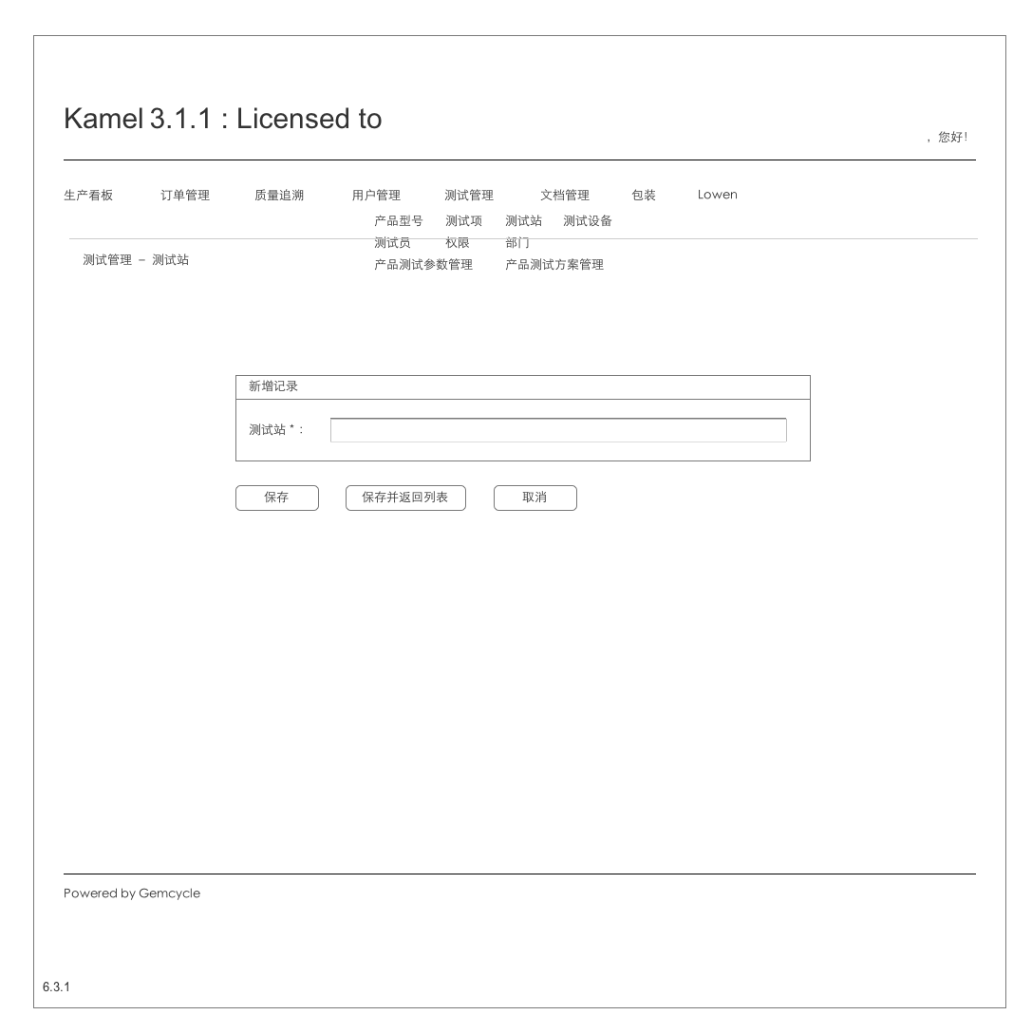

* 1. 6.3.2 Testing Management - TestStation - Edit
     1. User Interface

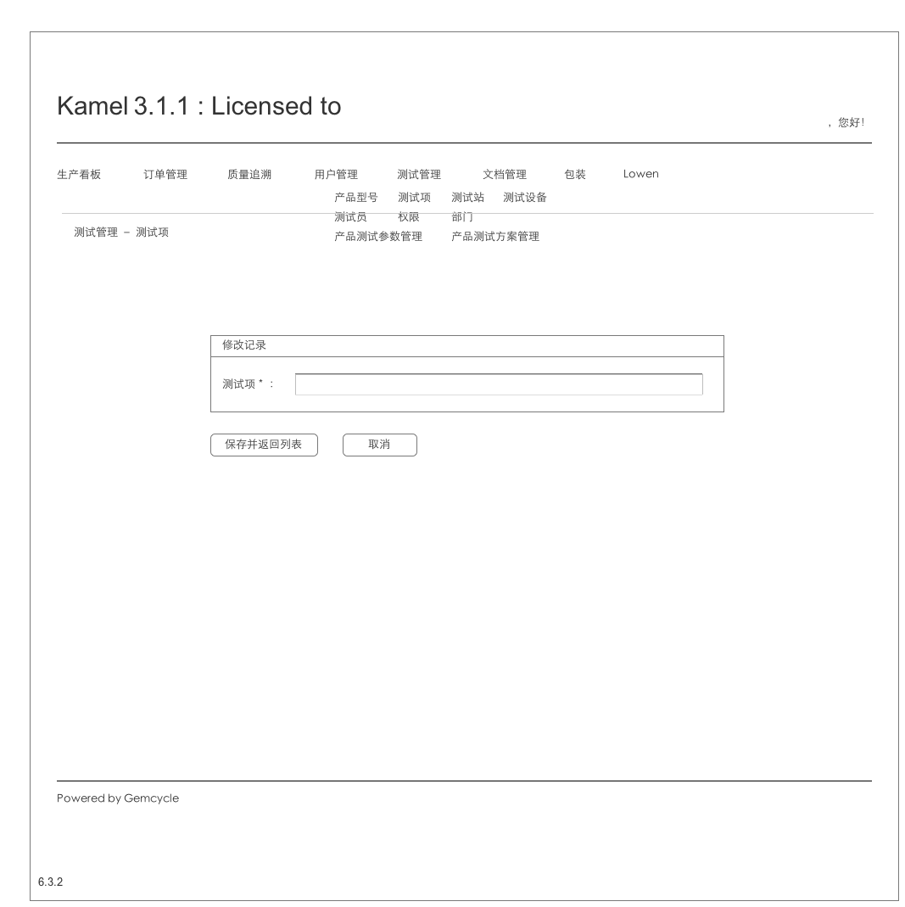

* 1. 6.4 Testing Management - TestEquipment
     1. User Interface

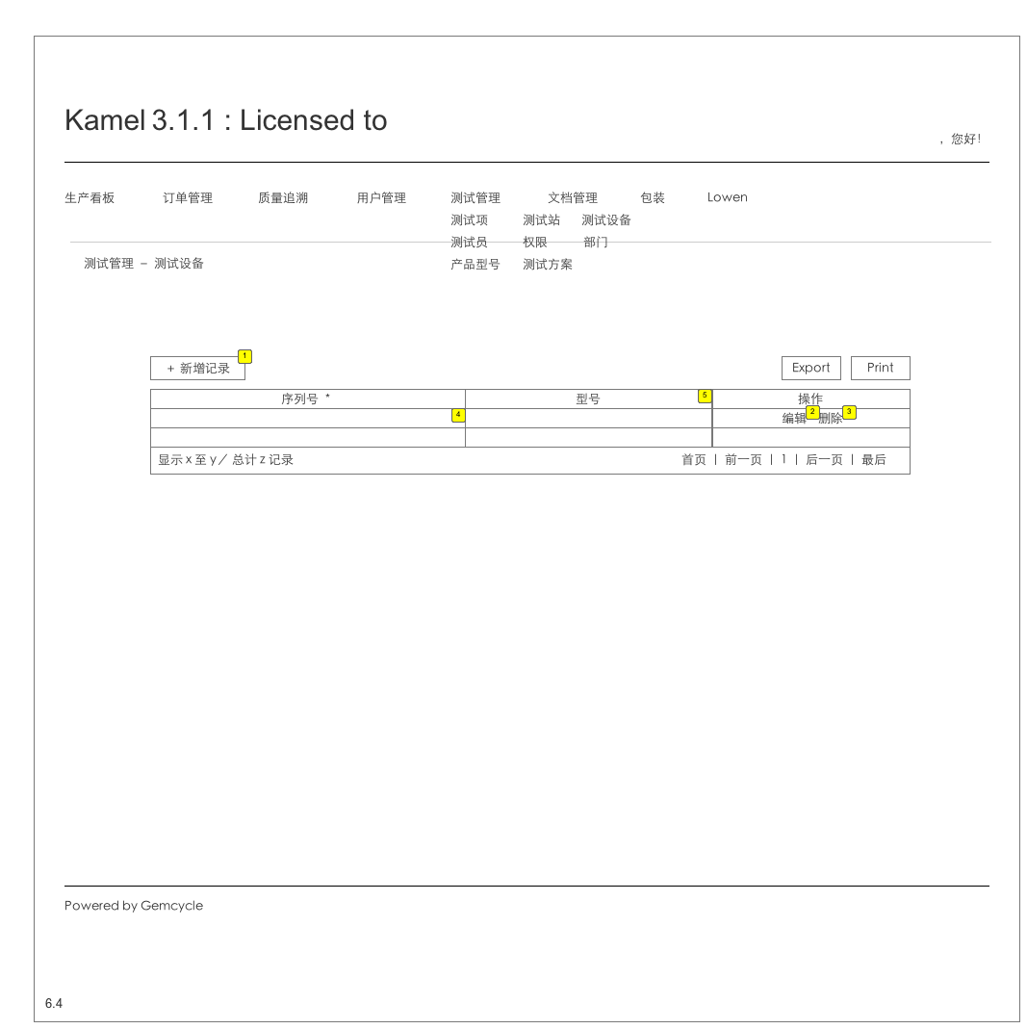

* + 1. Widget Table

| Footnote | Description | Version |
| --- | --- | --- |
| 1 | 转到6.4.1 | VER1-0 |
| 2 | 转6.3.2 | VER1-0 |
| 3 | 删除本条记录，删除前提示用户是否确定要删除。 | VER1-0 |
| 4 | 字符串，test_equipment表 | ver1-0 |
| 5 | 字符串，选填，默认为Null | ver1-0 |

* 1. 6.4.1 Testing Management - TestStation - Add
     1. User Interface

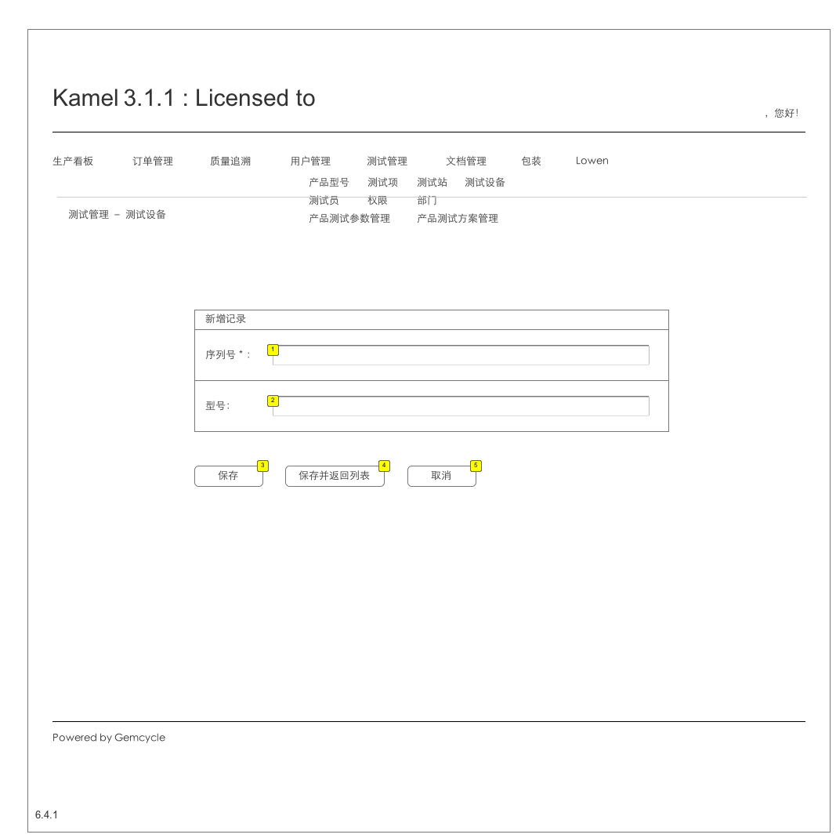

* + 1. Widget Table

| Footnote | Description | Version |
| --- | --- | --- |
| 1 | 必填项 | ver1-0 |
| 2 | 选填项 | ver1-0 |
| 3 | 新记录插入表test_equipment，清空输入项，等待输入新的记录。 | ver1-0 |
| 4 | 新记录插入表test_equipment，返回6.4。 | ver1-0 |
| 5 | 清空输入内容，返回6.4。 | ver1-0 |

* 1. 6.4.2 Testing Management - TestStation - Edit
     1. User Interface

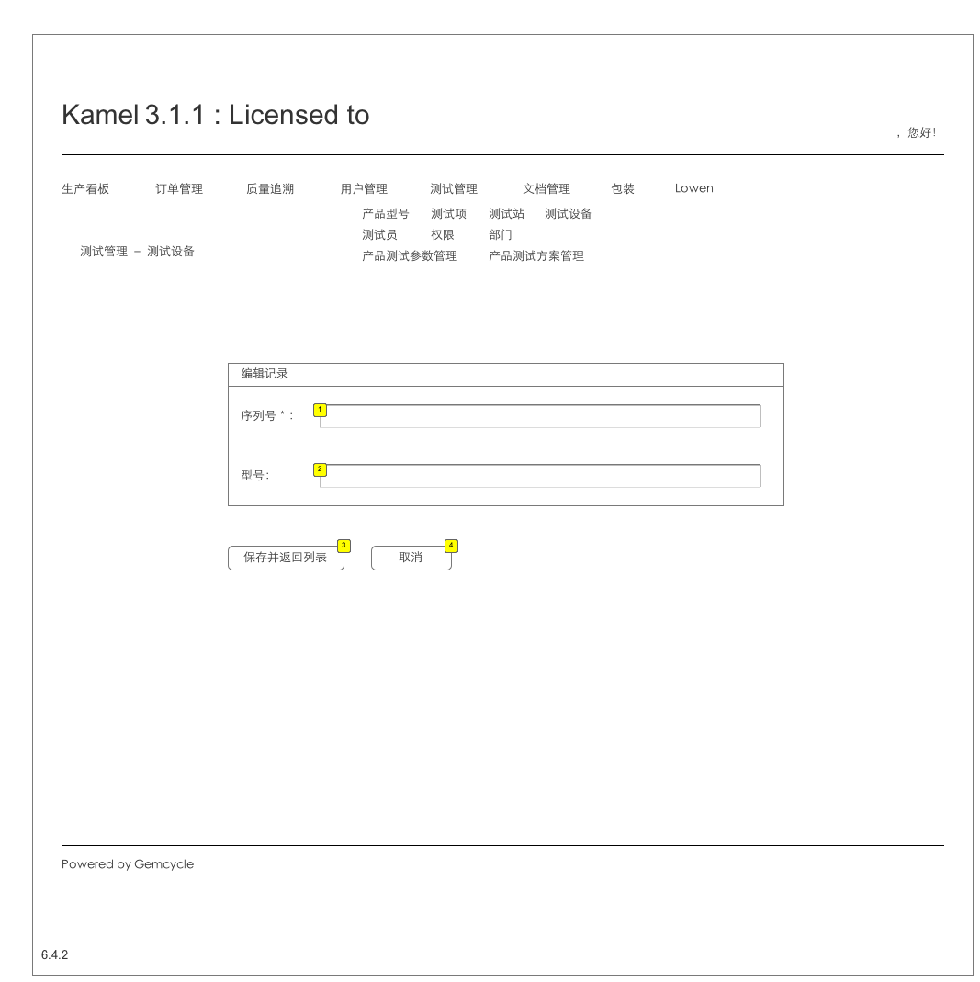

* + 1. Widget Table

| Footnote | Description | Version |
| --- | --- | --- |
| 1 | 必填项 | ver1-0 |
| 2 | 选填项 | ver1-0 |
| 3 | 新记录插入表test_equipment，返回6.4。 | ver1-0 |
| 4 | 清空输入内容，返回6.4。 | ver1-0 |

* 1. 6.5 Testing Management - Authorization
     1. User Interface

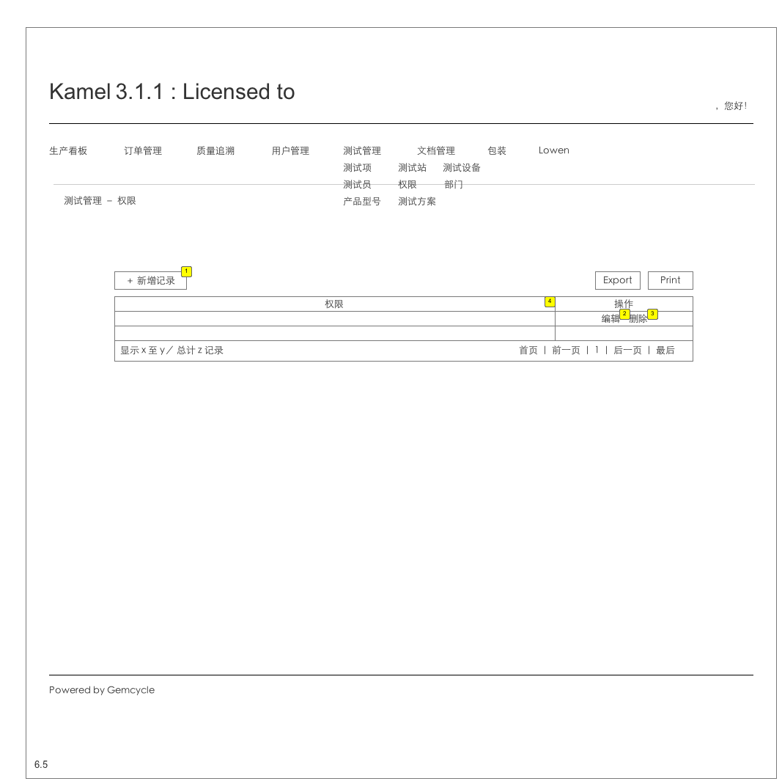

* + 1. Widget Table

| Footnote | Description | Version |
| --- | --- | --- |
| 1 | 转到6.5.1 | VER1-0 |
| 2 | 转6.5.2 | VER1-0 |
| 3 | 删除本条记录，删除前提示用户是否确定要删除。 | VER1-0 |
| 4 | 字符串，表authorization | ver1-0 |

* 1. 6.5.1 Testing Management - Authorization - Add
     1. User Interface

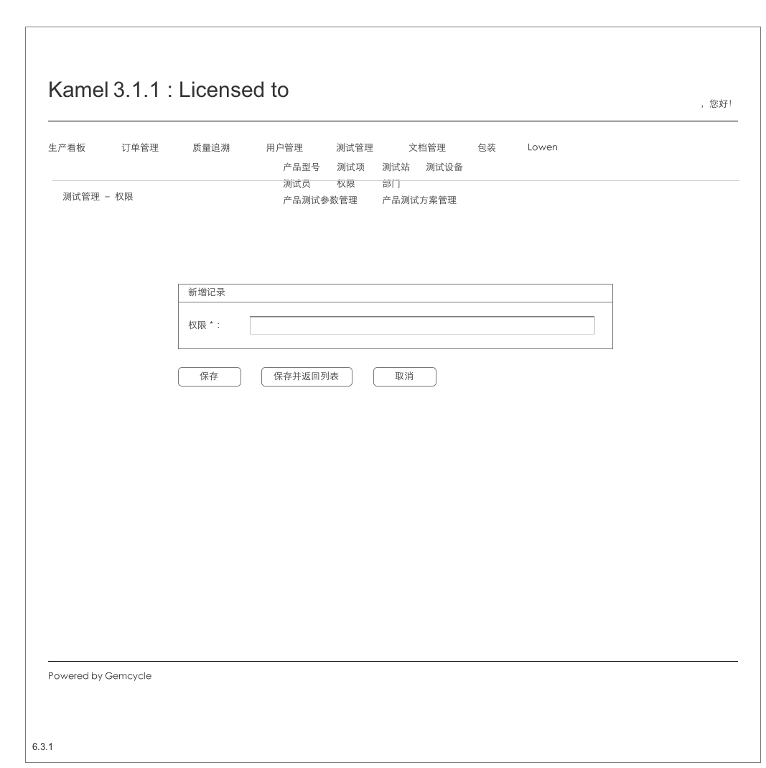

* 1. 6.5.2 Testing Management - Authorization - Edit
     1. User Interface

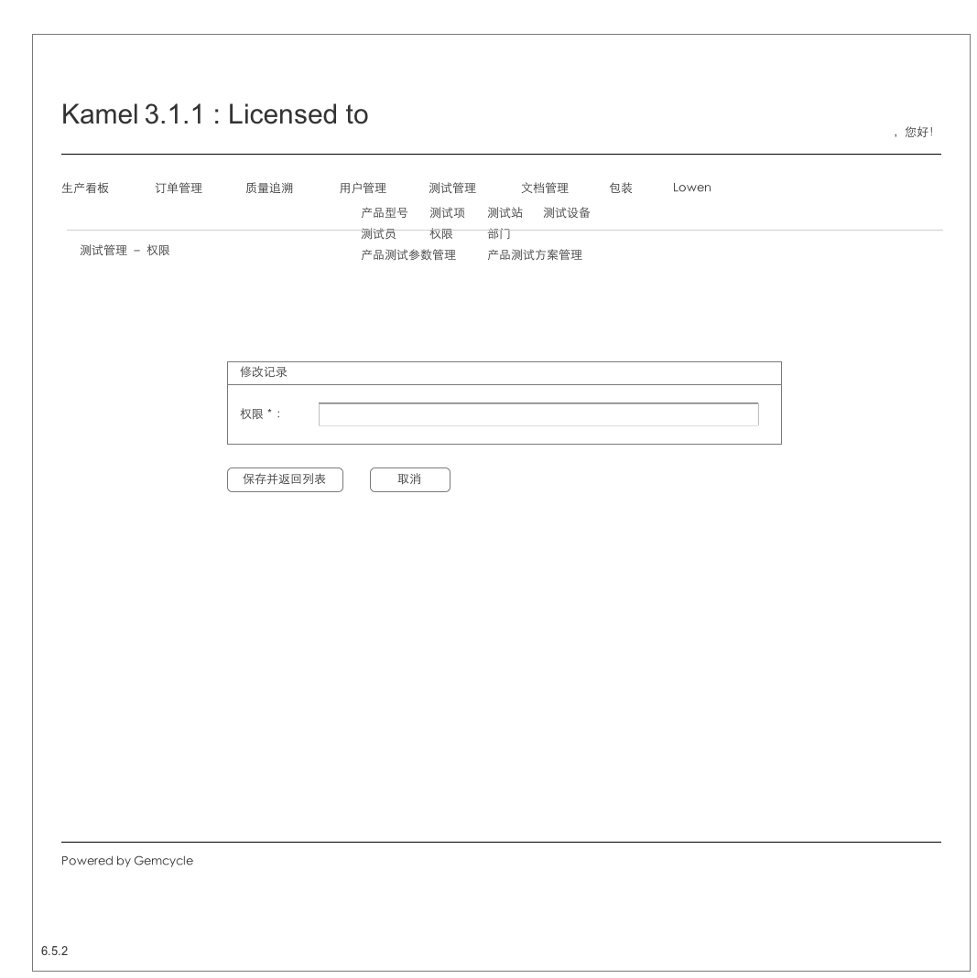

* 1. 6.6 Testing Management - Department
     1. User Interface

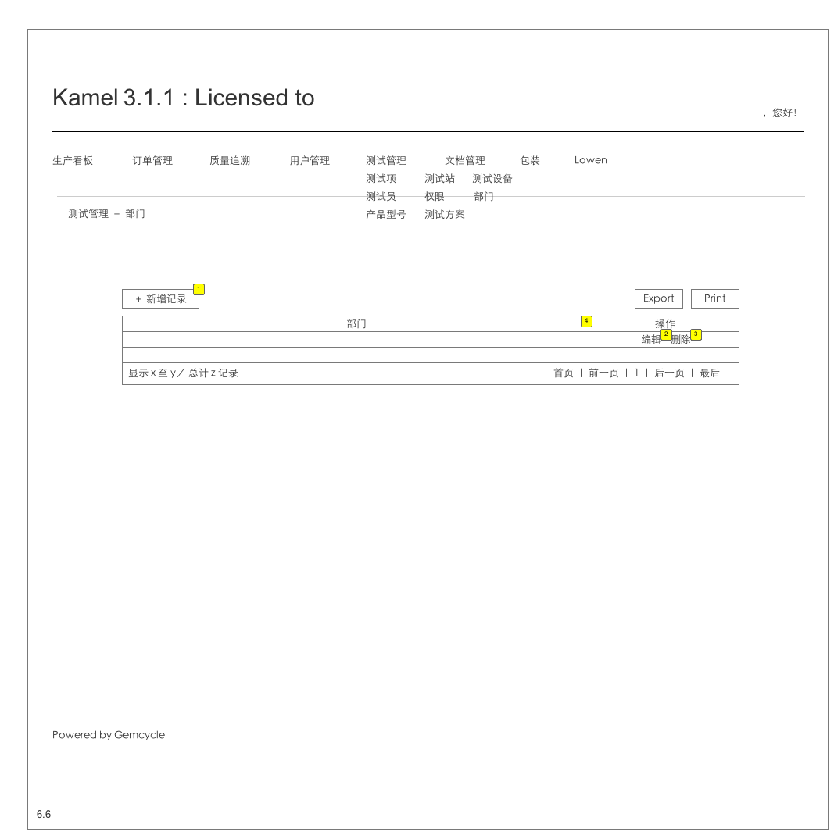

* + 1. Widget Table

| Footnote | Description | Version |
| --- | --- | --- |
| 1 | 转到6.6.1 | VER1-0 |
| 2 | 转6.6.2 | VER1-0 |
| 3 | 删除本条记录，删除前提示用户是否确定要删除。 | VER1-0 |
| 4 | 字符串，表Department | ver1-0 |

* 1. 6.6.1 Testing Management - Department - Add
     1. User Interface

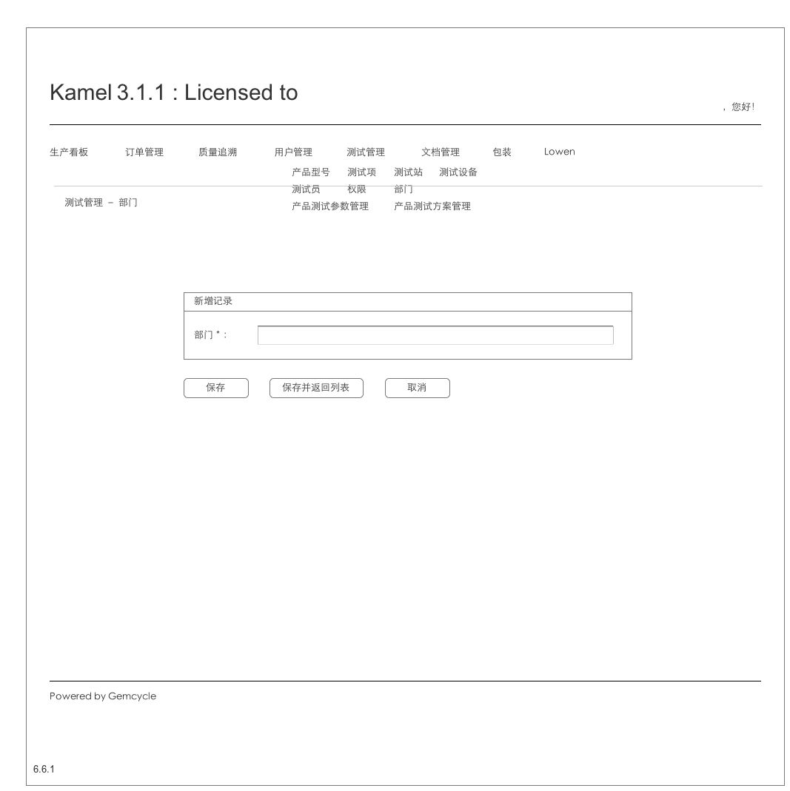

* 1. 6.6.2 Testing Management - Department - Edit
     1. User Interface

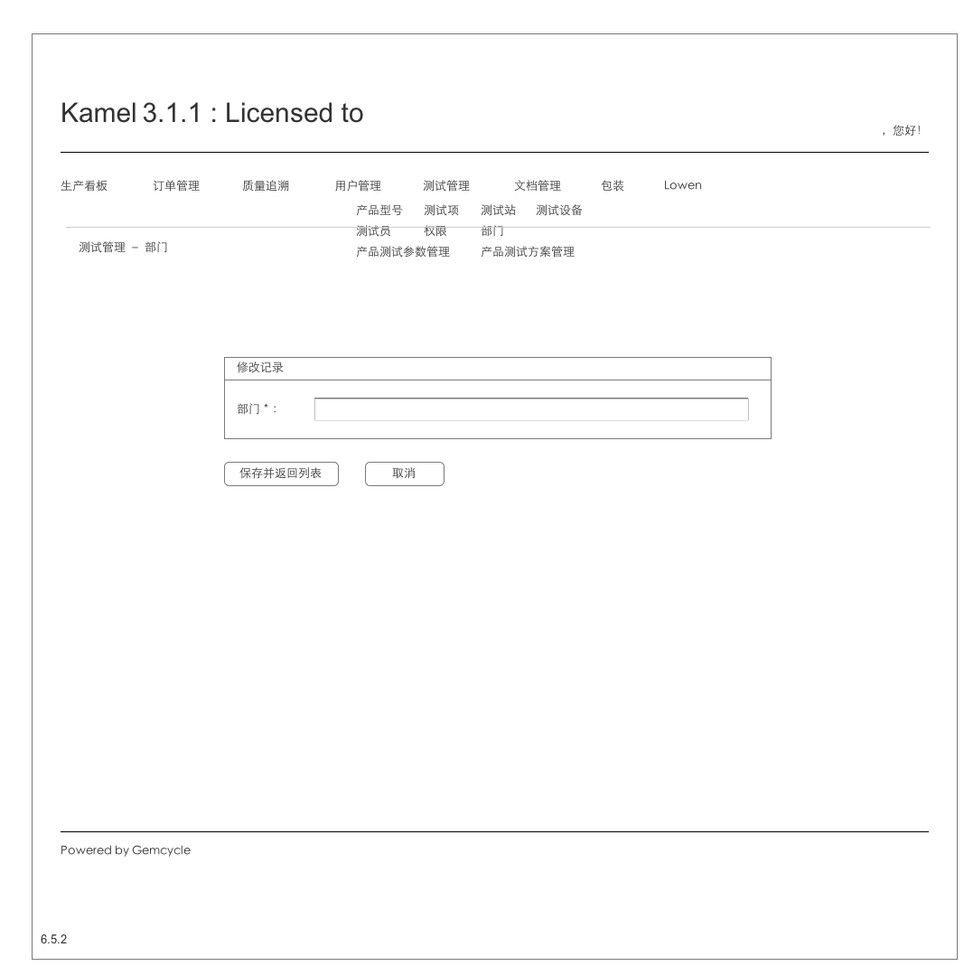

* 1. 6.7 Testing Management - Tester
     1. User Interface

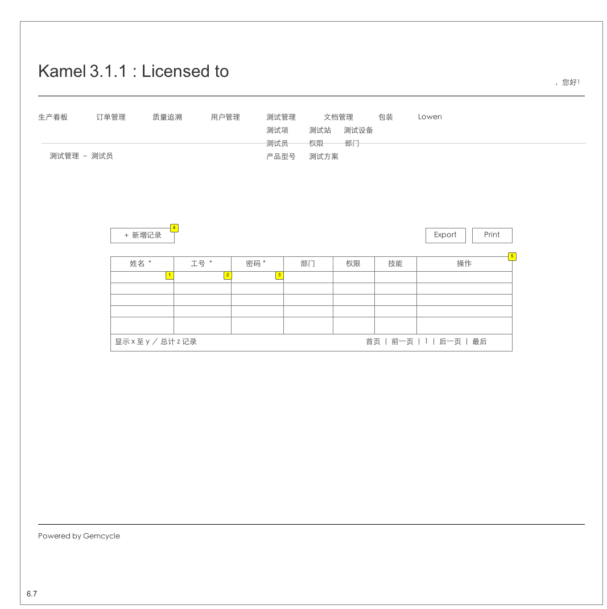

* + 1. Widget Table

| Footnote | Description | Version |
| --- | --- | --- |
| 1 | 支持中文名 | VER1-0 |
| 2 | 6为字母和数字 | ver1-0 |
| 3 | 6为字母和数字 | ver1-0 |
| 4 | 转到6.7.1 | VER1-0 |
| 5 | 表tester | ver1-0 |

* 1. 6.7.1 Testing Management - Tester - Add
     1. User Interface

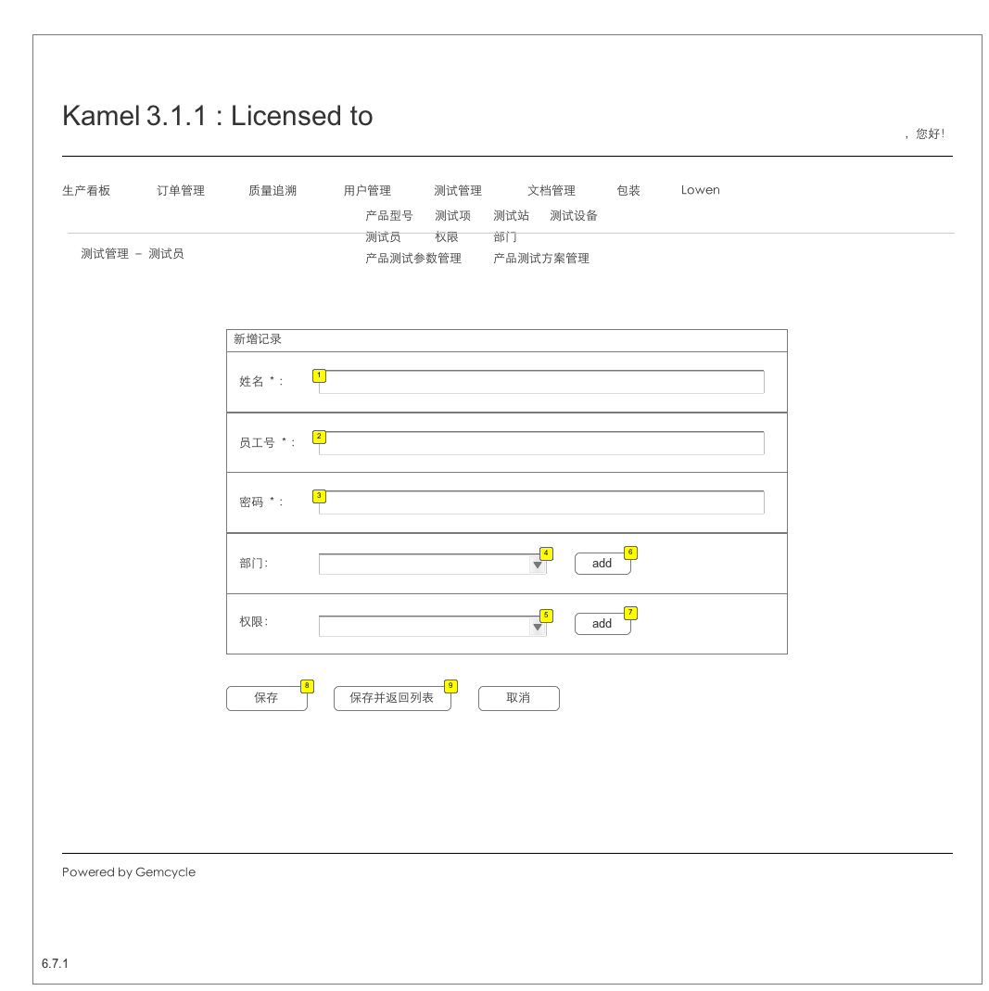

* + 1. Widget Table

| Footnote | Description | Version |
| --- | --- | --- |
| 1 | 必填项，字符串 | ver1-0 |
| 2 | 必填项，字符串 | ver1-0 |
| 3 | 必填项 | ver1-0 |
| 4 | 读取department表 | ver1-0 |
| 5 | 读取authorization表 | ver1-0 |
| 6 | 转6.6.1 | ver1-0 |
| 7 | 转6.5.1 | ver1-0 |
| 8 | 插入表tester，清空输入内容。 | ver1-0 |
| 9 | 插入表tester，返回6.7。 | ver1-0 |

* 1. 6.7.2 Testing Management - Tester - Edit
     1. User Interface

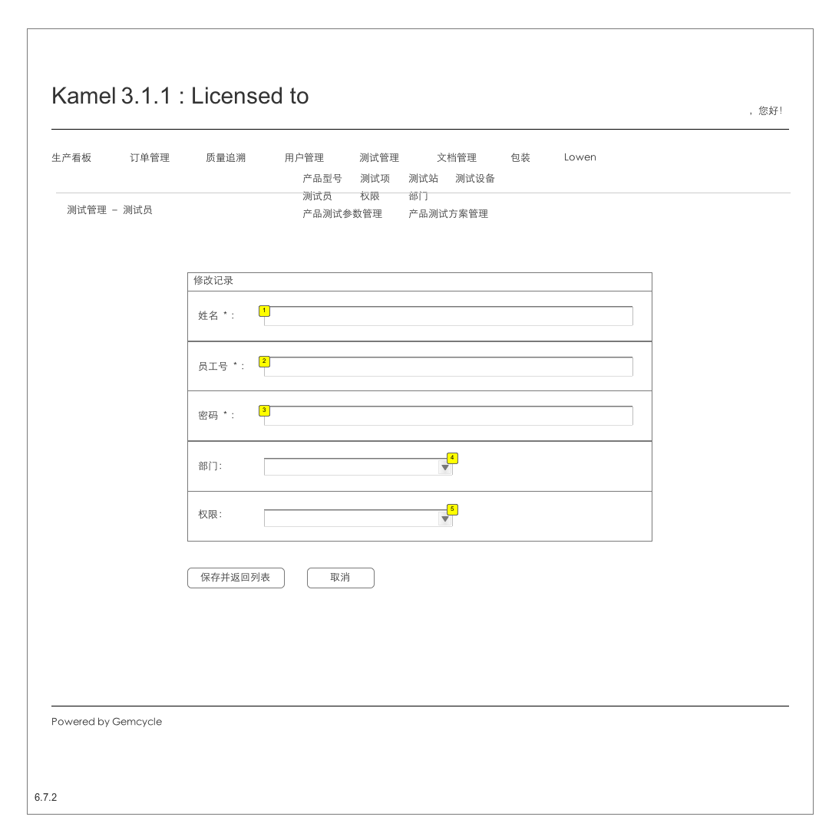

* + 1. Widget Table

| Footnote | Description | Version |
| --- | --- | --- |
| 1 | 必填项，字符串 | ver1-0 |
| 2 | 必填项，字符串 | ver1-0 |
| 3 | 必填项 | ver1-0 |
| 4 | 读取department表 | ver1-0 |
| 5 | 读取authorization表 | ver1-0 |

* 1. 6.8 Testing Management - TestConfig
     1. User Interface

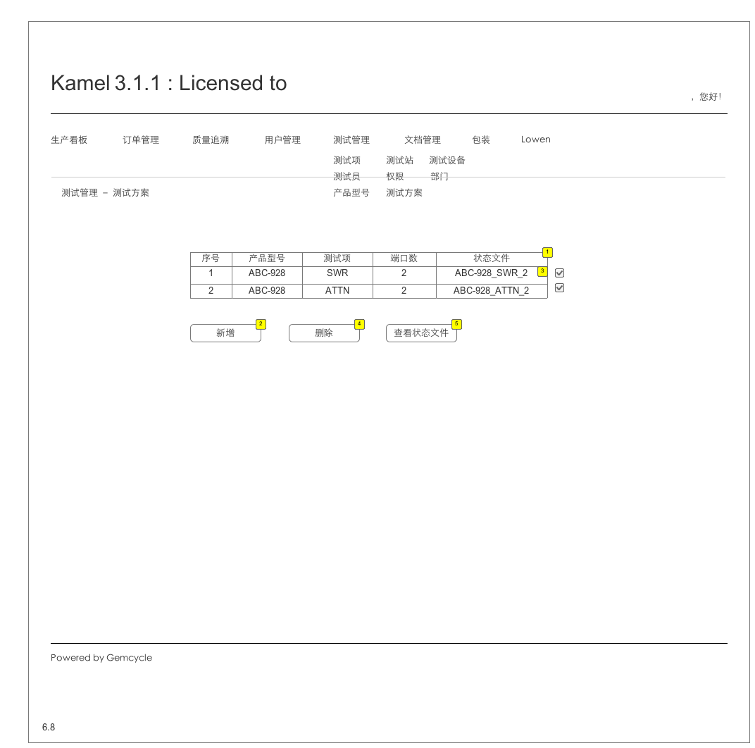

* + 1. Widget Table

| Footnote | Description | Version |
| --- | --- | --- |
| 1 | test_config表 | ver1_0 |
| 2 | 转到6.8.1 | ver1-0 |
| 3 |  | ver1-0 |
| 4 | 从test_config表中删除所选定的记录，从state_file表中删除该状态文件名称的记录，从state_file_define表中删除该状态文件对应的记录。更新测试方案表。 如果没有记录被选中，在表格下方、按钮上方，显示“请选择需要删除的记录” | ver1-0 |
| 5 | 转到6.8.2，以state_file检索显示test_config表和state_file_define表 | ver1-0 |

* 1. 6.8.1 Testing Management - TestConfig - Add
     1. User Interface

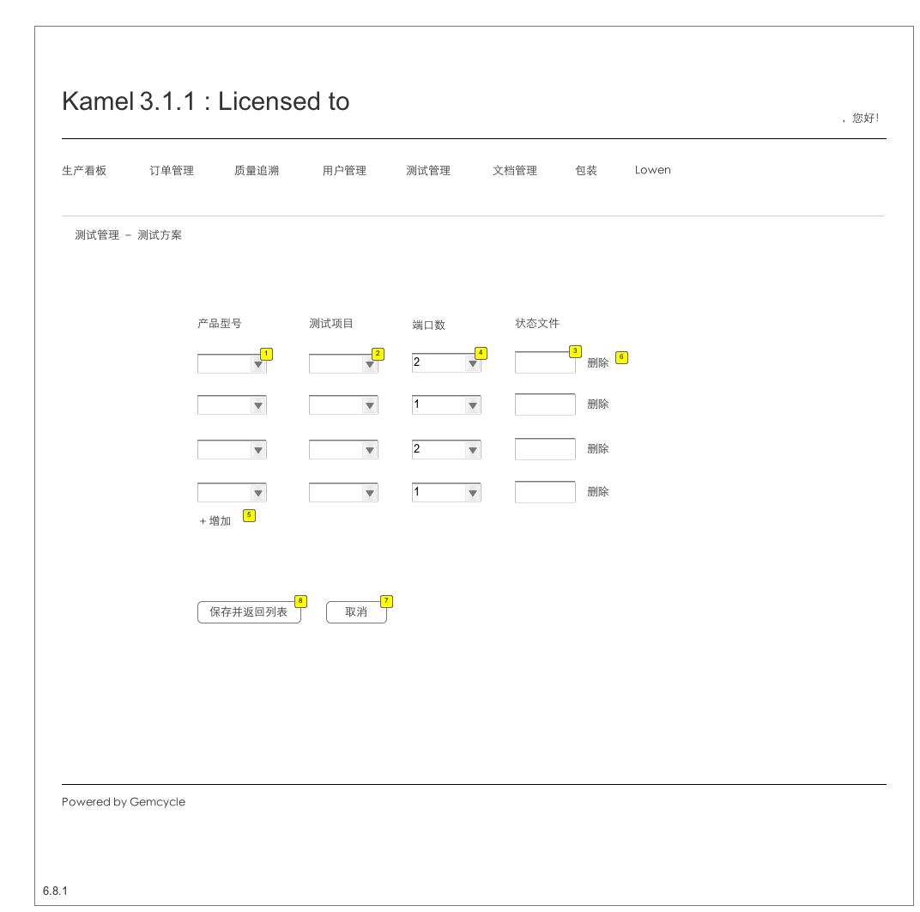

* + 1. Widget Table

| Footnote | Description | Version |
| --- | --- | --- |
| 1 | product_type.name，必选 | ver1-0 |
| 2 | test_item.name，必选 | ver1-0 |
| 3 | 等于product_type.name_test_item.name_ports，自动生成。不可编辑。 | ver1-0 |
| 4 | 表statefile.ports，必填 | ver1-0 |
| 5 | 增加一行 | ver1-0 |
| 6 | 删除该行 | ver1-0 |
| 7 | 返回6.8 | ver1-0 |
| 8 | 查state_file表该状态文件是否存在，如果存在，提示“xxx状态文件已经存在，请检查！”，等待重新输入；如果不存在，将状态文件名插入state_file表，整条记录插入test_config表，返回6.8。 |  |

* 1. 6.8.2 Testing Management - TestConfig - state_file
     1. User Interface

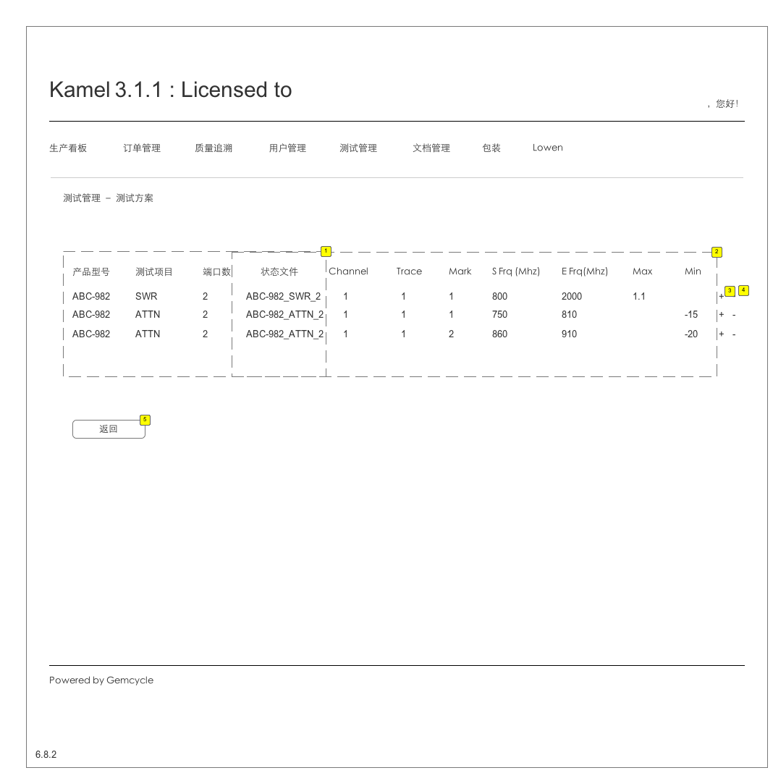

* + 1. Widget Table

| Footnote | Description | Version |
| --- | --- | --- |
| 1 | test_config表 | ver1-0 |
| 2 | state_file_define表，Channel, Trace, Mark, S Frq, E Frq, Max, Min的值可编辑。 | ver1-0 |
| 3 | 在state_file_define中增加一条该state_file的记录。点击“＋”，下方的记录下移一行，产品型号、测试项目、端口数、状态文件内容一样，其它内容由客户填写，在state_file_define中检查新增记录没有重复项。 | ver1-0 |
| 4 | 在state_file_define中删除该条记录 | ver1-0 |
| 5 | 返回6.8 | ver1-0 |

* 1. 7.1 File Management - View
     1. User Interface

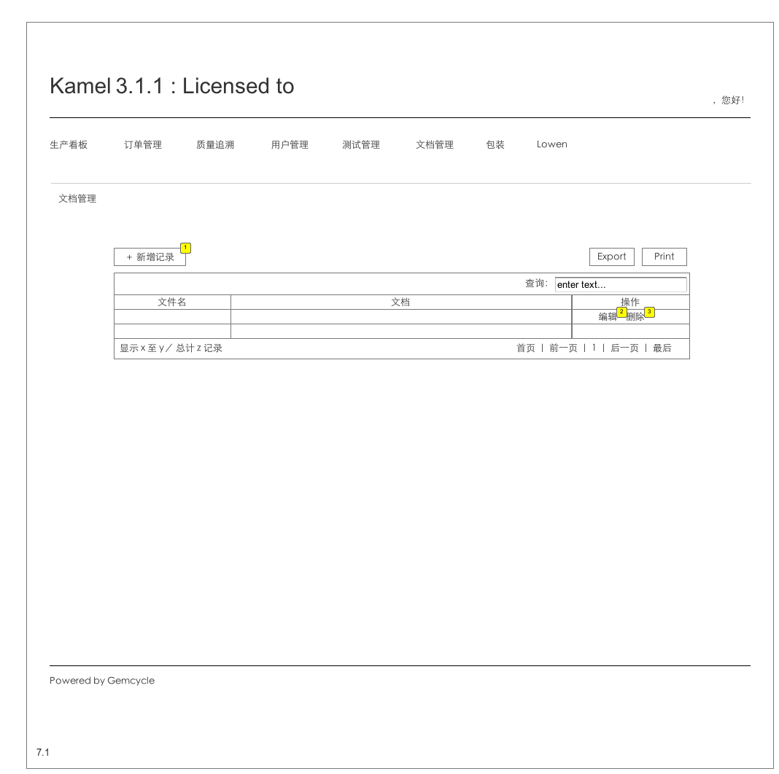

* + 1. Widget Table

| Footnote | Description | Version |
| --- | --- | --- |
| 1 | 转到7.2 | VER1-0 |
| 2 | 转到7.3 | VER1-0 |
| 3 | 删除本条记录，删除前提示用户是否确定要删除。 | VER1-0 |

* 1. 7.2 File Management - Add
     1. User Interface

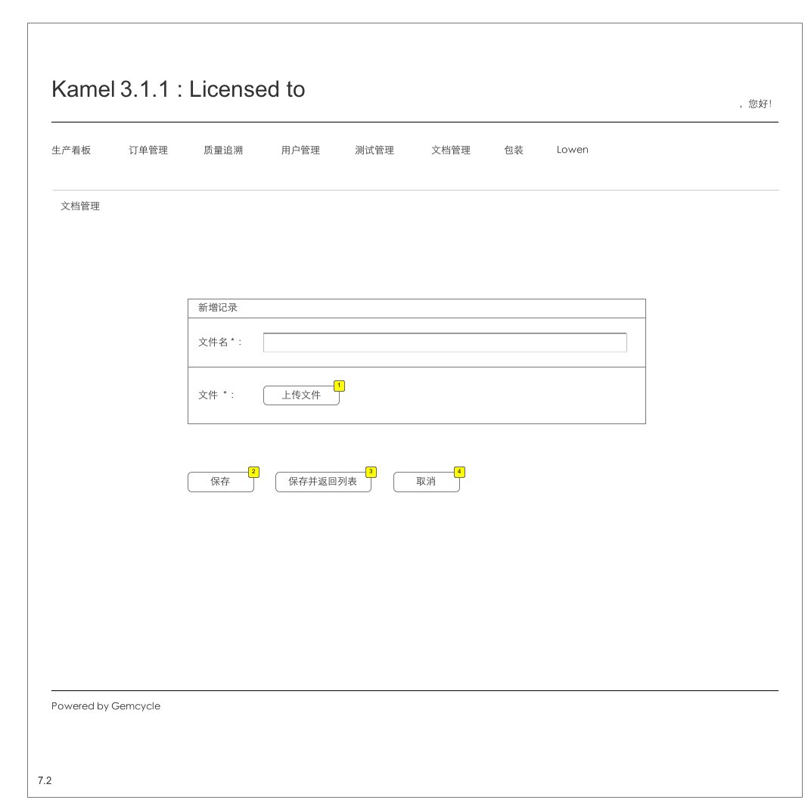

* + 1. Widget Table

| Footnote | Description | Version |
| --- | --- | --- |
| 1 | 弹出选择文件窗口，支持类型至少包括：doc, docx, xls, xlsx, ppt, pptx, txt, pdf, jpeg, png | ver1-0 |
| 2 | 插入file_management表，清空输入内容，等待新的输入。 | ver1-0 |
| 3 | 插入file_management表，返回7.1 | ver1-0 |
| 4 | 返回7.1 | ver1-0 |

* 1. 7.3 File Management - Edit
     1. User Interface

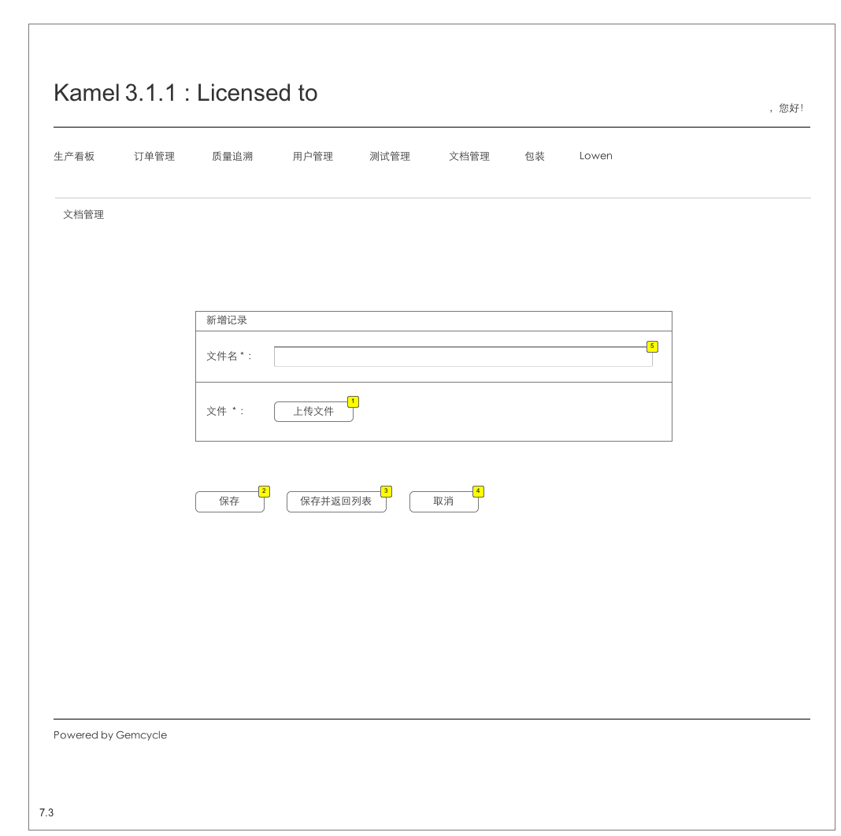

* + 1. Widget Table

| Footnote | Description | Version |
| --- | --- | --- |
| 1 | 弹出选择文件窗口，支持类型至少包括：doc, docx, xls, xlsx, ppt, pptx, txt, pdf, jpeg, png | ver1-0 |
| 2 | 插入file_management表，清空输入内容，等待新的输入。 | ver1-0 |
| 3 | 插入file_management表，返回7.1 | ver1-0 |
| 4 | 返回7.1 | ver1-0 |
| 5 | 显示要编辑记录的文件名 | ver1-0 |

* 1. Kamel Data Structure
     1. User Interface

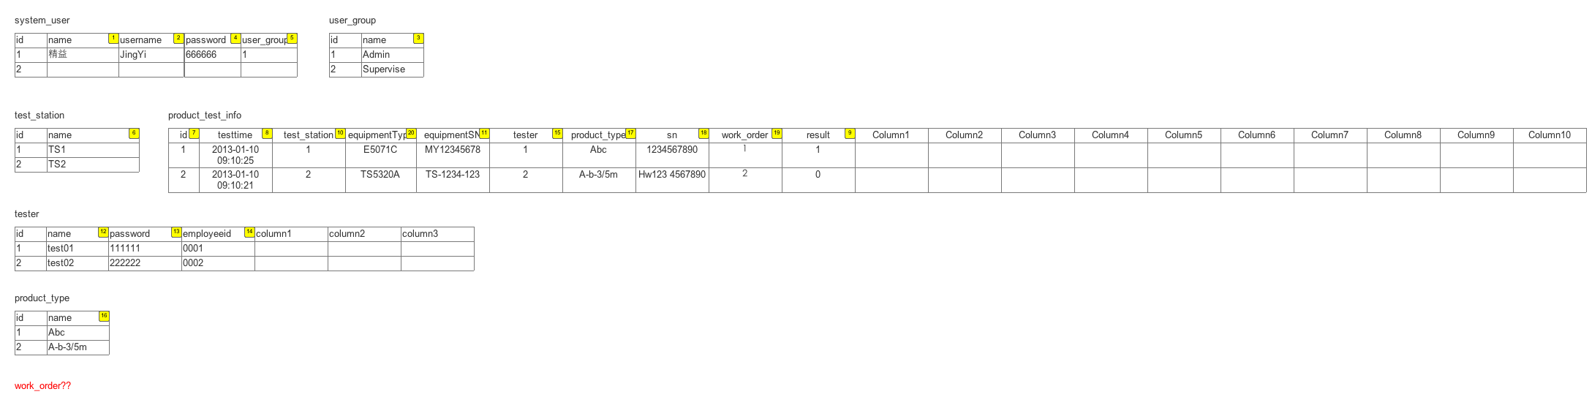

* + 1. Widget Table

| Footnote | Description | Version |
| --- | --- | --- |
| 1 | 字符串 | ver1-0 |
| 2 | 字符串 | ver1-0 |
| 3 | 字符串 | ver1-0 |
| 4 | 字符串 | ver1-0 |
| 5 | user_group id | ver1-0 |
| 6 | 字符串 | ver1-0 |
| 7 | 整型数 | ver1-0 |
| 8 | 长时间类型 | ver1-0 |
| 9 | 整型数，1: pass 0: fail | ver1-0 |
| 10 | test_station id | ver1-0 |
| 11 | 字符串 | ver1-0 |
| 12 | 字符串 | ver1-0 |
| 13 | 字符串 | ver1-0 |
| 14 | 字符串 | ver1-0 |
| 15 | tester id | ver1-0 |
| 16 | 字符串 | ver1-0 |
| 17 | product_type id | ver1-0 |
| 18 | 字符串 |  |
| 19 | 字符串 |  |
| 20 | 字符串 | ver1-0 |

* 1. Kamel Data Structure (Ref)
     1. User Interface

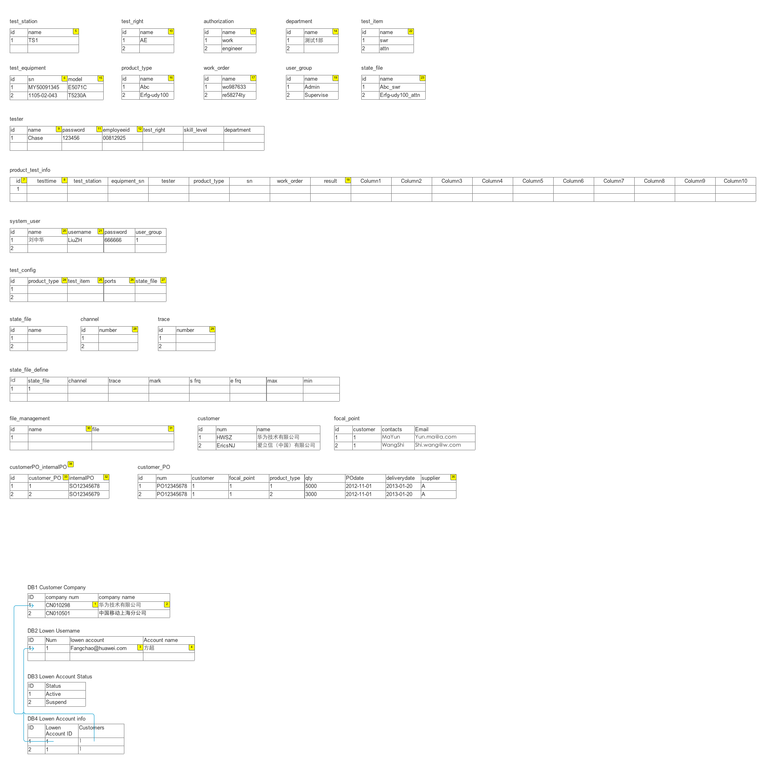

* + 1. Widget Table

| Footnote | Description | Version |
| --- | --- | --- |
| 1 | 字符串，只能包含英文字符和数字 | ver1-0 |
| 2 | 字符串，支持中文 | ver1-0 |
| 3 | 字符串，只允许email形式 | ver1-0 |
| 4 | 字符串 | ver1-0 |
| 5 | 字符串 | ver1-0 |
| 6 | 字符串，必填项 | ver1-0 |
| 7 | 整型数 | ver1-0 |
| 8 | 长时间类型 | ver1-0 |
| 9 | 字符串 | ver1-0 |
| 10 | 字符串 | ver1-0 |
| 11 | 字符串 | ver1-0 |
| 12 | 字符串 | ver1-0 |
| 13 | 字符串 | ver1-0 |
| 14 | 字符串 | ver1-0 |
| 15 | 字符串 | ver1-0 |
| 16 | 字符串 | ver1-0 |
| 17 | 字符串 | ver1-0 |
| 18 | pass, fail | ver1-0 |
| 19 | 字符串 | ver1-0 |
| 20 | 字符串 | ver1-0 |
| 21 | 字符串 | ver1-0 |
| 22 | 字符串 | ver1-0 |
| 23 | 字符串 | ver1-0 |
| 24 | product_type id | ver1-0 |
| 25 | test_item id | ver1-0 |
| 26 | 整型数 | ver1-0 |
| 27 | state_file.id |  |
| 28 | 整型数1-10 |  |
| 29 | 整型数1-10 |  |
| 30 | 字符串 | ver1-0 |
| 31 | 字符串，文件名 | ver1-0 |
| 32 | 字符串 | ver1-0 |
| 33 | customer_PO id | ver1-0 |
| 34 | 客户订单和内部订单一一对应 |  |
| 35 | 固定值，例如A客户的系统，该值为A | ver1-0 |

* 1. WebService
  2. －－－－－8 Packaging
     1. User Interface

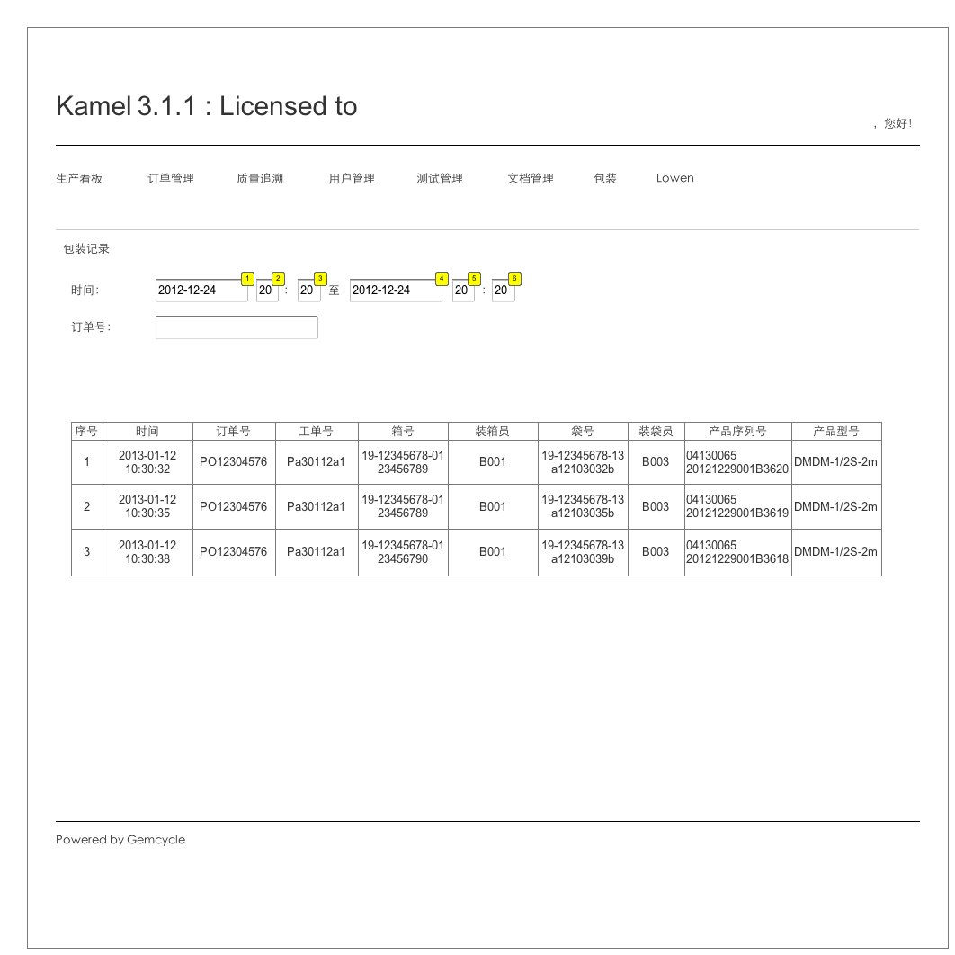

* + 1. Widget Table

| Footnote | Description | Version |
| --- | --- | --- |
| 1 | 日历形式选择日期。默认值1900-01－01。不显示。 | ver1-0 |
| 2 | 下拉菜单选择，0-23。默认选择00。不显示。 | ver1-0 |
| 3 | 下拉菜单选择，0-59，默认选择00。不显示。 | ver1-0 |
| 4 | 日历形式选择日期。默认选择2999-01－01。不显示。 | ver1-0 |
| 5 | 下拉菜单选择，0-23。默认选择00。不显示。 |  |
| 6 | 下拉菜单选择，0-59，默认选择00。不显示。 |  |

* 1. －－－－－Lowen - customer info
     1. User Interface

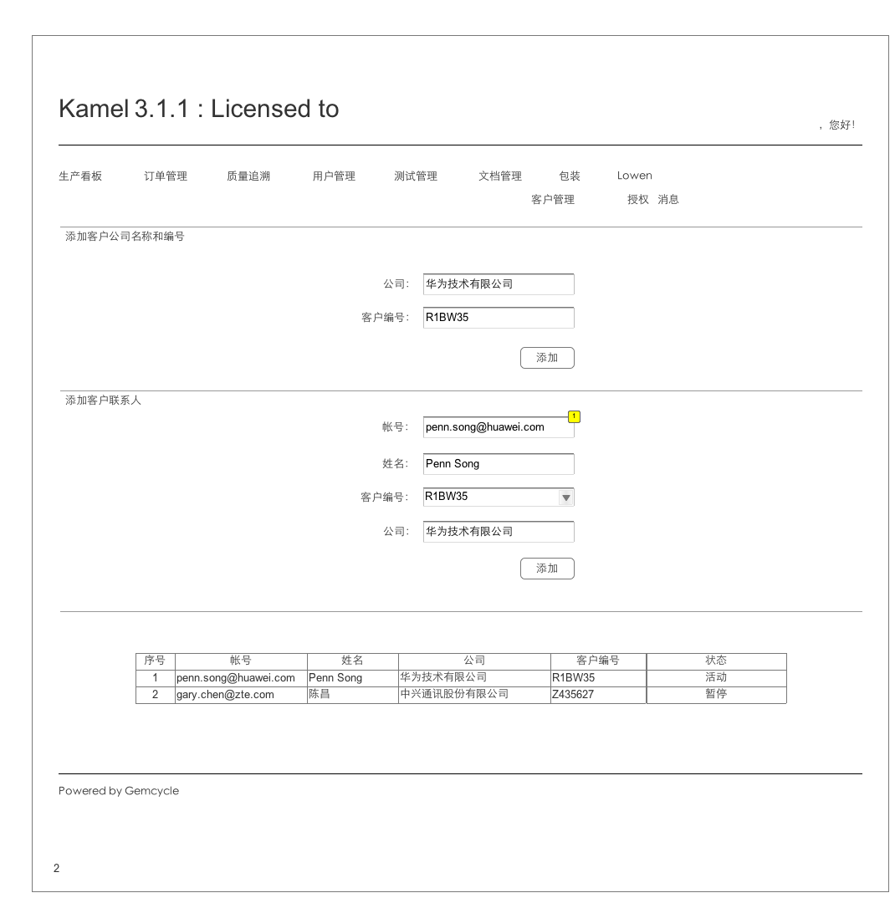

* + 1. Widget Table

| Footnote | Description | Version |
| --- | --- | --- |
| 1 | 客户的帐号，email地址作为帐号 | ver1-0 |

* 1. －－－－－－Testing Management - ProductParaM
     1. User Interface

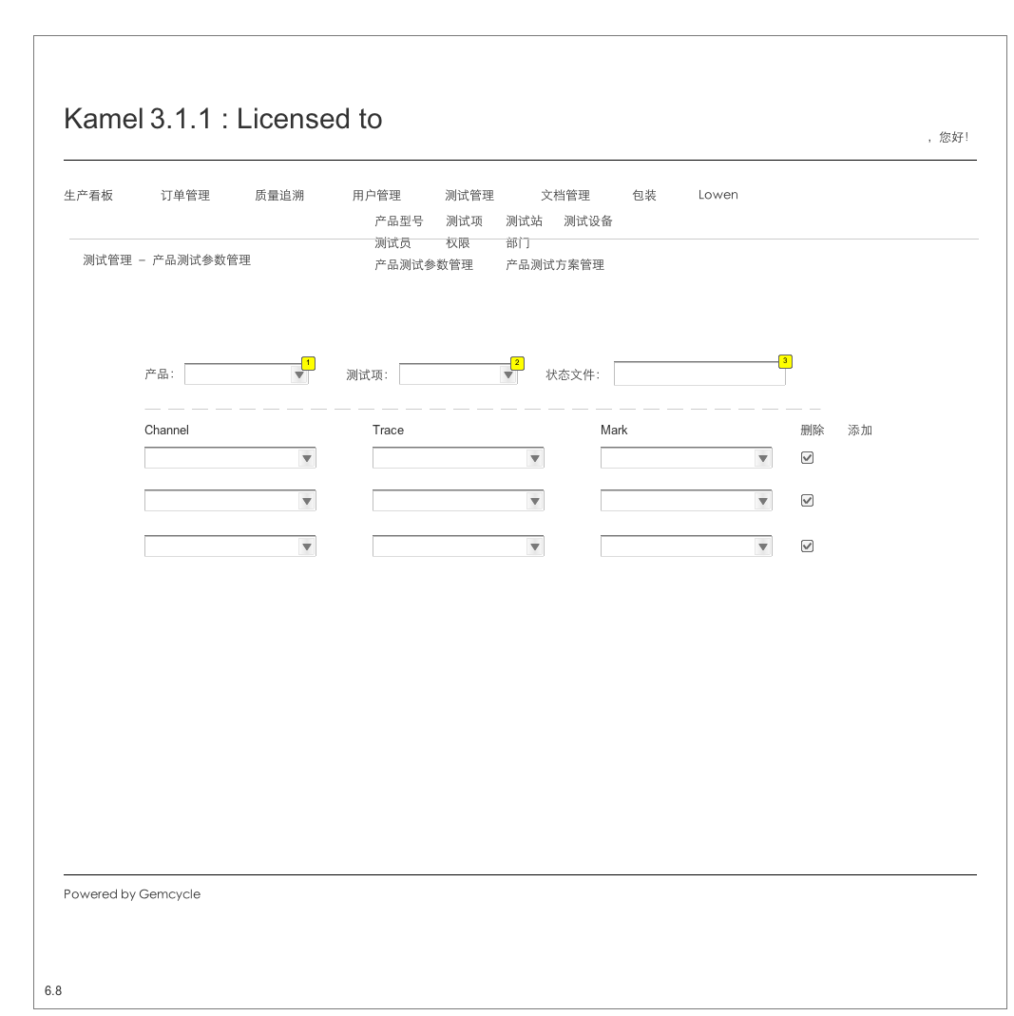

* + 1. Widget Table

| Footnote | Description | Version |
| --- | --- | --- |
| 1 | 取product_type | ver1-0 |
| 2 | 取test_item | ver1-0 |
| 3 | 1. 状态文件: 产品型号_测试项 2. 不可修改 3. 生成值插入statefile表 | ver1-0 |

* 1. Packaging Application
     1. User Interface

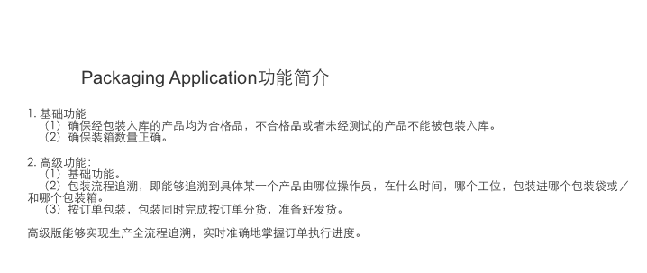

* 1. 1. Packaging Application Basic V1.0 - Login
     1. User Interface

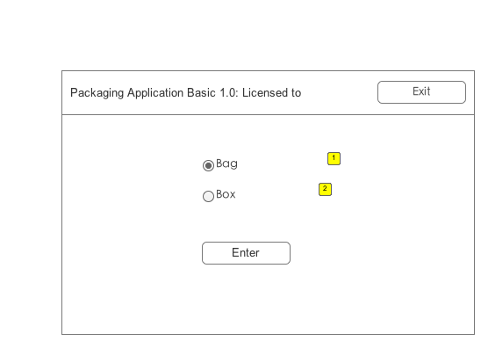

* + 1. Widget Table

| Footnote | Description | Version |
| --- | --- | --- |
| 1 | 转到1 | ver1-0 |
| 2 | 转到2 | ver1-0 |

* 1. 2. Packaging Application Basic V1.0 － 1
     1. User Interface

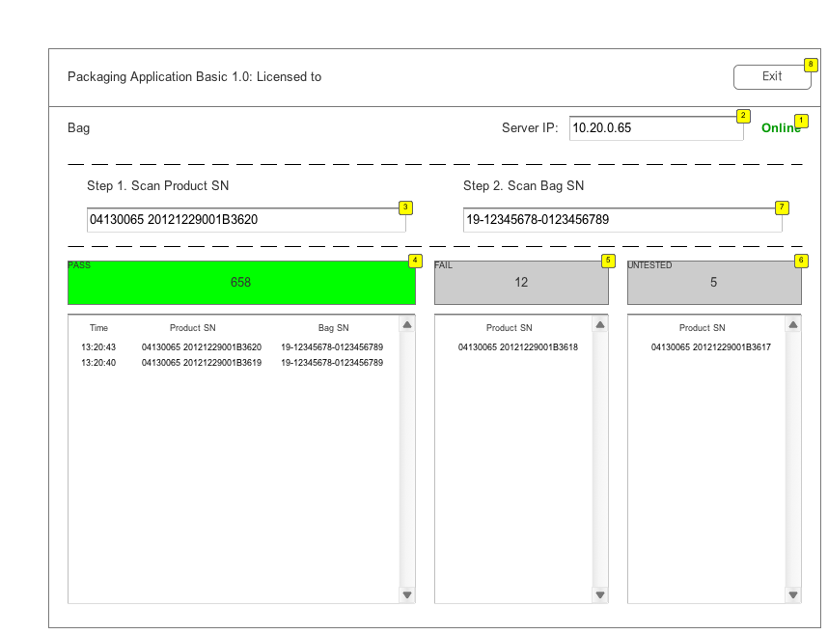

* + 1. Widget Table

| Footnote | Description | Version |
| --- | --- | --- |
| 1 | 检查网络状态 1. Online，绿色，可以工作 2. Offline，红色，不可以工作 | ver1-0 |
| 2 | 程序启动时，首先连接指定服务器。没有指定服务器地址，或者无法连接上服务器的时候，状态显示为offline，此时程序不工作，光标停留在此处；连接上指定服务器后，状态显示为online，光标跳转到step 1输入框。连接时，状态显示为connecting...。 程序工作时，如果和服务器连接断开，状态转为connecting...，光标保持在当前位置，等待网络恢复继续工作。 | ver1-0 |
| 3 | 程序能够连接上服务器时有效。等待输入产品条码。输入完成后回车，查询product_test_info.sn： 1. 有记录，如果product_test_info.result为pass，该产品为合格品，亮绿灯，绿灯计数＋1，光标跳转到step 2；如果不为pass，亮红灯，红灯计数＋1，光标保持在step 1，产品序列号显示到Fail栏中，同时上传服务器。 2. 无记录，亮黄灯，黄灯计数＋1，光标保持在step 1，产品序列号显示到Untested栏中，同时上传服务器。 | ver1-0 |
| 4 | 绿灯。不亮时为灰色。 | ver1-0 |
| 5 | 红灯，不亮时为灰色。 | ver1-0 |
| 6 | 黄灯，不亮时为灰色。 | ver1-0 |
| 7 | 扫入条码，生成packaging 1记录，显示到合格记录栏中，同时上传到服务器。Pass灯转为灰色。光标跳回step1。 | ver1-0 |
| 8 | 退出程序。 | ver1-0 |

* 1. 3. Packaging Application Basic V1.0 - 2
     1. User Interface

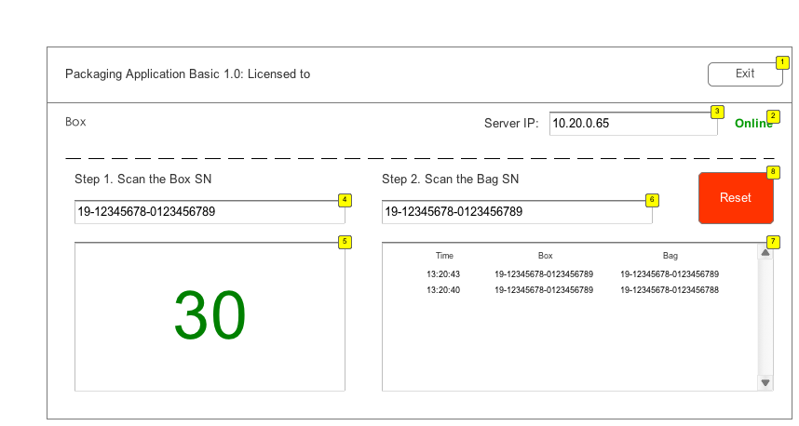

* + 1. Widget Table

| Footnote | Description | Version |
| --- | --- | --- |
| 1 | 退出程序。 | ver1-0 |
| 2 | 检查网络状态 1. Online，绿色，可以工作 2. Offline，红色，不可以工作 3. connecting, 正在连接，请等待 | ver1-0 |
| 3 | 程序启动时，首先连接指定服务器。没有指定服务器地址，或者无法连接上服务器的时候，状态显示为offline，此时程序不工作，光标停留在此处；连接上指定服务器后，状态显示为online，光标跳转到step 1输入框。连接时，状态显示为connecting...。 程序工作时，如果和服务器连接断开，状态转为connecting...，光标保持在当前位置，等待网络恢复继续工作。 | ver1-0 |
| 4 | 1. 首先，需要扫描包装箱序列号，此时包装袋编号输入框无效。 2. 扫描得到包装箱编号后，光标跳转到包装箱容量输入框。 3. 用户输入包装箱容量，回车确认，准备倒计数。 4. 光标跳转到包装袋。此时step 1包装箱输入框无效，直到倒计数到0。 | ver1-0 |
| 5 | 包装箱容量计数 | ver1-0 |
| 6 | 1. 输入包装袋序列号，和包装箱绑定，显示到记录栏。 2. 计数－1。 3. 判断是否计数到0，如果不为0，继续输入包装袋序号；如果到0，上传此包装箱记录到服务器，清空包装记录栏中的内容。光标跳转到包装箱输入框。 | ver1-0 |
| 7 | 包装记录栏 | ver1-0 |
| 8 | 重置键。点击后： 1. 提示“确定重置？当前包装箱记录将被清空。” 2. 如果确定，清空包装记录栏的内容，计数清0，光标跳转到包装箱输入栏。 |  |

1. Masters
   1. Master List

Kamel Login Master  
Kamel Master

* 1. Kamel Login Master
     1. User Interface

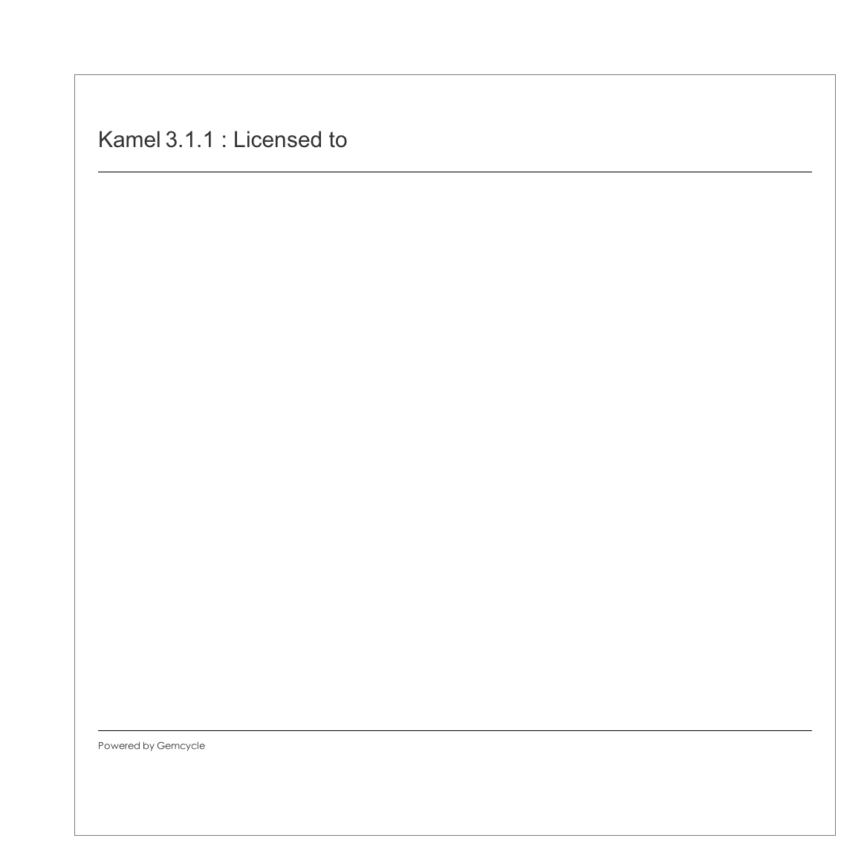

* 1. Kamel Master
     1. User Interface

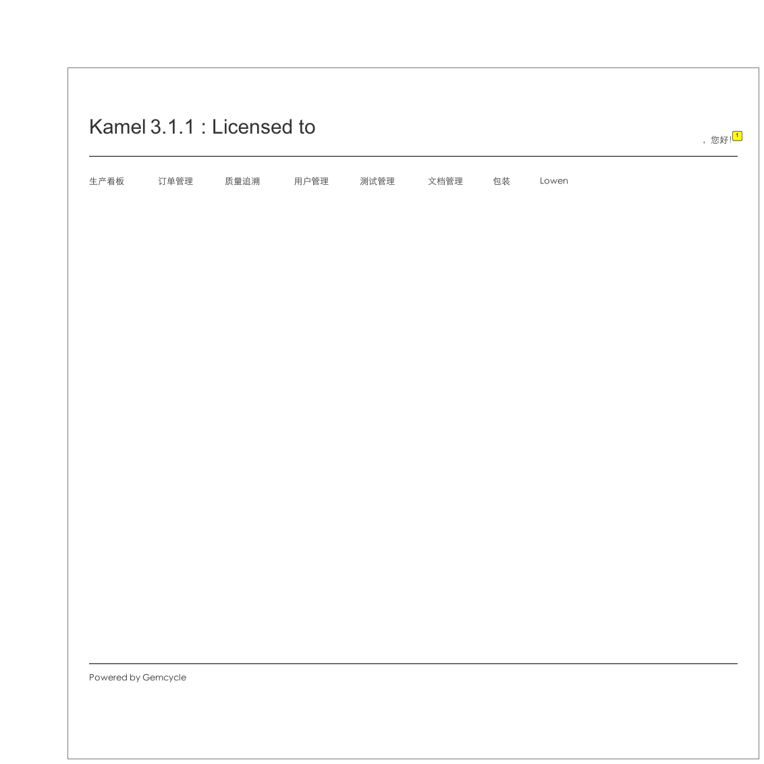

* + 1. Widget Table

| Footnote | Description | Version |
| --- | --- | --- |
| 1 | 显示用户姓名 | ver1-0 |