**Building the Core Community**

**Why should we build a ‘Smart Reddit’?**

Most of the media currently focus on infotainment. This might sounds like the way to go in 2015, but then again, how do you look different? Why would people come on your platform for more animal videos, funny gifs and the same *world news* that you already see everywhere?

Reddit is **boring** and mostly infotainment by its choice of default subreddits. Furthermore, if we look at the current alternatives to Reddit, like *Voat, Snapzu, Stackcity or Bitvoat*, they have **mostly** the same content, and also the same outdated and flawed content management system (Up/Downvoting).

Considering that most social media currently compete to attract the masses with dumb and shallow content, having **better content** – and by that I mean something that is clearly more interesting to anyone and customizable – would give us a **decisive competitive advantage**, as well as reinforcing our branding. In the current content-sharing market, I believe the cost of attracting a smart user is **cheaper** than a dumb user.

**Why is it Cost-Effective to market the platform to smart, ‘knowledge-oriented’ users?**

* Knowledge and learning is fun/erotic to a lot of people
* Beside fun, these users use Internet specifically to increase their knowledge/understanding of the World as an existential strategy (life quality, building wealth, building skills, competitive advantage over peers and opportunity input – stuff that is highly knowledge-dependent, today).
* Smart people are **actively seeking knowledge sources** – at the specific condition that those are reliable, and easy to use (cost/benefit).
* Smartness **transcends** hobbies, income, interests and jobs – which allows us to maximize social outreach.
* Smart users (we assume) aren’t exactly satisfied with Reddit nor with anything on the market right now. Furthermore, Quality content is unlikely to improve on Reddit (rather the opposite) or on any other concurrent platform.
* Smart people usually **care about governance, politics and content quality,** are against censorship.
* Smart people have **more influence** in society (opinion leaders / trend makers) – we want/need these people to kick start the project.

**Smart Content and Wealth Concentration**

**We should be highly aware of users’ expectations.** Monetizing something (which is what we’re doing) means that users tend to focus mostly on money-rewarding behavior rather than charitable behavior (Wikipedia, for instance, works because *no one* gets paid to write articles); meaning by that, **that if they fail to generate a ROI**, considering the time, energy and the money they invest in the system for voting/posting/viewing, they *might* lose interest in our platform.

A lot of people will be expecting to make some money with their content. If they ever talk about our platform, mainstream press will focus on the income making aspects and success stories of people making huge money on DATT, rather than the community and decentralization aspects; this will exacerbate theses expectations.

Let’s get real: **most users won’t generate any money, of very little, even if they try as hard as they can. Why so?**

1. **Money Related Reasons**

* People compete for money (people even compete for karma…)
* Posting content and interacting on the platform will cost money
* Money is in limited supply
* Individual accumulation is unlimited
* Success is highly talent/skill dependent. Some users are **better than others** to produce content and to understand what ‘likable content’ is.
* Some people will (at some point) become professional content producers/managers/curators and outcompete casual users (think AirBnB).

1. **Micro/Macrosociological Reasons**

Humans community (digital or not) are inherently pyramidal. In a given social context, people at the bottom or at entry level positions always look at those at the upper layers (ex: rich people, celebrities, popular kids in high school, popular users, etc.) to infer norms and give meaning to social organization ; they can also invest energy to get closer to them and know them better.

Furthermore, macroeconomics teaches us that entertainment – like food – is easy to substitute; multiple options can satisfy a single consumer.

Youtube is the perfect example of radical income disparities among content producing users: this happens precisely because most viewers don’t spend a lot of time researching different channels to optimize their experience, and stick with popular content producers they hear about on the Web, as they satisfy their need in entertainment enough. This explains roughly why PewDiePie has **57 million followers**, despite the fact that there are certainly thousands of talented video game commentators trying very hard to become big on Youtube.

We can expect the same thing to happen on DATT: most users won’t invest a lot of time and energy looking for less popular content/communities and will most likely stick with the most popular users/communities/curators on DATT; therefore participating to the wealth concentration.

***

Bottom line, **income distribution could look like Karma distribution on Reddit**. Here’s a distribution of Karma on Reddit – and Karma has no actual use I know of. On Reddit, 1% of redditors have 20% of all the karma (also, data is 17 months old – shit is probably crazier by now).

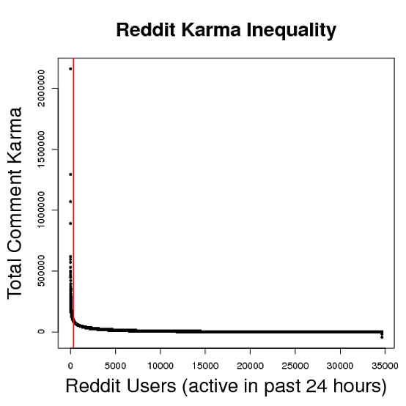

Source: https://www.reddit.com/r/dataisbeautiful/comments/27zyh6/karma_inequality_1_of_redditors_have_20_of_the/

By that I do NOT mean I disagree with the model we’re building; quite the opposite. I rather wanna stress the importance of **anchoring users with outstanding content**, so that they stay even if they never actually make any money (which is, statistically speaking, very likely).

**Syphoning Smart Users in our Gas Tank**

There are over 36 million registered users on Reddit. However, not all users contribute the same to the community. Considering current Karma distribution (see graph), we can assume there’s **an elite fraction of users** that produce most of the best content we find. **This is the *soul* of Reddit**. If we get this 5-10% of users, we can also assume their departure will affect Reddit’s content quality and slowly trigger an unstoppable mass migration towards our platform – like a syphon.

Furthermore, if these “elite users” – that are significantly better than others to produce good content – can choose between a platform where they make money and another one where they don’t, where will they go?

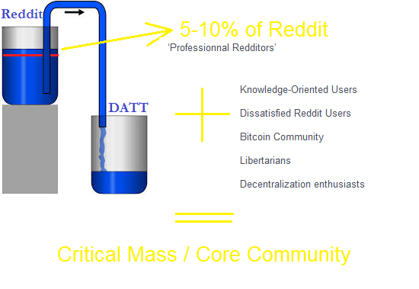

**What is Good Content/How do we Syphon the Elite?**

Tough metaphysical question, right? I believe there are three aspects to content quality:

1. Good content is specifically **Tailored for you.**

By that, I wanna highlight the obviously subjective value of content; good content is good content for you only. This is the weakness of Reddit and the ‘strength’ of Twitter/Facebook.

I believe we can work around this problem precisely by introducing a system of content curators: Specialized users that you can follow: a bit like with Tumblr, your frontpage is updated following the content they picked recently and according to simple content hierarchy rules. I explained my idea of content curation in a **longer paper** that I put on Github on September 21th.

1. Good Content is **Exclusive Content**

**This is where Reddit shines**: millions of users, experts on every topics; people with unique background/experiences; ask Reddit; AMA ; communities centered on the most specific topics, etc.

We should be able to do that once we have a big enough community (critical mass) – this is however definitely a deal breaker if we fail to do so… Have you come across a good *Ask Reddit* on Voat, yet? I doubt it.

1. Good content is **Meaningful**

People will click on memes and funny gifs if it’s in front of them, but that shit will never make them dream, open new life opportunities and give them a feeling of mental satisfaction and communion with the world/universe. Infotainment is the shit we put in our brain when we fail to find something truly interesting.

It’s a point I evocated earlier: users use Internet specifically to increase their knowledge/understanding of the World as an existential strategy (life quality, building wealth, building skills, competitive advantage over peers and opportunity input – stuff that is highly knowledge-dependent, today).

Good content is enlightening or useful; good content helps you becoming a better person and feel better. Good content improves your life like an intense philosophical or science discussion does.

**How to Make Smart Content Blossom?**

If we ask our community to post cat pictures and dead bodies, they will. However, if we encourage them to discuss topics that are enlightening, mind opening and radical, they will too. Reddit, in its early phase, was initially seeded with **fake profiles posting links to simulate activity**. The key was that the links being posted were the kind of content the founders wanted to see on the site over time.

Like a maestro – we as administrators – can show the community we care about what’s going on with the platform, influence the content they see and improve ultimately the overall experience. This means:

* Directing new users towards community we find the most interesting and thriving.
* Having a set of ‘default communities’ for new users – this should also be the content you see on DATT if you’re not registered yet.
* Recommending some content curators over others
* Encouraging specific kind of content (discussions vs. memes)
* Find a fair way to deal with undesirable content (remember r/fatpeoplehate?)
* Etc.

Basically, **managing and engineering the ‘contrast’** with Reddit.

***

In a nutshell, I believe that if we can create a product that’s specifically designed to be better than Reddit (our *dumb* cousin that nobody takes seriously), with superior content, superior content organization (through **Curators**) and monetary incentives to migrate and stay, **half of the marketing work** will already be done. Users will have **no single good reason** to stay on Reddit.

Guillaume

Dumaslap.guillaume@gmail.com