電腦視覺HW3

R10922176 陳冠頴

1. Origin-image and its histogram



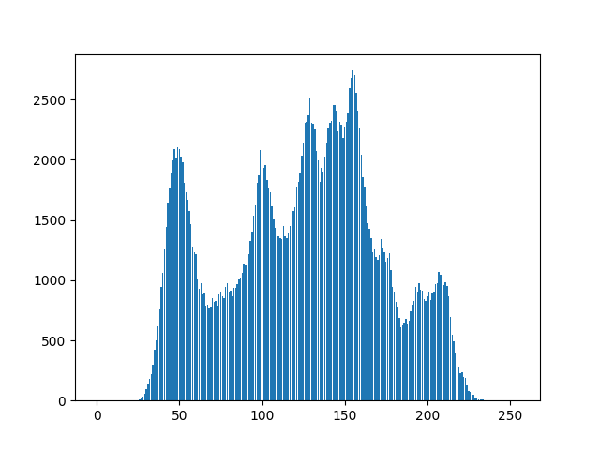

說明:

使用HW2就寫好的計算histogram的function: calculateDestribution()。

1. Image with intensity divided by 3 and its histogram



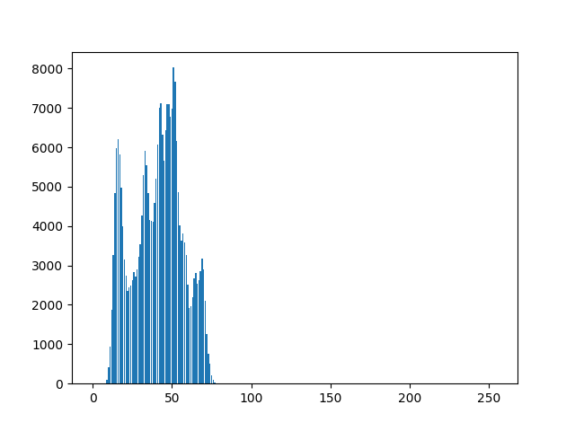

說明:

將每個像素值除以三。

1. Image after applying histogram equalization to (b) and its histogram



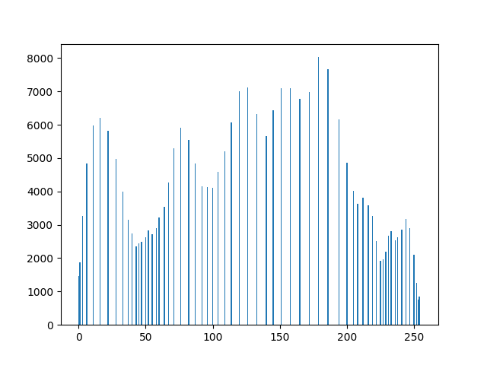

說明:

將(b)做好的圖片去做histogram equalization，遇到值為k的pixel就使用sum(hist[:k]) 將intensity <=k的個數算出來再套公式。

