COMP3331 - Lab 1

Exercise 1: nslookup

## Answer:

1. There are 3 IP address for [www.koala.com.au](http://www.koala.com.au)

* Name: www.koala.com.au
* Address: 104.18.61.21
* Address: 172.67.219.46
* Address: 104.18.60.21



In my opinions, the reasons that several IP address for one domain are:

* Loading balance. If the domain normally has a large number of users, 1 IP address might not be enough to handle it. Multiple IP address can be used to handle higher end-user traffic.
* Increase website performance. multiple IP addresses means the website hosted at multiple different locations, so user probably receive the response from the IP address that is “nearest to your location”. This is done to increase a specific website performance

1. It is “localhost”, it is the IP address for the computer I am currently working on.

#### Exercise 2: Use ping to test host reachability

## Answer:

**Reachable address:**

* [www.unsw.edu.au](http://www.unsw.edu.au/)
* [www.mit.edu](http://www.mit.edu/)
* [www.intel.com.au](http://www.intel.com.au/)
* [www.tpg.com.au](http://www.tpg.com.au/)
* [www.amazon.com](http://www.amazon.com/)
* [www.tsinghua.edu.cn](http://www.tsinghua.edu.cn/)
* 8.8.8.8
* 
* 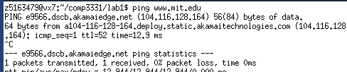
* 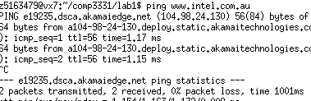
* 
* 
* 

**Unreachable address:**

* [www.getfittest.com.au](http://www.getfittest.com.au/)
* [www.hola.hp](http://www.hola.hp/)

these domains are unreachable, since they are invalid domains

**ping unreachable, but browser can:**

* [www.kremlin.ru](http://www.kremlin.ru/)

this domain is reachable on browser, but not ping. I think it is because this domain probably disables ping response for some security reason, like denying ping flooding.

#### 

#### Exercise 3: Use traceroute to understand network topology

1.

Traceroute output:

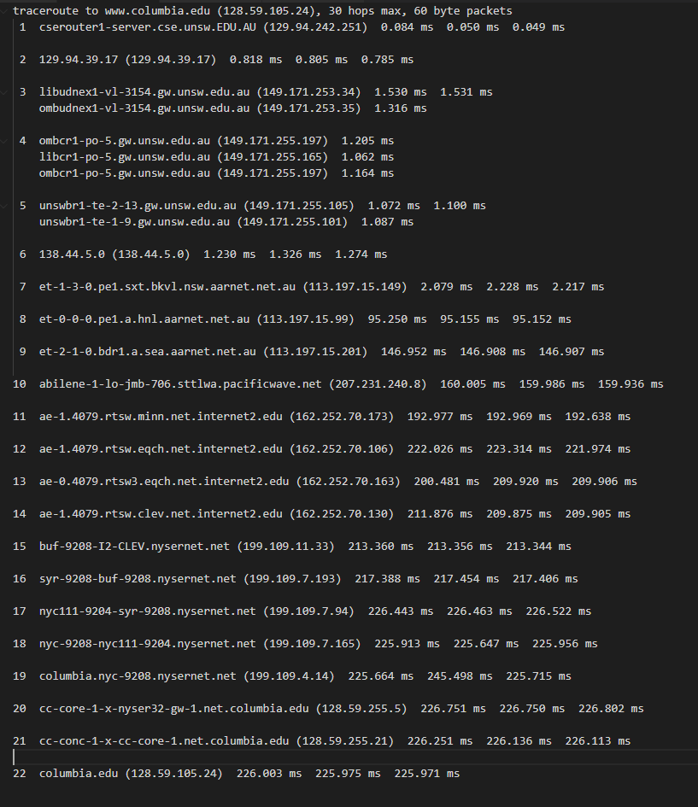

## Answer:

* How many routers are there between your workstation and [www.columbia.edu](http://www.columbia.edu/)?
  + - 21 routers from the output
* How many routers along the path are part of the UNSW network?
  + - 5 routers
* Between which two routers do packets cross the Pacific Ocean?
  + - 7 – 8
    - 113.197.15.149 – 113.197.15.99
    - We can observe the delay increase rapidly from 7th router to 8th router

2.

Traceroute output:

(i)  [www.ucla.edu](http://www.ucla.edu/)

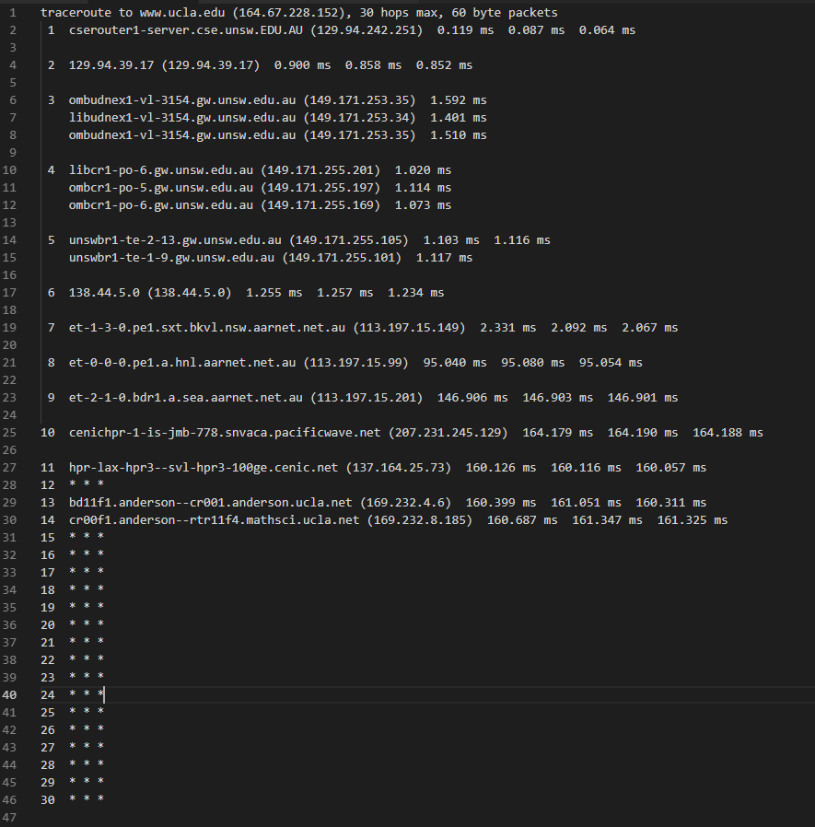

(ii)  [www.u-tokyo.ac.jp](http://www.u-tokyo.ac.jp/)

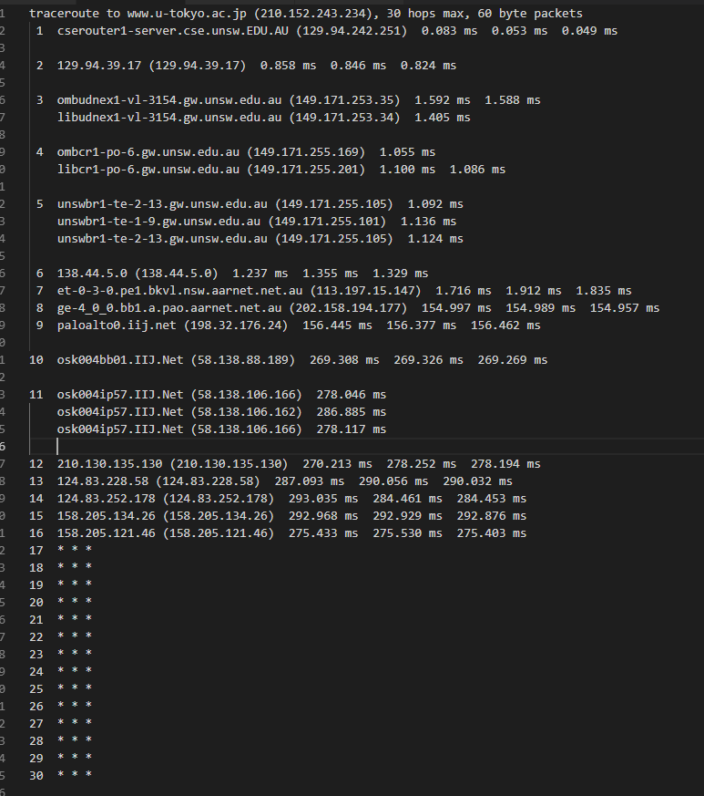

(iii) [www.lancaster.ac.uk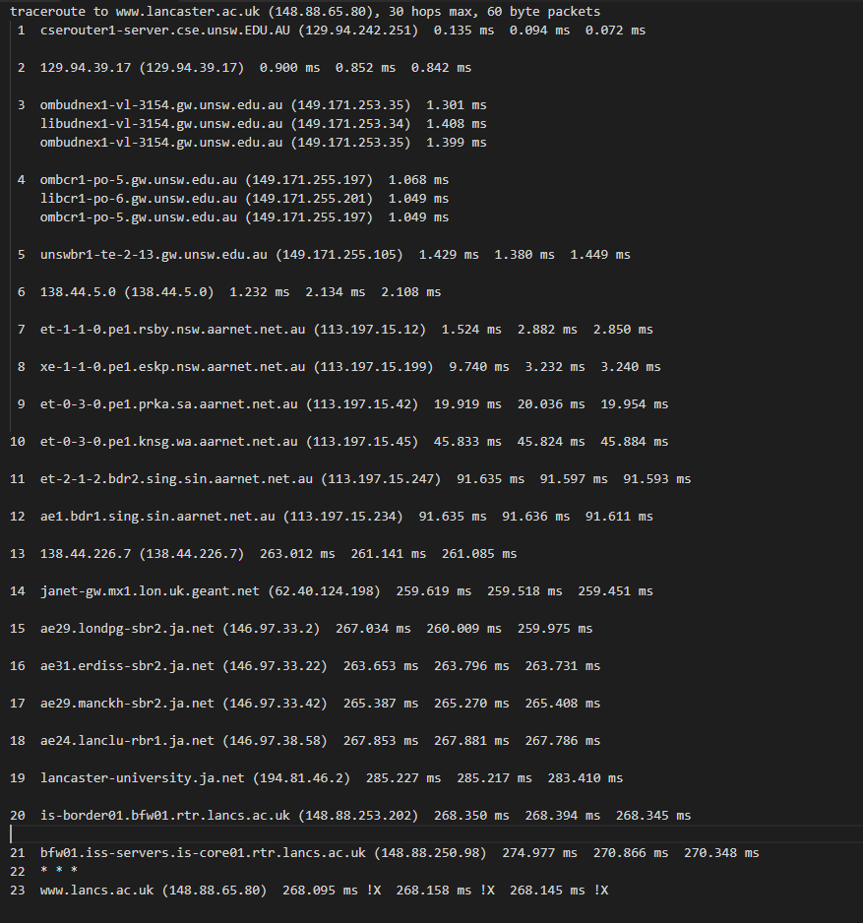](http://www.lancaster.ac.uk)

## Answer:

* At which router do the paths from your machine to these three destinations diverge?
  + - 6th row - 138.44.5.0
    - It belongs to Australian Academic and Research Network, located in Kensington, Western Australia

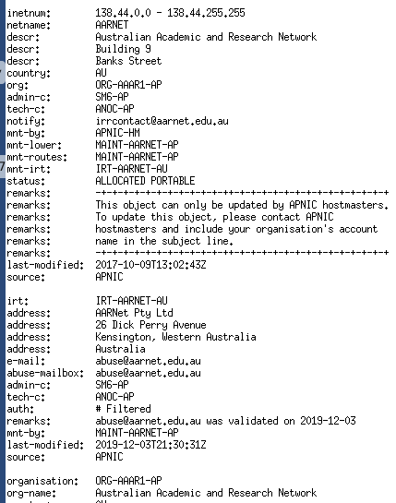

* Is the number of hops on each path proportional the physical distance?
  + - * Yes. As you can see, The IP address for 1st output is located in US, 2nd is located in Japan, 3rd is located in UK. And the order of distance between their location and Australia is UK>US>JP.
      * And we can see, apparently, the number of hops for UK is much larger than US and Japan. So, we can conclude it is related to the physical distance.
      * I cannot use the output of US and Japan to make a conclusion for this question, as there are too many asterisks in the output, we cannot count the valid hop from those output.

3.

For this question, I will use 129.94.242.117 as my local computer address. Since I use Vlab for this lab exercise.

#### [www.speedtest.com.sg/tr.php(202.150.221.170) and 129.94.242.117](http://www.speedtest.com.sg/tr.php(202.150.221.170)%20and%20129.94.242.117)

1. <http://www.speedtest.com.sg/tr.php> to 129.94.242.117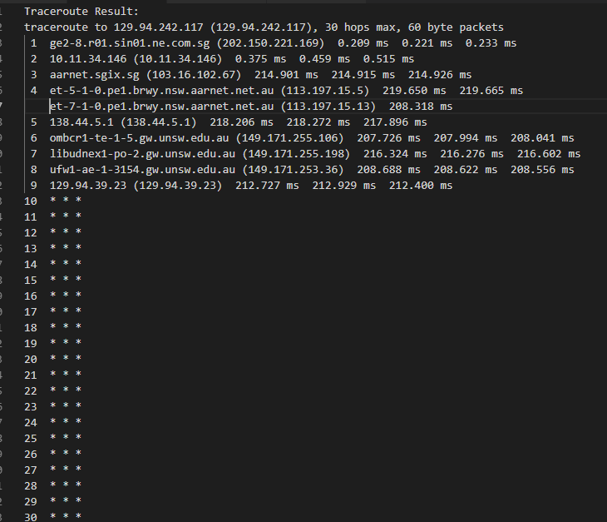
2. 129.94.242.117 to <http://www.speedtest.com.sg/tr.php> 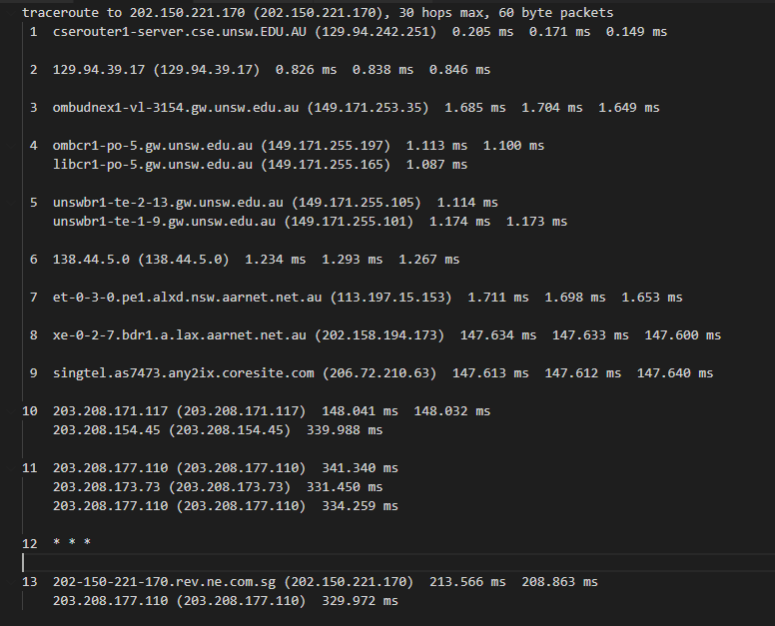

## [**https://www.telstra.net/cgi-bin/trace**](https://www.telstra.net/cgi-bin/trace) **(203.50.5.178) and 129.94.242.117**

1. [www.telstra.net](http://www.telstra.net) to 129.94.242.117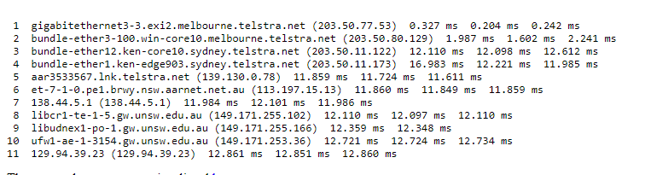
2. 129.94.242.117 to [www.telstra.net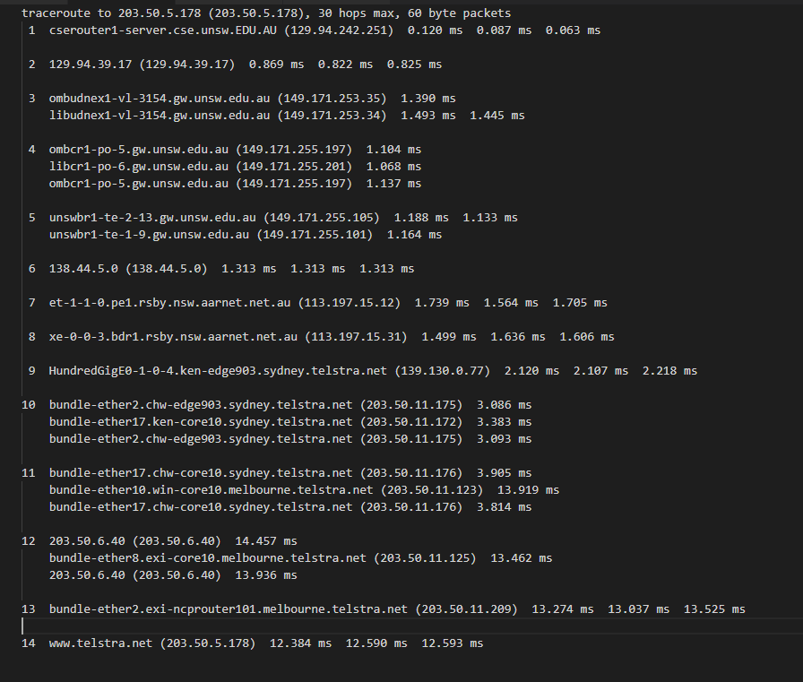](http://www.telstra.net)

## Answer:

* What are the IP addresses of the two servers that you have chosen
  + - I put the IP address in each subtitle
* Does the reverse path go through the same routers as the forward path?
  + - No, the number of routers the packet travel is different + different travel path
* If you observe common routers between the forward and the reverse path, do you also observe the same IP addresses? Why or why not?
  + - There are not common routers in my traceroute output. Since all the IP address are different.
    - The reason I did not observe common router is because maybe the network travel algorithm makes packets travel by different path, so packets travel through different router.

#### Exercise 4: Use ping to gain insights into network performance

For this question, I pick (i) [www.uq.edu.au](http://www.uq.edu.au/)(ii) [www.dlsu.edu.ph](http://www.dlsu.edu.ph/)and (iii) [www.tu-berlin.de](http://www.tu-berlin.de/)

1.

## Answer:

**Distance from UNSW to**:

(i)Brisbane: 734,280 m (ii)Manila: 6,265,900 m (iii)Berlin:16,084,000m

**Propagation speed 3x108 m/s**

T: (i)2.45ms (ii)20.89ms (iii)53.61ms

**Minimum RTT: (from .txt file, I will include those .txt file in submission)**

(i)16.42ms (ii)297.159ms (iii)277.215ms

**Ratio:**

(i)6.7 (ii)14.22 (iii)5.171

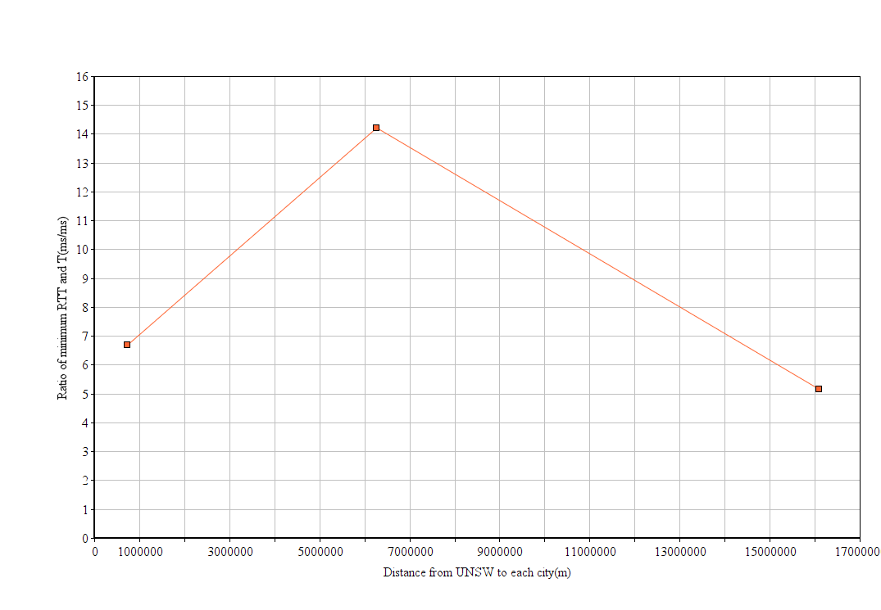

* Can you think of at least two reasons why the y-axis values that you plot are greater than 2?
  + - * Queuing time at each router during the trip. For routers between UNSW and destination, there may be exist some busy routers, so the total queuing time need to be considered.
      * Transmission time at each router is also one of the reasons. Each router between UNSW and destination have vary transmission time for the packet download+upload. The transmission time will affect the delay.
      * Processing time at each router. Processing time is negligible, but it still affects the delay.

2.

## Answer:

The delay is various over time. As the queuing time is one of the most important factors that affect delay. Some routers may be in the evening, and no busy in the morning, so it the packets arrive in the morning, queuing time will be faster.

So, delay vary over time.

3.

## Answer:

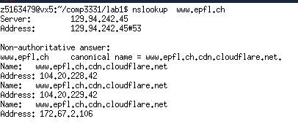

[www.epfl.ch](http://www.epfl.ch) is hosted by 3 IP address that I found from **‘nslookup’.**

And they are all located in US, not in Switzerland (Check by **‘whois’**)

4.

## Answer:

**Depend on:**

Transmission delay – transmission delay is the amount of time required to push all the packet’s bit into the wire, therefore larger packet need longer transmission time.

**Not Depend on:**

Processing delay – Processing delay is the amount of time that process packet’s header, and the size of header is constant. So, the packet size won’t affect this delay.

Propagation delay – Propagation delay only depend the distance between source and destination, and the propagation speed

Queueing delay – Queuing delay only depend the congestion level of router when the packets arrive.