# Water Flow Sensor using Arduino Pro Mini , Nrf24L and patch board.

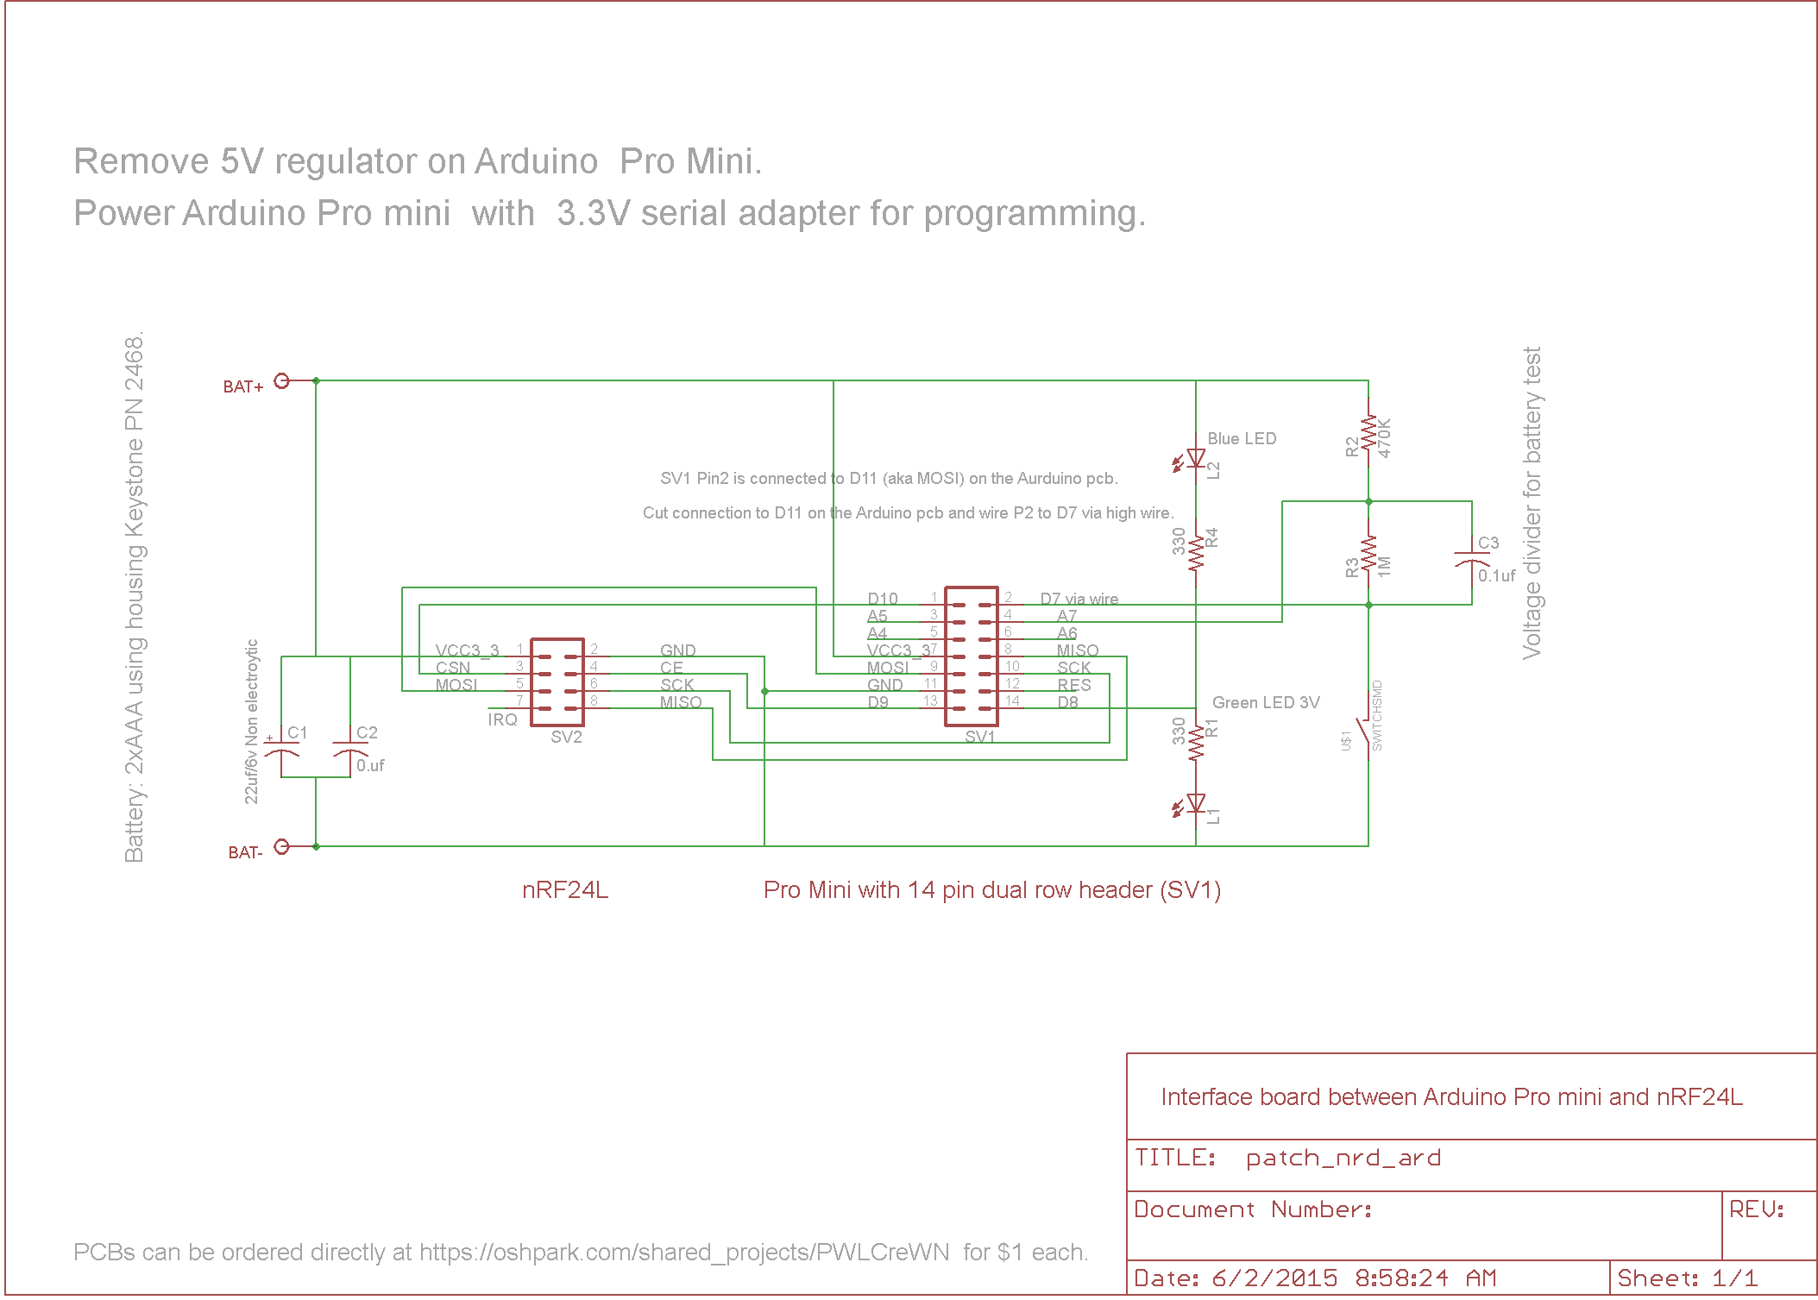

This is to be used with an Arduino Pro mini with a dual line header row of contacts on one end as pictured and with modifications applied as outlined below. The Arduino is running at 3.3V of a miniature 16 Mhz Xtal. This combination is theoretically out of specs and for a production run an Arduino that ran on a 8MHz xtal should be used. However that entails making a full PCB and making the thing from scratch.

Power consumption with single flow sensor and low duty flow trigger device:

Standby (sleep) 3 uA @3.3V

Active 20mA @3.3V

Batteries: Suggest 2 AA Lithium cells for longest battery live and max power output , but regular Duracell AA will work also .

Wire connections to sensors

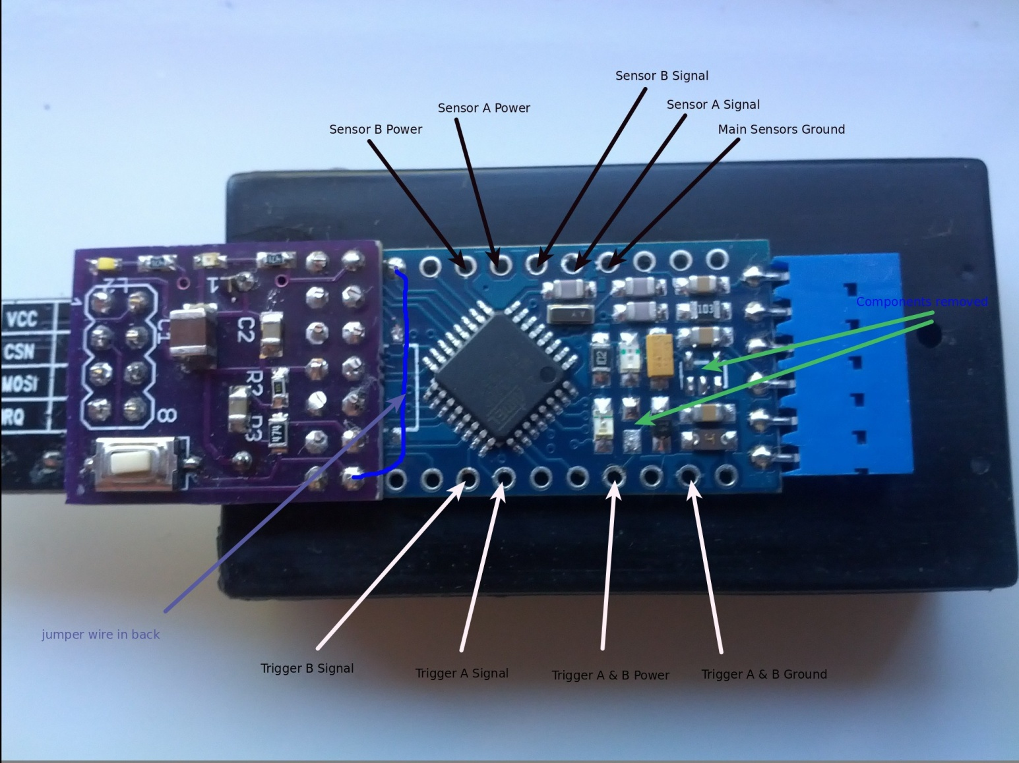

On Arduino board, cut trace emanating from pin D11 and add wire as shown above for battery voltage measurement.

# Start up and connection of Raspberry Pi

The Rpi is configured with a console mode user interface – no gui desktop. The default username “pi” with password “raspberry” is used . The easiest way to connect to the pi is by adding an USB keyboard and a HDMI monitor to it to get to a login console. Alternatively a ssh session ( use Putty) can be used via the network as long as you know the Rpi’s IP address on your network.

To find the Rpi’s IP address you connect the Rpi to your router via the cat5 cable, connect monitor and keyboard and power it on. After it’s done with booting log into account “pi” and issue command “ifconfig” . It will display it’s IP address on the second line displayed under “eth0 , inet addr”. Make note of this address , you will need it to point a web browser at it to get to the domotics gui.

The domotics server starts up automatically as a daemon on boot-up. It looks for the Mysensor gateway attached to the USB port. If you look at the boot log as it scrolls over the screen on startup you will notice that toward the end there is mention of domotics starting up.

As soon as the Rpi boot is finished the domotics user interface is available via a browser from another machine . Use the IP address from above as in <http://192.168.1.136> or <https://192.168.1.136> (in my case). From there you can control domotics .

The sensors have a push button and two LEDs on them. It is checked only during bootup of the sensor . and sets the meters counters back to 0.0 . The white LED is used to signal initial communication with the gateway on startup and then later whenever a reading is sent to the gateway again. The blue led signals just before the sensor enters sleep mode after 1 minute of no activity. If the white LED does not go out after power up of the sensor your distance to the gateway is too long or obstructed and the node cannot successfully communicate.

The gateway node has 3 LEDS to signal receive, transmit and error status . The green LED comes on whenever the gateway receives a message, the Yellow when it sends a message. On startup of a sensors both LEDs blink indicating to and from communication with the node. If these LEDs dont blink on startup of a node then the RF path is most likely too long or obstructed. The gateway also has two LEDs on the attached USB adapter . They also indicate rx/tx as seen from Domotics. Unfortunately the Chinese where cheap and used two red LEDs ..

The Switch on the Gateway does nothing.

# Arduino Firmware for Mysensor gatway and sensor node

The MySensor library v1.53 is used to build the sensor nodes, but I had to use V1.4 to build the gateway because of some bugs that prevented me from compiling the Gateway under 1.5. The Gateway code is their unmodified V1.4 Serial Gateway as found in the Examples directory

I enclose a CD with the source and Arduino build environment setup for the sensor nodes. The code should be easy to follow and is well documented inline. You find it under directory “Arduino/MyMySsensors/Watermeter”.

# Verification of sensor activity

On startup the Rpi and attached MySensor gateway need to be running before you power on the meter nodes initially . To check the nodes report open a browser and go to the utilities putdown to see all the sensors status icons. Then blow into one or the other meter and observe the white / blue LED on the node to confirm it communicates. After a while you should see that the status (red ) on the nodes has changed and that the least reported date is now current. The flow total takes a little time to get updated on the meter Icon . You can also go into the log pages and see report values and graphs.

I calibrated one of the sensors with a 1 gallon flow. The setup pages in Domotics have further calibration options for RFX meters in general . you can modify the number there to get an more exact reading should you find that my calibration was off. Bear in mind that the sensors are supposed to be mounted a certain way to all give the same counts/volume. I have not played with orientation to know if the change is significant or not.

# RF range

As stated in conversations before, the RF range of the Nrf24 module is basically limited to a personal space. You will encounter issues with lack of communication if there is no line of sight , or nearly line of sight . I basically get through one or two sheet rock walls if nobody stands in between and the antennas are aligned properly. You will have to experiment with antenna alignment yourself . I think best signal strength is obtained when the PCB antenna is aligned edge on to the other node.