PROG8170

Software Quality Assurance Techniques

Individual Assignment #**4** – 7.5% (45 marks)

**Due Date: Week of April 20th 2017 in Class**

Gurpreet Singh

7700370

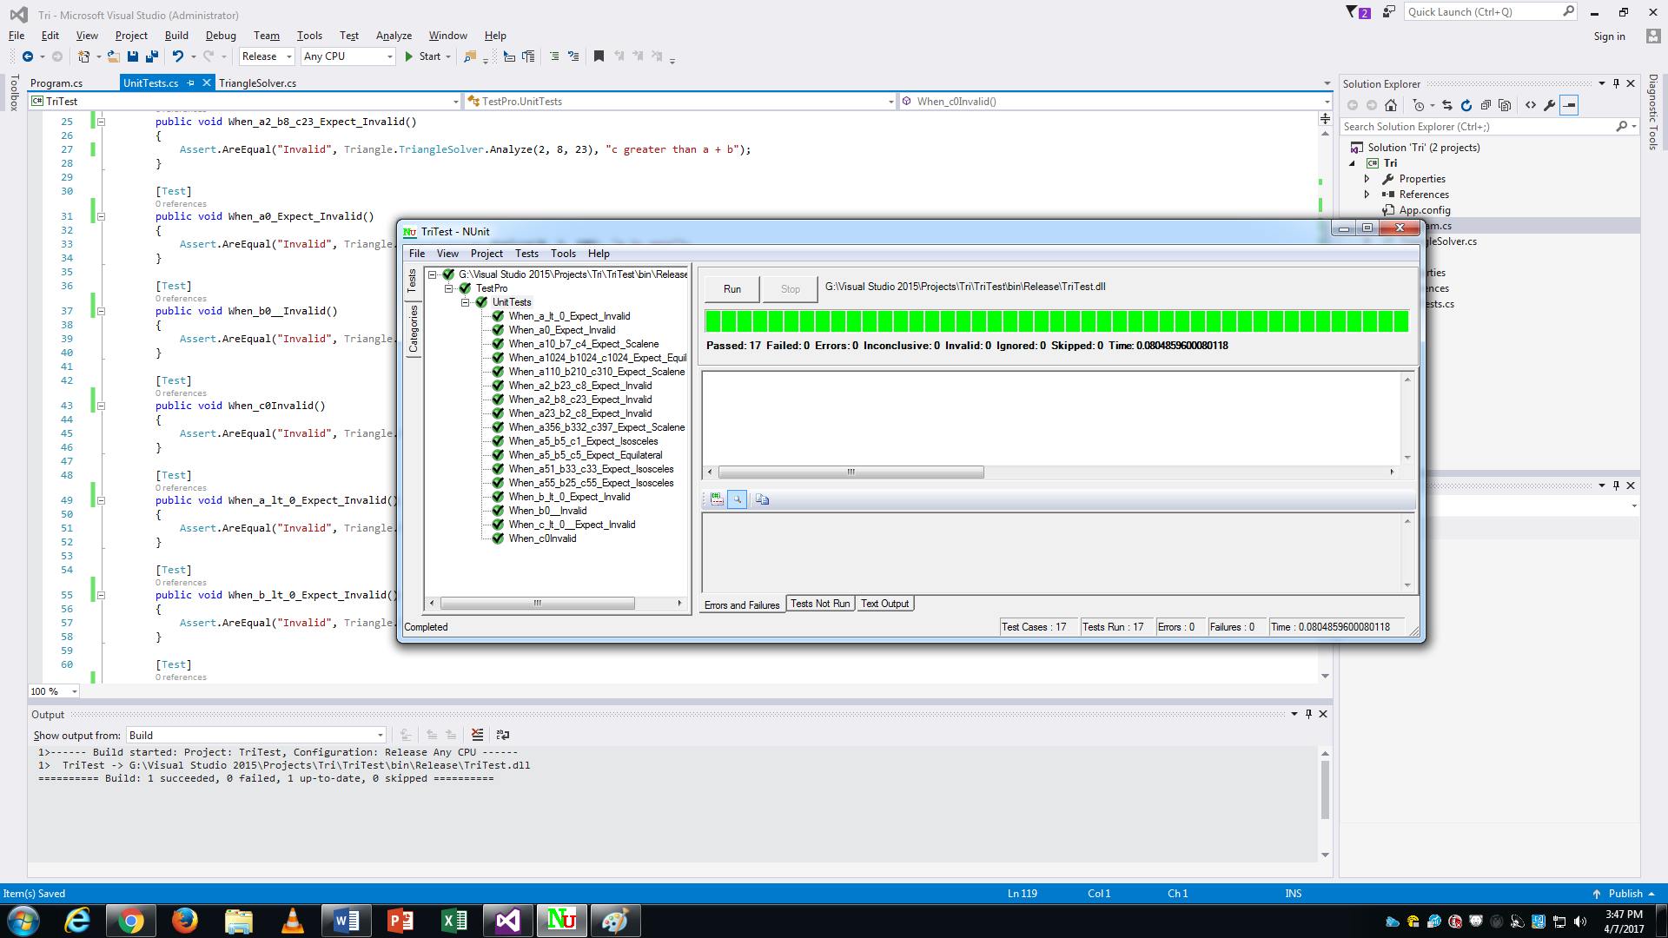

Screenshot of completed unit tests run successfully

Screenshot showing repository with a commit history.