The Broadcasters Audience Research Board estimates that 26.8 million UK households own at least one television in their home[1], often the centre piece of their lounge. A television then can have several devices attached, a DVD player, a games console, a Sky box etc. The lounge is often arranged to make the television the focal point[2], therefore the set up should be aesthetically pleasing and for optimum viewing often placed against or near to a wall. This documents assesses the usability and accessibility of the television and the devices which interact with it, and where possible suggests improvements that could be made.

Jakob Nielsen’s principles on usability are referenced throughout this document to evaluate the usability of the current set up. The principles were chosen as Neilsons Heuristics, developed with Rolf Mulich, has for nearly 20 years been one of the most widely used in the field of usability. The principles are

* Visibility of system status
* Match between system and the real world
* User control and freedom
* Consistency and standards
* Error prevention
* Recognition rather than recall
* Flexibility and efficiency of use
* Aesthetic and minimalist design
* Help users recognize, diagnose, and recover from errors
* Help and documentation

Appendix 1 contain a brief description of the principles terms. Where applied in this document they are shown in italics.

**Remote Controls**

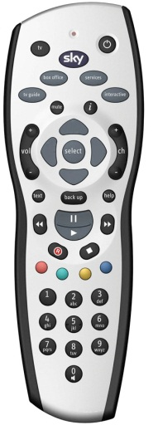

Figure 1 - Sky Remote

Figure 1 shows a standard Sky Plus remote with 41 buttons. 10 of these are numbers, 6 control Sky Plus, 2 scroll through channels, 15 are for menus and submenus, an off switch, and a volume and TV button do not come pre-set to work with a TV. Unable to find any research on the matter, friends and family were asked about their remote usage and none could list the correct number for more than 10 channels. They were all using their remote by going to the Sky Guide and then scrolling to select the channel. The other buttons commonly used were pause and play. In some instances 35 buttons on the remote were not used, and there was confusion as to what some buttons actually did. [3] This is not consistent with *minimalistic design*, as irrelevant options are being displayed at all times and Neilsen comments that ‘*even if* *90% of buttons are clearly labelled they become harder to understand because the remaining 10% interfere with your ability to form a simple mental model of the device and what each part of it does*.[4]

The Sky remote has been chosen to be assessed as it is the most common TV remote in a British home, with 10 million households having a version of a Sky box.[5]

In a flow state?

Ideally a user should be able to interact with all of their devices at once without feeling challenged by the process. Mihály Csikszentmihályi defined a flow state as being – *‘the mental state of operation in which a person in an activity is fully immersed in a feeling of energized focus, full involvement, and success in the process of the activity’*. [6] For a novice user a task such as changing the sound settings can mean having to try multiple remotes (the TV, the DVD player, or the stereo) to make an adjustment. If they choose the wrong one then they could go through irrelevant menu’s and change sound settings which may not actually change the sound output. This is a lack of *visibility of system status* as nothing appears to be happening, and an unconfident user will not enter the flow state as they will become confused.

A Smarter Remote?

Manufacturers have already begun releasing applications to control their devices, for example a user can switch Sky channels using an Ipad. To advance the current design a touch screen remote control (TSRC) which connects to all devices connected to the TV could be developed. The remote could be a standalone device or an app on a smart phone and would have voice recognition, have sound output, text display, and vibrate to allow haptic feedback for hearing impaired users.

With user permission usage tracking would allow the TSRC to learn its user’s preferences to re-organise the menu based on their trends, shortening the process of selection and becoming both *flexible and efficient*. In Figure 2 the smart phone application has learned that the user most frequently turns on the TV and then opens the Sky Guide to find a program to watch, so this is displayed first. Each menu would lead into a relevant sub menu that again matches the most common preference. Figure 3 shows a full size TSRC changing Sky TV.

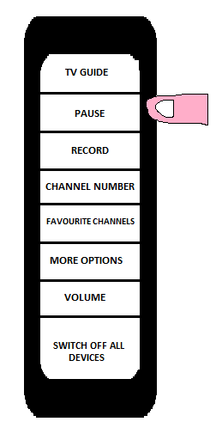

Figure 3 - Sky menu on a Smart Remote

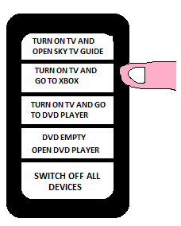

Figure 2 - Main menu on a smart phone

For the TSRC to be an advantage it has to be able to successfully allow the user to change the system in a faster and more simplified way than it takes using 2 remotes. The TSRC would use a multiple gesture touch pad and allow advanced users to complete simultaneous tasks on two sections of the screen, not currently possible unless a user can control a remote in each hand. In figure 4 the user is turning up the volume whilst pressing play for the DVD. Short cuts could be programmed for instance double tapping the remote brings up the volume or a triple tap to activate voice recognition. At each option the changes occurring are displayed to show *visibility of the system status*.

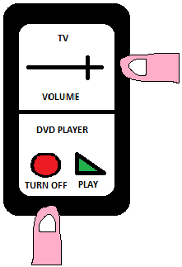

Figure 4 - Simultaneously adjusting volume and DVD player on a smart phone

*‘My granddaughter pressed some buttons on the remote and I couldn’t watch the TV until my husband came back and fixed it!’ -* Quote from a member of my own family.

As it turned out the issue was that the girl (2 years old) had zoomed in on the TV so that only a small part of the screen was visible and there was no clear way to reverse this. It was unknown if it was Sky or the TV that had been changed, and the user was not able to *recognize and recover from errors* so the system became unusable. User control and freedom states that an ‘emergency exit’ is required to allow a reverse of the settings. The TSRC would store the settings of all devices it connects to and make a copy every 24 hours, stored for a week. If a change happened that the user wasn’t expecting they could then revert back to a day’s settings they knew worked.

Mobility and cognitive difficulties

‘*Some things I find difficult because some days I have got more strength in this hand than others and some days I don’t feel anything. The buttons have got to be really easy to push’.* Quote from a 57 year old female. In a 2009 Ofcom Report - Experience of People with upper-body mobility and dexterity impairments. Even with the “normal” ageing process there is a reduction in physical and cognitive ability and requirements for the user can change in a short space of time.

|  |  |
| --- | --- |
| **User Action** | **Remote Response** |
| User says ‘Record a program” | TSRC recognises key word, wakes from standby, and responds “Which program would you like to record” |
| User responds “Record all episodes of Match of the Day” | If(Match of the Day found)  { Records all episodes of Match of the Day;  Responds “All episodes of Match of the Day will be recorded”}  Else {Responds “Program not found, which channel is it on?”;} |
| User responds if necessary | Further action if necessary |

The TRSC has several advantages for those who have dexterity issues. For the female detailed in the report using a remote has effectively become a hard operation. With a touch screen no pressing would be required, and for those with greater difficulties, voice recognition would remove the need for touch control. Voice recognition is more familiar to people now it is integrated into smart phones and the technology, whilst not perfect, is continuing to improve. A study showed that Apple’s Siri accurately recognised words and sentences 89% of the time. [7] Whilst the interpretation success rate was lower the commands given to the TRSC would be on a narrower range to that of Siri. An example of how this could be used is demonstrated in table 1. Speech, text display, or number of vibrations are all outputs that could be used to indicate to the user if the request has been successful or if more information is needed.

Table 1 – Activation by voice command

For visually impaired users the digital display could be set to rescale or recolour to make the screen more readable, and for those with cognitive problems the remote could display much larger buttons coloured prominently on a white background. Products like this are already promoted for dementia patients; large buttoned with a minimal number of selections to make them more user friendly[8]. A range of designs could be developed for specific target groups, indeed even displaying more buttons than the current 41 on the remote if an advanced user so desires.

In the Ofcom report there is a specific quote from a user who had taken 45 minutes to change the batteries in his remote. Whilst the cost could be slightly higher there is no reason why the TSRC could not have a lithium-Ion battery and be mains charged. The device would have a USB plug so when users do report back issues then software patches could be downloaded to rectify them.

Other considerations

In Western Culture a meaning of green is ‘to go’ and red can be ‘danger’ which is why green is usually an on button and red is usually an off button. However in other cultures it is the opposite. For example in South America green is associated with death and in Hindu red is associated with energy.[9] The TSRC would be set to display the correct buttons to fit the country it is being used in. There could be circumstances where a foreign user uses voice recognition, and if a different language is recognised then the remote should temporarily change all text to that language, and ask the user if the change is permanent. Cultural personalisation is a way to satisfy the *matching the system and the real world experience for that user*.

**Interacting with menus**

In nearly all circumstances there is only one purpose for a television menu - to allow the user to fix the problem they are having at that time. On my own television there are 10 submenus, the majority of which I had not seen until I began counting them for this essay. An option on the display menu was adjust ‘monochrome’, a term I have not come across before and within the menu a description was not available to me. Neilsen specifically stated in *help and documentation* that technical jargon should be avoided in a GUI. In this section the analysis of the menus are not limited to the television. Other devices such as Sky, Virgin, BT Vision, DVD Players etc. are also considered.

Users can be nervous at changing settings. Manuals are often lost and sometimes not clear enough to advise an unsure user. A functionality that would improve the *help and documentation* of a menu for internet connected devices would be that when a user has hovered over a menu for a few moments a link appears offering to bring up a video. This would show a representative of the company explaining in layman’s terms how to use that section of the menu. Within this video there would be a facility for users to leave comments and questions which would allow the company to update the menu or video in response to common problems. This would enhance the service offered to customers and potentially gain brand loyalty. Figure 5 displays a mock-up of this.

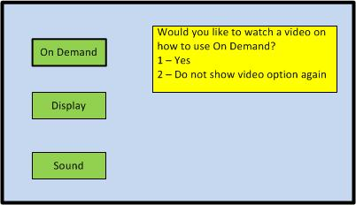

Figure 5 - Help video option appears if user is hovering over menu

On many current systems the menu does not change and prioritise the options according to what the user most frequently does. This is neither *flexible or efficient*. Usage tracking could allow the manufacturer to monitor common trends, and bring those options to the front page to improve the *efficiency*. To test *error prevention* the company could track when a menu is entered and then immediately cancelled. This would indicate that the user has gone to the wrong place, and if enough customers are doing the same thing it would be determined that the menu is unclear.

Presently all menu systems are different depending on the manufacturer, and sometimes depending on the version of the device within the manufacturers own product range. Many will share similar menus, for example Sky and Virgin both contain a TV guide, options to watch an On Demand content, change picture settings etc. A picture setting menu is also contained within the TV, which results in a duplicated option, potentially confusing a user and against *minimalistic design*.

The differences in menu’s can be straight forward for an advanced user, who might consider Neilsen’s *consistency and standards* to be met by the similar design. However for a novice it is entirely different and getting used to a new technology can be a barrier to entry. To achieve *consistency* an option could be to create a standardised menu system that runs on all major devices where similar functions are grouped in a superclass, and a sub class exists for features specific to just that device. Where duplication is found the menu is simply removed from the users list of choices. The *consistency* would enable a user to be familiar with a new device and over time *recognition* would become stronger. However competing business interests do make this extremely unlikely.

Another *consistency* issue with a TV is that the volume can be a problem when switching between channels or devices as they may require different outputs. For example whilst watching Sky my TV volume is set at 19, but through my laptop the volume needs to be changed to 50. Inevitably the adjustment is forgotten and when the TV is returned to Sky the volume is extremely loud. A better solution is for the TV itself to have a range of decibel output and override the volume settings whenever a sound is heard outside of that range.

TV set up

A television on a moveable wall bracket is an example of a good set up, particularly for a user who may struggle to get behind a TV stand. It can be pushed up against the wall where it will take up minimum space and can be manoeuvred to improve the view. Some are height adjustable and many can be rotated more than 90% to allow the user to change leads with far more ease. The TV also has to fit *aesthetically* within the home, and some users may not be able to install it themselves. There is also the issue of multiple dangling wires which need to be concealed.

Figure 6 is an example of how the back of many televisions look, and Figure 7 shows how 4 devices connected to a TV equates to 13 separate wires, not including the console controllers at the front. Inevitably over time these wires will get tangled and when a change is required it can be a frustrating experience. My own TV does not have the scart sockets to allow 3 devices to be plugged in simultaneously and whilst a multi-port scart extension can solve this, it involves yet more wires.

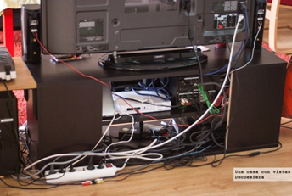

Figure 6 - Behind a TV

The Ofcom report found that some users with mobility issues did not have the strength to connect leads and had paid for their service provider to send an engineer to fix relatively minor set up problems. This is a costly solution to an accessibility problem not of their own making.

An ideal solution is to have a completely wireless set up between devices, but with current technology there is no way to effectively power a TV wirelessly in a user’s home. Streaming picture and audio however is possible and could eliminate at least 6 of the wires in figure 7. Less wires is an example of *minimalism*, however a user may not like the reduction in the *visibility of system status*, therefore a display if the device is actually connected would be required.

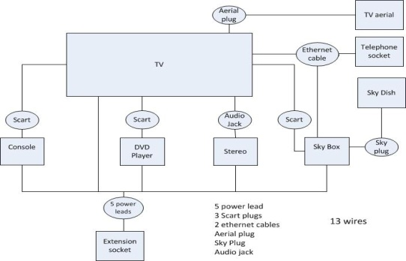

Figure 7 - Wires for my TV

The future for TV’s

It is important to remember that technological innovation and design have already greatly reduced many of the accessibility issues with a television. A 40” CRT, the Sony KV-40XBR800 released in 2002 weighed 138kg[10] compared to a 2012 40” LED Sony KDL-40HX853 which weighs only 13.7kg[11]. The wires themselves are also getting smaller, for example a HDMI lead is a third of the size of a scart lead.

The next major change in TV is likely to coincide with the roll out of superfast broadband. Currently an internet TV can have Love Film instead of a DVD player, Steam instead of a games console and Spotify instead of a CD player. Next year BT Vision plans to stream its new BT Sport channels live to its customers over BT Infinity[12]. The government has a target of delivering a minimum 2mbps[13] broadband to all households by 2015 with Openreach aiming to enable fibre to the cabinet to 75% of homes in 2014[14]. Speeds will continue to rise and costs will fall and it is entirely possible to see a future in 10 years where digital media is delivered not by aerial, satellite or discs but through fibre optic and into a wireless TV that requires only one wire - the power lead.

Ofcom estimates that 80% of UK homes have the internet, up 23% since 2006. 50% of those without internet access stated that they saw no advantage in getting access to the World Wide Web. With an increase in streamed media these tech novice’s may eventually wish to buy an internet enabled TV, and the manufacturer which has built up a reputation as having the most user friendly system will be in a very strong position.

Summary of findings

This report shows that the setup of a TV and the devices attached do not yet meet the requirements set out by Neilsen’s principles on usability.

Multiple remote controls are sometimes required to change a setting; this has led to confusion and in some instances where a mistake was made has meant someone could not watch the TV. Neilsen himself commented on remotes having ‘*horrendous usability’* in his blog, and that he only used 33% of the buttons[15]. Following the current trend of moving away from buttoned devices, the smart controller would attempt to solve these issues by identifying the users viewing habits and adapting itself to become more efficient. Menus are a challenge for users, and if the companies can improve the experience then the customers will respond by being loyal to the brand. The suggestions set out for an improved GUI are all achievable and would satisfy the requirements set out by Neilsen nearly 20 years ago.

The report has commented on the additional difficulties cognitive or disabled users have in operating their devices. Proposed solutions are to improve their experience and whilst every eventuality cannot be taken into account, the benefits the smart remote could bring are apparent to a wide range of users with mobility, hearing, or visual impairments compared to the current set up.

Any change a manufacturer implements has to be consumer driven, and the company which focuses on satisfying the widest range of potential customers will reap the benefits for years to come.

Bibliography

Books

Nielsen, J. Heuristic evaluation. In Nielsen, J., and Mack, R.L. (Eds.), [*Usability Inspection Methods*](http://www.nngroup.com/books/usability-inspection-methods). 1994 . Published by John Wiley & Sons, New York, NY.

Reports

Ofcom - Experience of people with upper-body mobility and dexterity impairments in the communications market. 2009. <http://stakeholders.ofcom.org.uk/market-data-research/market-data/consumer-experience-reports/ce09/> Published by GfK. Accessed 14/12/12

**Appendix 1**

Summary of Neilsen’s heuristics

Visibility of system status

A system should keep the user updated about the process it is completing, giving appropriate feedback.

Match between system and the real world

The systems responses should be understandable to the user and operate in a logical manner.

User control and freedom

The system should allow a user to reverse from an unintended change without having to change all the settings again.

Consistency and standards

The layout and wording in GUI should look the same throughout.

Error prevention

Stopping the user from being able to cause an error in the system by good design.

Recognition rather than recall

Minimizing the amount of mental effort the user needs whilst selecting options.

Flexibility and efficiency of use

Accelerators to speed to a user’s navigation of the system.

Aesthetic and minimalist design

Only relevant information should be displayed to the users.

Help users recognize, diagnose, and recover from errors

Error messages should be clear and concise and advise on the next step the user should take.

Help and documentation

Where errors cannot be prevented clear documentation must be produced to assist the user.

The heuristics were developed for software but there are overlaps with hardware, for example minimalist design can be seen in the evolution of a television as they become ever thinner.

**Appendix 2**

As I could find no available research on the subject and did not have the means to conduct a large scale study of my own, I asked friends and family about their own experiences with the Sky remote. This was done through an open discussion with each of them. To confirm my findings a survey with a far wider range of demographic would be necessary. The collated results are below.

|  |  |  |
| --- | --- | --- |
| **Demographic** | **How many channels can you recall?** | **Are there any buttons you do not know the reason for?** |
| Male, age 25 | 9 | N/a |
| Male, age 35 | 8 | N/a |
| Male, age 24 | 8 | N/a |
| Male, age 57 | 6 | Unsure of the colour buttons and service button |
| Female, age 57 | 5 | Unsure of the colour buttons, interactive and service buttons |
| Female, age 50 | 6 | Unsure of interactive and service buttons |
| Male, age 25 | 8 | N/a |
| Female, age 32 | 8 | Unsure of interactive and service buttons |

1. <http://www.tvlicensing.co.uk/about/foi-licences-facts-and-figures-AB18/> TV Licensing UK FAQ. Accessed 14/12/12
2. <http://www.channel4.com/4homes/rooms/living-room/design-planning-ideas/living-room-planning/plan-design-your-living-room-09-03-26> Channel 4 - Plan & Design your living room. Accessed 14/12/12
3. See Appendix 2
4. <http://www.useit.com/alertbox/20040607.html> Jakob Neilson’s blog (7/7/2004) - Remote Control Anarchy. Accessed 14/12/12
5. <http://corporate.sky.com/about_sky/key_facts_and_figures> BSKYB - Facts and Figures. Accessed 14/12/12
6. <http://www.publishing.waldenu.edu/> S Dhiram (2012) – Mindfulness and the Art of Living Creatively. Accessed 14/12/12
7. <http://www.washingtonpost.com/business/apples-siri-doesnt-work-very-well-research-report-finds/2012/06/29/gJQArtpPBW_story.html> Washington Post (12/6/2012)- Findings on Siri accuracy 14/12/12
8. <http://www.alzproducts.co.uk/handleeasy-321rc-tv-remote-control-for-elderly.html> Alzheimer and Dementia Products – Remote control. Accessed 14/12/12
9. <http://www.informationisbeautiful.net/visualizations/colours-in-cultures/> Information is beautiful – Colours in Culture. Accessed 14/12/12
10. [www.docs.sony.com/release/specs/KV40XBR800spec.pdf](http://www.docs.sony.com/release/specs/KV40XBR800spec.pdf) Sony - Specification of the KV40XBR8000. Accessed 14/12/12
11. <http://www.sony.co.uk/product/tv-102-40-lcd/kdl-40hx853/features#/technical-specifications> Sony - Specification of the KDL-40hx853. Accessed 14/12/12
12. <http://www.productsandservices.bt.com/products/tv/sports-on-bt-vision> BT Vision – Sports offered in Infinity only areas in preparation for BT Sport. Accessed 14/12/12
13. <http://www.bbc.co.uk/news/technology-19651311> BBC News (20/9/2012)- UK cities divide up fast broadband cash. Accessed 14/12/12
14. <http://www.superfast-openreach.co.uk/where-and-when/> Openreach – Superfast fibre broadband. Accessed 14/12/12
15. <http://www.useit.com/alertbox/20040607.html> Jakob Neilson’s blog (7/7/2004)- Remote Control Anarchy. Accessed 14/12/12