Change History

|  |  |  |  |
| --- | --- | --- | --- |
| A | Mar 31, 2023 | G. Chopcinski | Created |
|  |  |  |  |
|  |  |  |  |

# Introduction

This document describes the step to recreate the ASL130 firmware and its variants.

The source code is located in a GitHub Repository at the following location:

<https://github.com/garychop/ASL130_46K40.git>

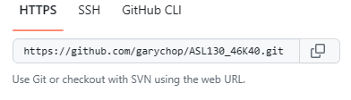

# Repository File Structure

## garychop/ASL130_46K40/Documentation.

This folder contains documents supporting the development of the source code and datasheets including these Software Build Instructions.

## Garychop/ASL130_46K40/firmware

This folder contains the source code files as well as the files to build the source code into the final hex files.

# Build Environment

This source code is built using Microchips MPLAB-X IDE version v6.00.

# Instructions

## Install Microchip X IDE

Install the Microchip X IDE.

Install the XC16 Tool chair (v1.6.1)

Ensure Device Support information: PIC18F-K_DFP (1.5.114)

## Get Source Code

Use “git clone” to retrieve the source code files and the supporting files from the GitHub repository.

## Build the Hex Files.

There are many variations that can be built for the ASL130. These variations are used for the LiNX, QLogic, MK6 and RNet varieties and largely address the issue of matching the ASL130 Joystick Neutral Signals to the Wheelchair electronics Input Modules.

A complete list of these variations is available in the MPLAB X IDE pull down menu and from the menu **Production -> Set Project Configuration** as depicted in Appendix A.

Select each desired configuration then build the hex file using F11 or the menu navigation.

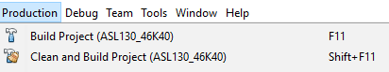

### Renaming the Hex Files

When all variations have been completed, the directory should resemble to the directory/file structure list in Appendix B. Each hex file can be loaded into the appropriate ASL130 product.

You may desire to rename the Hex Files to include the Version Number. The version can be found in version.h.

# Appendix A. Configuration Selection

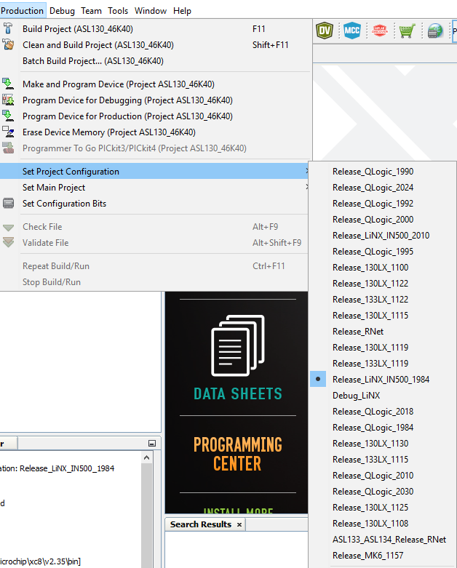

# Appendix B. Hex Files

