ASL110 Display / HHP Screen shots

By: G. Chopcinski Updated: Mar 16, 2020

**Based on version 1.6.0**

This document in includes all screens displayed on the ASL110 Display/HHP device for Display Version.

**Startup Screen**. You will see this screen when power is applied to the ASL110 Display/Head Array (system). You will also see this when the ASL110 Display and ASL110 Head Array are not talking to each other.



This screen still has the ASL Logo.

**Out of Neutral Screen**. You will see this screen when applying power to the system and a Pad is active or when changing features with a Pad active. This is simply informs the patient to release the pad(s) when ready to continue.

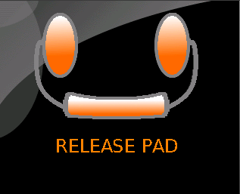

**Main User Screen** with Power On/Off feature selected.

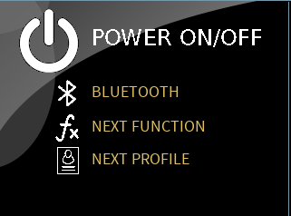

**Main User Screen** with Bluetooth Feature selected

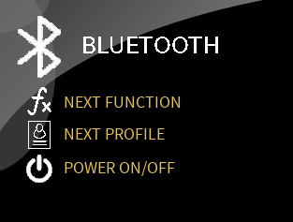

**Main User Screen** with Next Function Feature selected

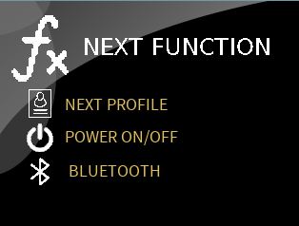

**Main User Screen** with Next Profile Selected

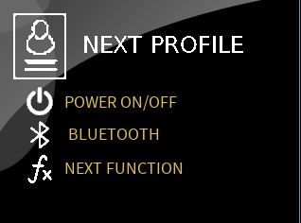

**Main User Screen** with RNet feature enabled and Power On/Off feature active.

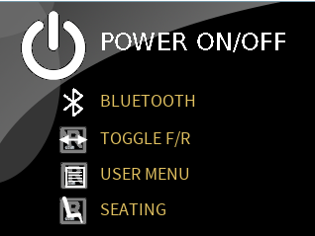

**Main User Screen** with RNet feature enabled and Bluetooth feature active.

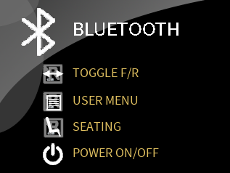

**Main User Screen** with RNet feature enabled and RNet Toggle Forward & Reverse feature active.

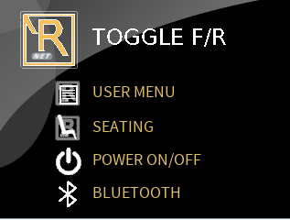

**Main User Screen** with RNet feature enabled and RNet User Menu feature active.

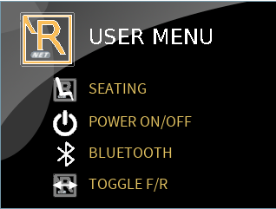

**Main User Screen** with RNet feature enabled and RNet Seating feature active.

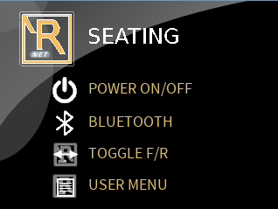

**Power Off screen**. This screen is displayed when the Power On/Off is selected and the buddy button was momentarily pressed. Press the Buddy button switch to enable the ASL110 Head Array’s normal operation. Essentially, this screen is informing the patient that the ASL110 Head Array is Idle and the wheelchair will not react to any pad activation.

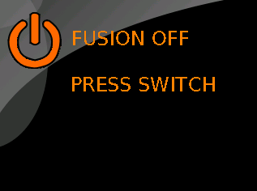

**Initial Programming Screen**. This is the first Programming Screen which is activated by pressing the Up and Down Arrow buttons simultaneously for 2 seconds.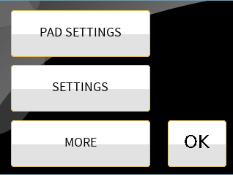

**Pad Settings Screen**. This screen is shown when the “PAD SETTINGS” button is pressed from the previous, initial Programming Screen.

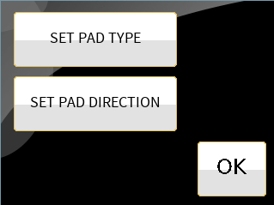

Pad Type Setting Screen. This screen is displayed when the “Set Pad Type” button is pressed from the previous screen. In this example, the Left and Center Pad are set to proportional and the Right Pad is set to Digital.

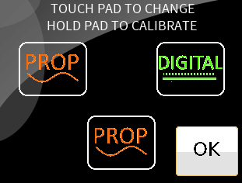

1st and 2nd Calibration Screens. The first screen is shown when a Proportional Programmed pad is pressed/touched for 2 seconds. When the OK button is pressed, the 2nd Calibration screen is shown.

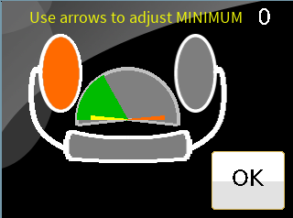 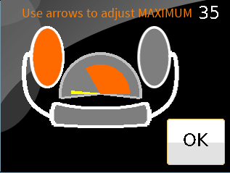

The Pad Direction Screen is shown when the SET PAD DIRECTION button is pressed in the previous screen. Touch the pad’s to cycle between Left, Right, Forward and Off.

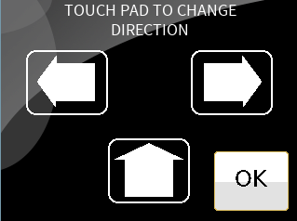

This screen is shown when the USER SETTINGS button is pressed from the main/first programming screen.

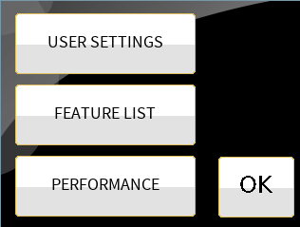

User Settings. This screen is shown when the SETTINGS button is pressed form the previous screen.

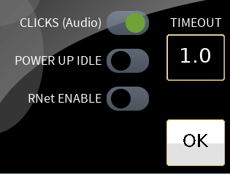

Feature Setting Screen. This screen is shown in response to presses the FEATURE LIST button in the previous screen. The left screen is displayed when the RNet feature is disabled. The right screen is displayed when the RNet feature is enabled.

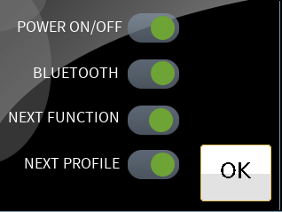 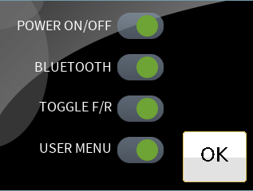

This screen is shown when the PERFORMANCE button is pressed from the previous screen.

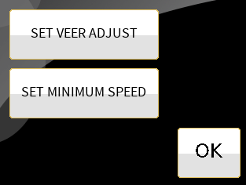

The Veer Adjustment screen is displayed when the “SET VEER ADJUST” button is pressed from the Pad Options screen.

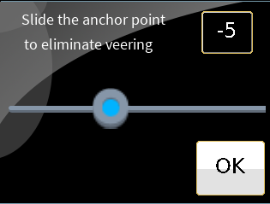

This screen is shown in response to the SET MINIMUM SPEED button from the previous screen.

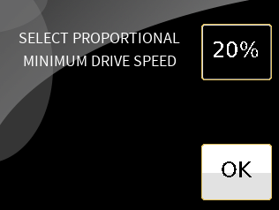

The following screen is shown in response to the MORE button from the main/first programming screen.

Note that the Version of the ASL110 Head Array and the ASL110 Display/HHP are shown on this screen.

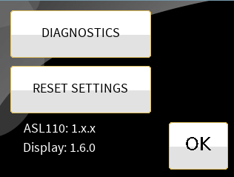

**Diagnostic Screen**. This screen shows the pad’s activation. The “100”’s next to the pad indicate the percentage of drive demand. The 100’s near the bottom of the screen indicate the raw values. The pad’s illuminate in orange (as depicted) when the pad is set to proportional and green when set to digital (not shown).

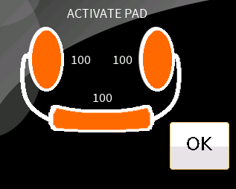

**Reset screens**. This screen is shown when the RESET SETTINGS button is pressed.

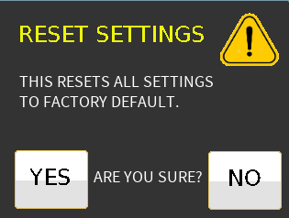

If NO is pressed, the previous screen is shown and no action is performed.

If YES is pressed, the parameters are reset to factory default and the following screen is shown. The OK button will show the main/first programming screen.

