Required Capstone Checkpoint 2.1: Retrieval Strategy Design and Baseline Implementation

Directions

You will continue working with the same dataset and scenario you selected for your capstone checkpoint in Module 1. In this activity, you will design and implement a baseline retrieval system that supports the types of queries required for your scenario.

Download this worksheet and save a copy to your device before you begin working. Type your responses directly into the document, save your completed work, and upload the finished file when you are ready to submit.

Use this worksheet to:
- Document your retrieval approach
- Capture representative retrieval queries and results
- Provide evidence that your retrieval system is functioning
- Observe how retrieval performance changes across different query types
- Reflect on where the retrieval approach performs well and where it struggles

1. Selected Scenario and Retrieval Approach
- Identify your chosen capstone scenario.
- Describe the retrieval approach you implemented (keyword-based, semantic, or hybrid).
- Briefly explain why this retrieval approach is appropriate for your dataset and query types.
- Describe any trade-offs you considered when selecting this approach
Scenario
☑ Research Paper Navigator
☐ Wikipedia Retrieval Engine
Retrieval approach used, brief explanation, and description of trade-offs considered
I chose a hybrid approach for this project that combines a BM25 keyword search and a vector search over ‘chunks’ of the documents to find potentially relevant information. Then the results from both methods were combined using reciprocal rank fusion to find the highest value chunks. I chose this approach because from the previous checkpoint, I learned that keyword search only found matching exact words whether they were directly relevant or not. I also found that pure semantic matching in 2.1 didn’t detect exact keyword matches very well because it also returned other words and phrases that were semantically the same.
Some of the more obvious trade-offs considered included the fact that hybrid retrieval was more complex than choosing either of the two individual methods.
Another tradeoff because of the hybrid choice was chunking (splitting the document into smaller segments) versus embedding whole documents. Since the embedding model used is limited to roughly 8,191 tokens and the research papers were larger, smaller chunks were the only option. This chunking and embedding process adds a level of complexity and planning in the choice of chunk size and other related parameters.

2. Baseline Retrieval System Evidence
- Provide evidence that your retrieval system was implemented and tested.
- Evidence may include screenshots, logs, outputs, notebook examples, code snippets, or brief descriptions showing that retrieval queries were executed successfully.
Evidence of retrieval system implementation and testing
Stats showing chunking and embedding the 153 PDF research papers.


Following is the code used to retrieve documents that match the given query using reciprocal rank fusion:
def retrieve(query: str, k: int = TOP_K) -> list[tuple[str, float]]:
"""Retrieval per RETRIEVAL_MODE, fused by Reciprocal Rank Fusion."""
rrf: dict[str, float] = defaultdict(float)
for ranked in _ranked_lists(query, CANDIDATE_POOL).values():
for rank, chunk_id in enumerate(ranked, 1):
rrf[chunk_id] += 1.0 / (RRF_K + rank)
ordered = sorted(rrf.items(), key=lambda kv: kv[1], reverse=True)
return ordered[:k]

The first example prompt: “In the paper Computer Aided Verification by Alexandra Silva, what does the abbreviation DNNV stand for?” Produced this output:
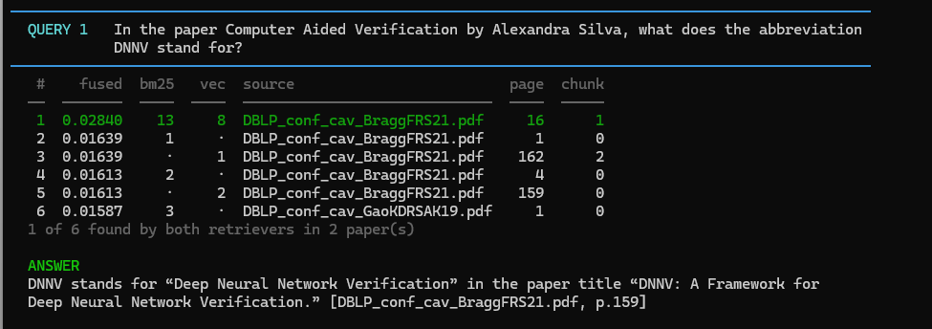
Answer: DNNV stands for “Deep Neural Network Verification,” as given in the paper title “DNNV: A Framework for Deep Neural Network Veriﬁcation.” [DBLP_conf_cav_BraggFRS21.pdf, p.159]

The result showed how the hybrid approach and the fusion using reciprocal ranking fusion produced the correct result when both bm25 keyword matching and simple vector search by themselves would not have ranked the results near the top.

3. Representative Queries and Retrieved Results
- Provide three to five representative queries relevant to your scenario.
- Include the retrieved results for each query.
- Focus on showing how the retrieval system behaves across different types of information needs. Where possible, include a mix of precise, conceptual, or broader exploratory queries.
Query 1
Query:
In the paper 'Is Self-Repair a Silver Bullet for Code Generation?', what does the paper say is the bottleneck for self-repair, and how much did human feedback improve the repair rate?
Retrieved results:
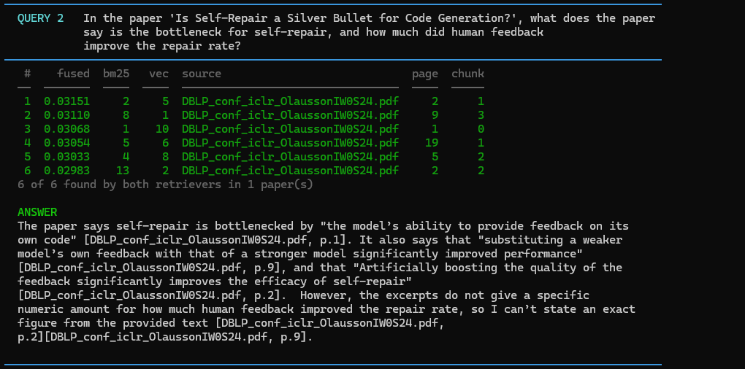f-repair”

Observations:
What worked well? All six matching chunks came from the same correct paper and both the vector and keyword retrievals found the content. Citations were correct and there were no hallucinations.
Challenges: The prompt had two parts and while the answer did correctly report what the bottleneck was, it didn’t answer the quantitative value asked for. After some research it appears that the actual answer fell into a different chunk than the chunks that were matched. I was able to change the chunk size from 1200 to 1400 and the results were returned. Chunking will likely play a big role in accuracy of the retrievals in the future.

Query 2
Query: How do these papers reduce the search space in program synthesis, and what does each approach sacrifice to do so?
Retrieved results:
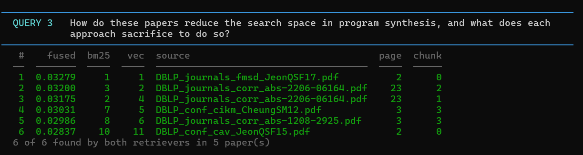
Answer:
The excerpts describe several different ways to reduce the search space in program synthesis:
- **Explicit vs. symbolic search**: one family of systems reduces search by either
“enumerating the candidate program space” explicitly or by “encoding the search space as
constraints” for a SAT solver. The excerpt says these are two different synthesis procedures,
but it does not say either one is universally better. [DBLP_journals_fmsd_JeonQSF17.pdf, p.2]
[DBLP_conf_cav_JeonQSF15.pdf, p.2] - **Adaptive concretization**: this approach reduces
search by identifying “highly inﬂuential unknowns” and using explicit search to “concretize
inﬂuential unknowns with randomly chosen values,” while leaving the rest to symbolic search.
The excerpt says this combines benefits of explicit and symbolic search and also parallelizes
naturally, but it does **not** explicitly state what it sacrifices beyond the fact that it
concretizes unknowns with random values. [DBLP_conf_cav_JeonQSF15.pdf, p.2] - **Abstraction
refinement / Blaze**: this reduces search by grouping “closely related solutions,” so “large
sets of solutions can be ruled out by evaluating only one abstract solution.” The excerpt
explains that this works by “equivalence reduction over abstract domains.” What it sacrifices
is not stated as a direct tradeoff, but the paper says such abstractions may be hard to design
or may not “effectively reduce the search space” in some settings.
[DBLP_journals_corr_abs-2206-06164.pdf, p.23] - **Observational similarity / metric
synthesis**: instead of abstract equivalence, this work groups similar programs using
“distance metrics” and ranks them. The excerpt says this is used “to perform search more
effectively,” and that it is “complementary to the abstraction refinement approach” and may
work when “abstract domains are hard to design” or ineffective. The sacrifice is not
explicitly spelled out in the excerpt. [DBLP_journals_corr_abs-2206-06164.pdf, p.23] -
**Constraint-based synthesis / Sketch-style symbolic search**: this reduces search by
representing candidate programs “through a set of equations which are solved through a
combination of inductive and deductive methods by a specialized solver.” The excerpt presents
this as an efficient mechanism for searching candidate programs, but it does not explicitly
name a sacrificed property. [DBLP_conf_cikm_CheungSM12.pdf, p.3]
[DBLP_journals_corr_abs-1208-2925.pdf, p.3] So, from the excerpts, the main common idea is:
**reduce the number of candidate programs or unknowns that must be explored**. The explicit
tradeoffs are only partially stated: adaptive concretization gives up some symbolic
completeness over the concretized unknowns by fixing them to random values, and abstraction-
based methods may sacrifice ease of design or applicability when good abstractions are
unavailable. [DBLP_conf_cav_JeonQSF15.pdf, p.2] [DBLP_journals_corr_abs-2206-06164.pdf, p.23]
Observations:
What worked well? What limitations, challenges, or unexpected retrieval behaviors did you observe?
The fusion ranking worked well in this scenario. The top chunk was recommended by both retrievers and the LLM created a well written summary of the most relevant data. Additionally, there were no hallucinations and the model honestly said that the papers didn’t say which one was better.
I discovered that there was duplicate content in two different pdf files. I could see a situation where having duplicate information like this could overload the ranking system and drown out other relevant data.

Query 3
Query: In the paper sk_p: a neural program corrector for MOOCs, quote the sentence where the term MOOC is defined.
Retrieved results:
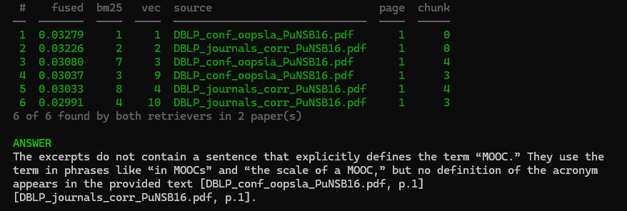
Observations:
This prompt returned a wrong answer on the initial run. It reported that the excerpts do not contain a sentence that explicitly defines the term “MOOC” in spite of the fact that there is a clear sentence in the Introduction of that paper that says “Massive open online courses (MOOCs) have become a popular way of teaching programming. As with the first prompt in this section, this problem also appeared to be a side-effect of chunk size. Changing the chunk size from 1200 to 1400 resulted in the proper retrieval.

Optional Additional Queries
Query:
What do these papers conclude about applying deep learning to diagnostic medical imaging?
Retrieved results:
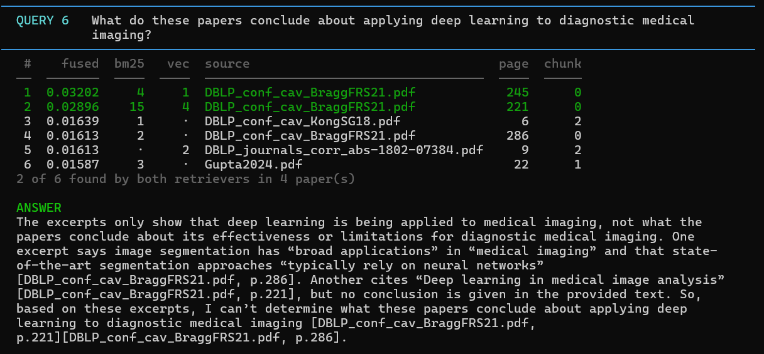
This prompt was created to ask a question that the corpus of research papers didn’t have detailed information about. I wanted to see if the model would hallucinate and include facts that weren’t in the papers.
Observations:
The retrieval returned relatively weak results with only 2 of 6 chunks agreed upon by both retrievers. The model correctly stated that no conclusion is given in the provided text and it couldn’t determine what these papers conclude about the subject.

4. Retrieval Performance Reflection
- Reflect on where your retrieval approach performs well and where it struggles.
- Consider how different query types affect retrieval quality, relevance, flexibility, or precision.
Retrieval strengths
The hybrid approach handled the prompts the best overall. One clear example is the first one I submitted asking what the abbreviation DNNV stands for. On its own, BM25 keyword search would have failed to return the relevant data as a top choice. Hybrid retrieval with reciprocal rank fusion, however, correctly calculated the combined scores and produced the correct result.
The hybrid approach seemed to perform better with questions that required multiple papers for answers. In these prompts, the results consistently showed cases where individually, the BM25 or vector search alone would not have been as effective as hybrid. In cases where chunks had mid-range scores on their own, correctly rose to the top, or near the top, when RRF was applied.
In simple terms, vector searches did well at finding documents that meant what my prompt asked for, keyword search found documents that had exact words found in the prompt, and adding fusion preferred those chunks where both methods had agreements.

Retrieval limitations or challenges
The chunking method / size directly affected the results of several prompts where part of the answer fell within one chunk and the rest of the answer fell within the neighboring prompt. The hybrid vector search returned the one chunk with the partial answer but ignored the chunk that contained the rest of the answer. For example, the multi-part prompt “In the paper “Is Self-Repair a Silver Bullet for Code Generation?', what does the paper say is the bottleneck for self-repair, and how much did human feedback improve the repair rate?” the query correctly returned content that answered the initial question but failed to return the amount of improvement.
I also experienced issues when multiple documents existed with the same content. The duplicates caused the rankings to be overloaded with the returned content potentially leaving out other good candidates that would have been useful context.
Adding extra context in a prompt gives BM25 keyword and vector searches more words to match against. Those extra words can cause extra chunks to be returned that match that extra text instead of the answers I really want.

Patterns observed across different query types
What patterns did you observe when comparing retrieval performance across different query types? How did these observations influence your understanding of the strengths and limitations of your chosen retrieval strategy?
The documents where the vector and keyword matching scores agree tend to have the highest quality answers. Queries where both retrievers found agreed on all six chunks were generally high quality answers. Weaker answers came from those where only 1-2 answers were found by both retrievers.
The chunk size also has a distinct effect on the quality as well. My solution used a fixed size of 1200 token chunk size but when a prompt failed to return a proper, expected result, changing the chunk size resulted in better results. It seemed that chunks were split in the middle of the relevant content which makes sense when fixed length chunks were used.
In my limited tests, questions that refer to one paper by name and ask for an exact string are where the two retrievers tended to disagree the most and the result to not return the correct chunk. Results that are found in multiple documents tended to be where answers were of the highest quality and the retrievers agreed the most.

5. Retrieval Strategy Reflection
If you were continuing to improve this system, would you keep the same retrieval approach or make changes? Explain your reasoning.
Reflection
With what I know now, I would keep the same hybrid approach with reciprocal rank fusion. However, I would add a few additional steps. First, I would update the chunking algorithm to chunk by paragraph instead of an arbitrary token count. I would also remove duplicate content from the documents as they were being chunked. Duplicates have the potential of overloading the rankings with this duplicate information.

Supporting Materials
Additional Evidence (Optional):
If needed, include any additional screenshots, output excerpts, or code snippets that support your responses above. No additional files or repository link are required for this checkpoint.

End of Required Capstone Checkpoint 2.1
Return to the assignment page in the learning platform to upload and submit your completed capstone checkpoint and complete any remaining items in this module.

