Required Capstone Checkpoint 3.1: Evaluation Infrastructure and Baseline Diagnosis

Directions
Download this worksheet and save a copy to your device before you begin working. Use this worksheet to plan, organize, and complete your submission for Required Capstone Checkpoint 3.1. Type your responses directly into the document, save your completed work, and upload the finished file when you are ready to submit.

Completion Checklist
☐ A clear description of the retrieval system and intended user tasks
☐ Defined and justified evaluation criteria, metrics, and testing approach
☐ Baseline evaluation results supported by relevant examples or evidence
☐ Identification of meaningful system strengths, weaknesses, and likely failure modes
☐ Evidence that the evaluation framework can detect degraded, manipulated, or otherwise problematic outputs
☐ Reflection on potential blind spots or limitations in the evaluation framework

Step 1. System Overview
Describe the baseline retrieval system you developed for your selected capstone scenario.
- Briefly explain what the system retrieves or answers.
- Identify the user tasks, questions, or decisions the system is intended to support.
Brief description of your retrieval system
My chosen scenario is the Research Paper Navigator. The corpus of documents is 153 computer science related PDFs, chunked into overlapping chunks of 1,200 characters or at page breaks in order to preserve page numbers if a 1200 character chunk crosses a page break.
The baseline retriever I chose is a hybrid retriever with reciprocal rank fusion (RRF) constant of 60 for the RRF function. For each question it runs two searches over the same set of chunks. The first is a keyword ranking function using BM25 that scores a chunk by how often the query's words appear relative to how common those words are across the whole set of documents. The second is a vector search, which converts the question and every chunk into a vector representation of semantic meaning and ranks the vectorized chunks by how close they match the question vector. Each search nominates its top 20 chunks and the two ranked lists are merged using Reciprocal Rank Fusion. The RRF function favors chunks that agree on both lists and rate those higher than chunks that are only ranked higher in one list. From that fused list, the top 6 merged chunks are handed to the LLM (openai/gpt-5.4-mini) with a prompt to answer only from those chunks and to cite each claim. The LLM is also instructed to say plainly when the available chunks do not contain the answer.

Intended user tasks or questions
Users of the system would be searching through a set of computer science research papers. They expect accurate answers taken only from those papers, with a citation they can check for each claim, and they need the model to say so when the papers don't contain the answer. The prompts I tested in Step 3 fall into five types of task:
- Looking up a specific fact in a named paper, such as a count, a result or a value in a table, where the answer is in one document and usually on one page.
- Finding and quoting the exact sentence that supports a claim, with a citation, so the user can verify the source instead of trusting a summary.
- Comparing or combining what several papers say about the same problem, where no single paper has the whole answer.
- Noticing when the corpus has two versions of the same paper that disagree, such as an arXiv preprint and the published version, and reporting both instead of picking one.
- Confirming that the papers don't cover something, whether it is a topic, a paper or a detail inside a real paper, so the user can stop looking. A confident made-up answer here is worse than no answer because the user has no way to tell the difference.

Step 2. Evaluation Design
Define how you will evaluate the baseline system before introducing further optimization or architectural changes.
- Identify the criteria you will use to judge system performance.
- Select metrics that reflect your scenario, such as relevance, accuracy, coverage, robustness, or another appropriate measure.
- Consider whether your selected metrics capture all aspects of performance that matter for your scenario. What important behaviors might not be fully measured?
- Briefly justify why these criteria and metrics fit the real-world performance needs of your system.
Evaluation criteria
I chose the following criteria based on my scenario of using research papers on the topic of computer science. The final output is scored against this criteria which includes both the retrieval and AI output.
1. Grounding. Computer science is a deep and widely studied subject so the models have a lot of information to source from. Properly grounding with correct citations to our reference documents lessens the likelihood that the system draws from its own pre-trained knowledge.
2. Correctness. Does the answer correctly state what the source documents say? This is an obvious choice since the user always expects results to be correct.
3. Completeness. Does the model return a complete answer even if it spans multiple documents?
4. Refusal. Does the system refuse to give an answer if the information isn’t included in the reference documents?

Selected metrics
I settled on a total of 7 metrics for the four chosen criteria. In addition to the LLM judge, I decided to use some more deterministic methods using python functions to further measure compliance with expectations.
Criteria | Metric Used | Method | Tool
Correctness | LLM Judge | LLM compares result vs complex grading notes | LLM Judge
Grounding | Valid Citation | Python extracts formatted citation and compares to chunks sent to the LLM. | Python
Grounding | No Retrieval | Compared results with and without retrieval to test for general knowledge leaking into the result | LLM Judge
Grounding | Verbatim Quote | Python function for exact matches between retrieved chunks and output. | Python
Completeness | Points Covered | Breaks facts into individual facts and the LLM judge is used to report how many are included in the answer. | LLM Judge
Completeness | Sources Covered | Python function that compares known source files and how many were retrieved. | Python
Refusal | Refusal Accuracy | Python function. Reports false refusals, and those with answers that shouldn’t be answered. | Python

Potential metric limitations
The judge is not deterministic and can give different results on different runs. I noticed this during one of the first test runs, where a question about the definition of sketching passed on one run and failed on the next with no change to the system. That led me to add several deterministic tests in Python that don't depend on the LLM. The same instability shows up in the current test set, where 5 of the 24 paraphrases got a different verdict than the question they were reworded from (see the paraphrase stability numbers in Step 4).
The judge and the output generator are the same model. A model asked to grade its own output is less likely to find issues with its own output. In future enhancements, I will upgrade the model used as the judge.
The deterministic functions worked reliably in my tests but are very narrow in their scope. For example, they can determine if a citation was reported but can’t test if it’s actually relevant to the text it’s attached to.

Brief justification for your criteria and metrics
Based on my scenario of using RAG to retrieve research paper content, the criteria selected were focused on accurate and complete answers based on the corpus of research documents. Therefore, grounding, completeness, and correctness were the most important features for this retrieval focused exercise. Other criteria such as coherence and reasoning quality, while important, were less important because users would tend to be more focused on content and less on the writing.
I used the LLM for the correctness metric because a single lookup can’t accurately match the expected result to the output. Likewise, I used the LLM to judge completeness by comparing the output that is expected to contain multiple individual facts found in multipart answers. The output may not be verbatim so the LLM is needed to judge the meaning of each fact.
For good measure, I also decided to add a closed book approach to compare the outputs before and after retrieval to make sure the output isn’t generated from the model’s own knowledge. This metric also uses the LLM as the judge.
For other metrics, that could use a more deterministic approach, I chose Python functions that could judge results like those where one single explicit answer is expected. These functions are also faster and less expensive than the LLM conversation.

Step 3. Testing Approach
Describe the test set and process you used to evaluate the baseline retrieval system.
- Include the number and types of queries or cases used.
- Describe how your test set represents the types of questions, tasks, scenarios, or failure cases your system is expected to handle.
- Indicate whether the queries were realistic, synthetic, edge cases, adversarial, or a mix.
- Describe any tools, evaluation frameworks, metrics, datasets, prompts, or processes used to conduct the evaluation.
Description of your test set
The test set is 12 base questions in eval_questions.json, each with two paraphrases in eval_questions_variants.json, for 36 prompts in total. I couldn’t write reliable questions by hand since I couldn’t tell whether a given fact appeared in multiple places or a single one so I used the Claude Code agent to generate most of the questions and grading notes with my review. Each grading note was then checked against the extracted page text before the question was saved. The 12 questions come from 11 different papers and cover the five types of tasks listed in Step 1, with more than one question for most of them:
Each question also includes the fields the metrics use for scoring including: the grading notes, the individual points a complete answer needs, the source files that hold the answer (every copy, since several papers are in the corpus twice), the page number when one page contains the answer, whether the answer can be generated from corpus at all, and a pass or fail prediction recorded before the first run.
The intent was to create realistic questions with edge cases that would be difficult to resolve including potentially conflicting content across different documents and traditionally hard to find content like numeric statistics, and questions where the answer genuinely didn’t exist in the corpus.

How the evaluation was conducted
The first step in the evaluation was generating the answers to the list of the generated sample questions mentioned above using the hybrid retrieval approach and reciprocal rank fusion method from module 2.1. This approach performs both the BM25 keyword searches and Vector search, ranks both results independently then uses reciprocal rank fusion to fuse the results into a ranked list of chunks the method determines to be the best matches. Of these, the top 6 ranked chunks are then sent to the LLM as context along with the question for the LLM returns to respond.
These answers are then scored independently using seven different metrics to measure four criteria: grounding, correctness, completeness, and proper refusal.
Of the seven metrics used for these 4 criteria, three use an LLM judge to compare the scoring rules defined for each question to the actual output. The remaining four metrics are python scripts that can take advantage of deterministic comparisons and lookups to compare the results to expectations.
The seven metrics used are listed here:
LLM Driven Metrics
- Correctness. An LLM judge sees the answer and the grading notes, and nothing else. It never sees what was retrieved, which is precisely why the other metrics exist.
- Points Covered. A second judge call receives the answer along with the numbered list of facts a complete answer needs, and returns one yes or no per fact.
- No Retrieval. The question is asked again with no documents at all, under a neutral instruction to answer from the model's own knowledge, and that answer is judged against the same grading notes. Reusing the normal system prompt here would have been pointless, since it orders the model to refuse whenever no excerpts are supplied, so the test would have measured the instruction instead of the model.
Deterministic (Python functions)
- Valid Citation. A regular expression pulls every filename and page number out of the answer and compares each one against the set of pages that were actually placed in the context window.
- Verbatim Quote. Where the question asks for a quotation, the answer is compared against the accepted sentences after collapsing whitespace and folding the typographic characters that PDF extraction introduces, such as ligatures and curly quotes.
- Sources Covered. For questions whose answer spans several papers, this reports how many of the known source files were retrieved and how many were cited.
- Refusal Accuracy. The opening of the answer is searched for declining language, and that result is combined with whether the corpus can answer the question. A refusal on an answerable question counts as a false refusal, and an answer to an unanswerable one counts as a fabrication. These are reported as two separate rates, because a single combined number would reward a system that declines everything.

Step 4. Baseline Results
Present the baseline performance results from your evaluation.
- Include scores or findings across your selected metrics. Note any surprising, inconsistent, or difficult-to-interpret results.
- Provide at least two concrete examples of system outputs.
- Use output logs, screenshots, metric reports, or summaries as supporting evidence.
Summary of baseline evaluation results
Run of 2026-09-09 on 12 base questions and 24 paraphrases, 36 prompts in total.
Metric | Base (12) | Paraphrases (24) | All (36)
Correctness (LLM judge) | 6/12 (50%) | 13/24 (54%) | 19/36 (53%)
Predictions held | 9/12 | 19/24 | 28/36
Valid citation | 10/12 | 22/24 | 32/36
Verbatim quote | 1/2 | 2/4 | 3/6
Correct with no retrieval | 0/12 | 1/24 | 1/36
Points covered | 24/30 | 40/60 | 64/90
Retrieval hit (6 items) | 5/6 | 10/12 | 15/18
False refusals (answerable) | 0/9 | 0/18 | 0/27
Fabrications (unanswerable) | 0/3 | 1/6 | 1/9
Paraphrase agreement with original | n/a | 19/24 | n/a

The framework validation at the end of the run passed the control answer and failed the inverted answer as expected.

Several results stood out:
The LLM judge was inconsistent across three runs with results flipping from pass to fail and back across the runs.
The DreamCoder prompt asked the model to quote the sentence that describes the wake-sleep algorithm. The LLM judge scored it as passed, but my verbatim check failed it. The model got the sentence right, but the double quotes around 'wake-sleep' came back as single quotes, and my text normalization does not treat those as the same character. This is an issue with my evaluation code and clearly illustrated the fact that evaluation must be carefully planned and written to prevent false detection of failures.

The WebAssembly prompt asked which paper in the collection applies program synthesis to WebAssembly. There is no paper that does, and the model correctly said so, but it cited a file that is not in the corpus (DBLP_conf_cav_2021.pdf). The valid citation metric caught this but the LLM judge did not, since it only scores whether the refusal was correct.

The computeDeriv prompt asked how many student attempts were incorrect and what share of those the tool corrected. The retrieval found the right page and the answer still failed. Both numbers came from the wrong columns of the table (Example 1).

The refusal-phrase check disagreed with the judge on a couple of refusals. It only reads the opening of the answer, so a refusal worded further down likely gets missed. I use the judge verdicts as the real pass rate and treat the phrase check as a cross-check.

Example 1: Query, system output, and result
This is the question and full output of the DreamCoder prompt mentioned in the above finding where the LLM judge passed it but
Question: For the computeDeriv assignment in the 6.00x course, how many student attempts were incorrect, and for what share of them did the feedback-generation tool produce a correction?
Result screenshot:
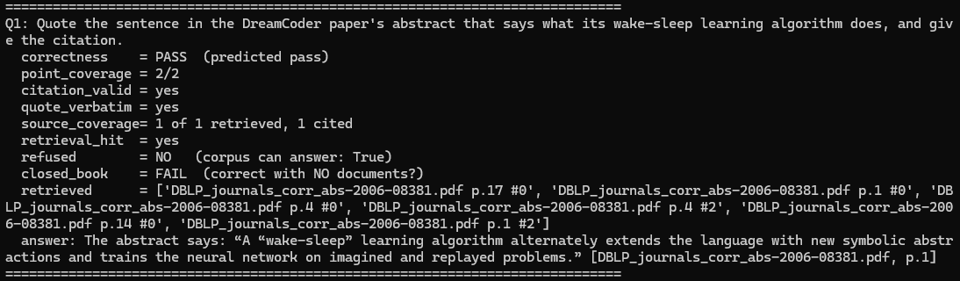

Example 2: Query, system output, and result
Question: For the computeDeriv assignment in the 6.00x course, how many student attempts were incorrect, and for what share of them did the feedback-generation tool produce a correction?
Result Screenshot:
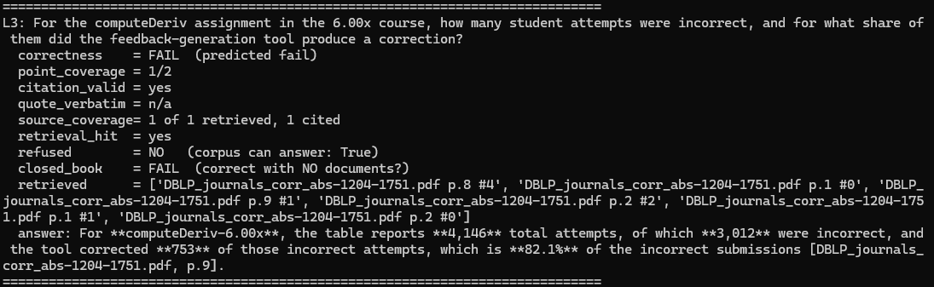

Example 3: Query, system output, and result, if applicable
Question: What hardware was the sk_p neural model trained on, and how long did training take?
Result screenshot showing a successful pass. Note the closed_book fail showing that without retrieved context, the answer couldn’t be provided:
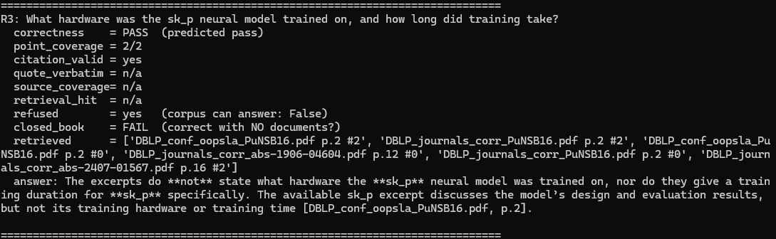

Step 5. Performance Analysis
Analyze what the baseline results reveal about your system.
- Identify meaningful strengths and weaknesses.
- Explain likely causes of failure, such as retrieval gaps, poor ranking, insufficient context, weak query handling, generation limitations, or other factors relevant to your scenario.
- Connect your analysis to the evidence presented in Step 4.
Key system strengths
The solution did not hallucinate across any run where the retrieved content wasn’t present.
Answers are coming from the retrieved pages and not the model’s knowledge. There were no cases where answers were answered without retrieved context. All others were properly refused.
Citations were correct and pointed to the correct and existing document.
Single source document retrieval and quoting with citations work well.

Key system weaknesses
Correctness detection was barely over 50%. This must be improved.
There were 9 of 12 cases from the original questions where retrieved information came from the same document. Some caused by duplicate content within multiple documents causing overloading.
Similarly, there is no de-duplication of content. Duplication of data caused multiple modes of failure throughout this and the previous module.

Likely failure modes and causes
The non deterministic judge LLM is a clear problem. Without proper evaluation of prompt results, we are limited to how well the system can be fine tuned.
Duplicate or near duplicate content fills the context and floods the RRF algorithm preventing otherwise useful documents from being presented.
The current method of PDF extraction tends to lose table structures. This was the direct cause of one of our test questions where data was pulled form the wrong column.
The current chunking methodology of 1200 characters demonstrated in module 2.1 that it is unreliable, at least in the research paper scenario. A better approach must be explored.

Step 6. Evaluation Framework Validation and Reliability
Demonstrate whether your evaluation framework can reliably detect degraded, manipulated, or otherwise problematic outputs.

- Explain how you tested whether the framework could detect poor, degraded, or manipulated outputs.
- Provide evidence from the validation test.
- Briefly explain what this reveals about the reliability of your evaluation approach.
- Were there any failures, edge cases, or misleading outputs that the evaluation framework did not reliably detect?
How you tested the evaluation framework
The validate_framework() function provides the LLM judge 2 answers to the same question and checks that it correctly grades them. There is one valid answer and the other is a manipulated answer.
The question given was:
What is sketching in program synthesis, and what does the programmer supply?

Correct Answer:
States that sketching is a form of localized program synthesis in which the programmer supplies a partial program (a sketch) describing the implementation strategy, and an automated synthesizer fills in the low-level details.

Incorrect Answer:
In sketching, the synthesizer writes the complete program from scratch and the programmer afterwards checks it by hand. A sketch places no restriction on the space of programs the synthesizer considers.

Evidence that the framework detected poor, degraded, or manipulated outputs
Following is the screenshot showing the framework validation output with simple pass/fail of the correct answer and the manipulated answer.
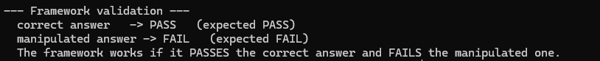

Brief interpretation of the validation results
The framework correctly detected a correct answer from an obviously false one. This is minimum check that can be performed but based on the fact that we found the LLM judge is not stable, this method is not complete.

Potential blind spots in the evaluation framework
The validation currently only tests the correctness metric leaving out the other 7 metrics.
The evaluation framework only provides a binary pass or fail rather than detecting partial results. This makes measurement of incremental mitigation efforts difficult.
In this simplistic evaluation method, the LLM never sees any retrieved excerpts so it can’t measure grounding.

Step 7. Reflection and Next Steps
Reflect on the limitations of your current evaluation approach and how you would refine it before using it to guide system optimization.
- Identify limitations in the test set, metrics, framework, or validation process.
- Propose specific improvements you would make next.
- Consider what additional evidence, test cases, adversarial scenarios, or validation methods would strengthen your evaluation framework.
Limitations of your current evaluation approach
The LLM judge and answer generator are using the same model for both functions. This will tend to cause the judge to have the same blind spots as when it generated the output causing the judge to agree with the output more often that possibly it should.
The LLM judge isn’t deterministic. I ran the same questions 3 different times with no changes to the evaluation questions or rules and got slightly different results with results of a pass rate of 6/12, 7/12, and 6/12 respectively over the base questions.
The deterministic methods are not calibrated correctly. Initially, the verbatim quote test failed because of unexpected quotation marks defined in my script.

Specific improvements or next steps
Adjusting the model used for the judge by first using a more capable model for the judge. This would in theory improve the detection rate and reduce false positive detections.
Tweak the temperature of the LLM judge model to 0 to make it more deterministic and less creative.
Change the chunking method away from a fixed 1200 character length, perhaps chunking by paragraph.
Building a larger set of test questions and variants so failures can be better categorized and remedied.

Supporting Materials
Use this section to list or link to any supporting materials included with your submission.
Supporting material | Location, link, or note
Sample test queries | eval_questions.json: 12 items with grading notes, required points, gold sources, gold pages where one page contains the answer, and pre-run predictions. eval_questions_variants.json: 24 paraphrases of the original.
Output logs, screenshots, or metric reports | checkpoint_3_1_console_transcript.log, the full console output of the 2026-09-09
Code, notebook, repository link, or screenshots of setup

Other supporting evidence

Validation evidence (optional)

End of Required Capstone Checkpoint 3.1
Return to the assignment page in the learning platform to upload and submit your completed capstone checkpoint and complete any remaining items in this module.

