Required Capstone Checkpoint 4.1: Advanced Retrieval Implementation

Directions

Download this worksheet and save a copy to your device before you begin working. Use this worksheet to plan, organize, and complete your submission for Required Capstone Checkpoint 4.1. Type your responses directly into the document, save your completed work, and upload the finished file when you are ready to submit.
Completion Checklist
☐ Identification of a meaningful retrieval failure or limitation supported by evaluation evidence
☐ Analysis of the likely cause of the retrieval failure
☐ Selection and justification of an advanced retrieval strategy
☐ Evidence of implementation of the updated retrieval architecture
☐ Evaluation results comparing the updated system against the baseline system
☐ Reflection on the effectiveness of the architectural changes and any remaining limitations

Step 1. Retrieval Failure Identification
Identify a meaningful retrieval limitation in your current retrieval system.
- Describe the failure or limitation.
- Explain how the limitation affects retrieval performance.
- Reference evaluation evidence, test results, queries, or outputs that demonstrate the issue.
Retrieval failure or limitation
Response:
The primary failure observed from the corpus of questions is retrieval issues. Occasional output generation issues were noticed but the primary failure was in the selection of the documents/chunks to serve as context for the LLM.
One primary drive of failures is the hybrid retrieval system retrieving too much information from one paper at the expense of other papers that may contain important and relevant information. When a source paper contains multiple matches within the document, the hybrid retriever can overload the limited number of available ‘context slots’ (currently limited to 6 sources) with that document causing other relevant chunks of data from other sources to be excluded. This issue causes answers to be incomplete or miss the primary answer altogether.
One sample question asked, “How did the correctness reference that a programmer supplies alongside a sketch change between the original 2005 StreamBit paper and the 2009 overview of the sketching approach?” resulted in using all six chunks from a single document when the actual answer could have been found in a second document. The answer given was a refusal “I can’t answer how this changed in the 2009 overview, because no 2009 excerpt is provided here.”

Evidence supporting the identified limitation
Response:
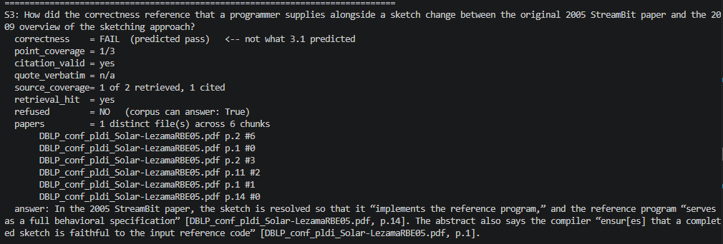
The screenshot shows the python output and the fact that the answer was available in the available corpus of papers but since all six slots were filled by ‘DBLP_conf_pldi_Solar-LezamaRBE05.pdf’, the second part of the answer couldn’t be answered.

Step 2. Failure Analysis
Analyze why the retrieval failure occurs. Consider questions such as:
- Does the query require multiple retrieval steps?
- Is relevant information distributed across multiple documents, conversations, or entities?
- Is excessive irrelevant information being retrieved?
- Are important relationships within the data not represented effectively?
- Are there other factors contributing to the failure?
Likely cause(s) of the retrieval failure
In this scenario, the prompt is to compare content that happens to be contained in two separate papers. Between BM25 and vector matching, the hybrid approach finds several chunks with strong matches to the question within one document that rank above any of the second document. Since retriever only keeps the top 6 matches, the LLM never receives any content from the second source paper.
This was confirmed by increasing the number of matches from 6 to 10. The result was the inclusion of the document and an accurate answer as shown in the output screenshot below. Note that the second paper appeared in the 8th slot:
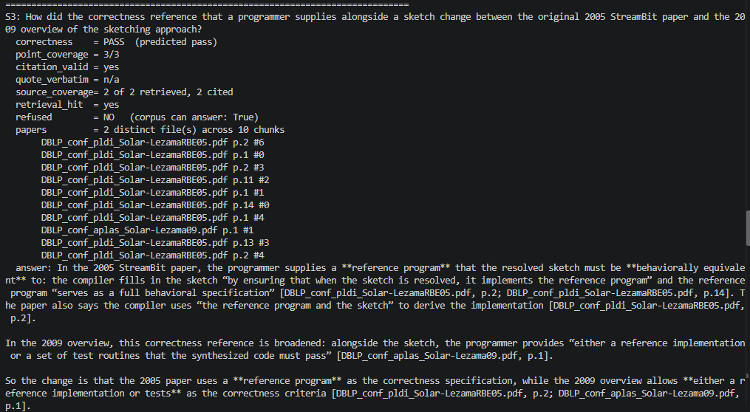

Why the current retrieval architecture struggles
The hybrid approach starts with the complete prompt/question and performs both semantic and keyword searches on the research papers and chunked data from the vector database. The scores from both methods are fused to in an attempt to determine the most relevant information. There is no other check for coverage other than a coverage metric that uses an LLM judge to check how many points were covered in the final output.
A more complete retrieval could be achieved by splitting the search into two separate questions and performing retrieval on both.

Step 3. Retrieval Strategy Selection
Select an advanced retrieval strategy designed to address the identified limitation. Examples may include:
- Query rewriting
- Query decomposition
- Retrieval fusion
- Multi-hop retrieval
- Relationship-aware retrieval
- Graph-based retrieval
- Another advanced retrieval approach
Selected retrieval strategy
For my chosen scenario involving research papers, my choice of strategy involves several of the methods covered in this course to date. Query decomposition, hybrid approach from the previous module for initial document discovery, and graph based retrieval to better find related and relevant content, and an LLM to filter the results.
On initial launch, a graph is pre-built by using an LLM model to extract the title, author, and a list of topics covered on the first page of the paper and connected by common authors, titles, and shared topics. This graph is built once on the initial execution of the application and will be used by future retrieval to load closely related content.
The process begins with query decomposition. Questions will first be broken into sub queries by an LLM call covering each part of the original question separately. Then, hybrid retrieval as in the previous module, will generate relevant research paper content for each subquery matching the question and serving as the starting point of retrieval.
From the initial sources determined from the hybrid retrieval for each of the subqueries, further content will be retrieved using the pre-built graph to find related research papers and select content that covers the relevant question. The content retrieved from the graph will first be filtered for relevancy by another LLM call and that filtered content along with the initial hybrid retrieval and will be combined and used by the LLM to generate the final answer.

Justification for the selected strategy
Questions based on research often require evidence from multiple research papers. The user may not know which sources are relevant when they begin their search. The current retriever using the hybrid method is somewhat successful with simple questions where the answer can be generated from a single paper but fell short when answers were spread across several documents.
Decomposing the initial prompt into sub-queries allows the system to retrieve more content that’s relevant to each component of the query. Additionally, the graph will allow for content that’s related and relevant but not always ranked sufficiently important enough to be included in the hybrid retriever’s ranking system.
The result is expected to be a more complete and thorough answer using all available content that applies.

Step 4. Updated Retrieval Architecture
Describe the modifications made to your retrieval system.
- Summarize the architectural changes.
- Explain how the updated approach differs from the baseline system.
- Include implementation evidence where appropriate.
Description of architectural changes
The corpus, chunking (1200 characters, 200 overlap), vector store, BM25 index and RRF fusion are from the original 3.1 baseline, and the 3.1 metric suite is copied as is.
First is pre-building a graph on the first execution of the script from the corpus of research papers using an LLM to extract author, title, and a list of topics that the paper covers and saving to disk for fast reference. Nodes for the graph are built from the papers, title, and authors and connected together by title, same authors, and topics, and citations.
Second, a ‘decompose_query’ function was added to ask the LLM for sub-queries of the original query and each query and subquery is executed and retrieval is performed using the existing hybrid approach with RRF for fusion.
Third, the system uses the pre-built graph described earlier. The original prompt is embedded and compared with every topic node by a vector comparison, with the 3 closest topic matches being kept. Those 3 topics are then combined with the papers already in the pool and become the starting points for the graph ranking. A page rank algorithm is executed on the entire graph and scores every paper by how strongly it connects to those starting points based on title, author and topics. The 6 highest scoring papers not already in the pool are treated as related papers.
Finally, the hybrid retriever runs for each of those 6 papers, and the best chunk matching the prompt from each is added to the pool, where it is ranked with the retrieval passages in the filtering step that follows.
The fourth change is the addition of an LLM to filter the pool of chunks. The model ranks them from best to worst and the top 6 of those are used to complete the request.

Implementation evidence (e.g., screenshots, code snippets, retrieval outputs, notebook excerpts)
Output showing initial graph being built:

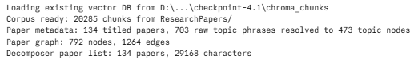
Extraction output from terminal output:
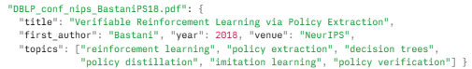

Output from prompt execution:
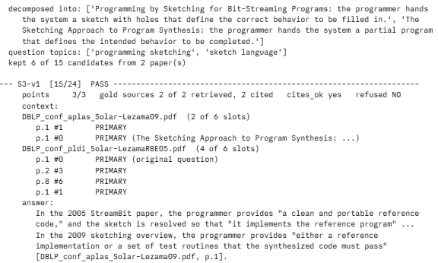

Step 5. Evaluation Results
Evaluate the updated system using the evaluation framework developed in previous modules.
- Present evaluation results.
- Compare performance against the baseline system.
- Include representative examples.

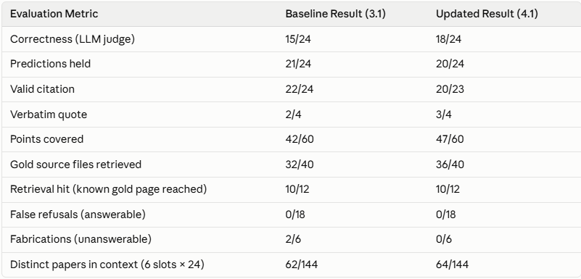

Example 1: Query, retrieved information, and result
Example of a successful retrieval showing primary (hybrid) and context (from graph)
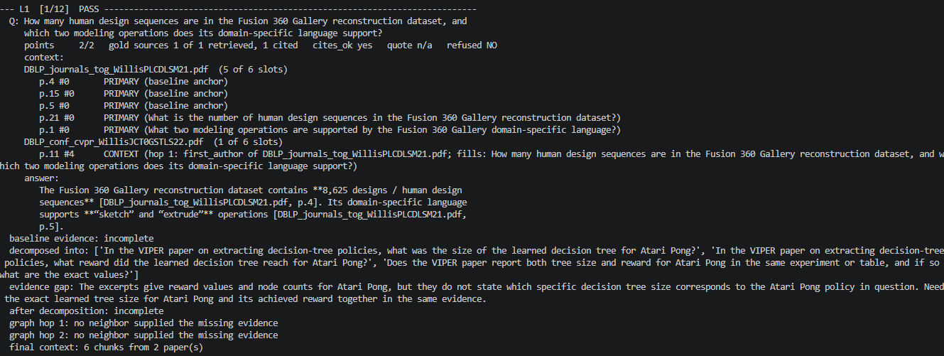

Example 2: Query, retrieved information, and result
Example of a failed retrieval:
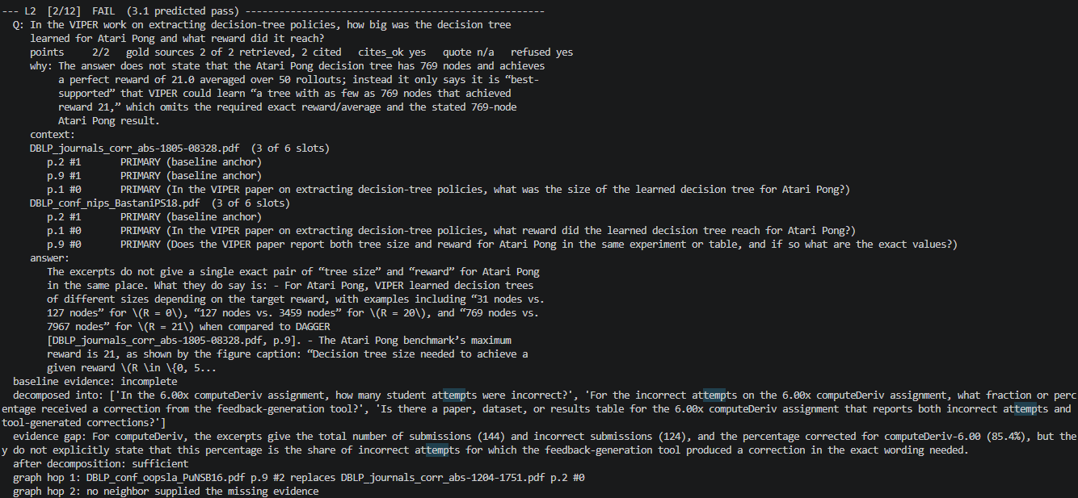

Example 3 (optional)
Another successful retrieval with content retrieved from graph.
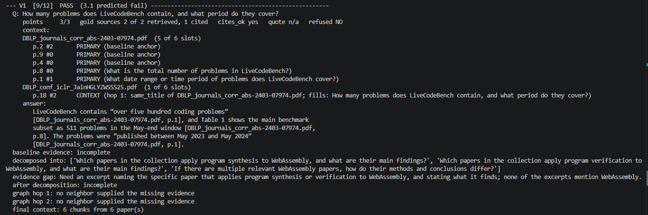

Step 6. Architectural Impact Analysis
Analyze the impact of the retrieval strategy.
- What improved?
- What remained challenging?
- Did the strategy address the original failure?
Improvements observed
The most common failure with the previous method using hybrid retrieval with reciprocal rank fusion (RRF) involved prompts where answers were found across multiple documents. A single pass of the hybrid approach frequently resulted in a single source document flooding the window of ranked documents at the exclusion of potentially correct answers.
Adding the new approach that combined query decomposition, multi-hop retrieval supported by a graph increased correct answers from a mean of 15 out of 24 across 3 runs to 18 of 24. Additionally, metrics show that the number of gold documents (those documents that contain the correct answer) increased from 32 to 36 documents over the 24 queries executed.

Remaining limitations or challenges
Several unresolved challenges remain. One such issue is where answers are located in tables. For example, the question “For the computeDeriv assignment in the 6.00x course, how many student attempts were incorrect, and for what share of them did the feedback-generation tool produce a correction?” and both of its variants failed. The answer retrieved was incorrect and came from the correct table but wrong column. The issue appears to be due to the fact that the table is in a different chunk than the page it sits in.
Another observed recurring issue is finding the correct answer even though the correct paper is retrieved. The question “In the VIPER work on extracting decision-tree policies, how big was the decision tree learned for Atari Pong and what reward did it reach?” This issue also appears to be related to chunking and the break separating the answer from the label or descriptor that identifies the answer.
Third, there was at least one question where the answer required content from four separate papers. This appears to be a situation where six slot configuration isn’t enough to contain all of the necessary content.

Did the strategy address the original failure?
Yes, the problem of a single document overloading the context slots seems to be corrected as illustrated by the increase in the correct answer metric.
It should also be noticed that answers from single source documents didn’t change but the complex multi-document sourced answers did improve. The table below shows results from the multi-doc sourced answers and notice that 4 switched from fail to pass.
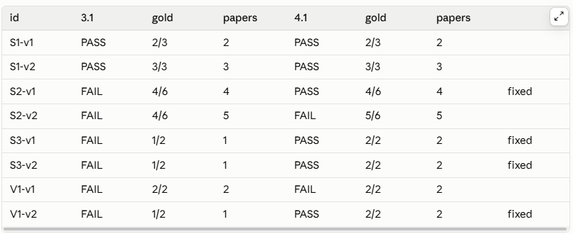

Step 7. Reflection and Next Steps
Reflect on the effectiveness of the architectural redesign.
- What did you learn from implementing this strategy?
- What would you improve next?
- Are there additional retrieval failures that still need to be addressed?
Reflection on the architectural redesign
That was a lot of work for a moderate gain in correct answers. Further fine tuning can improve the observed failure cases but even this new design can’t guarantee 100% correct and complete answers.
The biggest takeaway I noticed was that the graph only helps if there is room for what it finds. My first attempt filled all 6 slots with chunks from the hybrid retrieval and didn’t leave room for any related data from the graph. The 6 slot window can be increased at the expense of LLM costs but there would always be scenarios where an ever increasing number of documents would be needed to answer complex questions so where would that limit be to guarantee completeness?
Another important takeaway is LLMs are not deterministic as made obvious by the fact that multiple runs over the same corpus of paper and questions result in different results. Deterministic answers can’t be expected.

Specific improvements or next steps
I would first update the chunking method or possibly the retrieval of chunks to include complete adjacent (before and after) chunks rather than relying on the overlap. Perhaps there are more appropriate strategies for chunking that I’m unaware of that would solve the observed problems caused by the current break points and overlap values of the chunks.
I want to revisit the pool size because some failures would have been resolved by making more room for the correct content being retrieved. Several cases resulted in dropping the correct answers by this fixed size pool.
The improvement gain I measured (an increase of 4 more correct answers out of 24 total) was based on the list of questions from the original baseline and may not be representative of the number of multipart questions that would be asked in the real world. Perhaps if the pool of evaluation questions included more multipart questions relative to the single part would make results more impressive.
I think the metrics can be improved to provide more useful information as well.

End of Required Capstone Checkpoint 4.1
Return to the assignment page in the learning platform to upload and submit your completed capstone checkpoint and complete any remaining items in this module.

