Required Capstone Checkpoint 5.1: Designing and Evaluating an Agent-Based RAG System

Directions
Download this worksheet and save a copy to your device before you begin working. Use this worksheet to plan, organize, and complete your submission for Required Capstone Checkpoint 5.1. Type your responses directly into the document, save your completed work, and upload the finished file when you are ready to submit.

Completion Checklist
☐ Description of the agent-based system and task
☐ Explanation of how the system coordinates retrieval, reasoning, and multistep execution
☐ Evaluation results from 2-3 representative multistep test cases
☐ Description of refinements made to the system
☐ Analysis of the impact of those refinements
☐ Reflection on system strengths, limitations, and future improvements

Step 1. System Design
Describe the task that your agent-based system is designed to complete.
Examples may include generating reports, answering complex questions, synthesizing information across multiple documents, or completing another multistep task relevant to your capstone scenario.
Task description
This checkpoint uses a combination of previous techniques and the addition of an agentic loop to perform agentic RAG and to answer the user’s questions from the corpus of research papers.
This system builds on the 4.1 checkpoint with its hybrid retrieval with RRF fusion adding an agentic loop with a LLM and python functions (tools) to ask the hybrid retriever to find content, evaluate it for completeness, and create followup queries as needed to arrive at the most complete answer it can.

Agent workflow: Describe how your system works
Consider:
How retrieval is incorporated into the workflow
Instead of being a step in the process of generating an answer, the retrieval becomes a tool used by the agent to retrieve content, give it back to the agent for evaluation where the question is refined and sent back to the retrieval tool for more content.
LangGraph is used to define the process with nodes and edges between those nodes to define the workflow. The process begins with the ‘search’ node using the hybrid retriever created in the previous checkpoint to retrieve the initial set of documents from the user’s complete question. The planning node then compares the question to the content retrieved to determine if it contains sufficient information to answer. If not, the ‘planner’ node creates targeted questions and sends to the retrieval tool. This loop continues up to 4 times max before the answer is generated. Because the retrieval tool doesn’t currently use any date features to compare different versions of a document, a final LangGraph node called ‘versions’ is used to check for other versions of the document and retrieves that content prior to generating the answer.
How the system performs reasoning or intermediate processing
The agent reasons at two different nodes in the graph. First, the planner node determines which question to ask of the retrieval node to retrieve the data it needs to complete the request. The second area is generating the output from the retrieved context to answer the user question properly.
Other nodes in the graph are Python functions used as tools by the agent and don’t make any LLM calls.
Any prompts, tools, or workflow components used to guide agent behavior
The agent uses the ‘tools’ in the form of python functions that the agent’s ‘planner’ node can choose from.
The ‘search’ tool runs the broad hybrid search over the entire set of papers.
‘search_in_paper’ uses the same hybrid search to find content within a named paper.
‘related_papers’ uses the knowledge graph to find files connected to a given paper by title, author or topic.
Another tool, ‘clarify’ can be called by the ‘planner’ node if a question is too vague or requires more information.
The LLM prompts to note are the PLAN_SYSTEM prompt which instructs the LLM that given the user prompt, content already retrieved, and actions already taken, to use the appropriate tool and the circumstances for when each of the tools would be called. It also instructs the LLM to create a checklist to include relevant documents or the word ‘MISSING’ for each item it needs to complete the answer.
The answer prompt (AGENT_ANSWER_SYSTEM) instructs the LLM to answer questions only from the content retrieved and to cite every claim using the references returned by the retrieval tool and attached to each chunk.

Step 2. Initial Evaluation
Develop and evaluate your system using 2-3 representative test cases for your capstone scenario. Each test case should require more than one retrieval step or action.
For each test case, compare the agent-based system with your fixed retrieval pipeline from Checkpoint 2.1 or 3.1. Record relevant differences in answer quality, completeness, retrieval behavior, model calls, latency, or cost.
Evaluation results
Summarize the results of your testing:
I initially chose three different questions that came from original evaluation test set of 12 to test different scenarios. They were representative of the different scenarios that those 12 tested.
- The first question labeled L1 in the test set requires two pieces of fact from a single paper and should not need multiple iterations of the agent loop.
- Question 2 (S3) asks to find changes between two similar documents testing the retriever’s ability to include both documents.
- The third question (V1) discovered seemingly contradictory information between two documents and failed in previous checkpoints.

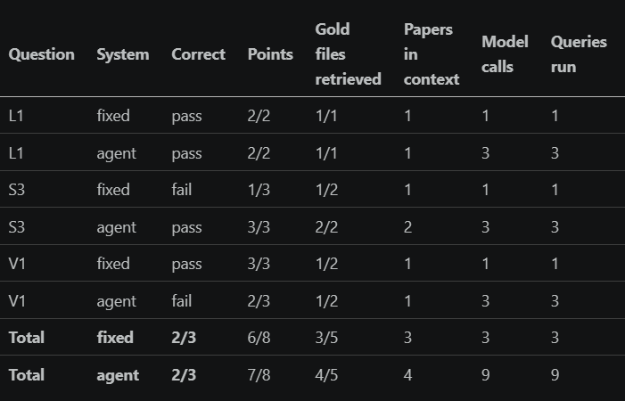

Overall, the agent performed better on these tests but still failed the question where contradictory information was found in the source documents.
AS the results show, question S3 was answered well by the agent vs the original 4.1 approach. It both answered the question and retrieved both gold files but at the expense of additional LLM calls.

Strengths observed
The agentic method answered the question that the original method did not which required comparing and finding differences between two similar documents. The agent’s planner was able to recognize content was returned from the first and that separate retrieval was needed for the second paper where the hybrid approach alone was saturated by data from the first at the expense of the second.

Weaknesses or challenges identified
The question that requested a comparison of two papers failed because the hybrid retriever was saturated by one document and the second document wasn’t revealed. The agent didn’t know there was a second document to be retrieved and thus the answer failed.
Another major issue discovered in earlier checkpoints but not part of my 3 tests in this checkpoint is an ongoing issue with identifying values from tabular data. It appears that they may need special treatment or separate embedding to allow for retrieval.
LLM calls cost real money and additional time depending on the chosen model and the number of iterations the loop has to use to complete.

Step 3. System Refinement
Based on your evaluation results, make one or more improvements to your system. Examples may include:
- Improving system prompts
- Adjusting workflow structure
- Modifying retrieval behavior
- Improving how the agent uses retrieved information
Changes implemented
Multiple paper comparisons continued to be a problem. I reintroduced a knowledge graph as a tool that the ‘planner’ node can call to retrieve documents related by title, author, and similar topics rather than relying on the LLM to query for the right documents. The first version used the LLM to try to find related documents which didn’t work. The agentic loop frequently stopped after one iteration pointing to an evaluation step that was too loose.
I made incremental changes to arrive at a result that was an improvement over the previous checkpoint’s pass rate of 75% ( 9 out of 12).
The first improvement was just a practical step to begin the process with a dedicated search node prior to the planner. This wasted a LLM call because the planner would always have to search first anyway.
Second, I made the initial search bucket of results equal to the hybrid search’s bucket. I had anticipated fewer, better quality results without the need to hold more documents but this assumption was wrong.
The third change was to modify the ‘Plan’ node to keep track of items needed to answer the question by asking the LLM to 1) split the question into sub-parts and 2) return a checklist with each part along with its source document or the word ‘MISSING’. The LLM used by the planner node then chooses the next action to ‘Answer’ if the checklist is complete or ‘Search’ if data is missing and further search is required.
The fourth change refined the prompt in the plan node to create a better and more targeted query rather than reusing the full question.
The fifth change modified the prompt to give a better description of when to search for related papers.
As a final tweak, I targeted a failure observed when near duplicate documents existed (for example, original and revisions) in an attempt to find relevant data from otherwise discarded chunks or documents. I tried to maintain a generalized approach for this and not target a particular case because this seemed to be fairly common across the corpus.

Justification
The changes were made to improve some of the recurring failures from previous checkpoints. One of the recurring themes was multi-paper questions failing because one paper would tend to overload/saturate the hybrid retrieval system.
A second and somewhat related failure that I attempted to fix was one where two documents had relevant content but were very similar in content. In particular, a case where two documents were similar but one was a revision of the first and contained newer information. The previous retrieval approaches always became saturated by the first (older) paper resulting in missing the document with the correct answer.

Step 4. Impact of Refinement
Evaluate the updated system. Describe any changes in task completion, accuracy, relevance, or overall system behavior. Compare the refined agent-based system with both its initial version and the fixed baseline. Explain whether the refinement improved performance and identify any trade-offs.

Impact on system performance
The first two changes had no real impact on the overall outcome. They were more of a cleanup of the initial LangGraph workflow removing an extra step and changing the retrieval Top_K parameter back to match the 4.1 checkpoint’s parameter.
Changes 3 and 4 improved the correctness score as judged by the LLM by a minimal amount but covered more available points from the corpus of documents. That came at the expense of extra processing time.
The 5th refinement improved the correctness score and added 2 extra model calls.
The final modification that looked for other versions of a paper succeeded at finding the proper answer to a case that had yet to succeed in past checkpoints. It did produce one fewer correct answer than the previous refinement but given that both the points covered and number of gold files were improved, I consider this an improvement- especially given the non-deterministic nature of the LLM judge.
The results after each are refinement are summarized below.
Agent | Correctness | Points Covered | Gold Files | Model Calls | Time (sec)
Initial | 8/12 | 23/30 | 13/20 | 37 | 51.2
Changes 1 & 2 | 7/12 | 21/30 | 13/20 | 26 | 48.7
Changes 3 & 4 | 9/12 | 25/30 | 13/20 | 26 | 64.3
Change 5 | 11/12 | 24/30 | 13/20 | 28 | 62
Change 6 | 10/12 | 24/30 | 14/20 | 27 | 78.9

Comparison of initial and refined systems
After building the agentic loop and several iterations of enhancements, the agentic RAG method created more correct results than the based on the 12 evaluation questions. It also seemed to be more stable producing 10/12 correct results on 3 consecutive runs while the baseline approach used by checkpoint 4.1 varied between 7 and 9 correct out of the same 12 questions.
The agentic AI also showed improved output of the points to cover and matched the baseline method in the number of gold documents retrieved. That additional correctness came at the expense of more than double the number of LLM calls over the baseline and more than double the amount of time to complete the 12 questions.

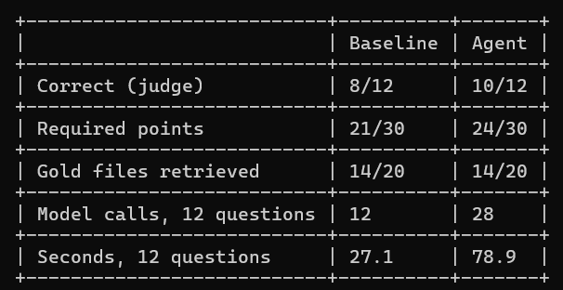

Step 5. Reflection
Reflect on your experience designing and evaluating an agent-based RAG system.
What contributed most to successful task completion?
The third change that asked the LLM to return a checklist of required items seemed to make the biggest improvement. It caused the agent to make another pass to retrieve a paper and include it in the answer. This paper had been excluded by other previous runs. The metrics also show that it increased the number of points covered in the output.

What limitations remain?
The two other failure modes include questions that require an answer found in tables. This case has been an issue since the first checkpoint and seems to require a new way of embedding the tables or another more advanced technique.
The other failure I’ve consistently encountered is cases where correct answers are spread across many documents. In one case, 6 papers contained points that should have been included but only 2 papers were used.
Another limitation is the variable nature of the LLM judge. Across 3 consecutive runs, the correctness score would vary by 1-2 correct answers.

What improvements would you prioritize next?
Devise a strategy for embedding and retrieving tabular data.
Use a more deterministic approach to score the checklist rather than letting the LLM judge its completeness.
New or modified strategy for managing situations where a large number of documents contain answers to the question. Using TOP_K with the hybrid search limits the context sent to the LLM answer node.

Supporting Materials
Use this section to list, describe, or link to any supporting materials included with your submission.
Supporting material | Location, link, or note
System prompts:
Evaluation results:
Screenshots or diagrams: | 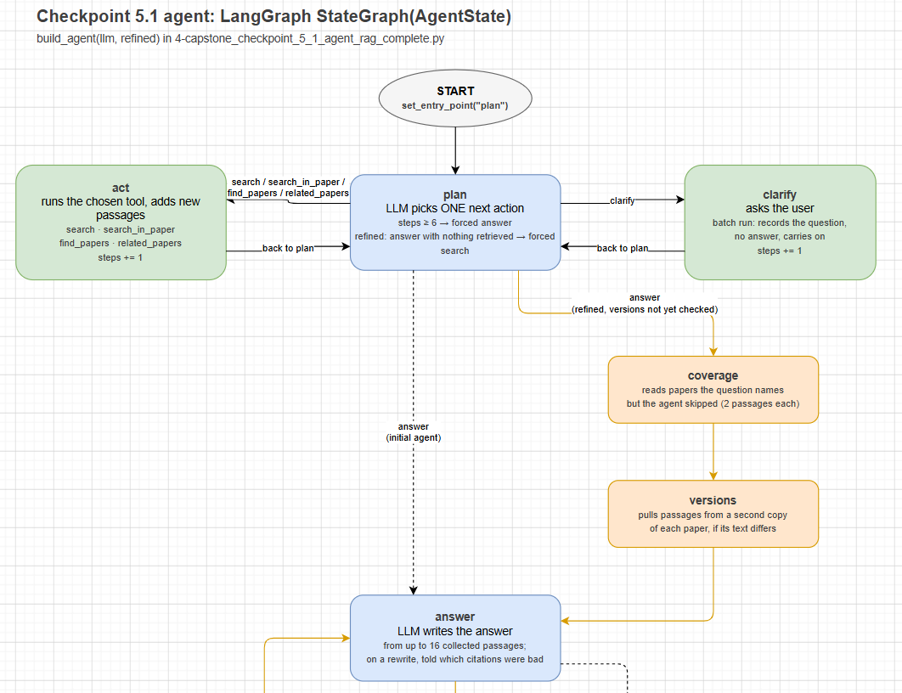
Code, notebook, or repository link: | TBD
Other supporting evidence:

End of Required Capstone Checkpoint 5.1
Return to the assignment page in the learning platform to upload and submit your completed capstone checkpoint worksheet and complete any remaining items in this module.

