APPENDIX A

Student Number : A00001003

Object Oriented Software Development Project

Introduction
This application allows for the management of Teams and Drivers associated with Formula 1 motor racing. It will allow the creation, reading, update, display and deletion of data from two lists, Teams and Drivers, from csv files in storage. The application will support a table like summary view of all teams or all drivers. It will also allow selection of a specific team or driver for which the detailed information can be viewed, updated, deleted and searched for using prompts from a CLI console. It will also allow for the searching for the drivers of a specific team by ID

Domain Classes
The application makes use of two main domain classes, Drivers and Teams.
The Drivers class contains the following fields.
ID, Driver, Country, Team, Car, Engine, Tyres & Points
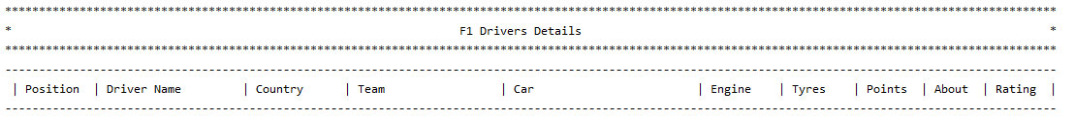

The Teams class contains the following fields.
ID, Team, Engine, Country, Races Entered, Races Started, Drivers, Total Entries, Wins, Points,Poles, FL (Fastest Laps) & Podiums
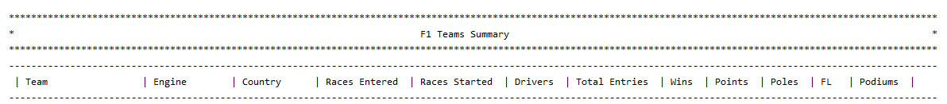

User Stories

- As an Application User, I want to be able to read all Teams from file storage and display a summary in a table format.
- As an application user I want to be able to add a Team to the database, update the file in storage and show the details in a table format.
- As an Application User, I want to be able to update selected details for a selected Team in a table format.
- As an Application User, I want to be able to delete a selected Team and save the updated Team List to file storage.
- As an Application User, I want to be able to select a specific Team and display the Drivers that race for that Team.
- As an Application User, I want to be able to read all Drivers from file storage and display a summary in a table format.
- As an application user I want to be able to add a Driver to the database, update the file in storage and show the details in a table format.
- As an Application User, I want to be able to select a specific Driver and display the Team that the driver races for.
- As an Application User, I want to be able to update selected details for a selected Driver in a table format.
- As an Application User, I want to be able to delete a selected Driver and save the updated Driver List to file storage.

Menu Structure
F1 Championship 2019 Information Database
Do you want information on the Teams or on the Drivers?
- Select Option 1 for the F1 Teams Summary
(Displays Team Summary Table and View Team Submenu Options (Y/N)?)
- Select Option 2 for the F1 Drivers Summary
(Displays Driver Summary Table and View Driver Submenu Options (Y/N)?)

If you select Y-Yes you are presented with a 7 Option SubMenu with options outlined below.
If you select N-No you exit the application.
If you wish to select Option 1 in the Main Menu read this paragraph
- Do you want to create a New Team in the database? If so, please enter Option 1 & enter the New Team Details in order as requested.
- Do you want to View a Teams Drivers in the database? If so, please enter Option 2 & enter the ID for the Team Drivers you wish to view.
- Do you want to Update the Team Name in the database? If so, please enter Option 3 and enter the Team ID that you wish to update along with the New Team Name as requested.
- Do you want to Update a Teams Points in the database? If so, please enter Option 4 and enter the Team ID that you wish to update along with the New Team Points total as requested..
- Do you want to Delete a Team in the database? If so, please enter Option 5 and enter the Team ID that you wish to delete.
- Do you want to return to the Main Menu? If so please enter Option 6
- Do you want to Exit the Application? If so, please enter Option 7.
If you wish to select Option 2 in the Main Menu read this paragraph
- Do you want to create a New Driver in the database? If so, please enter Option 1 & enter the New Driver Details in order as requested.
- Do you want to View a Teams Drivers in the database? If so, please enter Option 2 & enter the ID for the Teams Drivers you wish to view.
- Do you want to Update the Driver Name in the database? If so, please enter Option 3 and enter the Driver ID that you wish to update along with the New Driver Name as requested.
- Do you want to Update a Drivers Points in the database? If so, please enter Option 4 and enter the Driver ID that you wish to update along with the New Driver Points total as requested..
- Do you want to Delete a Driver in the database? If so, please enter Option 5 and enter the Driver ID that you wish to delete.
- Do you want to return to the Main Menu? If so please enter Option 6
- Do you want to Exit the Application? If so, please enter Option 7.

If you select Option 3 in the Main Menu please be aware the Application will terminate with a “Application has been exited” message
Test Documentation
User Story | 1 Start Application
Test Case ID | 1
Description | Display the main menu
Given | - Application is not running  - Data files exist on disk
When | - Application is started
Then | - Main menu is displayed  - User is asked to choose option 1,2 or 3
Test Status | Passed

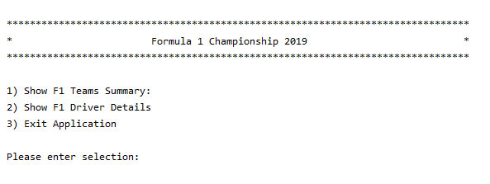
User Story | 1B Enter Non-Integer Type Character
Test Case ID | 1B
Description | Option Non-Integer Character Entered
Given | - Application is running  - Main Summary menu is displayed  - Non-Integer Character is entered
When | - Application is running and Option 1,2 or 3 is requested
Then | - Exception in thread "main" java.util.InputMismatchException  - Process finished with exit code 1
Test Status | Failed

User Story | 2 Display Team Summary
Test Case ID | 2
Description | Option 1 - Display the Team Summary
Given | - Application is running  - Main Summary menu is displayed
When | - Display Team Summary option selected
Then | - Team Summary table is displayed  - View Team Submenu Options (Y/N)?  - Y – Yes - Team Summary table is displayed along with 7 Option Submenu  - N – No – Return to Main Menu (Y/N)?  - Y - Yes – Main Menu Displayed  - N – No – Application is exited
Test Status | Passed
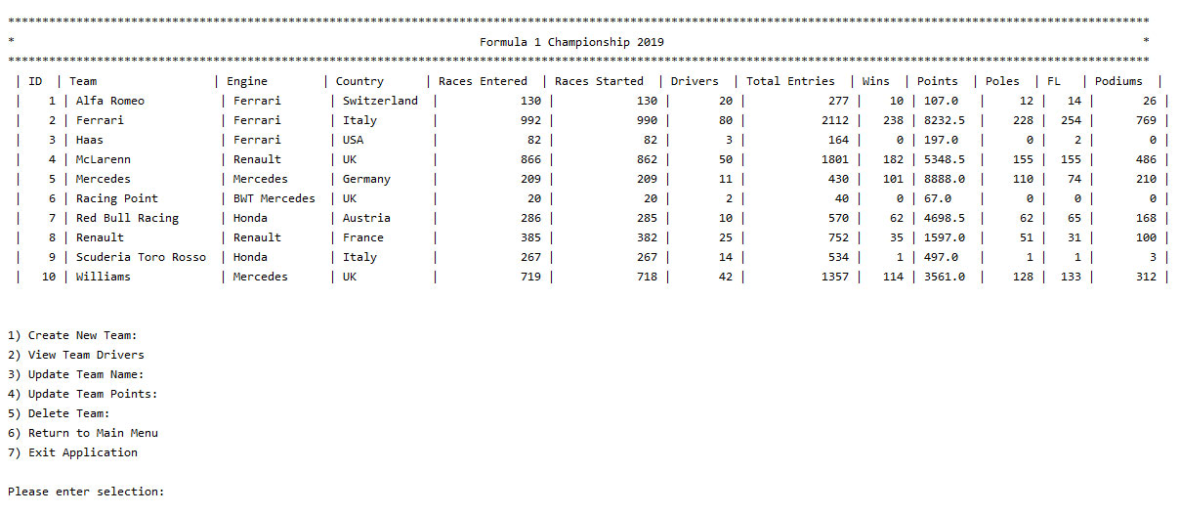
User Story | 3 Create New Team
Test Case ID | 3
Description | Option 1 - Create New F1 Team, update summary list and write to file
Given | 1. Application is running  - Team Summary & 7 Option Submenu are displayed
When | 1. Create New Team option selected
Then | 1. New Team Details are requested in a specific format  - Relevant details are inputted by user  - New Team Details are added to summary & written to file
Test Status | Passed
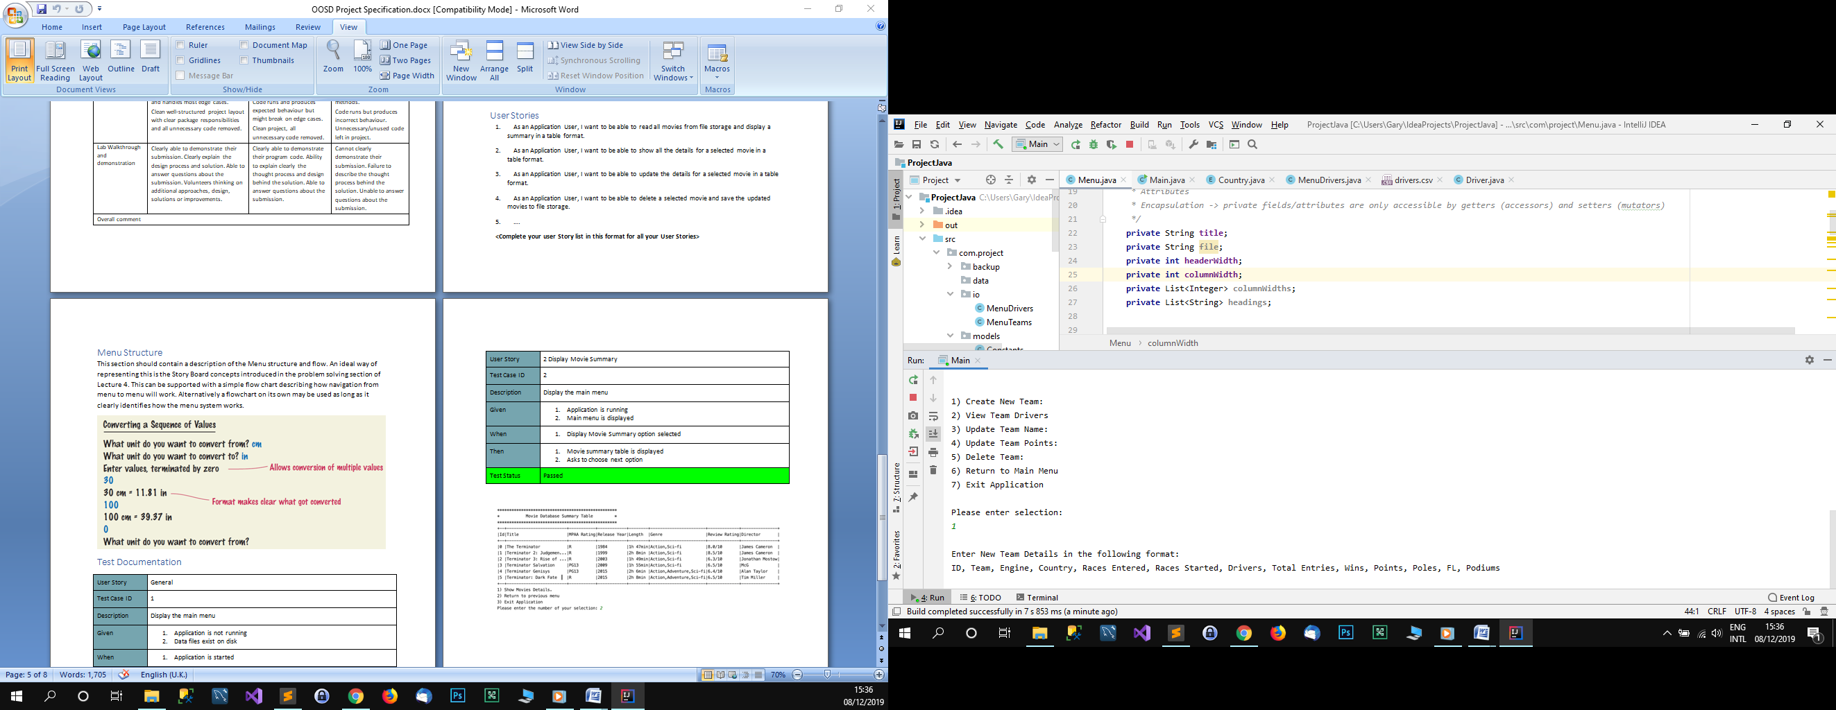

User Story | 4 View Team Drivers
Test Case ID | 4
Description | Option 2 - View Driver for selected Team via ID
Given | 1. Application is running  2. Team Summary & 7 Option Submenu are displayed
When | 1. View Team Drivers option selected
Then | 1. Relevant Team ID is requested  2. Specific ID as per Team Summary is inputted by user  - Team Drivers specific to that team are display
Test Status | Passed
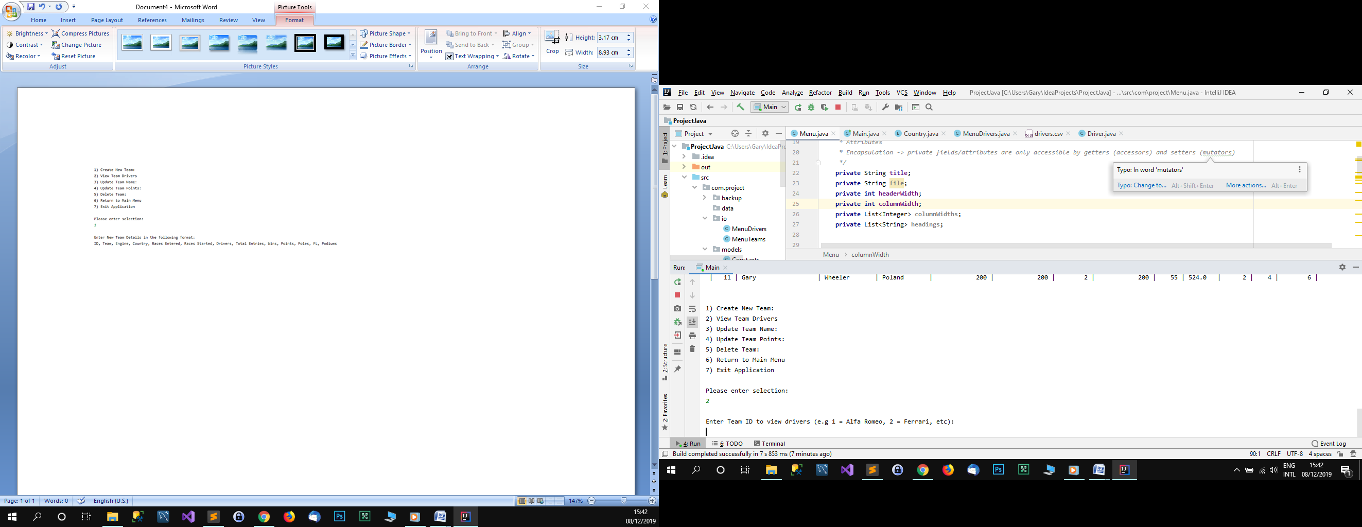
User Story | 5 Update Team Name
Test Case ID | 5
Description | Option 3 - Update Team Name for selected Team via ID
Given | 1. Application is running  2. Team Summary & 7 Option Submenu are displayed
When | 1. Update Team Name option selected
Then | 1. Relevant Team ID is requested  2. Specific ID as per Team Summary is inputted by user  - New Name for Team as per ID is requested  - New Name for Team is added to summary & written to file
Test Status | Passed
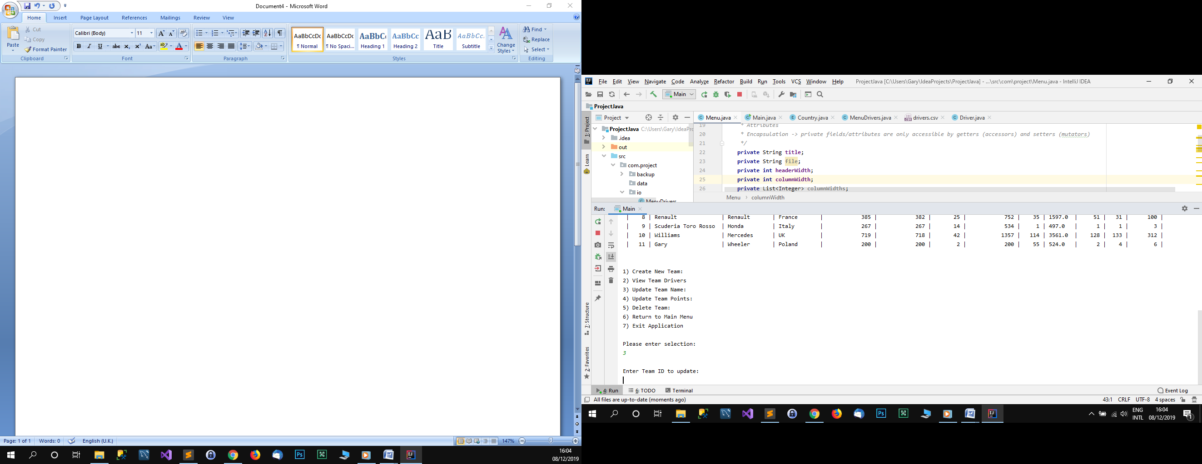

User Story | 6 Update Team Points
Test Case ID | 6
Description | Option 4 - Update Team Points for selected Team via ID
Given | 1. Application is running  2. Team Summary & 7 Option Submenu are displayed
When | 1. Update Team Points option selected
Then | - Relevant Team ID is requested  - Specific ID as per Team Summary is inputted by user  - New Points Total for Team as per ID is requested  - New Points Total for Team is added to summary & written to file
Test Status | Passed
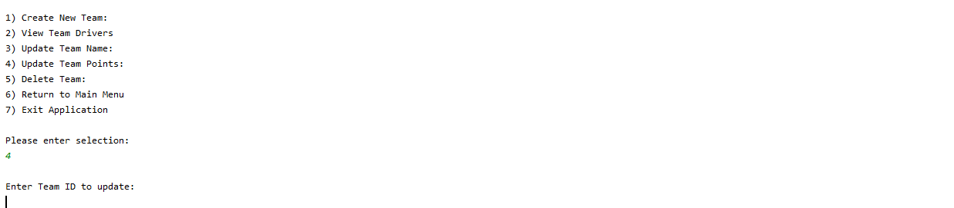
User Story | 7 Delete Team
Test Case ID | 7
Description | Option 5 - Request Delete for selected Team via ID
Given | 1. Application is running  2. Team Summary & 7 Option Submenu are displayed
When | 1. Delete Team option selected
Then | 1. Team Details are requested in a specific format  2. Relevant details are inputted by user  - Deleted Team details are removed from summary & written to file
Test Status | Passed
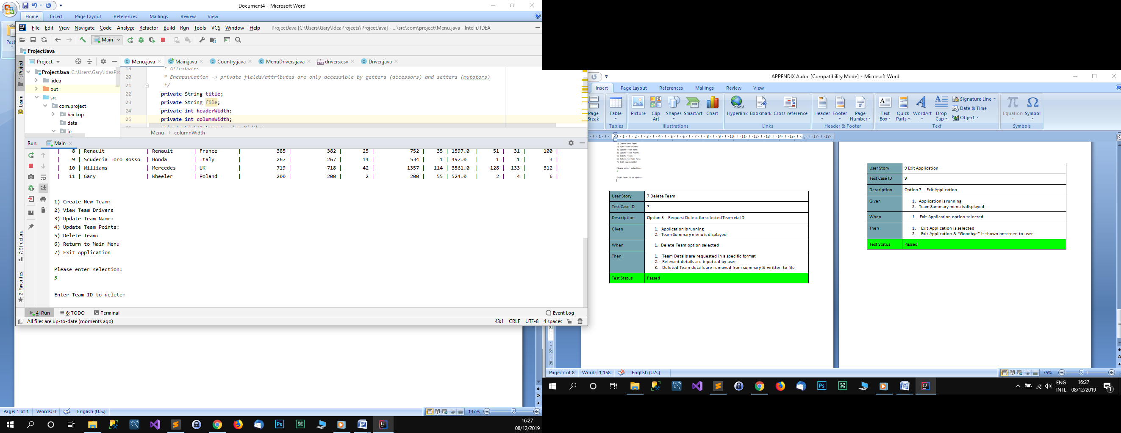

User Story | 8 Return to Main Menu
Test Case ID | 8
Description | Option 6 - Return to Main Menu
Given | 1. Application is running  2. Team Summary & 7 Option Submenu are displayed
When | 1. Return to Main Menu is selected
Then | 1. Return to Main Menu is selected  - Main Menu is shown onscreen to user
Test Status | Passed
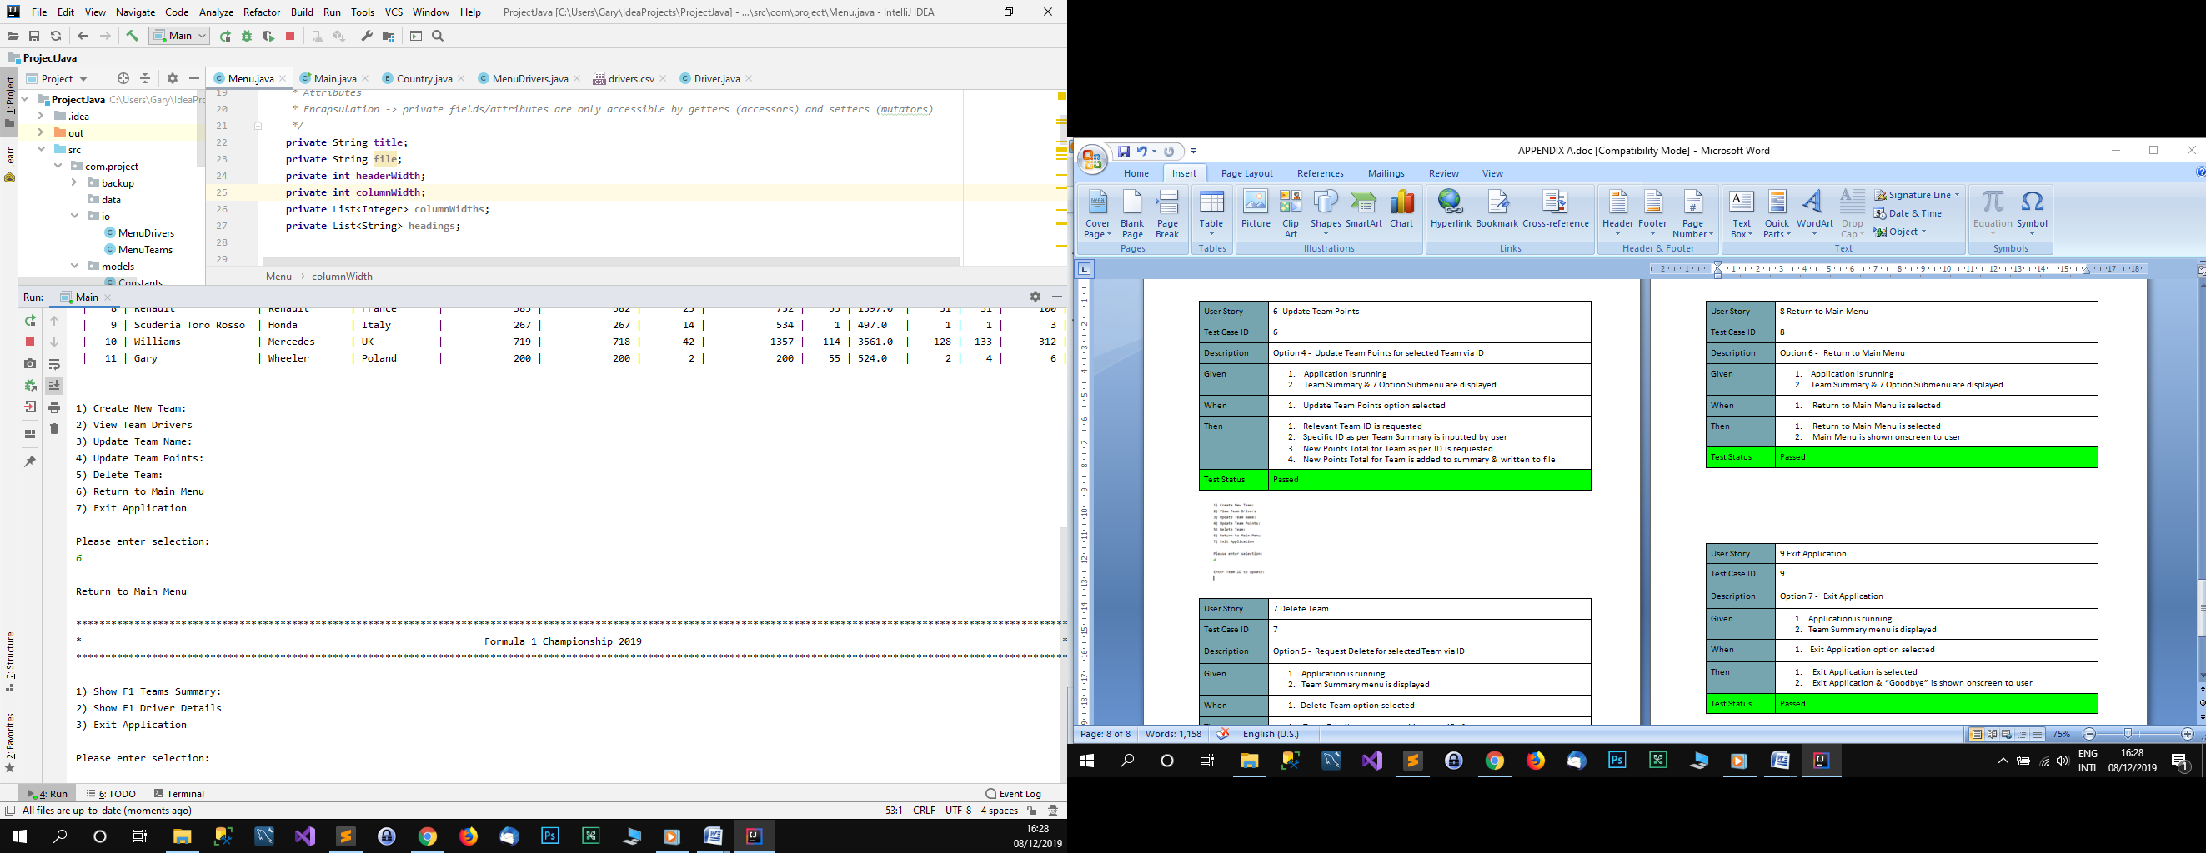
User Story | 9 Exit Application
Test Case ID | 9
Description | Option 7 - Exit Application
Given | 1. Application is running  2. Team Summary & 7 Option Submenu are displayed
When | 1. Exit Application option selected
Then | 1. Exit Application is selected  2. Exit Application & “Goodbye” is shown onscreen to user
Test Status | Passed
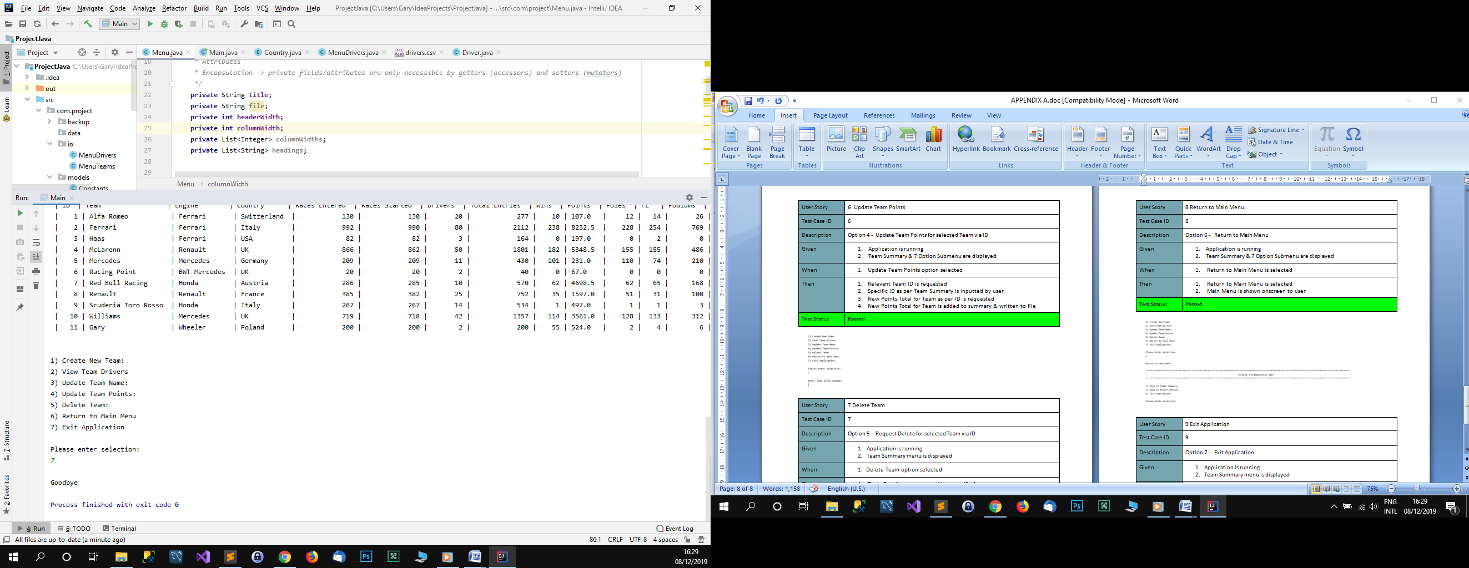
Please note the test cases for the Drivers

Select Option 2
Display Drivers Summary

Select Option 1
Display Teams Summary
(Main Menu)
Application Starts
Files Exist in storage
View SubMenu Options Y/N?
No
Yes

View SubMenu Options Y/N?
No
Yes

–

Select Option 3
Exit Application

(Driver Summary Menu)
Select Option 1
Create New Driver
View SubMenu Options Y/N?
No Yes . ..

(Driver Summary Menu)
Select Option 2
View Team Drivers
View SubMenu Options Y/N?
No Yes .

(Team Summary Menu)
Select Option 2
View Team Drivers
View SubMenu Options Y/N?
Yes No

(Team Summary Menu)
Select Option 3
Update Team Name
View SubMenu Options Y/N?
Yes No

(Driver Summary Menu)
Select Option 3
Update Driver Name
View SubMenu Options Y/N?
No Yes .

(Team Summary Menu)
Select Option 4
Update Team Points
View SubMenu Options Y/N?
Yes No

(Team Summary Menu)
Select Option 6
Return to Main Menu
Returning to Main Menu.......

(Team Summary Menu)
Select Option 5
Delete Team
View SubMenu Options Y/N?
Yes No

(Team Summary Menu)
Select Option 7
Exit Application

(Driver Summary Menu)
Select Option 4
Update Driver Points
View SubMenu Options Y/N?
No Yes .

(Driver Summary Menu)
Select Option 5
Delete Driver
View SubMenu Options Y/N?
No Yes .

(Driver Summary Menu)
Select Option 6
Return to Main Menu
Returning to Main Menu.......

(Driver Summary Menu)
Select Option 7
Exit Application

Return to Main Menu Y
N
No
Yes

Return to
Y Main Menu
N
No
Yes

(Team Summary Menu)
Select Option 1
Create New Team View SubMenu Options Y/N?
Yes No

Main Menu
Team Summary Menu

