# Write up:

## What does this experiment do?

This experiment uses the automobile dataset which has attributes about the car and then predicts the 25th/50th/75th quantile for the price of the automobile.

## Training experiment

Sample dataset: the data has 26 variables as shown below.

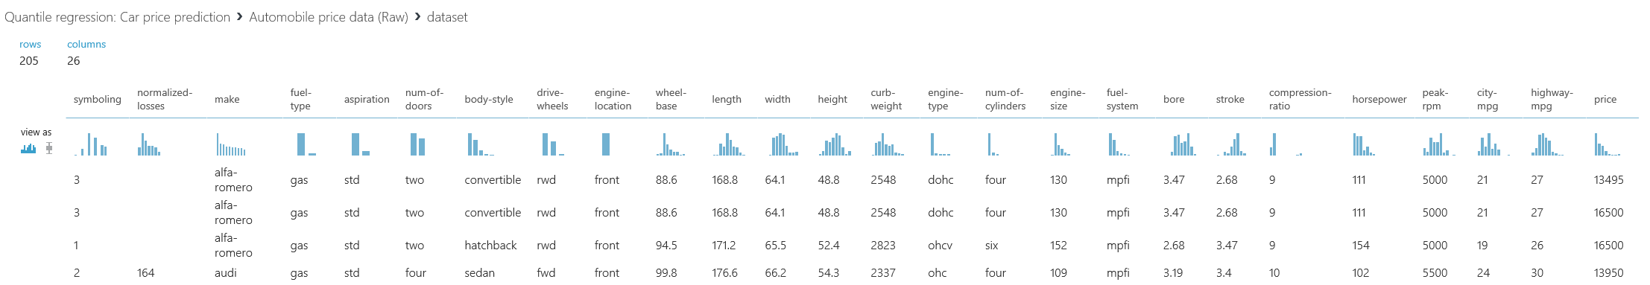

Understanding the experiment flow:

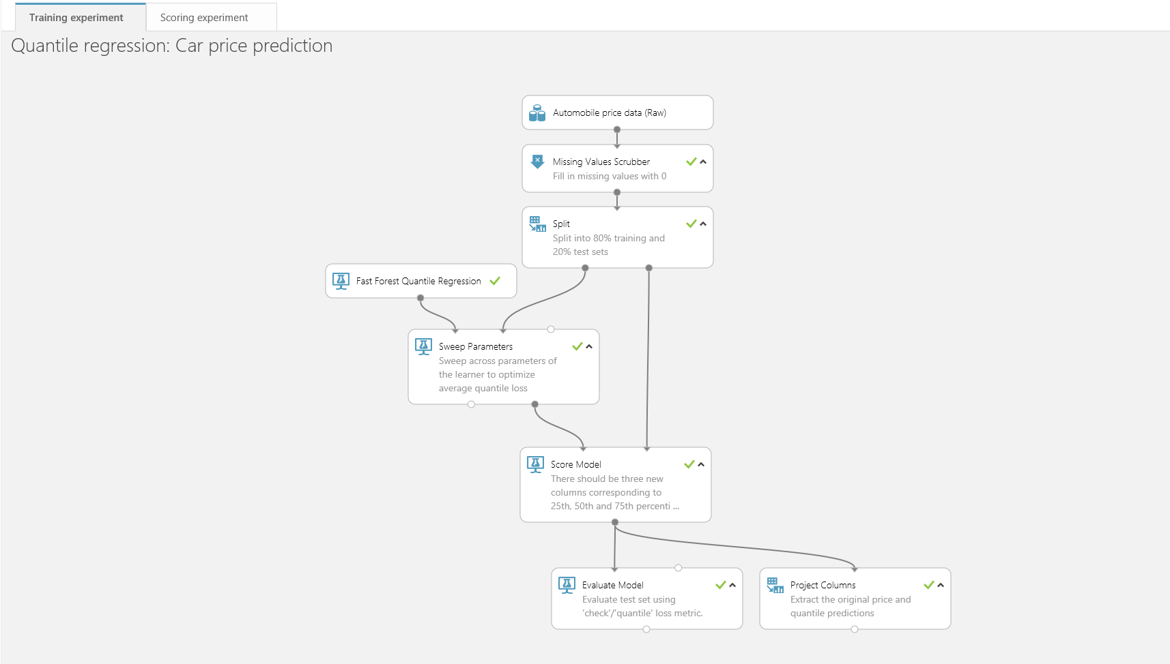

* Input the raw saved dataset.
* The dataset has both continuous and categorical variables (features) and the dependent variable (label) is continuous.
* Perform a missing value treatment using the ‘Missing Value Scrubber’.
* Split the dataset into 80:20 (80% for training and 20% for scoring).
* The algorithm/learner used is ‘Fast Forest Quantile Regression’. 80% of the data is used for training.
* ‘Sweep Parameters module’ is used to optimize the metric (average quantile loss) across all parameters for the learner.

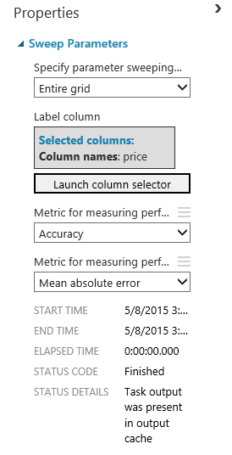

* The model is then scored using the remaining 20% of the dataset.

Now there are 3 additional variables generated Scores for quantile (0.25/0.5/0.75).

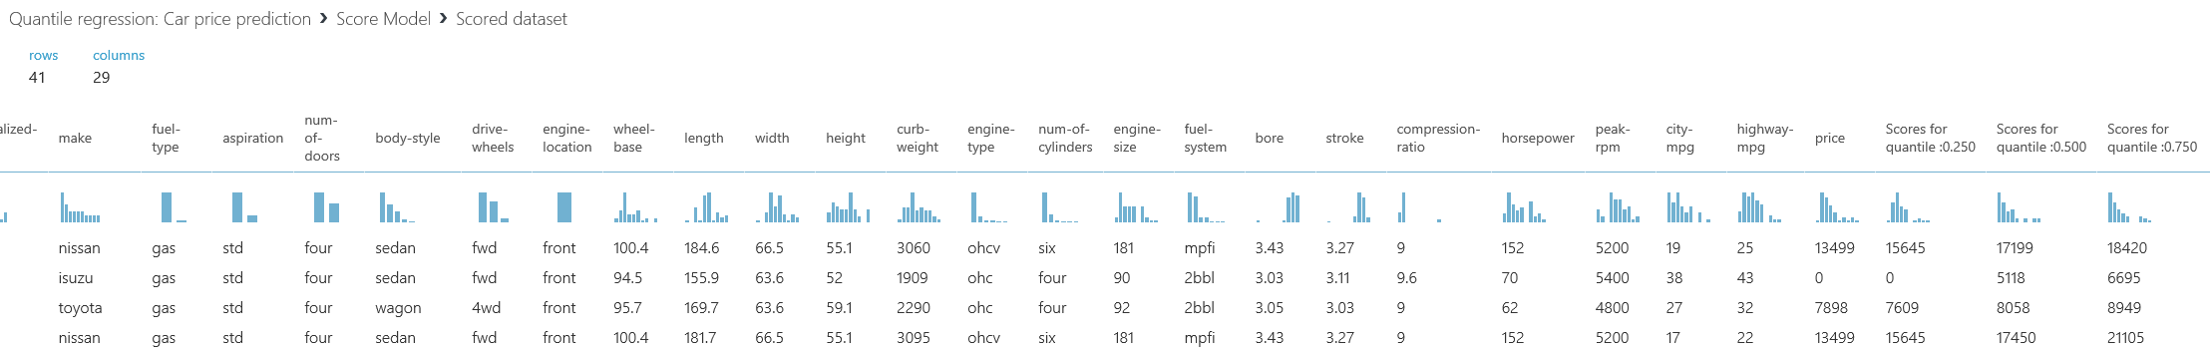

For a definition of quantile: <http://en.wikipedia.org/wiki/Quantile>

* The ‘Evaluate model’ module generates the following performance metrics.

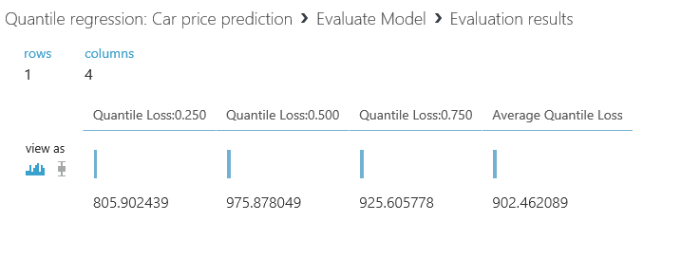

## Scoring experiment

Once the training experiment has run successfully, select the option to ‘Create Scoring Experiment’



A scoring experiment is automatically generated for the user with a Web service input/output.

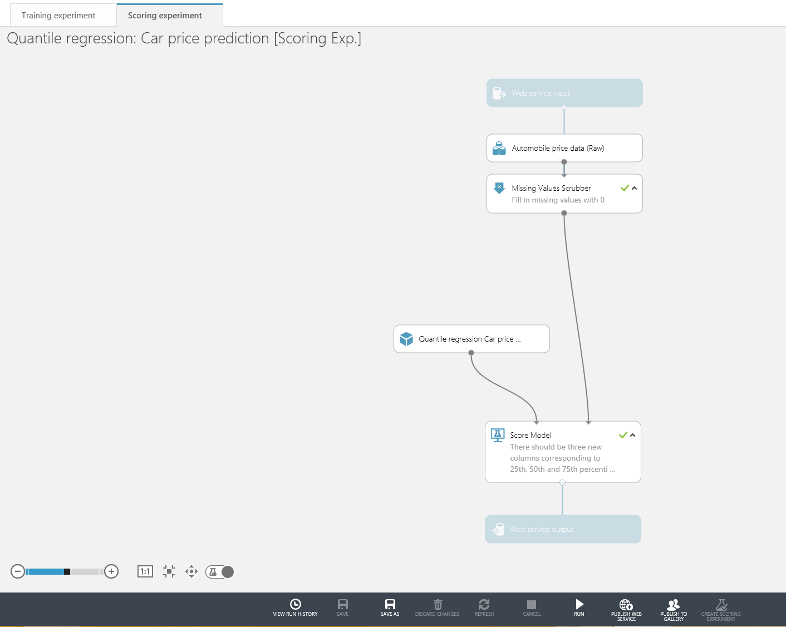

Run this experiment and then select to ‘Publish Web Service’.

## Web Service

In the web service panel the user should be able to see the newly added web service and has the option of invoking this web service as a RRS/BES.

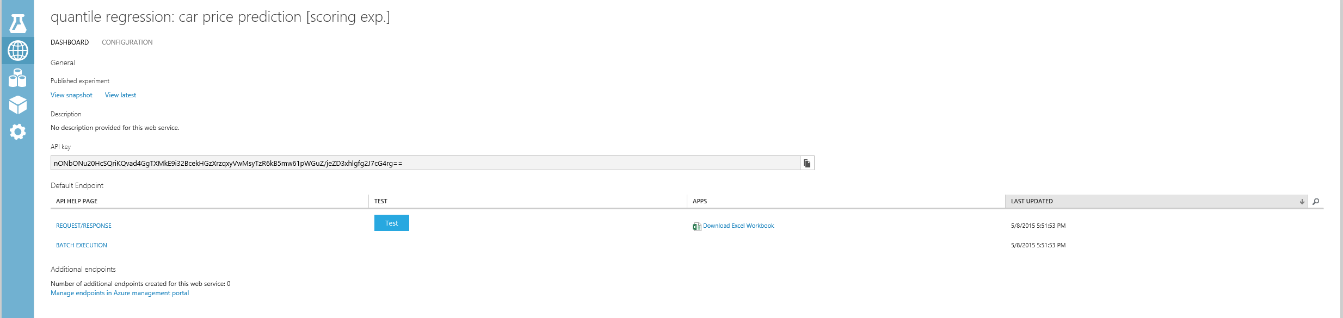

To quickly check the web service, the user can select the ‘Test’ option as shown.

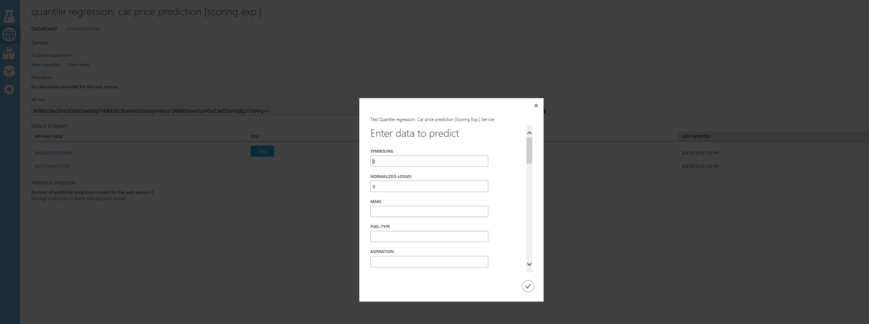

The output is generated as follows from the RRS invocation.

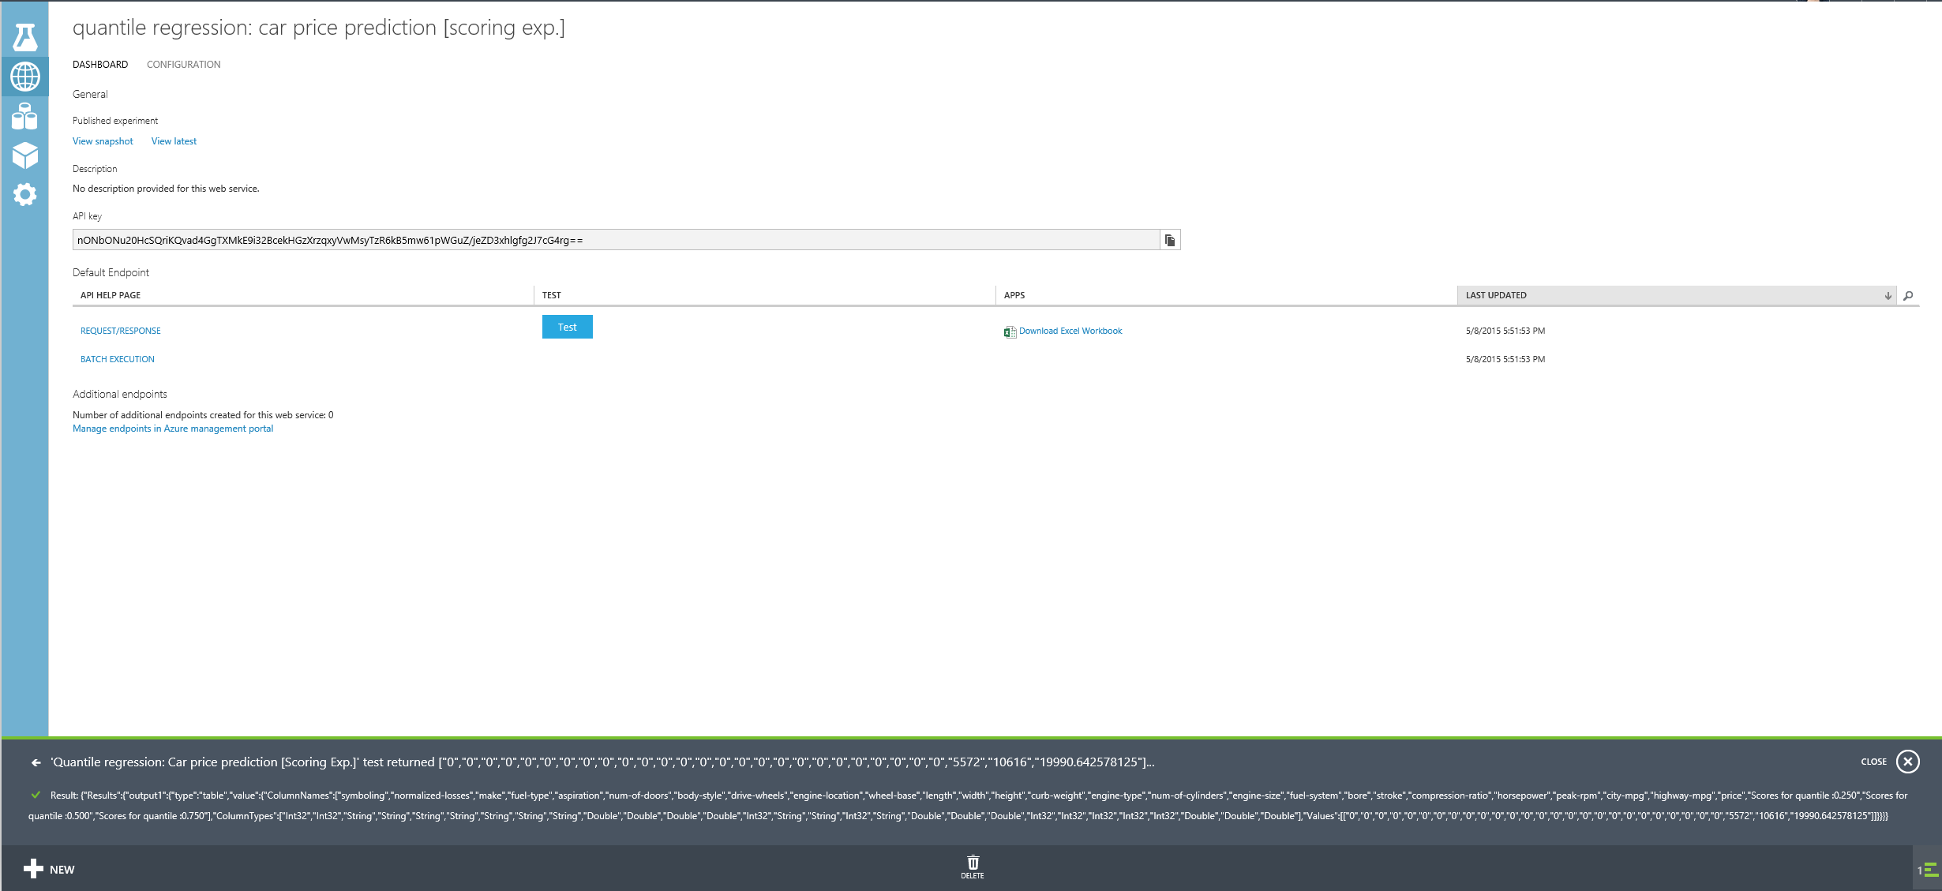

Interpreting the results: The user gets the predicted value for the 25th/50th/75th quantile for the price of the car with a specific set of attributes.

For more details on configuration for the web service refer to the API help page:

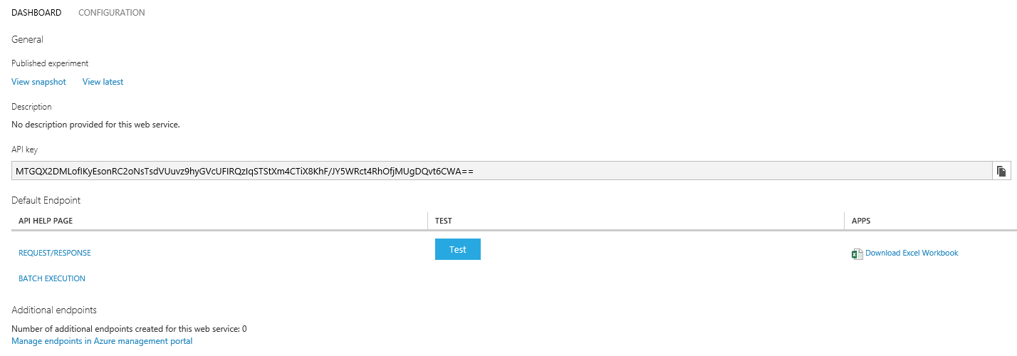

Upon clicking on the API help page for Request/Response, the user gets additional details on various configuration parameters.

