Gary G Ku
08/2020
Guided Capstone Project Report

Over the course of the analyses we found that Big Mountain seems to be undercharging in ticket prices for the amount of facilities that it offers. Currently Big Mountain charges $81 while the model created suggests that they charge closer to $94 give or take $10. The expected profit increase from this if Big Mountain retained the same amount of visitors would be $2275000. Although a price hike of $13 may not seem feasible, the data shows that Big Mountain would be justified in increasing its prices somewhat.

Based on the data the resort features that seem to have the biggest effect on ticket prices are the number of runs, the number of fast quads, the height of the vertical drop, and the area of snow made by snow makers. These are the features to focus on if Big Mountain is looking to justify further price increases. This is supported by a variable importance plot based on a random forest model as shown below:
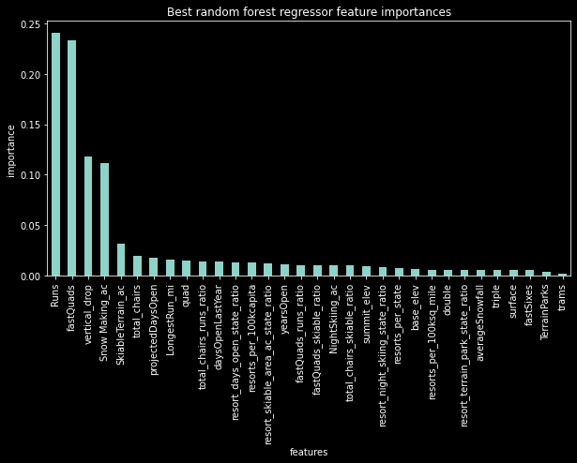

Another discovery was found in regards to the increase in operating costs caused by adding an additional chair recently. The operating costs of adding an additional chair was recorded to be $1540000. Based on the statistical model created, adding one additional chair seems to only justify a ticket price increase of $.80 resulting in an increased annual revenue of around $1400000. This suggests that adding an additional chair does not seem profitable.

Currently the course of action advised based on the data would be to increase the current ticket price as an increase would be justified based on the analysis of the data. Also it may be worth it to increase the number of runs as well as increase the vertical drop while increasing the ticket price which may increase profits if operation costs don't increase at a faster rate.

For any potential future projects, knowing the operation costs of each variable would help in determining what areas to invest in. The modeled price for Big Mountain is higher than the actual price because the company based its prices off of the average prices of other resorts even though it had above average facilities. It may also be a marketing strategy to make Big Mountain's prices more competitive. A business executive may be able to use this information to possibly cut the extra chair to save costs or develop a strategy to increase ticket prices. To make this model more useful to the business analysts it might be a good idea to make a program with an intuitive UI that would make pricing forecasts based on user-entered parameters as well as historical data.

