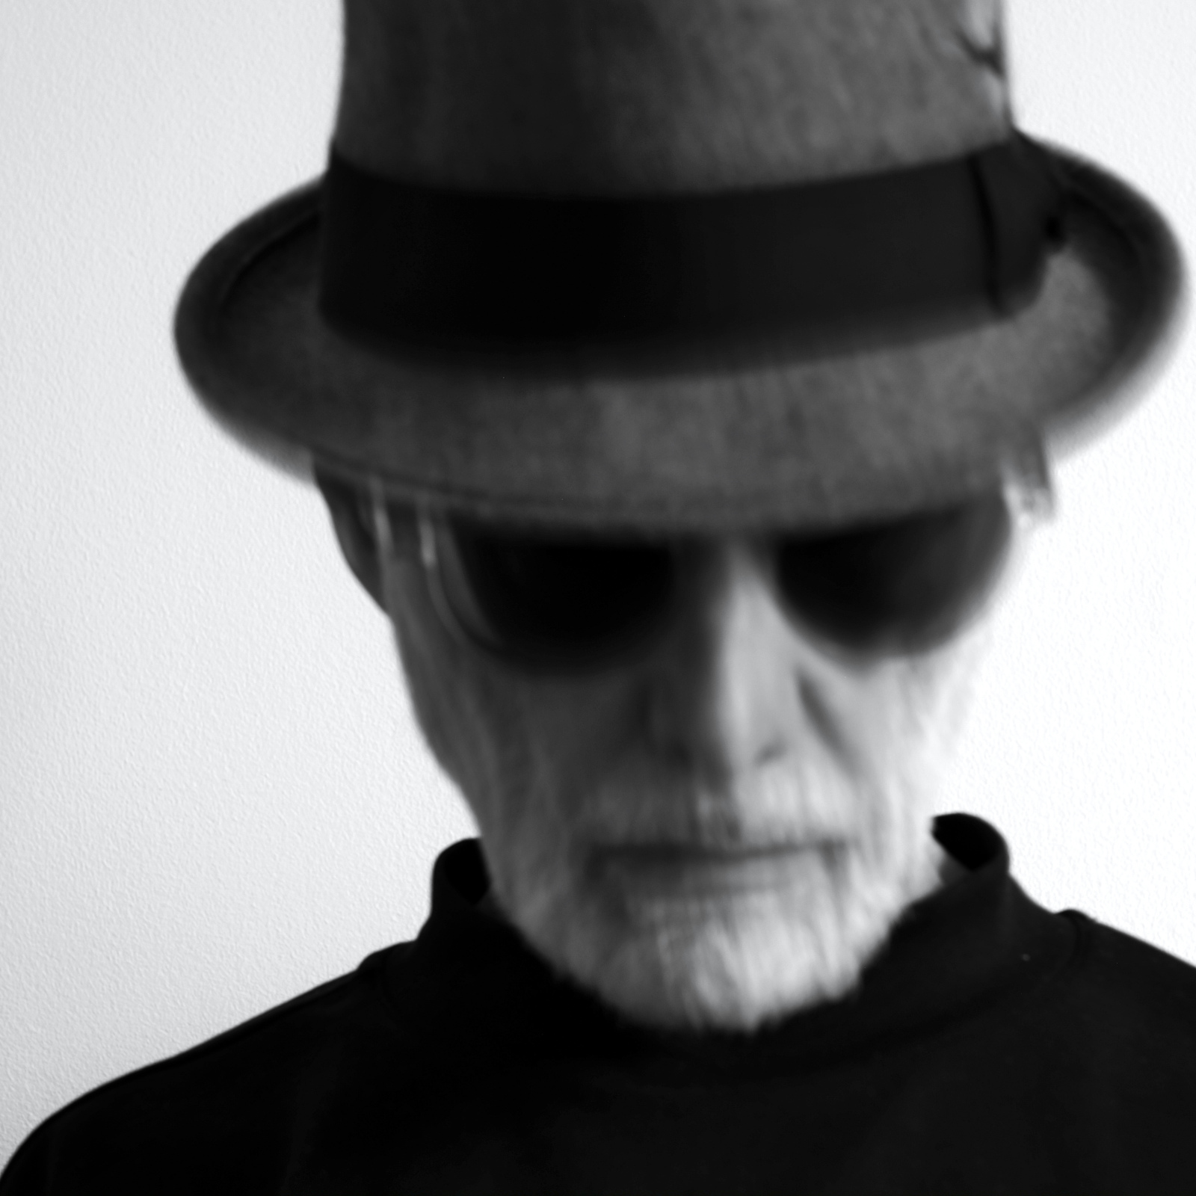
contents
bikers
buildings
glimpses
morning
people
rockers

