DBHW01 410887043 電機三 何祐豪
1.
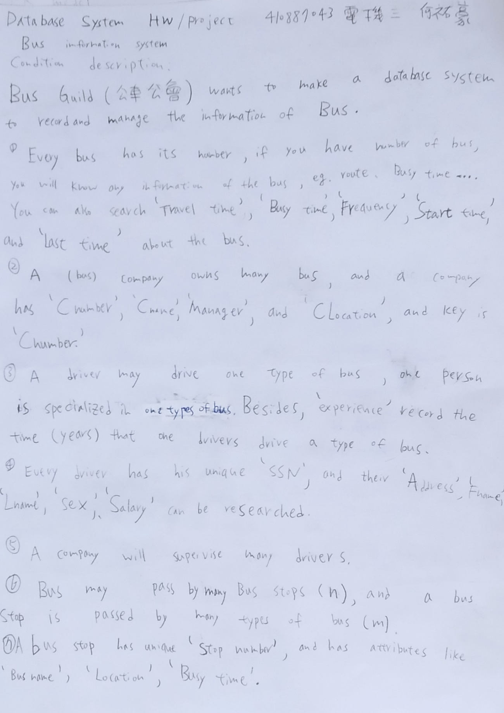
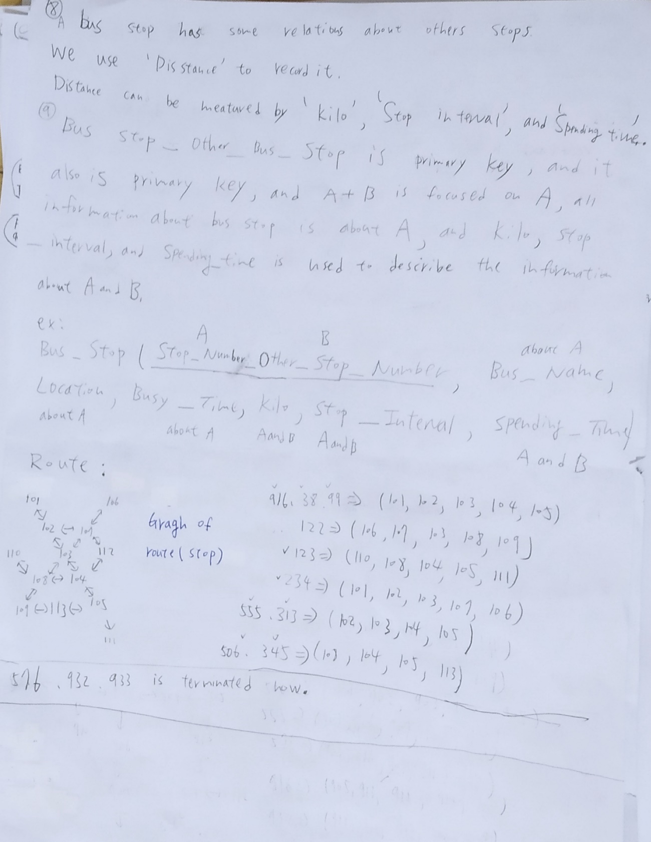
2.
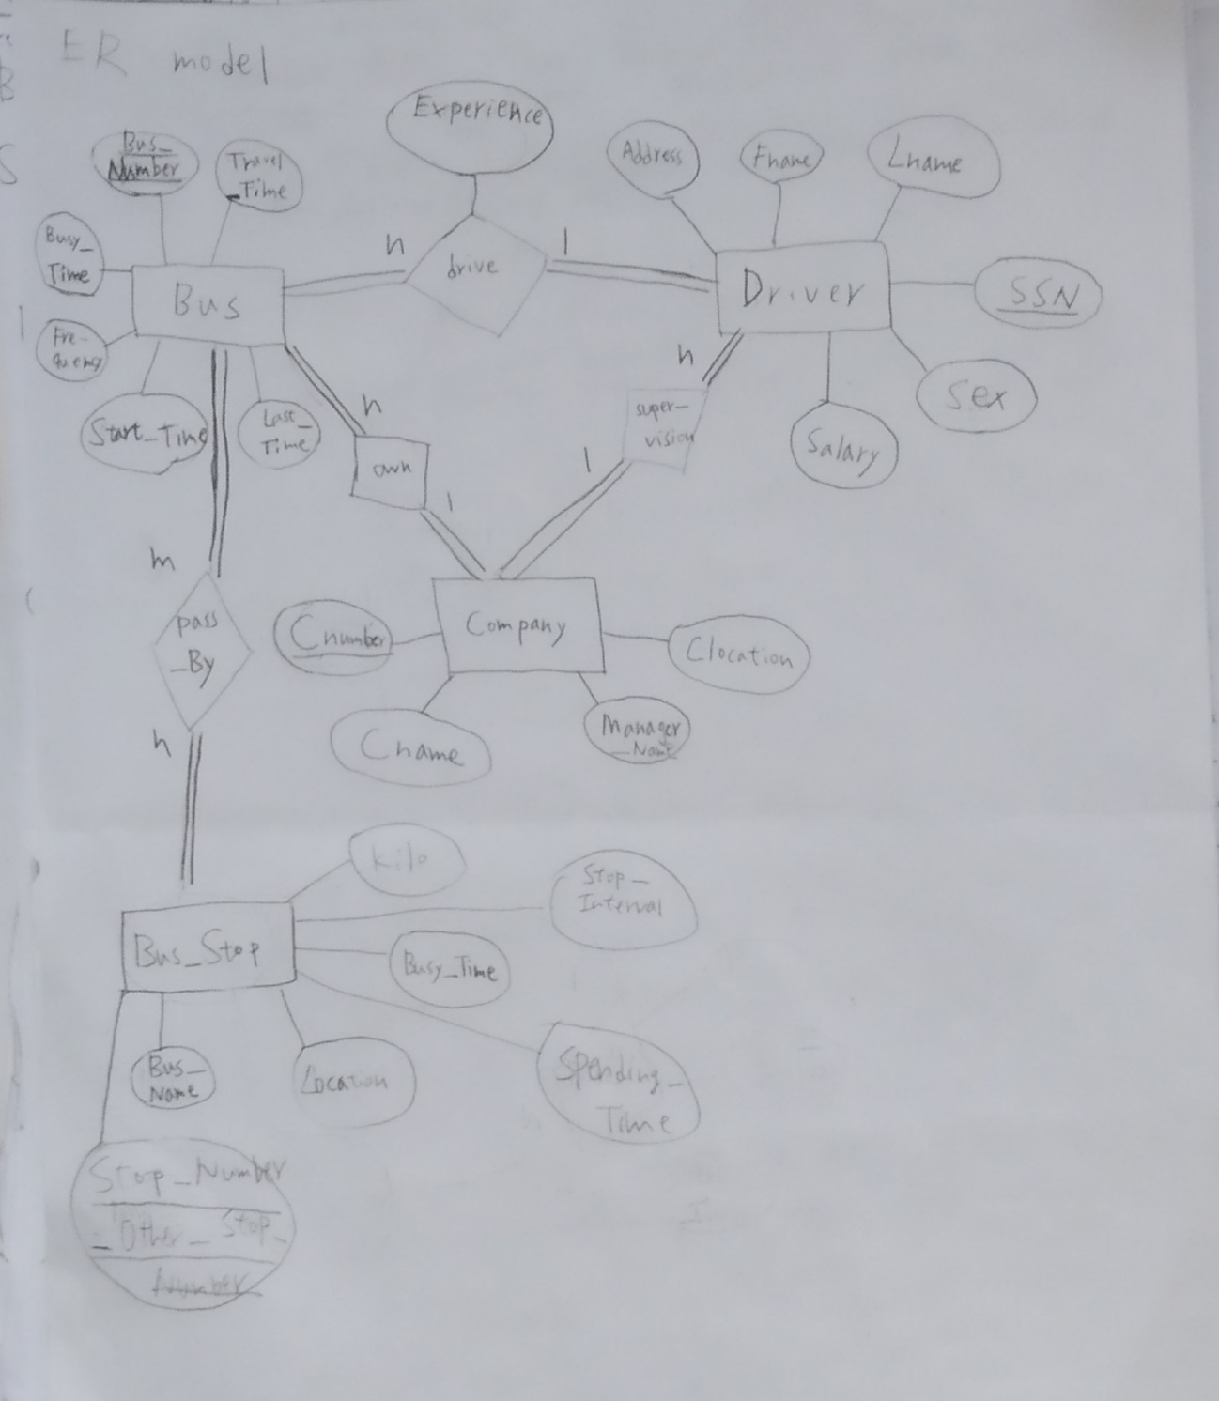
3.
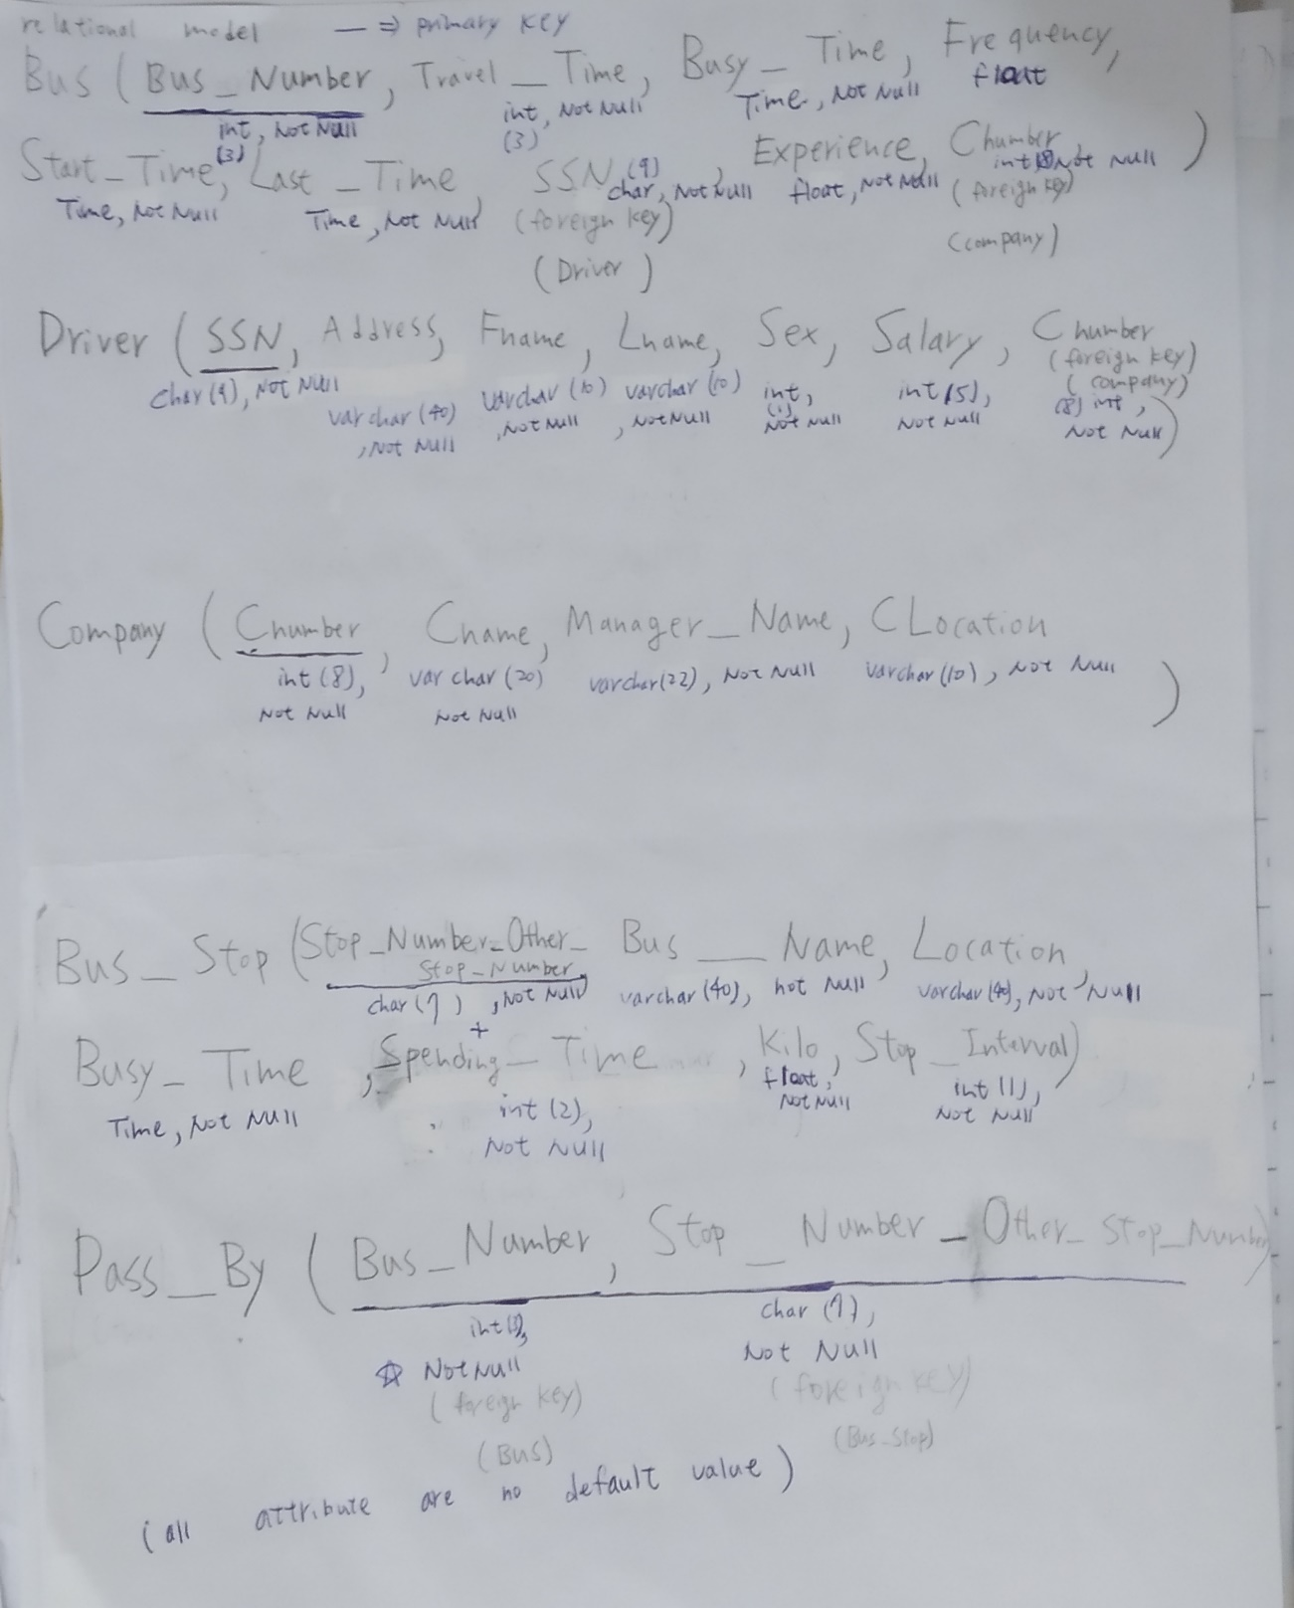

4.
關聯圖
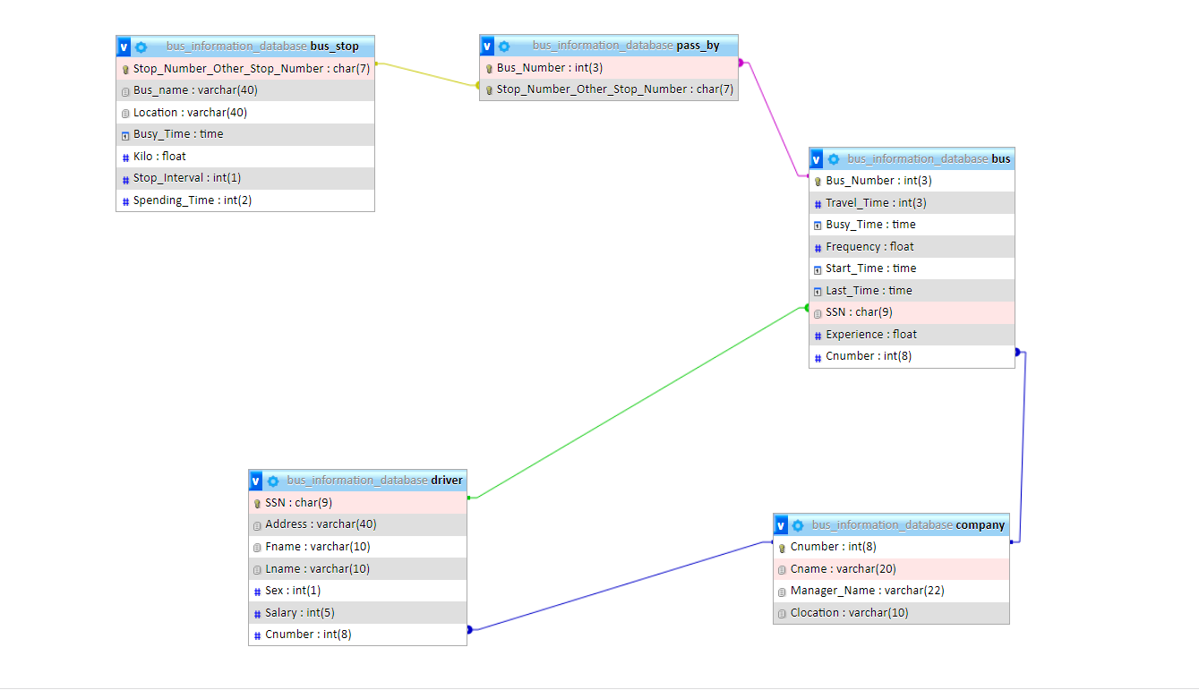

Query1: Find Fname, Lname, and Sex of the driver(s) that salary > 30000 NT dollars regardless of what company is belonged to.
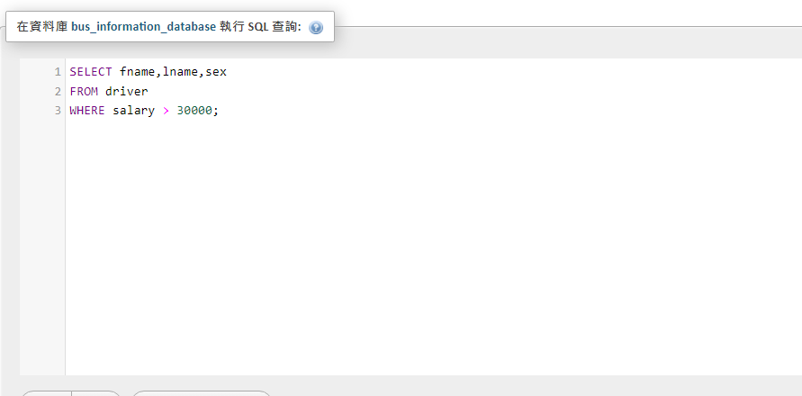

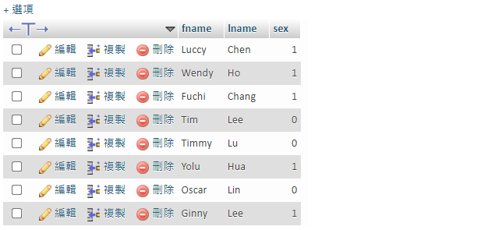

Query2:Find what company is located in Sanxia, and list company name, manager name.
Besides,Find the driver(s) who works for that company(s), list driver’s SSN, driver’s Fname, driver’s Lname, and driver’s address.

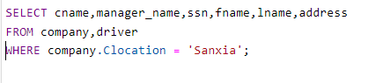

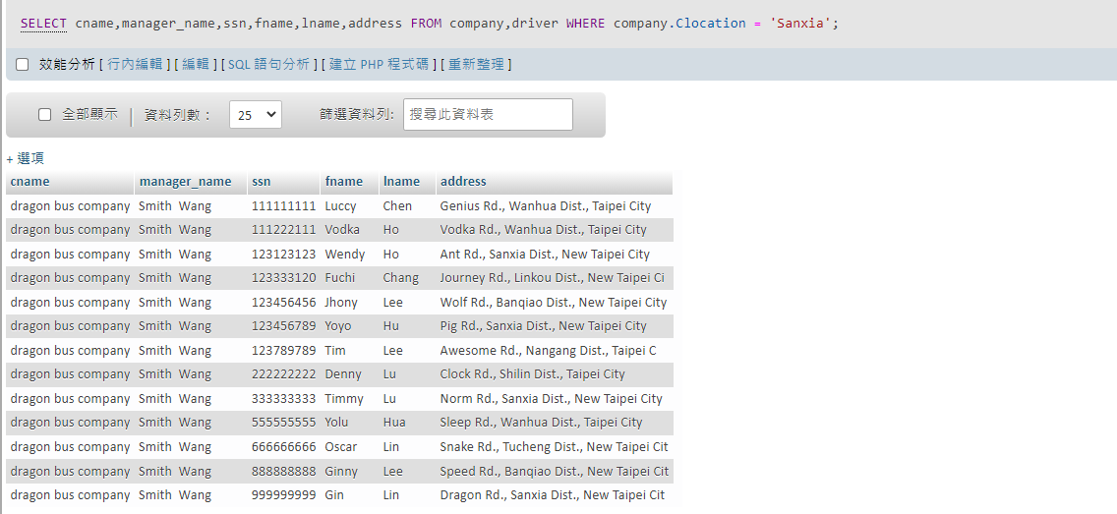

Query3:One person wants to use bus information database system to find how to go to ‘Fish Pool’.
He(She) wants to know the stop number of ‘Fish Pool’, what stop is next to ‘Fish Pool’, what kinds of bus(es) can
arrive in, and the frequency of that bus(es).
