PyQt5 環境建置

1. Install pyqt5
   1. Command:

pip install pyqt5 lxml

Install pyqt5 & lxml

lxml可不安裝

1. Install pyqt5-tools (designer)
   1. Command:

pip install pyqt5-tools

Install pyqt5-tools

* 1. continue

1. 新建立一個專案
   1. 打開designer AP

Command: **pyqt5-tools designer**

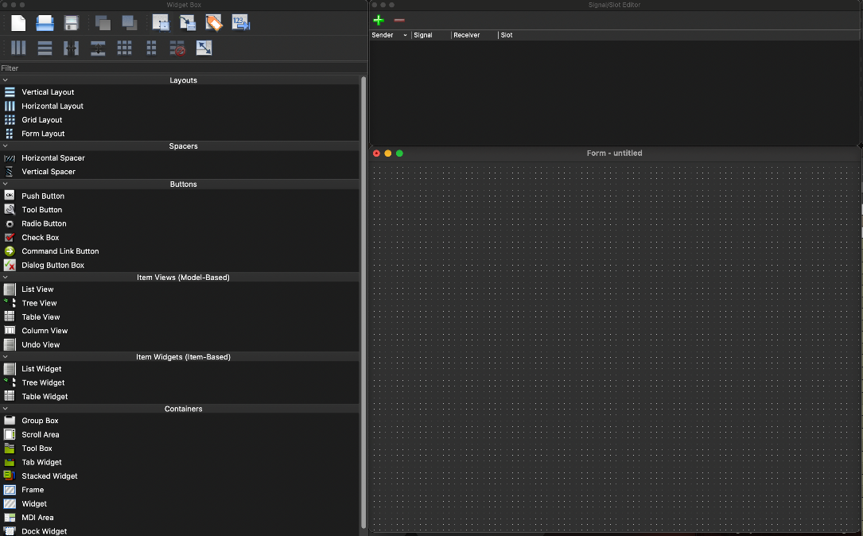

* 1. 建立新的專案
  2. *.ui -> *.py, 將ui檔案轉換成py檔案，and *.py is named label.py

Command: **pyuic5 -o *.py *.ui**

* 1. Create UI folder and copy label.py into the UI folder
  2. Create a new main.py and import label.py’s class.
  3. Execute python main.py

1. continue