 | Base Metals Crammer |  |  |  | Fri 26th Jan 2001
Yesterday’s Crammer explored the possibility that the deregulation in Pacific NW power pricing has made it uneconomic to smelt aluminium in that region, threatening permanently their 1.655m mt of smelter prodn (580kmt open).
Yesterday’s left hand chart of aluminium power cost per metric tonne vs spot power cost looked so extreme that it forced a double take, showing smelting power costs of $8000/mt of primary aluminium basis a spot power cost of approx. $500/MWhr – spot power prices have spiked to $3000). Today I’ve shown a toned down version of the same chart basis my estimates of long term project financed power prices, discussed below:
Even using the more representative longer term power price implied by gas fired power generation basis gas at $4-$5/MMBtu, returned a smelting power cost per metric tonne of primary aluminium between $640-$800 before capex and generator running costs. If a smelter built a dedicated gas burning power plant, then the capital expenditure and interest costs bump the power price to $1040 per metric tonne of primary aluminium (basis $5 gas), before alumina costs, labour costs and margin etc are added in. Current alumina prices are around $150/mt but, if the Pacific Northwest smelters come back onstream, you can expect alumina prices to recover towards $250-$300/mt. Multiplying by 2, this gives an alumina cost of between $500-$600 per metric tonne of aluminium. Even using the lower of the 2 alumina numbers, this gives a power and alumina cost of $1540 per metric tonne of aluminium before payroll and other costs are added in.
To gauge just how bad this looks for the future of NW smelter production, compare this $1540 power and alumina cost figure to historical LME aluminium prices. The chart on the right shows a cumulative distribution of LME cash, 3m, 15m and 27m prices since June 1991. Cash LME aluminium has been below $1540 for almost 70% of the time back to June 1991. Taking the same alumina price of $500 per mt of aluminium, and adding in the European/Gulf power cost of around $160-$320/mt of primary aluminium, gives a competitor power and smelter cost of $660-$820/mt before payroll and other costs. This looks a much better starting point against historical aluminium prices.
The market seems to be realising the risk that the smelter shutdowns are more permanent than temporary, with LME 3m aluminium trading up to $1628 today and cash-3ms opening at $70 back a lender this morning.
Looking at the LME aluminium 3m chart (bottom right chart), the very long term downtrending overhead resistance is vulnerable at $1645. Before then, a short term resistance at $1630 and an Elliot Wave triangle resistance at $1636 are upside targets. If broken, expect technical buyers to add some of their power to this power related aluminium price rally.
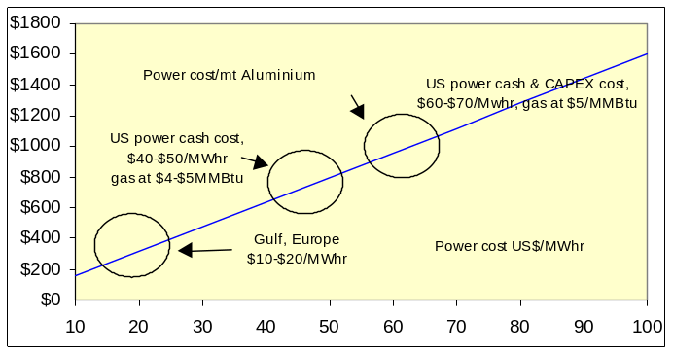 |  |  |  | 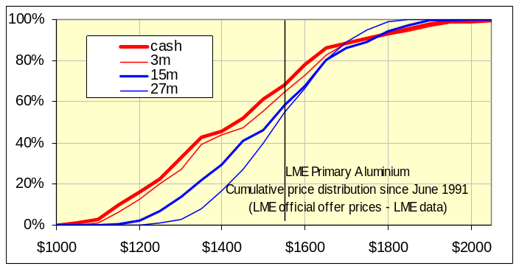
Focusing on aluminium, the Crammer completely missed the impact regional power prices had on other less power intensive industrial activity, so the Phelps Dodge news caught me by surprise.
Yesterday afternoon, Phelps Dodge announced they had initiated the closure of 3 copper facilities, Chino and Tyrone (N.Mexico) and Sierrita (Arizona) by issuing WARN notices (Worker Adjustment and Retraining Notices) which are sent at least 60 days prior to any shutdown. Last year, Chino produced 123,000mt of copper, Tyrone was 72,121mt and Sierrita 111,130mt. Most production shutbacks in the US are accompanied by temporary tightening in US physical premiums as the company may cover their previous sales commitments by securing their own stock in exchange warehouse or through merchants. The chart on the left shows the LME copper forward price curve over the past 4 days. Despite the price fall, the March tightness is still evident, with a contango through the balance of 2001 and a backwardation through 2002 onwards. LME copper stocks in the US act as a buffer on the COMEX-LME arbitrage, but these have fallen. From (bad) memory, LME copper stocks in the US hit a maximum around 500,000mt (mostly Long Beach 140? Los Angeles 110? New Orleans 180?), but the west coast LME stock buffer has dropped to around 60,000mt. If Phelps source local copper, this stock buffer may fall further. In the backwardations of 1996-1997, the Crammer tracked an interesting intra-month stocks arbitrage between LME Long Beach and COMEX San Manuel and Tucson. This saw copper stock cycle between the LME warehouse prior to 3rd Wednesday, and the COMEX before the end of the month, for a round trip cost guessed at approx. $30/mt? Will this re-emerge if the backwardation tightens?
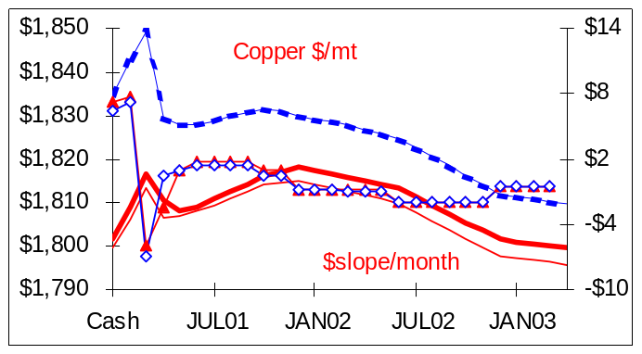 |  |  |  | 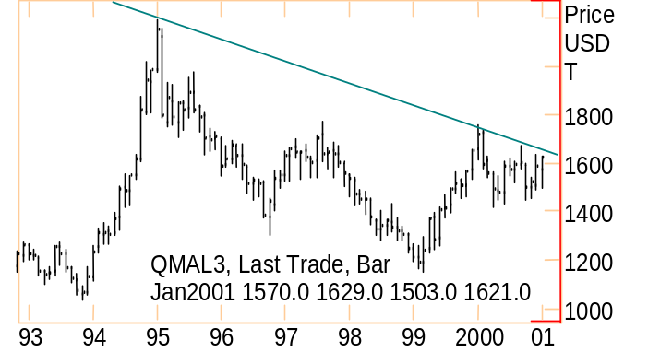
Rohan Ziegelaar (London) |  | Direct Tel: 44(0)20 7783 2415 | Fax: +44 (0)20 7783 1419 |  |  | Rohan.Ziegelaar@enron.com
This material is provided to you for discussion purposes only and is not intended as an offer or solicitation for the purchase or sale of any financial instrument or security, nor does this material constitute investment or trading advice. Enron Metals Limited makes no representation or warranty, express or implied, as to the truth, accuracy or completeness of this material and neither Enron Metals Limited or any of its Affiliates, nor any of Enron Metals Limited’s employees, officers or agents of its Affiliates shall be liable for any matter owing out of or in connection with this material of the use of it. Opinions expressed are the opinions of the author and do not necessarily represent the opinion of Enron Metals Limited or any of its affiliates. Enron Metals limited or its affiliates may hold positions or make markets in financial instruments identical or economically related to transactions discussed herein.

