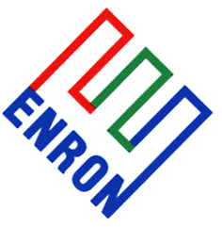 | Base Metals Crammer |  |  |  | Mon 29th Jan 2001
Judging by aluminium’s $40 rally since the middle of last week, there is increasing awareness of the risk of further production cutbacks in the Pacific North West. Some of those fears were realised this morning, when PLATTS reported (a source close to the deal claiming) that Michigan Avenue Partners plans to cut an undisclosed amount of output from Alcoa’s 204,000mt Longview smelter, once it takes ownership of the plant on Feb 1. MAP said they were looking at creative solutions to the region’s power situation, but are also committed to exploring options to provide good power to their facility. Any cuts are subject to union consent, but details of any power sale to Bonneville Power (BPA) or any production cutbacks won’t be released until the sale is completed.
Seven out of the 10 smelters in the region have either a proportion or all of their power fixed by BPA at US$22.60/MWhr, translating to a power charge of approx. $360/mt of primary aluminium on this fixed price power.
With power for 204,000mt/year fixed at $22.60/MWhr, Longview has the most tonnage fixed at this price in the region. To satisfy European Union conditions on their merger with Reynolds, Alcoa had to sell at least 25% of Longview, and the deal with MAP is believed to be for a 100% sale of Longview.
Excusing the approximate nature of my guessing, a back of the envelope calculation suggests the following:
To stay open: Like other smelters in the region, Longview’s current power contract will run until October 2001. Tonnage: basis 204,000mt/year equals 137,000mt between February and September.
Power: 137,000mt by 16MW/mt at $22.6/MW = $49.4m power costs
Alumina: 2mt at $150/mt by 137,000mt = $41m alumina costs
Wages, etc: 2000 workers (?) at average employment cost of $50,000 pa (?) for 8 months = $67m (say $70m including)
Revenues: Feb-Sept Aluminium = $1630 average by 137,000mt = $223m
Therefore, approximate payoff to staying open = $63m (very rough, apologies)
To shut: This is completely dependent on the price at which MAP can exit the remainder of the power contract, so is expressed in chart form on the left side.
Power Sale: 3,280,000MWs/year for Feb-Sept = 2,187,000MWs for sale between US$22.6 to US$400/MWhr (?)
Wages Feb-Sept = as above, say $70m
Restart costs = For Oct 2001, or when (if) the regional power market stabilises = $10m (yet another guess).
Looking at the left chart, the red line shows my guess at the power price dependent payoff to shutting Longview between Feb and Sept 2001, while the blue line shows my guess at the payoff to running the plant over the same period ($63m).
All numbers are very approximate and before tax and any other considerations.
The chart suggests that, if MAP can sell their remaining power back to BPA or into the grid for more than $66/MWhr, then this makes more economic sense than operating the smelter over that period, basis my guessed figures.
The chart on the right shows the forward curve of 2 west coast power contracts. Front month COB is running around $320/MWhr before slipping to $50 for Q2. Assuming Feb around $350/MWhr, this gives an average of $156/MWhr for the Feb-Sept period under consideration. The Palo Verde contract is running higher, averaging around $240 for the strip (guessing Feb at $250/MWhr). Guessing between the 2 curves at $200/MWhr this suggests a payoff of $357m if the smelter closes.
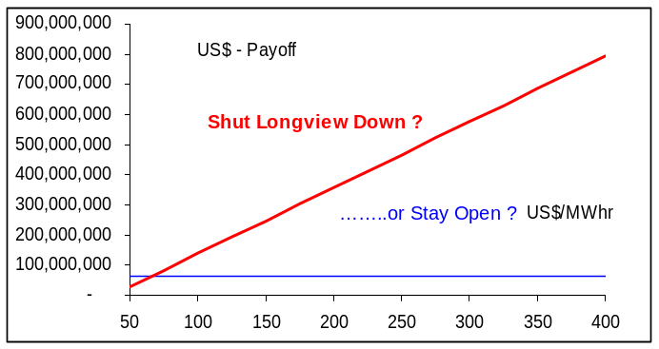 |  |  |  | 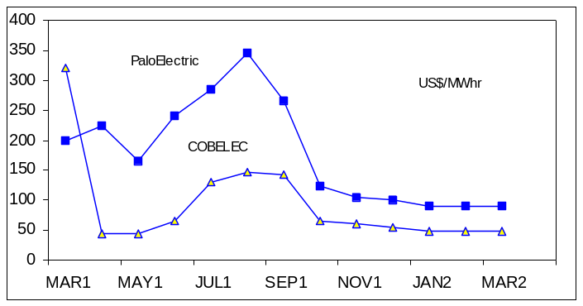
The chart on the left shows the LME aluminium forward curve over the past 4 days, showing the tighter nearby dates as a short market covers upside exposure. Despite the backwardation from Cash, aluminium stocks are rising only intermittently and stand at 391,400mt this morning. The chart on the right shows LME aluminium options open interest by strike for April calls (red line) and puts (blue blocks). At 4550 lots, $1650 is the big April strike and short market makers are nervously looking to cover their upside exposures for nearby dates. So they’re vulnerable to further news of production cutbacks.
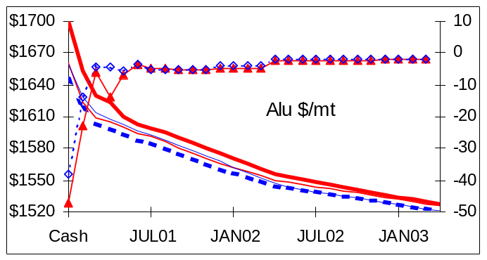 |  |  |  | 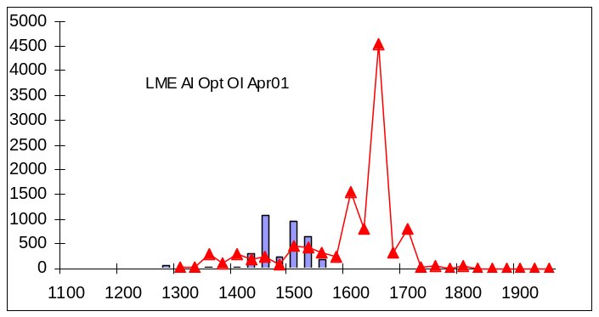
Rohan Ziegelaar (London) |  | Direct Tel: 44(0)20 7783 2415 | Fax: +44 (0)20 7783 1419 |  |  | Rohan.Ziegelaar@enron.com
This material is provided to you for discussion purposes only and is not intended as an offer or solicitation for the purchase or sale of any financial instrument or security, nor does this material constitute investment or trading advice. Enron Metals Limited makes no representation or warranty, express or implied, as to the truth, accuracy or completeness of this material and neither Enron Metals Limited or any of its Affiliates, nor any of Enron Metals Limited’s employees, officers or agents of its Affiliates shall be liable for any matter owing out of or in connection with this material of the use of it. Opinions expressed are the opinions of the author and do not necessarily represent the opinion of Enron Metals Limited or any of its affiliates. Enron Metals limited or its affiliates may hold positions or make markets in financial instruments identical or economically related to transactions discussed herein.

