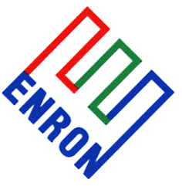 | Base Metals Crammer |  |  |  |  |  |  | Thurs 25th Jan 2001
Of all the base metals, power prices are a large part of aluminium smelting costs. This explains why new smelter capacity is increasingly sited near sources of cheap power, for example using natural gas in the Gulf, and hydro or thermo power in Scandinavia. For a metals guy, power seems a little mysterious, luckily there is a wealth of publicly available data.
In the Pacific north west, the power deregulation of the late 1990s encouraged some smelters to reduce their power dependency on longer term fixed price contracts from hydro power sources, instead choosing to take some exposure to the free market price. But the free market power price has risen to levels where aluminium smelting is uneconomic, because of a combination of factors including low water tables, environmental concern over salmon runs, seasonal higher demand from neighbouring states, cold weather, generation problems and environmental opposition to certain types of power plant construction. Doing some simple sums when considering an aluminium smelter project, the major costs are alumina + power + capital (& interest) + other costs (labour, margin). Looking at alumina first:
Alumina prices range between $150-$400/mt, and it takes approx. 2 mt of alumina to make 1mt of aluminium. Current alumina prices are around $150/mt, unsurprising given that over 1million mt of N. American smelter capacity is shut at the moment. So alumina costs are around $300/mt of primary aluminium, rising to $800/mt of aluminium if alumina ever gets back up to $400/mt. Taking a look at power:
As an approximation, aluminium smelting uses 16 Mega Watts (16 MW) for every tonne of aluminium produced. New aluminium smelter projects will look for power prices in the $10-$20/MWhr range, for a running power cost of between $160-$320/mt of aluminium. The chart on the left shows the power cost in US$/mt of primary aluminium against a wide range of power prices in US$/MWhr. The extreme bottom left of the chart (circled) shows typical European and Gulf power costs in the $10-$20/MWhr range (x-axis), corresponding to $160-$320/mt of primary aluminium cost. But power prices in the Pacific NW have peaked beyond the scale of this chart, implying power costs per mt of aluminium far in excess of $9000/mt. The chart on the right shows the 27m LME aluminium forward curve over the past 4 days (bold red line most recent), which puts the power price component into perspective.
The peak power price risk in this region dwarfs any other variable risk for a smelter, which explains why over 1million mt of capacity out of 1.655 million mt of NW smelter capacity has already shut.
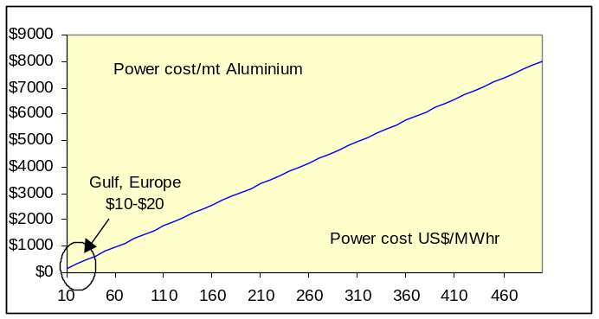 |  |  |  |  |  | 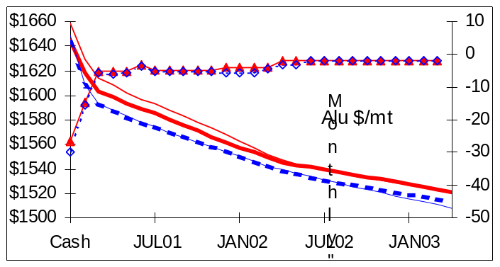
The following table shows the region’s smelters. New power contracts with BPA are due to start in October 2001. Details aren’t clear, but a lot of the earlier contracts were struck around US$22-$23/MWhr for around 60% of capacity (some had none, some had 100% cover). With the power price action of the last 3 years, will the BPA grant more generous cover from October 2001 to smelters, some of whom have shut down and resold power at good profits into the spot market?
Anything less than 100% smelter cover (26,500 GW/yr of base load) leaves smelters exposed to the risk of higher power prices, but all the smelting capacity is at risk should smelters or the BPA divert smelter power into a spiking free market.
So things don’t look good for NW smelting operations in the medium to long term. Going further forward, the North Western Power administration is considering plant plans for approx. 3700 MWhrs of gas fired new capacity, with approx. 4 year development and construction timescale. This translates out to approx. 32,000 GW annually of gas fired power capacity (compares to 26,480 GW annually of smelter power requirement).
But this is gas fired, and with forward gas around $4-$5 MMBtu, this gives an approximate running power cost per mt of aluminium around $640-$800/mt (taking into account energy inefficiencies), and this is before capex and other costs.
Last night, PLATTS reported that Washington state announced plans to introduce tax breaks for new power generation serving aluminium smelters, provided the smelter got 10% of power from alternative fuels like wind or solar power or implement energy saving schemes. The scheme also includes proposals for exemption from natural gas use tax provided certain employment levels were maintained for 5 years. The legislation wouldn’t be implemented until April, at least.
These have only been approximate calculations. But, if the region’s smelters are facing structurally higher floor prices for power in the future and have access or exposure to a seasonally violent spot power market, the risk profile of the NW Pacific smelter business appears significantly different from new smelters built in recent years. Shipping costs of only $90/mt for primary aluminium from the Gulf or Scandinavia into the US Midwest, comparable to $5.60/MWhr on the power price, don’t favour these smelters either.
figs in 000s mt |  | Max Capy |  | Shut |  |  | Open |  |  | Yearly Power GW
Tacoma |  | 73 |  | 73 |  |  | 0 |  |  | 1,168
Mead |  | 212 |  | 212 |  |  | 0 |  |  | 3,392
Troutdale |  | 121 |  | 121 |  |  | 0 |  |  | 1,936
Intalco |  | 282 |  | 70 |  |  | 212 |  |  | 4,512
Vanalco |  | 115 |  | 115 |  |  | 0 |  |  | 1,840
Wenatchee (265 MoU) |  | 215 |  | 95 |  |  | 120 |  |  | 3,440
Columbia Falls |  | 170 |  | 170 |  |  | 0 |  |  | 2,720
Goldendale |  | 180 |  | 137 |  |  | 43 |  |  | 2,880
The Dalles |  | 82 |  | 82 |  |  | 0 |  |  | 1,312
Longview |  | 205 |  | 0 |  |  | 205 |  |  | 3,280
TOTALS |  | 1655 |  | 1075 |  |  | 580 |  |  | 26,480
Rohan Ziegelaar (London) |  |  | Direct Tel: 44(0)20 7783 2415 |  | Fax: +44 (0)20 7783 1419 |  |  |  | Rohan.Ziegelaar@enron.com
This material is provided to you for discussion purposes only and is not intended as an offer or solicitation for the purchase or sale of any financial instrument or security, nor does this material constitute investment or trading advice. Enron Metals Limited makes no representation or warranty, express or implied, as to the truth, accuracy or completeness of this material and neither Enron Metals Limited or any of its Affiliates, nor any of Enron Metals Limited’s employees, officers or agents of its Affiliates shall be liable for any matter owing out of or in connection with this material of the use of it. Opinions expressed are the opinions of the author and do not necessarily represent the opinion of Enron Metals Limited or any of its affiliates. Enron Metals limited or its affiliates may hold positions or make markets in financial instruments identical or economically related to transactions discussed herein.

