May 2, 2001

To: M. Maggi

cc: J. Arnold S. Gibner
V. Kaminski Z. Lu
S. Puthigai J. Griffith

From: Bob Lee - Research

Subj: Volatility Skew No-Arbitrage Constraints

This memo defines a series of checks to preclude arbitrage between a set of posted option prices with the same underlying price, interest rate and time to expiration, but with different strikes and volatilities. It is desired to have these checks performed on option prices for natural gas that are being posted to EOL. It is recognized that some of the listed checks are already performed in EOL; they are included in the table only for completeness.

The definitions of the checks in terms of Bid and Offer prices are listed in Table 1. The skew curve is not checked directly, rather the prices for options at various strikes generated from a particular skew curve must be compared to confirm no-arbitrage. The figure below illustrates the relationships of the prices used in the table. The bid-offer spread always acts to reduce the possibility of arbitrage.
K₁
K₂
K₃
Call
Price
Strike
Offer
Bid

Attachment 1 summarizes a derivation of the arbitrage conditions in terms of the Black-Scholes price for a European digital call option.

In addition to the conditions specified in Table 1, a complete set of arbitrage checks includes:

- Put/call parity holds (within the bid-offer spread)
- Option price is < underlying futures contract

Table I - Volatility Skew Arbitrage
Condition | Arbitrage if Violated | Required Bid–Offer Relationship
Call
Slope of call price with increasing strike is negative (< 0) | If slope is positive, a digital call has a negative value, so counterparty can buy a digital call (sell N calls at strike K and buy N calls at strike [K-1/N] and pocket the profit). | Bid(K₂) – Offer(K₁) < 0
Slope of call price with increasing strike is > - PV($1) [European]  > - 1 [American] | If slope < - PV($1), a digital call has value greater than the discount factor. Counterparty sells digital call, puts PV($1) in bank and pocket the difference | Offer(K₂) – Bid(K₁) > -PV($1) [Euro]  (K₂ – K₁)  > -1 {Amer}
Call price triplets are convex with respect to increasing strike  (strike price intervals are assumed to be equal) | If concave (negative 2nd derivative), counterparty can buy a butterfly call spread (buy call at K–1/N, sell 2 calls at K and buy a call at K+1/N) at a net profit. | Offer(K₃) – 2*Bid(K₂) - Offer(K₁) > 0

Put
Slope of put price with increasing strike is positive (> 0) | If slope is negative, a digital put has a negative value, so counterparty can buy a digital put (buy N puts at strike K and sell N puts at strike [K-1/N] and pocket the profit). | Offer(K₂) – Bid(K₁) < 0
Slope of put price with increasing strike is < PV($1) ) [European]  < 1 [American] | If slope > PV($1), a digital put has value greater than the discount factor. Counterparty sells a digital put, put PV($1) in bank and pockets the difference. | Bid(K₂) – Offer(K₁) > PV($1) [Euro]  (K₂ – K₁)  > 1 {Amer}
Put price triplets are convex with respect to increasing strike  (strike price intervals are assumed to be equal) | If concave (negative 2nd derivative), counterparty can buy a butterfly put spread (buy put at K+1/N, sell 2 puts at K and buy a put at K-1/N). | Offer(K₃) – 2*Bid(K₂) - Offer(K₁) > 0

Relation of Digital Call and Volatility Skew

An approximate digital call can be constructed from M plain vanilla call as

M C(K-1/M) – M C(K) where K is the strike price and C(K) is the Black-Scholes price of a call option.

Substituting the Black’s formula (for a futures contract) and rearranging terms we can write:

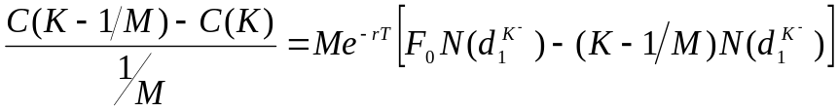

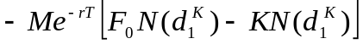

Now 1/ M = ΔK (the distance between strikes), so

In the limit as M → ∞ and ΔK → 0, 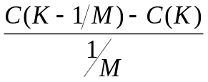 → 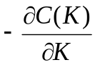

And as M → ∞, 1/ M → 0, so 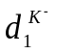 → 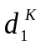 and 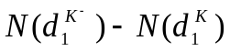 → 0, etc.

So 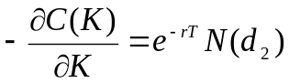 - price of a digital call

N(d) is the cumulative normal and 0 <= N(d) <= 1 and we have an arbitrage if the probability distribution implied by the price of a digital call is not in these bounds, i.e.,

If N(d) < 0, digital call has a negative value

If N(d) >1, digital call has value greater than the discount rate.

