DealBench, LLC

Business Plan

January 2001

Index

1. Executive Summary 4
1.1. The Company
1.2. Mission Statement
1.3. Forecast
2. Identifying the Opportunities 6
2.1. Overview
2.2. DealRooms
2.2. DataRooms
2.3. Auctions
3. DealBench Solutions 12
3.1. Overview
3.2. Key Business Tools
3.3. Technology (System Architecture & Security)
3.4. DealRooms
3.5. DataRooms
3.6. Auctions
4. Market Size Analysis 18
4.1.Size of Market
4.2 Penetration Rate
5. Replication Costs 23
6. Pricing Strategy 25
6.1.Overview
6.2 DealRooms
6.3 DataRooms
6.4 Auctions
7. Revenue Model 28
8. Marketing Strategy 30
8.1 Overview
8.2. Direct Marketing
8.3 Strategic Marketing Alliances
8.4 Indirect Marketing
9. Analysis of the Competition 32
9.1. Overview
9.2. Software Solutions
9.3. Indigenous Solutions
9.4 Competing Hosted ASP Solutions
10. Competitive Advantages and Barriers to Entry 39
11. Strategic Alliances (Investors & Partners) 41
11.1. Long-term platform ownership
11.2. Description of Ideal Partner
12. Financial Projections 42
12.1. Valuation Model
12.2. Income Statement
12.3. Balance Sheet
12.4. Statement of Cash Flows
13. Management Team 45
13.1. Harry Arora, Chief Operating Officer
13.2. Jeff Bartlett, Director of Business Development
13.3. Suresh Raghavan, Director of Technology and Operations
13.4. Don Herrick, Director of Marketing for Bank Syndications
14. Appendices 46
14.1. Projected Time Line
14.2. Historical Information

1. Executive Summary

1.1. The Company
DealBench™, LLC (“DealBench” or “Company”), a 100% owned subsidiary of Enron Corporation, is a hosted application service provider (“ASP”) that provides collaboration & transaction platforms on which licensees can complete large-scale B2B transactions. DealBench platforms can be grouped into three types of hosted applications – DealRooms, DataRooms and Auctions. These platforms allow transactions to be presented dynamically, conducted interactively and (if desired) auctioned effectively.

DealBench applications are licensed by businesses that originate transactions such as banks that syndicate certain bank products, equipment lease finance companies that syndicate a portion of their originated leases and sellers of large-ticket transactions that require datarooms for due diligence. In each case, a licensee invites numerous parties to collaborate on document preparation, view transaction materials and indicate a level of financial interest. DealBench invitees pay no fees to access Deal Areas. Rather, DealBench usage fees are paid by sellers that benefit from both a more efficient deal process and through better price realization. DealBench services enable clients to increase the efficiency and effectiveness of their transaction execution professionals. Further, the platform allows users to communicate with clients and counterparties in a more timely manner and to utilize dynamic price discovery to capture significant value.

DealBench has applications in a number of different businesses. Initially, resources have been focused on bank loan syndications, large-ticket lease syndications, capital market transactions, acquisitions & divestitures, insurance transactions and procurement RFQs & auctions. These businesses have been selected as those in which the ratio of realizable benefit to expected cost of using DealBench services is highest and where value added is substantial and identifiable.

A carefully articulated marketing strategy is critical to capturing and sustaining an adequate revenue base. DealBench’s marketing strategy is three pronged. First, marketing will be directed to potential large users such as commercial banks, large-ticket equipment lease finance companies, investment banks and law firms (such marketing may include a free trial license or some other pricing incentives). While expensive, this direct marketing is expected to result in rapid initial usage and increased product awareness within those institutions that could become potentially important licensees. Importantly, DealBench expects to leverage its parent companies’ strong historical relationships with many of these potential large licensees to accelerate what can often be a lengthy sales cycle. Second, strategic alliances with other eCommerce sites and professional service firms (such as large law firms, consulting firms and commercial banks) will be pursued to accelerate penetration. Third, indirect marketing through targeted advertising and mailers to a more inclusive list of businesses will be used to achieve a broader distribution at a reasonable cost.

As reflected in the DealBench business model, the business has minimal and controllable variable costs. As such, once transaction revenues are sufficient to cover certain fixed costs, incremental revenues translate primarily to bottom-line profitability. By using direct marketing to large accounts and forging certain strategic alliances, DealBench plans to establish base-load volumes during the first year. Thereafter, marketing and technology spending will be increased to enable broader penetration of the established customer base.

Providing innovative, customer-focused applications is critical to DealBench’s long-term success. As multi-media services gain widespread acceptance and digital signatures become widely utilized during B2B transactions, many additional opportunities will emerge in the collaboration and transaction spaces. DealBench plans to continually add innovative services that specifically address the needs of participants in certain large-ticket B2B transactions and offer a broad array of value added business services to our clients. Finally, DealBench will continually identify new domains that leverage the 5 key DealBench business tools and other features that have been or will be incorporated into the platform.

1.2. Mission Statement
DealBench provides a secure Internet-based platform that enables our customers to conduct B2B transactions. DealBench provides a collaborative environment to share documents, conduct auctions, host webcasts, manage deal information and monitor deal progress - instantly, efficiently and effectively.

1.3. Forecast
The following table summarizes certain figures from the 5 year DealBench business model.

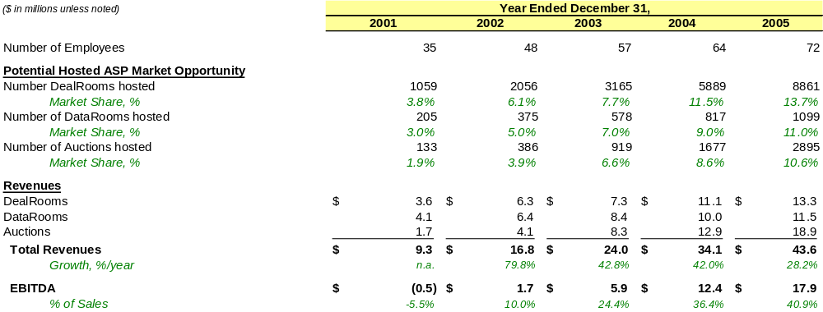
Figure 1: Summary DealBench Forecast 2001 to 2005

2. Identifying The Opportunities

2.1. Overview
Large B2B transactions are typically complicated and complex, involving a significant amount of information, lengthy analysis, and negotiation by numerous interested participants. The process of preparing and presenting information and negotiating transactions typically requires a considerable amount of highly paid professionals’ time. Senior management, investment bankers, analysts and attorneys spend significant time working on such transactions. Over the last few years, technology solutions have dramatically improved the efficiency with which deals can be consummated – in presentation, communication, speed of execution and amount of required negotiation.
During the past two decades, B2B communication tools have evolved from typed letters sent by postal mail to electronic word-processed documents sent by email. As B2B collaboration takes center stage, companies will soon leverage the powerful collaboration benefits that can be derived by utilizing online eCommerce platforms.


Figure 2: Evolution of B2B Communication Tools

Despite these improvements, most deal-making is still static and one-dimensional. Bounded pitch-books, presentations to full rooms of people and newly created models and projections are still commonly accepted methods by which large-scale transactions are completed. The DealBench vision is that during the next five years, the efficiency of such processes will dramatically improve, resulting in large productivity gains for highly paid professionals and a substantial change in the quality of the deal-making process, resulting in a significant competitive advantage for those who embrace such change.

The following two examples illustrate the usefulness of the new deal making process where DealBench beta tests have proved highly successful.

DealBench DataRoom Solution:
Problem: A Fortune 100 corporation desired to rapidly monetize its ownership interest in five electric power generation plants. The company’s financial advisors had advised that a substantial due diligence dataroom would need to be put together. Financial advisors first circulated a “teaser” to numerous parties followed by an information memorandum to 50 prospective buyers. After analyzing initial responses, the company desired to share a significant quantity of information with second round bidders. Historically, the company and its financial advisors would have selected three finalists based on their bids, reputation and likelihood of closing and requested them to serially perform due-diligence in a physical data-room with over 2000 documents (80,000 pages). Such a process would have required approximately four weeks, subsequent to which each bidder would have been provided additional time to analyze due diligence information prior to submitting their final bids. The company decided the process could be dramatically improved.

Solution: DealBench provided a beta solution to address the clients’ basic due-diligence needs. A virtual data-room was created that allowed prospective bidders to perform their due diligence of deal information using a secure online platform. Importantly, the client was able to keep 28 bidders involved, finish the process in a much shorter period of time, and receive significantly more attractive bids (including the most attractive one that would not have been selected as a “top 3 finalist”).

DealBench Online Auction Solution:
Problem: A Fortune 100 corporation desired to minimize its costs during a large new-construction project. Under terms of its construction agreement, the primary contractor was allowed to pass material costs directly to the corporation. For a particular expensive product, there were three equally qualified suppliers. Historically, the company would have requested that a representative from each of three chosen firms meet with the purchasing manager to understand the material requirements, make a “pitch” and submit a price quote. After receiving bids, the purchasing manager would select the two most attractive and invite them to negotiate on various terms, including price. Such a process would take a few weeks and would involve role playing, posturing and schmoozing by each of the vendors. The company decided the process could be made more efficient for both it and its suppliers.

Solution: DealBench enabled the purchasing manager to conduct a more efficient process that allowed him to provide all the vendors with more elaborate information regarding specific project needs and encourage them to submit any questions or suggestions. Answers to these questions were echoed back through a “Frequently Asked Questions” page on the website. At a designated time, each of the three vendors participated in a live online auction during which time each saw others bids (anonymously) and competed for the business while better understanding the “true market price”. The Purchasing manager spent less time coordinating the bidding process, provided more accurate and timely information to suppliers and realized costs savings of approximately 30%. Importantly, the three suppliers appreciated both the increased efficiency and transparency of the transaction process.
Regardless of industry specifics, most large transactions are similar in many respects, typically involving multiple parties (buyers, sellers, bankers, lawyers, engineers, etc.) that perform tasks that include:
- Collaborating during development of deal materials
- Reviewing/Approving final deal materials
- Making a sales-pitch to interested counterparties
- Performing due-diligence
- Submitting competing proposals with unique terms
- Selecting one counteparty with which to execute final contracts
- Monitoring certain deal aspects over an extended period (regulatory?)

DealBench has been specifically designed to meet the needs of each of these steps, making the collective deal process more efficient for all parties involved.
Deal participants require real-time access to the most recent versions of transaction documents. Deal Managers have historically had to distribute new versions of documents via FedEx, fax machine or email – typically a laborious and time-intensive process. Using DealBench, all parties to a transaction can access the most recent versions of deal documents 24 hours a day, seven days a week using a simple web browser. DealBench has been designed to allow licensees to stream multi-media presentations such as video clips and presentations that are synchronized with video and/or audio.

Figure 3: Process Flow Diagram of Representative Transaction:
Financial
Advisors
THE
DEAL
Buyer
Seller
Attorneys
Attorneys
Engineers
Engineers
Financial
Advisors
Other
Other

Advisors

2.2. DealRooms
By utilizing DealBench, licensees can streamline transaction information flow during large-dollar, complex transactions that require significant coordination/collaboration between numerous entities. Rather than place deal materials on static paper, documents can be hosted on a web-platform in order to allow for i) more efficient information dissemination, ii) timely and consistent communication to deal participants (via “Frequently Asked Question” feature, DealLine Messaging and Calendaring and other features), iii) robust multi-media presentation of relevant information such as streaming media presentations on topics such as asset-overview, business strategy, company financial information and others, iv) efficient collection of information from interested parties. DealRooms can be used to address the needs of several specific niches, including:

Bank Syndications
Currently, the bank loan syndication process is handled by specific groups within larger banks. These syndication groups put together extensive presentation packages and often ship by overnight courier to other banks that have historically been interested in a certain companies’ or industries’ credit. Buyers in this secondary market typically make copies of syndication books for different internal groups, perform certain credit analysis and ultimately fax indications of interest in the subject credit back to the syndicating bank.

Lease Syndications
According to US Department of Commerce statistics, in 1998 new leases captured 30% of all new durable equipment sold in the US. The leasing industry is expected to originate $260 billion in new leases in 2000, growing to $280 billion during 2001. In order to reduce exposure to specific asset types or certain counterparty credit, many lessors chose to syndicate originated transactions. Currently, these lease syndication transactions are handled by syndication groups that put together extensive presentation packages and typically ship by overnight courier to between 0 and 25 different lease finance companies that have historically displayed an interest in that certain asset class. The purchasers typically create valuation models, make copies of syndication books for various internal groups to review and ultimately fax indications of interest in the subject leases. The process is highly inefficient and based largely on historical business relationships.

Insurance Syndication / Legal Collaboration / and Other Opportunities
In addition to bank and lease syndications, numerous additional business transactions can be made more efficient with a customized DealBench solution. Even for small transactions with multiple parties, business can capture attractive time savings by utilizing the DealBench solution.

Other potential opportunities include:
- Legal Collaboration – while most mid- and large-tier law firms have sophisticated document management technology (from providers such as iManage, NIKU-Legal Anywhere and PC Docs), few firms have robust deal collaborative solutions.
- Capital Markets Transactions – banks would benefit by using DealBench during bond offerings, equity offerings and certain other capital markets transactions.
- Insurance Market –Similar to Bank and Lease syndications, originating Insurance companies often syndicate certain risk contracts. DealBench key business tools are well-suited to address Insurance syndication needs as well.

2.3. DataRooms
As companies have sought to increase market pricing power by consolidating mature industries, the pace of merger & acquisition activity has dramatically increased over the past decade. Total U.S. M&A transactions with a value over $1 billion has grown from 7,575 transactions worth $342 billion in 1994 to over 11,000 transactions worth $1.7 trillion during 1999. In addition, during the past several years, an unprecedented number of companies have gone public – a fact that is expected to result in massive consolidation as weaker companies look to combine with stronger players.
During these large business combinations, the seller and financial advisor(s) often spend considerable time and effort to gather overview documents, important contracts and other information in one physical location (or dataroom) to enable multiple interested parties to sequentially evaluate such due diligence materials.
To optimize the efficiency of deal execution teams, corporations, investment banks and law firms are looking for ways to streamline the deal process by incorporating collaborative internet tools. One particular opportunity lies in the current antiquated method by which transaction teams perform due diligence on M&A candidates. Opportunities for increased efficiency/effectiveness during the due diligence process include: i) reducing lengthy travel time for deal participants, ii) increasing the number of simultaneous bidders that can access dataroom materials, iii) automating the process by which dataroom managers ensure the security of confidential documents, iv) increasing the effectiveness and availability of information provided. Since human “capital” (time) in this specialized business is typically in scarce supply, involved parties aggressively seek to streamline current business processes wherever possible. Ultimately, more efficient Datarooms will lead to shorter transactions, increased turnover and better client service.
Additional opportunities may also exist within certain other financial market transactions that might include asset sales (such as oil & gas property divestitures), private equity placement due diligence, bankruptcy proceedings and commercial real estate due diligence.

2.4. Auctions
Overview
Success of companies such as FreeMarkets, eBreviate, VerticalNet, Commerce One and other enterprises has proven the value of introducing pricing competition into the process of procuring large-ticket items from manufacturers (and dealers) of items with certain commodity-like features. Companies that have utilized auctions for commodity-like transactions have often realized savings of between 10% and 50%, depending on the number of deal participants and the competitive dynamics of the particular business segment.

Current options available to procurement managers include i) outsource purchasing activities to FreeMarkets for a steep price (average client paid $1.2 million/year during 1999), ii) spend substantial capital dollars to build their own online auction platforms using Ariba or CommerceOne solutions or use e-marketplace solutions that are expensive and suffer from a material lack of liquidity.

With increasing acceptance of dynamic pricing as a common way of transacting business, there now exists a definite need for a hosted auction solution that allows sourcing groups to setup and manage their own live online auctions. Along with the basic web platform, these providers also need appropriate customer support, training, consulting and other related-services. This general need for such auctions is particularly acute in the energy business where a number of proprietary trading sites have recently been launched including Pantellos and Enporion.

3. DealBench Solutions

3.1 Overview
DealBench B2B transaction platforms have been designed to facilitate more efficient large-scale business transactions and to enable powerful collaboration during such deals. The platform allows licensees to create three different types of Deal Areas and to manage level of access to that space. Deal Areas provide various kinds of functionality that are also customized to specific business needs. DealBench platforms can be classified into three areas – DealRooms, DataRooms and Auctions. DealBench currently addresses the DealRoom needs of three niches – Bank Syndications, Lease Syndications and Legal collaboration. DataRooms are focused on meeting the organization and security needs of the acquisition and divestiture clients. To date, Auctions have been focused on licensees’ procurement needs. These types of Deal Areas have been called “Domains” on the actual DealBench.com platform.

3.2.Key Business Tools

Tool #1: Document Collaboration
Document Sharing
Licensees can upload or download files of all types (MS Word, MS Excel, Adobe PDF, etc.) to a secure Deal Area on the DealBench platform. This feature provides all invited deal participants with continuous (24 hrs/day) access to the most recent deal materials by using a simple internet browser and connection. Further, by providing access to previously uploaded versions, participants deal participants can more effectively collaborate during document preparation.

Security Features
Differing from a public “marketplace” alternative, DealBench provides a secure, password-protected eCommerce platform that allows licensees to control access to a customizable Deal Area. The Deal Manager specifies the level of access granted to participants. A Deal Manager chooses between seven specific security levels that specify whether User is authorized to upload documents, view certain sensitive areas of the site, submit an indication of interest, view the closing process and act as a surrogate Deal Manager. During 1Q 2001, security features will be augmented with the ability to control view, print and save access on a document basis (rather than on a Deal Area basis). Other features expected to be implemented include document comparison (such as black-lining) and an option to provide email alerts when new documents are posted.

Tool #2: Auctioning/Bidding
Licensees decide the method by which they wish to receive bidders’ pricing indications. Alternative pricing tools range from the simple collection of indications of interest to hosting live online auctions (either standard auctions or reverse auctions for sale and procurement activities, respectively). Frequently, by introducing competition into the pricing discussions, licensees realize material savings during the sale/procurement process. Licensees can also choose from a range of value-added auction services (from basic online platform technology to a complete outsourcing of the sale or procurement process).

Tool #3: Multi-Media Capabilities
Using the DealBench platform, licensees can host slides, audio and video files that can be shared with other deal participants. Further, audio and video files can be synchronized with MS Powerpoint materials to create a dynamic and more effective presentation. Specific uses include:
- Management Presentations – relevant information related to the transaction (i.e., credit statistics during a bank syndication, overview of transaction structure during a Leveraged Lease portfolio syndication)
- Asset Overview Presentations – Video of assets offered for sale (DealRooms, Auctions)
- Technical Discussions – Audio and/or Video of technical professionals discussing assets to be sold over the DealBench platform (for example, engineers/geologists discussing specific oil and gas properties to be sold)

Tool #4: Secure Communication (DealLine™ Messaging)
DealBench also incorporates an electronic communication tool called DealLine Messaging. Using DealLine allows licensees to more effectively communicate/collaborate with deal participants. Specifically, licensees can communicate via one-to-one or one-to-many electronic messages that can be directed to either an inbox located on the DealBench platform or the email address that the invitee submits during registration.

Tool #5: Deal Management Tools (DealNotes™)

Using DealNotes™, licensees can more effectively monitor deal participant progress. Reports can be generated that show the specific pages that users have downloaded, participation statistics (which bidders have indicated interest) and statistics with respect to video downloads. These DealNotes can be customized to provide the Deal Manager with real-time information regarding invitees’ activities while working on the specific transaction.

Other DealBench Services
In addition to the five key functional tools listed above, DealBench provides many marketing and customer services functions that include:
- 24 hours/day, 7 days/week multilingual (up to 130 languages) customer help desk through a toll free telephone number in both the US and UK to train first-time users and answer basic technology questions (such as forgotten passwords, instructions on loading Adobe Acrobat, RealPlayer, etc.).
- Client Marketing: DealBench team that can be deployed to help train licensee’s employees on DealBench functionality
- Archival Services: ability to choose how deal information is stored post-closing

3.3. Technology (System Architecture & Security)
Overview
The DealBench platform has been thoughtfully designed utilizing the best available technology that will provide a competitive advantage going forward. Both the physical and virtual architecture are state-of-the-art designed to maximize the platform’s scalability and modularity. The platform is built around SUN enterprise class servers, CISCO Network topology and a UNIX operating system with built-in redundancies and fail-over capabilities. DealBench also utilizes TIBCO middleware to enhance system reliability. Two levels of security (site level and deal-specific) and industry best-practices for back-ups, change control and related procedures have also been incorporated into the platform.

To ensure that institutional knowledge is accumulated over time, DealBench employs a 10-person technology team with significant eCommerce application development experience. By utilizing employees rather than consultants, DealBench expects to more efficiently incorporate future technologies and implement customized solutions.

The platform is designed to ensure a favorable user experience by focusing on customer support through a help desk that is available 24 hours a day, seven days a week. In summary, the DealBench platform consists of state-of-the-art hardware, software, people and procedures that result in technology as a sustainable competitive advantage.

3.4. DealRooms
Bank Syndications
By using the DealBench platform, licensees can dramatically increase both the execution efficiency and ultimate effectiveness of their syndication efforts. Instead of waiting for pitch books to be prepared and sent by overnight courier to participants, syndication teams collaborate on Deal Area documents and electronically invite potential purchasers to privately view such materials. The following table lists major benefits to both syndicators and secondary market purchasers.

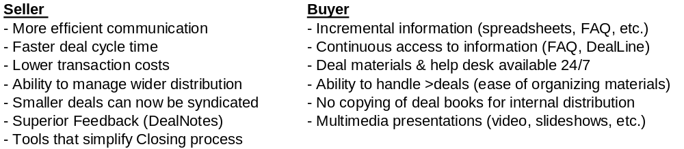
Figure 5: Summary of Benefits to DealBench DealRoom users:

Each of the five DealBench key business tools addresses functional needs of both sellers and buyers in bank syndications. By logging onto the DealBench platform, deal participants have 24-hour, real-time access to the latest deal materials. In summary, DealBench increases the organization, efficiency and effectiveness of syndication professionals’ important activities. With the same staff, syndication groups can complete more deals in a shorter period of time.

Lease Syndications
In addition to the same benefits as described above (bank syndications), lease syndication professionals can specifically utilize:
- Multi-media: digital pictures and video of unique assets that are part of a lease portfolio that is being syndicated
- FAQ Sheets: secondary market buyers are kept consistently informed by interactive use of a “frequently asked questions” sheet.

Other DealRoom Transactions
With some customization based on interactive customer feedback, the existing key business tools can be enhanced to meet the deal collaboration needs within numerous additional niche markets. Such opportunities include various capital markets transactions, syndication of certain insurance products and Legal Collaboration wherein DealBench can be used by attorneys to more efficiently organize and manage complex transactions involving multiple outside parties. Impending DealBench platform enhancements that will ultimately address such needs include:

- Email alert – option to notify deal participants by email when docs have been posted
- Separate Deal Areas – allow licensees to partition Deal Areas for multiple parties involved in transaction (buyer, seller, advisors, media relations, etc.)
- Full Text Search – allows users to perform text search across all documents loaded onto Deal Area to which they have been granted access
- Digital Signature Room – ability to use verifiable digital certificates to legally execute transaction documents (in compliance with recently signed law)
- Comments History – ability to add comments boxes to documents to enable better communicate rationale behind changes to deal materials

3.5. DataRooms
DealBench’s online dataroom solution enables licensees to dramatically improve the efficiency with which deal participants complete the due diligence process during large M&A transactions. By converting documents from paper to digital form, information can be more easily organized, searched and distributed.

DealBench incorporates the latest 128-bit encryption technology to deter unauthorized use of due diligence materials. Further, Technology incorporated into the DealBench platform ensures the highest degree of security through both site- and document-level access. Additionally, DealBench will be incorporating certain server-based security tools that allow licensees to maintain real-time and complete control over the ability of dataroom participants to view, save or print individual documents. Content is distributed through proprietary encryption protocols that use the RS4 standard.

DealBench provides a logical and intuitive user experience that expedites the due diligence process by enhancing communication between participants and, importantly, enabling the seller to conduct the dataroom process with bidders in a parallel (rather than serial) process. By allowing multiple parties to view deal materials simultaneously, additional participants can be included without extending the deal timeline. DealBench allows sellers to avoid eliminating potential bidders due to manpower or physical dataroom constraints.

Current Dataroom functionality includes basic security (Deal Area-level password protection) and can effectively handle approximately 1,000 total documents. However several technology enhancements are currently being incorporated into the DataRoom platform that will enable licensees to protect sensitive documents from being downloaded, saved or printed until/unless the DataRoom manager authorizes such action. This superior security feature is expected to result in a powerful solution that will convince companies and their financial advisors to move M&A datarooms online.

DealBench licensees realize benefit by utilizing DealNotes summary information that allows the deal manager to understand the specific documents that each dataroom participant viewed or copied. This could enable the seller to better understand the concerns/interests of potential buyers.

3.6. Auctions

eCommerce and the Internet are redefining the relationship between buyers and suppliers. While business relationships will continue to play an important role during purchasing decisions, the Internet will enable companies to streamline and reduce the cost to introduce competition into many business processes. This trend is particularly true in the procurement arena, where both buyers and sellers can realize significant benefits from online-based purchasing initiatives. Whether a Deal Manager conducts a live or discrete auction/bidding event, both the buyers and the sellers benefit from DealBench’s Internet-based technology offering.

Figure 6: Summary of Benefits for DealBench Online Auction users
(assuming reverse auctions for procurement activities)
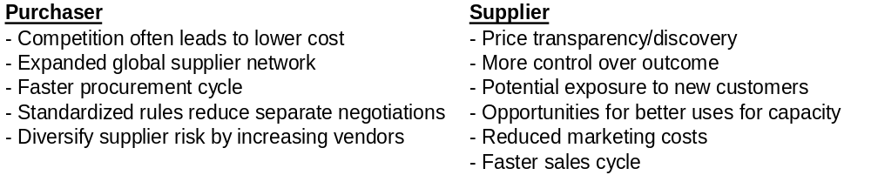
Most large companies today issue request-for-quotes (RFQs) via US mail, overnight courier services, fax, or email. In addition to streamlining the RFQ management process by using DealBench’s document collaboration tools, customers can realize important benefits by conducting live online auctions, the most important of which is additional competitive dynamics in procurement efforts.

DealBench provides robust technology that enables several types of highly-configurable online auctions. Generally, licensees (Deal Managers) may conduct forward or reverse auctions with live, sealed-bid, or multiple-round formats. General auction formats currently offered by DealBench are defined as follows:

- Reverse Auctions: In a live reverse auction, the price goes down as one single buyer receives bids from multiple sellers. DealBench reverse auctions are always “private”, meaning that the Deal Manager pre-screens participants and invites only those companies with which it will desires to do business.
- Forward Auctions: A forward auction is one in which a seller of goods or services ultimately transacts with the highest bidder. Typical forward auctions include asset sales and other processes in which the seller wishes to obtain the highest possible prices.

DealBench offers the following formats for either type of auction:
- Live: Bidders can adjust their bids during a pre-specified bidding period. They do not know who the other bidders are but do know how their bids compare to the current best bid and can adjust their bids accordingly.
- Sealed-bid: Bidders submit a one-time offer to the buyer (or seller). They do not know who the other bidders are nor do they have information on the offers submitted by other participants.
- Multiple Round: Bidders submit offers for goods/services. Deal Manager selects finalists and communicates range of bids submitted by the finalists. Using new market information, finalists then re-submit bids.

DealBench is also considering offering several other auction formats, including forward and reverse Dutch auctions. To compete effectively with companies like Freemarkets and eBreviate, DealBench intends to provide third-party sourcing expertise to clients (see Pricing Strategy).

EnronOnline Marketing Advantage
DealBench has negotiated an agreement with EnronOnline to manage all of its auctions conducted on behalf of its customer base. Launced in November 1999, EnronOnline is the world’s largest eCommerce site, currently executing over 5,000 trades a day with a completed notional volume worth over $300 billion during 2000. A DealBench server on the EnronOnline site will handle all the RFQ deals and auctions of commodity products for approximately 5,000 EnronOnline clients in the energy business (i.e., energy independents, utilities, and generation companies). We expect this marketing arrangement to provide DealBench with a significant head-start in the energy-related auction space.

4. Market Size Analysis

4.1. Size of Market
Overall B2B eCommerce is expected to rise dramatically over the next several years, as companies and employees become acclimated to transacting in a “paperless world”. Worldwide eCommerce is project to reach almost $7 trillion by 2004 with almost 50% coming from North America.

DealRooms
To estimate market size for DealRooms, three methods have been used to arrive at approximate figures that represent an overall size of this nascent business.
The first estimate is based upon the premise that most deal-making and collaboration involve lawyers, attorneys and paralegals. Assuming 750,000 lawyers in the US, with the average one working on 20 deals a year and that each lawyer would utilize an average of $2,400 per year on collaboration & transaction services in the future. Today, a portion of this total is spent on FedEx, fax and document preparation charges. This provides us with a market-size of $1.8 billion for the United States. Assuming European and Asian markets are, in aggregate, half the size of the US market, worldwide market-size would be $2.7 billion.
While many assumptions are necessary, every attempt has been made to be conservative with unknown figures. For example, in estimating number of deals per lawyer - while some attorneys may work on fewer than 20 deals per year that require external collaboration, many deal-centric attorneys may work on significantly more and spend much greater resources on collaboration. Therefore, $2,400 per attorney per year seems to be justified. A large part of this collaboration market might be very captive to organizations and not realistically attainable, therefore to estimate penetration rates large discounts have been assumed when estimating total market size.
A second method of calculating dealroom market size is a “bottoms-up” methodology of identifying each niche within which collaboration platforms are expect to be utilized and summing niches such as: ($ in millions)
Figure 8: Estimated size of DealRoom market:
Bank Syndications (10,721*$5,000/deal) $54.0
Leasing transaction (6,000*$3,000/deal) 18.0
Capital market transactions (11,156*$5,000/deal) 56.0
Insurance transactions (estimate) 50.0
Intellectual Property briefs and petitions (estimate) 50.0
Export / Import processes (estimate) 250.0
Government needs – Fed & State level (estimate) 200.0
Total $700.0

Finally, a third way to estimate the number of annual DealRoom transactions is to assume one major deal per $1 million of economic output or 8 million deals – each deal requiring $250 in collaboration expenses, yields an overall market-size of approximately $2 billion.
Providing support for these three estimates for market size, demand for online B2B transaction platforms has increased dramatically over the past several years. Companies increasingly use the Internet as a means of communicating, presenting and executing B2B transactions online. Specifically within the bank loan business, a majority of the largest U.S. banks that arrange corporate revolvers use a web platform (in this case IntraLinks) to efficiently syndicate their commitments. During the first three quarters of 2000, $780 billion of bank revolvers were arranged by U.S. banks. In the near future, all banks will utilize a web platform to complete their large-ticket B2B transactions.

DataRooms
Among top-tier investment banks, 11,000 M&A transactions were completed worldwide during 1999. In addition, numerous large-ticket asset purchases and sales were closed. We assume another 10,000 asset transactions (10 transactions per year for each Fortune 1000 company) – a total of 21,000 transactions an year. An average charge per data-room of $20,000 would result in an overall market-size of $ 420 million.

Auctions
Based on industry research and government statistics, we estimate that manufacturers worldwide purchase approximately $5 trillion each year of "direct materials" -- the industrial parts and raw materials that they incorporate into finished products. Because these direct materials are often custom-made to buyers' specifications, there are no catalogs or price lists to enable buyers to make price comparisons. Purchasing direct materials is further complicated by supplier fragmentation in many markets and the importance of product quality and other variables in supplier selection. Because this complexity leads to market inefficiencies, it is widely understood that buyers of direct materials often pay prices that are too high.

Dynamic pricing models offer an attractive process by which buyers can reduce these inefficiencies. Although few companies are currently utilizing dynamic pricing tools such as online auctions and exchanges, DealBench expects that adoption will dramatically increase as mechanisms by which buyers more efficiently purchase a large percentage of their most important goods. In addition to basic auctions that are today, buyers will make purchasing decisions based not just on price, but on other factors such as the timeliness of delivery, reliability and quality. As factors other than price become increasingly important in online purchasing initiatives, DealBench will integrate additional functionality into its online auction offering.

It is expected that real-time models (ie, online auctions and exchanges) will grow 20-fold over the next five years, reaching almost $750 billion in volume by 2004. Of this total, $217 billion will be made within the Utilities sector, $37 billion within the Petrochemical sector, and $10.9 billion in the Construction sector, three key industry segments that DealBench will initially target. Due to the complexity of direct materials purchasing, we believe that Internet technology alone cannot solve the challenges faced by large industrial buyers. To address these needs, DealBench intends to combine its Internet technology with services that are customized to buyers' needs, including strategic sourcing expertise.

To understand the size of the online auction market for energy-related goods and services, several sources have been tapped by DealBench. A summary of the various estimates is shown in the table below:

Figure 8: Estimated size of energy-related online auction market:
Auctionable Spending in the U.S. $1.7 - $2.3 trillion
Amount Auctioned Online $53 - $69 billion
Expected Auctions in 2001 60,000
Auctioneers revenues $ 600 million
Energy Auction Volume $1.4 - $1.8 billion
Expected Energy Auctions 2001 2,000 – 2,100
Energy auctioneers revenues $ 25 million

Based on industry data analysis conducted by DealBench we expect auction volumes to grow 50% annually over the next four years and auctioneer revenues are to grow by 25%, factoring in price declines as the services become widely used. While market size estimates and growth rates vary widely by source, there is no question that the addressable market for DealBench in the online RFQ management and auction space is substantial.

4.2. Penetration Rate
DealRoom
Use of DealRooms is expected to grow dramatically, as companies increasingly seek to leverage collaborative attributes of internet connectivity to increase transaction execution efficiency. In several business sectors (such as Bank Syndications), online document collaboration platforms have already captured a large market share.
Different sections of the market will have different rates of penetration. In the bank syndications where virtual deal-rooms are already being used we expect our market-share to be 8% in 2000 and ramp up to 35% in 2005. We hope to leverage our relationships and enter into strategic alliances to enable this to happen. We do think this assumption is on the conservative side and we may be able to reach this penetration by 2003 or 2004. We expect a 15% deflation in the price realization, with an average bank syndication dealroom to go from $ 5000 in 2001 to $2500 in 2005.
In the leasing business, we expect to have a 5% marketshare in 2001 and hope to capture 25% of the market in 2005. The pricings in that market are going to be lower at $3,000 in 2001 going down to $2,000 by 2005.
For other applications – insurance, law firm applications, we expect our marketshare to go from 2% in 2001 to 10% in 2005, growing linearly over this period. A big part of this is going to be indirect marketing.

DataRooms
By utilizing existing deep relationships with most every major investment and commercial banks, as well as working relationships with numerous law firms that have large M&A groups, DealBench expects to be quickly capture a large market share for online virtual datarooms. For licensees, the value proposition is so powerful that most entities that are organizing physical datarooms for large transactions will seek to leverage collaborative online platforms to increase the speed with which due diligence processes can be completed, thereby increasing deal execution efficiency. We expect our market-share to go from 2% representing 200 datarooms in 2002 to 11% representing 1100 datarooms in 2005. The price deflation would take the average price of a dataroom from $ 20,000 in 2001 to $ 10,500 in 2005.

Auctions
As mentioned in Section 6.1 (Size of the Market) DealBench estimates that approximately 2,000 online auctions will be conducted in the Energy and Utilities industries during 2001. Given Enron’s strong presence and business relationships in the energy industry, we are confident that DealBench should be able to obtain a 10% market share in 2001, which equates to 200 auctions conducted over the course of the year.
These auctions may include purchases of commodities, purchases of capital equipment and procurement for the construction of energy-related infrastructure. It is expected that auction volume would increase steadily as external direct marketing efforts intensify through June 2001, and we should expect to conduct [one to two auctions per business day] during the second half of the year.
During 2001, DealBench estimates that it will generate approximately $1.5 million in revenues from auctions, based on 130 auctions conducted at an average price of $12,500 per auction.

It should be noted that the projected per auction pricing is quite favorable compared to available information on fees charged by DealBench’s online auction competitors. While specific pricing was not divulged, a co-founder of eBreviate has stated that depending on certain factors, their per-auction price would be in the mid-five figure range (~$40,000 - $60,000). FreeMarkets, Inc. currently charges customers based upon a subscription fee basis with fees generally approximating 0.75% to 1.5% of an agreed-upon total spend plus a percentage of generated savings. Although FreeMarkets does not charge on a per-auction basis, $2 million in committed spend would cost a customer $20,000, assuming a 1% fee and excluding any fees payable resulting from savings realized during the auctions.

5. Replication Costs
Replication costs represent an important consideration since it represents one clear alternative from the licensee’s perspective. Further, this pricing level represents the price at which customers would chose to devote the time/effort to implement an internal solution rather than utilize a hosted ASP solution. Such replication costs would vary between the separate services that DealBench expects to provide.

Replication costs can be divided into the tangible costs (ie, hardware, software and quantifiable maintenance) and opportunity costs that arise both from an inability to bill such costs forward (as do most banks and law firms) and from foregoing the opportunity of using precious IT resources elsewhere.

Replication costs for a DealRoom solution would depend upon the scale, security and back-bone that is ultimately chosen.

Hardware Software Annual Maintenance
NT based ASP system $40,000 $250,000 $100,000
Shrink wrapped package 60,000 200,000 50,000
Unix based with Oracle 100,000 750,000 200,000

Replication of the DataRoom is intrinsically harder due to the complex nature of technologies and solutions. As there are currently no comparable “off-the-shelf” alternatives, replication would be much more difficult.
Hardware Software Annual Maintenance
NT based $150,000 $350,000 $200,000
Unix based 300,000 700,000 400,000

The maintenance includes medium level of call center or help desk services which will need to be supported internally for clients to use and sort out problems

For an auctioning system these numbers are higher
Hardware Software Annual Maintenance
NT based $200,000 $800,000 $400,000
Packaged software Moai \Ariba 250,000 750,000 700,000
Unix based 300,000 1,000,000 350,000

To summarize, single users are not expected to be willing to pay >$200k for deal-rooms, >$500k for data rooms or >$750k for auctions. Clients that are able to pass along these deal fees to other parties (such as law firms) may represent an exception. Customers who spends $50k on deal-rooms or 250k on data-rooms or auctions annually would find replication ineffective and not worthwhile

The risk is the appearance of more packaged software which will make these implementation easier. Our expectation is that the maturation of multi-media services and rate of technological change would encourage broader usage of the ASP solution for the chunkier B2B market. However the small and mid size firms would extensively rely on hosted services – these would be the firms which spend way less than the above thresholds – $2,000 to $50,000 per year spending on these services. This would be a substantial market accessible through indirect marketing.

6. Pricing Strategy

6.1. Overview
DealBench pricing strategy will be based on the following principles:
- DealBench will not attempt to take a “percentage of each transaction”
- Licensing fees can be paid on either a per transaction or a per time period basis
- Pricing structured to encourage maximum use of DealBench services.
- Large-volume licensees migrate to per period, one-time users per transaction

6.2. DealRooms
Although pricing for different domains will vary, it will generally be structured to encourage maximum use of the DealBench platform in order to achieve rapid market penetration. Specific pricing will be based on the number of users invited (directly tied to customer support costs), storage utilized (affects technology hardware requirements) and the amount of customization requested (affects programmer resources consumed).
Lease Syndications
The DealBench for Lease Syndications platform can be licensed on either a per deal or a per period basis. On a “per deal” basis, pricing will be based upon a pricing table (see example below) that tied to the number of invitees and the amount of the storage consumed. This pricing matrix will be subject to a $5,000 per deal minimum.

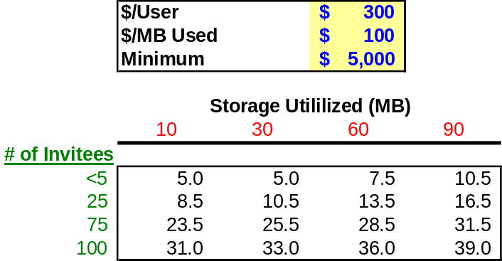
Figure 9: Sample deal pricing assumptions and matrix ($000 per deal):

On a “per period” basis, pricing will also be based upon the per deal table (see above). However, significant discounts will be provided to licensees with significant transaction flow. The specific pricing plan will be negotiated with each licensee but generally will be dependent upon the type of discount offered per additional deal added as well as the amount that must be "committed" or paid up front.

Example: Global Leasing estimates that it will conduct approximately 30 syndications per quarter. Global also estimates that it will do no less than 15 syndications but may do up to 50 during the quarter. DealBench would encourage Global to enter into an agreement where Global prepays for part of its syndication needs and then pays extra for each additional syndication. In this case DealBench would allow Global to place up to 15 deals for $35,000 (or for $2,333 per deal on the first 15 deals). For each additional syndication Global would pay an amount per deal that is less than $2,333 per deal. DealBench would also offer Global the opportunity to prepay more transactions, lets say 25 deals, at a lower price per deal and offer even more reduced tariffs after that.

The point of per period pricing is to encourage users to place all transactions on the platform, large as well as small deals. By having the prepayment feature, at a discount, the licensee will be motivated to place transactions on the system. Furthermore, the even greater discounts after that will make the system convenient for the rather smaller deals.

6.3. DataRooms
Pricing for DataRooms will be based on the number of invitees (which affects the amount of requested customer support services), the amount of storage (which affects server capacity and network resource requirements) and amount of scanning and related services that are requested during setup of the virtual online DataRoom. Pricing is expected to range from $10,000 to $50,000 depending upon numerous factors including number and size of documents, value-added-services required, storage consumed, number of dataroom participants/invitees and other cost-related factors.
Purchasing decisions for DataRooms are expected to be made by both selling corporations and its financial and/or legal advisors. However, it is expected that these expenses will ultimately be passed along to the seller. Minimal pricing pressure is therefore expected in this domain.

6.4. Auctions
Generally, DealBench will pursue an aggressive pricing strategy that is intended to be competitive with alternative service providers that have begun to appear in the online B2B auction space. Especially on large-ticket transactions, Enron’s material experience base is expected to enable DealBench to rapidly capture significant market share.

Pricing for Auctions will be based upon which of three level of services a licensee chooses:
- Basic – Licensee entitled to use of DealBench platform for live online auction. Under this alternative, licensees would be responsible for hosting their own auctions.

- Enhanced – In addition to Basic services, licensees would benefit from utilizing the collective experience of the DealBench auction team professionals for professional training (using materials prepared by Enron’s auction management group), RFQ management advice and other general consulting services.

- Premium – In addition to Enhanced services, licensees would benefit from the collective expertise of Enron Global Strategic Sourcing professionals in areas such as:
- i) Supplier identification
- ii) Supplier pre-qualification
- iii) RFQ creation and management
- iv) Deal Structuring (number of lots, timing, live vs. sealed-bid)
- v) Post-event analysis
- vi) Other pre-defined services

For Basic service licensees, pricing will be determined by applying a matrix that incorporates certain factors such as the number of invitees and the nominal value of transactions completed on the DealBench platform. The intent for such pricing is to capture a decreasing percentage of the value created by utilizing DealBench as a price discovery mechanism. If necessary, a fee cap may be granted in order to close certain licensing transactions.

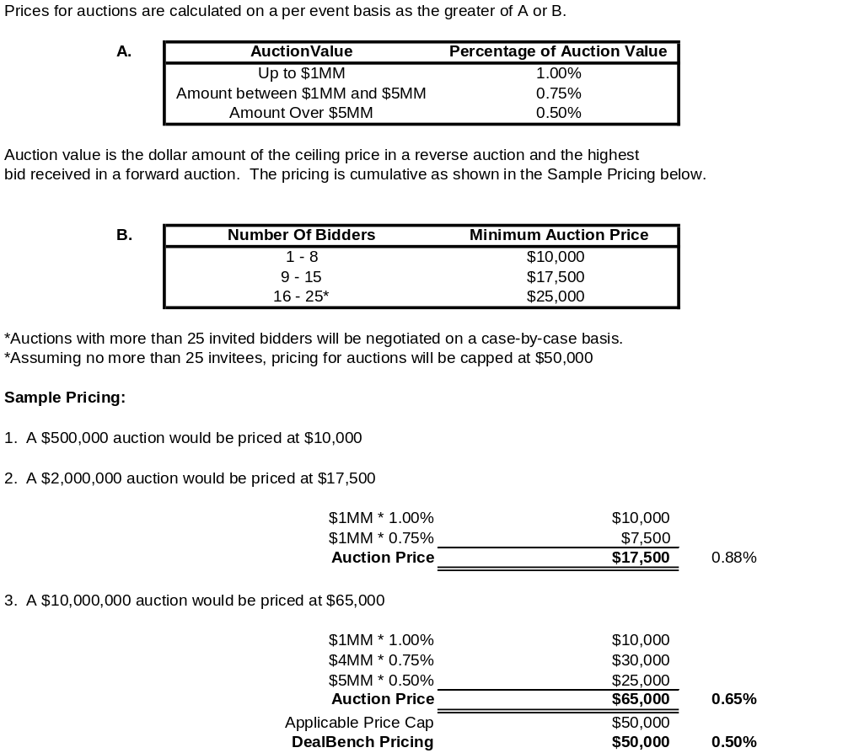
Figure 10 – DealBench Online Auctions Pricing Matrix

7. Revenue Model

The following table provides a breakdown of revenue projects. Principals incorporated into the revenue model include:
- Conservative and justifiable estimates of transactions on which DealBench applications would be likely improve deal efficiency
- Estimation of likely market share backed by thorough competitive analysis (see Section 9: Analysis of Competition)
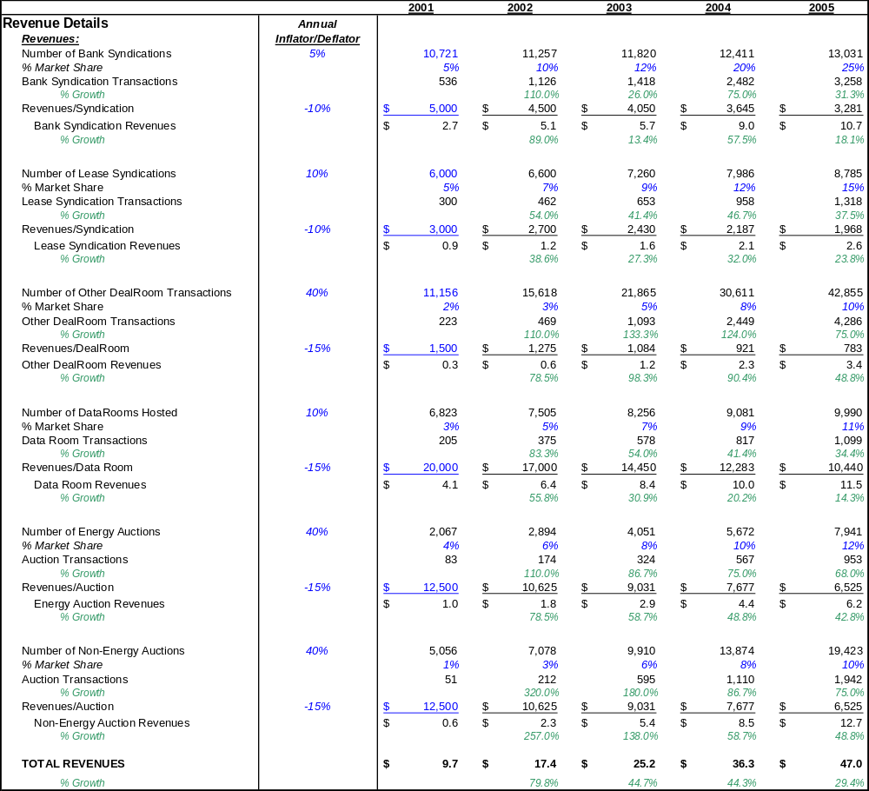
- Initial pricing based on average expected revenues per transaction based on substantial marketing efforts within each respective business. Model incorporates declining pricing power, as increased competition from platforms and alternative technologies emerge and force price reductions to maintain market share.

Even with declining pricing power and conservative assumptions on market penetration rates, DealBench expects to increase total revenues over the next 4 years from almost $10 million in 2001 to $50 million in 2004, implying average annual growth of almost 50% per year.

8. Marketing Strategy

8.1. Overview

Marketing plan
DealBench will use a three-layered marketing strategy:
- Initially, direct marketing to select “beta-test” customers, ensure acceptance and create a channel for input into product development
- Alliances with a variety of users and online hubs catering to groups of users
- Indirect marketing through mass-mailings, shows, conferences and advertisements in business and focused journals

Target customer groups
The potential customer base is a broad range of businesses globally, who collaborate and negotiate in the course of their business. It also includes governments, agencies and other enterprises that extensively collaborate on projects. The potential customer base includes both large businesses and entities and the mid to small size players. One of the primary choices of our marketing strategy is to segment this market and address it in order of
- Lucrativeness of the customer base – larger customers may pay more and derive more value from efficiencies and time saved
- Our competitive advantage in marketing to them – arising from Enrons’ native business space, our relationships and our spheres of influence

Based on these criteria we have chosen to market our products to banks, investment banks, law firms, utilities, IPPs, pipelines and chemical companies. As we build more alliances we will look at other target markets.

8.2. Direct Marketing
The direct marketing organization would be setup into three product groups
- DealRoooms
- DataRooms
- Auctions

In the beginning it is expected that each product group will be staffed with two to three professionals that have strong relationships with specific clients in the target customer groups. Objectives of the direct-marketing team during the first 12 months will include:
- Signing up first 10 sizeable customers for each product group
- Create product awareness and buzz
- Open channels of market intelligence – functionality/features upgrade ideas, pricing strategy (what will the market pay?) and competitive analysis

Although direct marketing is a rather expensive method by which to acquire customers, it is effective for OEM customers and also allows DealBench to build presence and understanding of customer needs. This would entail DealBench marketing professionals visiting the major clients at their premises, demonstrating the product, soliciting feedback and following up to close the business. The sales cycle could be typically 3 – 6 months and would include trial licenses where the client uses the system without any charges for a few deals.

8.3. Strategic Marketing Alliances
This is the second level of attack within a few months after the direct marketing is initiated. One alliance group of two professionals tackles all three segments. This involves writing deals with large strategic customers and other customer groups, online hubs and portals. The most important of these is the captive deal with another Enron entity EnronOnline where we provide collaboration and auction services exclusively to their 2000 strong trading clientele. EnronOnline is the largest eCommerce site in the world. It is THE site for all natural gas and electricity trading and we hope to use this to get a head start in marketing to utilities and energy producers. The alliance would involve DealBench having numerous links on EnronOnline and a page which provides information and advertises current related deals on DealBench.
In return DealBench will develop and manage the auction-site for ENRONONLINE (for deals where Enron acts as the principal).

We expect to sign 10 or more other alliances in the first year. The target alliance partners are potentially large users of DealBench services, portals that aggregate smaller users of these services and proprietary sites (like EnronOnline) which want to offer value added services to customers. On some alliances we might offer some form of revenue sharing for the site that through which customer are acquired. However, we expect to avoid alliances with dot-coms and weaker companies that have less potential for long-term survival. The target alliance partner should be strong, profit making company which would want to work with us to provide a speedy and inexpensive solution for their users or customers. We do, however expect to work with industry groups (like Pantellos or Envera) because we think they offer a door into the member companies.

8.4. Indirect Marketing Alliances
This is the third and final piece of our marketing plan to acquire mid-size to smaller customers and penetrate our target markets deeply. We also expect significant spill-over into new markets using indirect marketing. We expect to send mails (emails and post-mails) to large target groups, we expect to mail freebies to high probability customer groups. We expect cold-calls into target groups and finally advertise in focused business journals to increase awareness, adoption and usage. The indirect marketing group would be staffed by two or three professionals who would run these programs in conjunction with the direct marketing force and the business alliance developers.

9. Analysis of The Competition

9.1. Overview
Competition for DealBench can be generally categorized into the following three areas:

- Software Solutions
- Indigenous Efforts (including development by system integrators)
- Competing Hosted ASP Solutions
- Marketplaces (Pantellos)
- Collaboration & Transaction sites (IntraLinks)
- Bundled collaboration & transaction sites (FreeMarkets)

9.2. Software Solutions
Several competitors offer to provide packaged software solutions that run on a licensee’s servers. Documentum, Filenet, Livelinks and iManage all offer solutions that enable licensees to internally host document management systems. Such solutions offer enable licensees to efficiently organize and host documents that can be viewed using a simple browser and internet connection. Ariba, Moai and Oracle all offer solutions that enable licensees to conduct auction services. Licensees that DealBench expects to pursue will understandably look to internal solutions to fulfill some/all of their transaction needs.

However, such solutions require licensees to invest in upfront implementation and licensing fees, annual maintenance fees and (occasionally) transaction-based fees. Total costs can reach several $ million for large users. Maintenance and associated training and support costs alone can distract from core competencies and require significant financial backing. For most potential licensees, the a hosted ASP solution will provide a more timely and cost-effective alternative. With the possible exception of the most technologically sophisticated users, most clients will not choose to implement proprietary, hosted solutions. In Section 5.0 (Replication Costs), a detailed analysis is provided on how a typical auction facility can cost clients over $1 million or more.

Moreover, medium- and smaller-sized firms do not have access to robust hosted software solutions. For example a law firm with 50 attorneys will find our service a far less riskier option.

We profile Ariba and CommerceOne, the two heavy-weights in eCommerce software.

Ariba, Inc.
- Originally a provider of procurement software for large corporations
- Expanding breadth of its technology and developing value added services
- Additions often come via acquisition
- Acquired TRADEX Technologies, Inc. and TradingDynamics to provide more software tools, including auctions, for corporate clients and e-marketplaces
- Will acquire SupplierMarket.com in 3Q2000 for 6.3 million shares of stock (~ $580 million)
- SupplierMarket.com provides online marketplace for manufactured direct materials, including bolts, nuts, fasteners, rubber and glass products, corrugated packaging, and injection and blow-molded plastic components. The company targets the lower end of the customer parts and assemblies market, with a self-service RFQ marketplace for low-engineered custom parts and assemblies

Commerce One, Inc.
- Primarily a provider of software systems for e-commerce
- Has also developed an extensive suite of tools and related services for its customers
- Leveraged its strength in the procurement of indirect goods and now offers software and services for direct materials procurement through its MarketSite portal.
- Through its CommerceBid.com acquisition, has developed a wide variety of auction technologies and services that can be hosted on portals such as its own MarketSite or on private branded websites
- CommerceBid services include forward auction, request for quote (RFQ), reverse auction, and exchange mechanisms

IManage
- Company provides e-business content and collaboration management software.
- Company positions its product as addressing key aspects of managing, organizing and delivering information and content to the right person at the right time
- Product also boasts effective content access, delivery and notification based on relevance to particular projects, processes and individuals.
- Originally targeted towards legal teams the company currently targets the product to financial services, retail, manufacturing and distribution, banking and professional services
- IManage is publicly traded with a market cap of $80MM

Livelink
- Solution provided by Open Text Corporation (marketing cap. = $0.5 billion)
- Intranet and extranet collaborative platform that allows users to work concurrently and have a virtual hard drive accessible.
- Does not allow internet collaboration and not designed for “one off” collaborations (as in a transaction). Rather, Livelink has been designed as a repository for long term collaboration via a companies’ extranet.

9.3. Indigenous Efforts

There are a number of clients who will develop their own solutions using simpler technologies. These solutions might be limited in their scope but might be inexpensive to put together. In our view these efforts are going to be most expensive on the long run and will be harder to justify in face of our pricing strategy. We have found number of clients mulling over such solutions but find it hard that these solutions would be really implemented.

9.4. Competing Hosted ASP Solutions

Marketplaces
These are numerous sites, in each industry, which offer to disintermediate current brokers by bundling collaboration, transaction and brokerage services or the network effect. The idea being, everyone will come directly to these sites to conduct business and the marketplaces will charge a hefty fee for the same. These marketplaces are typically focused narrowly in specific industries.
The marketplace model has been under serious attack because it is considered as competition by all current players and as such is ostracized by them. Many of these firms have gone under and many others are struggling for lack of liquidity.

In the table below, several eMarkeplaces in the leasing space are profiled, along with information that describes their primary business focus.

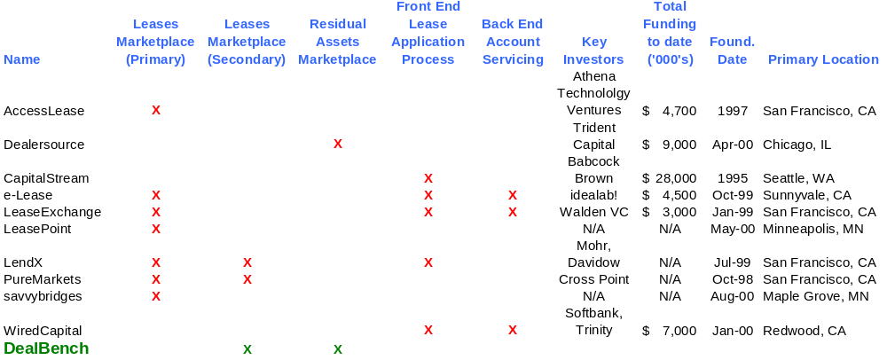
Figure 11 – Competitor Analysis for DealBench’s Lease Syndication platform

LendX
- Formed in 1999 with VC financing from Mohr, Davidow Venture Partners, New Enterprise Associates Venture Partners, Angel Investors, L.P.
- Initial LendX focus was on the primary origination of equipment lease finance transactions.
- In June 2000, entered into strategic relationship with The Leasing Exchange, a 30-member organization that serves as a “marketplace” for large-ticket leasing transactions. LendX will attempt to technology-enable The Leasing Exchange by providing a secondary syndication platform over which leasing companies sell individual leases or portfolios thereof.
- In October 2000, launched a secondary lease syndication platform over which companies can place their individual leases or portfolios online for sale to other lease finance entities. Fees for such services range from 20-30 bps depending on the size of the transaction.

Strengths:
- New business. In theory attractive both to lessors and lessees by bringing new business and providing wide range of quotes.
- Ease of use. Sites are usually easy to use and understand.
- Neutrality. Usually a neutral site controlled by neither lessor nor lessee.
Weaknesses:
- Critical mass. Lessors will only be interested if there are large number of lessees actively posting transactions, while lessees will be attracted to an eMarketplace which has large number of lessors subscribed to it.
- Adverse Selection. In practice sites usually attract lessees who require lenders of last resort. According a recent study conducted by KPMG Consulting and our conversations with lessors, most of the lessees who go to an eMarketplace with the intention of actually transacting, do so because they have very limited borrowing alternatives. Lessors of superior credit quality, on the other hand, are understood to go to an eMarketplaces only for its price discovery services, rather than with the intent of actually closing a transaction online.
- Internet fear. In certain cases, lessors fear an onslaught from an internet revolution and are unwilling to aid websites that extract value and control from their clients at their own expense.
- Broker Intermediation. Lessors are wary of utilizing an “intermediary” website/broker. Lessors are willing to use a broker only when it is perceived that they bring substantial value to the table: such as sourcing a very large deal or structuring a very complex transaction.
- Very easy to replicate by others. It is very easy to form an eMarketplace, all that is needed is a working software and the ability to convince lessors to sign up for its services.

Collaboration & Transaction sites
Several start-up competitors have collaboration tools that are included on their respective platforms. However, most of these companies are not backed by differentiated technology and/or substantial capital resources. However, a few of these competitors are thriving, notably in the emerging P2P (peer-to-peer) space.

In the DataRoom space, numerous competitors offer limited document hosting services. However, few offer the DealBench combination of robust security features and full platform solution that enhances the user experience. The table below summarizes DealBench’s features relative to those of certain of its competitors. Further information on IntraLinks and RecordCenter.com is also provided in the subsequent paragraphs.

Figure 12 – Competitor Analysis for DealBench’s online dataroom platform
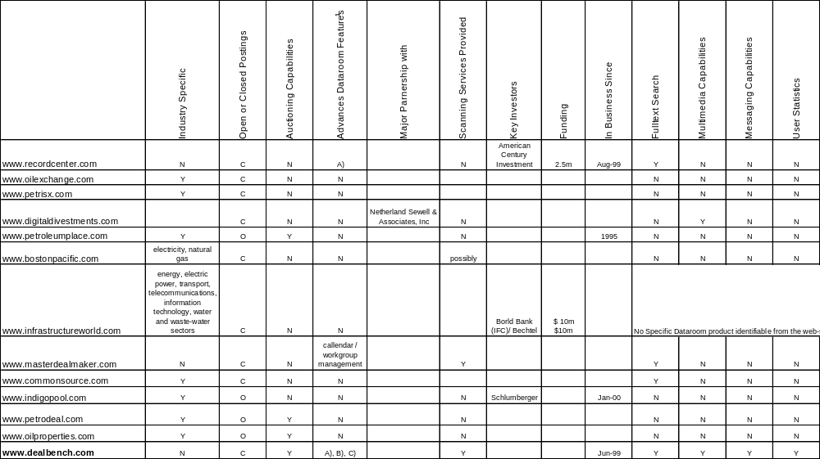

IntraLinks
Although IntraLinks has become the most widely used internet platform, its technology platform has several drawback including: i)lack of two-way communication - deal participants cannot indicate interest in participating in the transaction, ii)lack of multi-media capabilities – although IntraLinks expects to incorporate multi-media capabilities during mid-2001.

- Founded in June 1996, Intralinks provides online platform for easier collaboration and messaging over the Internet among business entities during complex transactions.
- During 1999, 694 transactions conducted over IntraLinks with 1,700 organizations and over 24,000 individual registered users have used their services. High profile customers included Chase, JP Morgan, Citigroup, GE Capital and Bank of America. During 1999, 22 of the top 25 syndicated lenders (ranked by LPC) used Intralinks to facilitate their transactions
- Products include: IntraLinks ASAP, IntraLinks for the Loan Syndication Market, IntraLinks DealSpace for Corporate Finance, IntraLinks DealSpace Acquisition Trustee, IntraLinks for the Legal Community, IntraLinks DataRoom, IntraLinks for the General Business Community and IntraLinks PharmaSpace.
- Platform based on Lotus Domino and Lotus Notes. Lotus Domino provides access to Lotus Notes over the Internet, while Lotus Notes provides the document repository function. Conversion to new Unix/Oracle database platform is expected during 2H 2000.
- Have used Cintra and other consulting firms for platform design/programming
- Funding sources: private placements of equity securities ($66.9 million to date from inception) , bridge loans ($600,000+ 2,000,000) and exercise of warrants ($500,000). Chase owns approx. 17%, VC firms own approx.

RecordsCenter.com
- A document and information management services company for legal, corporate and investment banking.
- ASP solution started as a virtual clearinghouse and library for legal documentation and it evolved into a document sharing and versioning, virtual calendar, virtual minutes and virtual data room for transactions.
- The company presents value added by allowing private branding and claiming easy integration with customer's system.
- Company founders include two former corporate mergers and acquisitions lawyers and the former MIS Director of a major international law firm. Institutional investors include C3 Holdings and American Century Funds

Bundled Transaction & Collaboration sites (FreeMarkets)
There are a number of firms that have bundled transaction and collaboration services with other sourcing consulting services and have positioned themselves as experts. We believe their current pricing and penetration model is unsustainable for the long run.

FreeMarkets, Inc.
- Organizes and conducts real-time interactive competitive bidding events for buyers of industrial parts, raw materials, commodities, and services
- Considered industry leader in B2B online auctions
- Average customer savings approximates 15%
- Charges a % of auction fee (typically 1%) and a % of savings fees
- Conducted 1,690 auctions in 3Q2000, representing approximately $2.9 billion in auction volume
- Has conducted over 6,000 auctions representing $10 billion in volume since inception in 1995
- Reports 84 customers
- Recently expanded into auction services for surplus assets and inventory
- Expanding internationally with offices in Brussels, London, Singapore, Hong Kong and New Delhi

eBreviate
- Leading competitor to FreeMarkets
- Owned by EDS/AT Kearney but established as a stand-alone business unit in April 2000
- During first year of operation, conducted 50 auctions with volume of $2 billion for over 30 clients
- Sells software on a license basis or a per event fee, typically in mid-five figure range
- Auction sizes range from $1MM to $320MM
- Offers a patent pending “total cost functionality” that helps clients value non-price attributes such as incumbency, quality, delivery time, and customer service.
- Recently added forward (upwards) auctions and electronic RFPs
- Primarily offers a product rather than a consulting service
- Will be able to gain significant leverage from EDS and AT Kearney

ICG Commerce
- One of the most directly comparable companies to FreeMarkets
- Private company backed by Internet Capital Group, Inc. and other strategic investors
- Offers a broad array of online procurement services
- Specific services include spot buys, aggregated buys, forward/reverse auctions, e-catalogs, eRFQs/eRFPs and exchanges
- Like FreeMarkets, no upfront software or license fees for customers
- Emphasis on providing procurement services, almost on an outsourcing basis, is a key distinguishing factor of the business model

Conclusion
DealBench intends to leverage its existing, deep business relationships to quickly overcome the status quo and early competition and to eventually seek strategic partners to ensure that DealBench technology remains the superior deal collaboration tool in the future. During the near-term, DealBench will seek to overcome status quo, as individuals with insufficient technology background learn more efficient ways of conducting business. In several years, however, new technologies may arise as legitimate threats. However, a combination of cutting-edge technology with customized solutions should enable DealBench to gain and maintain a leadership position within the space.

10. Competitive Advantages & Barriers to Entry

Competitive Advantages:
DealBench enjoys significant competitive advantages with respect to our competition.
- Enron as beta client – Enron entities represent excellent beta test clients for each of DealBench’s platforms. Enron culture of innovation encourages each group to embrace new technologies. DealBench applications represent the collective collaboration between several of Enron’s most innovative teams of professionals that have agreed to beta test products and provide strong client feedback. Specifically, DealBench has received considerable input from Enron’s global strategic sourcing (procurement) group, Enron Global Finance, Enron Insurance and many other Enron Asset groups that have used DealBench to host online M&A datarooms. Going forward, Enron represents a core client, that at fair market prices is expected to provide over $1 million/year of revenues.
DealBench’s online auction business will realize a significant “head-start” in its marketing efforts by leveraging an agreement with EnronOnline. Specifically, DealBench will manage all EnronOnline auctions conducted on behalf of its customer base. EnronOnline is the world’s largest eCommerce site, executing over 5,000 trades a day and over $300 billion in notional volume during 2000. A DealBench server on the ENRONONLINE site will handle all RFQ deals and auctions of commodity products for 5,000 ENRONONLINE clients in the energy business (i.e., energy independents, utilities, and generation companies).

- Ability to attract and retain Technology talent – DealBench derives its technology expertise from the same group of experts who have built EnronOnline and other significant B2B technology applications. Unlike our VC-backed startup competitors who use third party support during development, DealBench has the advantage of being designed from inception on a scalable architecture with reliable and redundant systems architecture. This also provides us with an ability to attract and retain the best and brightest IT professionals who are not typically available to start ups.
- Deal-Making at the core – DealBench has been built by deal professionals for deal professionals. Each of the DealBench Founders and members of its core business development team are professionals with strong backgrounds in successfully completing large-ticket transactions and that understand where technology can be used to improve execution efficiency. One recent beta test client offered the following assessment: “Working with DealBench, you know they understand your needs and the way transactions get done. They get it”. DealBench’s business development team ensures that the final product adds substantial value to licensees of the respective deal platforms.
- Relationships and leverage – As 100% owner of the DealBench platform, Enron helps open doors with prospective OEM clients. Further, Enron maintains strong, historical business relationships with numerous potential clients. These relationships have led to beta-test agreements with several high-volume potential licensees. Discussions are currently underway with a number of these licensees to expand such relationships to include strategic business partnerships.
- Access to capital – DealBench upper management has spent much less time and focus raising operating capital than many of its competitors. Rather, time has been spent to create technology, craft strategy, understand customer needs and execute the business plan. Employee focus has been focused solely on client needs, customers acquisition/penetration and NOT on short-term stock price fluctuation or proximity to an IPO.

Barriers to Entry:
The key to long term success is to build barriers to entry or large switching costs for our clients. Contractual switching is hard to implement because this is an innovative service and few client can be convinced to be locked-in to it for a period of time. Hence we have to create these barriers in other innovative ways.
- System training – The more the clients professionals learn our system, the more broadly it is used the more difficult it becomes to switch. Hence DealBench pricing is time-period based for unlimited use. This allows our clients to justify hosting smaller deals and spend more time on the DealBench platform.
- Custom development – As we are evolving our system, we endeavor to build client specific preferences in our system which encourages system loyalty. Our system allows clients to have one password for all deals with the dual-security system which is superior to other alternatives.
- Maintenance hosting – We encourage clients to maintain deals on our systems, once the active phase is over. Therefore, once a significant number of deals are being maintained on the system, switching to another system may prove difficult/costly for clients.
- Strategic alliances – By bundling our services with other large B2B eCommerce platforms, we hope to make it extremely cost efficient for the end client to use our services.

Majority of our competition is software, that can be implemented by a firm. The current trend is towards increasing out-sourcing of services, because of the high costs of attracting and retaining talented IT professionals who can maintain these software implementations and also keep up with new technology. Also the degree of innovation also makes it preferable to stay flexible rather than lock yourself into one technology or one vendor.

This gives us as a hosted service some significant advantages. We may also introduce enterprise level hosted service, especially for the auction & RFQ clients so that the larger OEM clients have dedicated service.

11. Strategic Alliances (Investors & Partners)

11.1. Platform Ownership
In the near term, 100% Enron ownership provides a number of meaningful benefits. Such benefits include: i) certainty of capital funding (little time spent on fundraising activities), ii) full support of Enron “network” of professionals (legal, accounting, business analysis, marketing, graphics, etc.), iii) information flow between DealBench and other Enron Net Works eCommerce initiatives and iv) rapid customer acquisitions by leveraging Enron’s existing business relationships.

Long-term, outside ownership of the DealBench platform will become increasing attractive to increase the success rate of marketing efforts by presenting the platform as a Neutral site upon which business can be transacted and providing a more logical permanent ownership story. Neutrality during the marketing process might enable DealBench to capture a larger share of certain markets, as licensing decisions are not adversely affected by relationships between potential customers and Enron (or any other owner that is not perceived as neutral).

11.2. Description of Ideal Partner
Certain characteristics will become important as DealBench seeks a long-term strategic partner. Such characteristics include: i) perceived neutrality, ii) long-term ownership certainty (do equity holders of partner better match the DealBench business plan?), iii) marketing expertise (can you continue to increase market share in certain niche areas by realizing synergies of marketing multiple products to the same audience) and iv) platform familiarity (have I already used the platform?).

12. Financial Projections

12.1. Income Statement
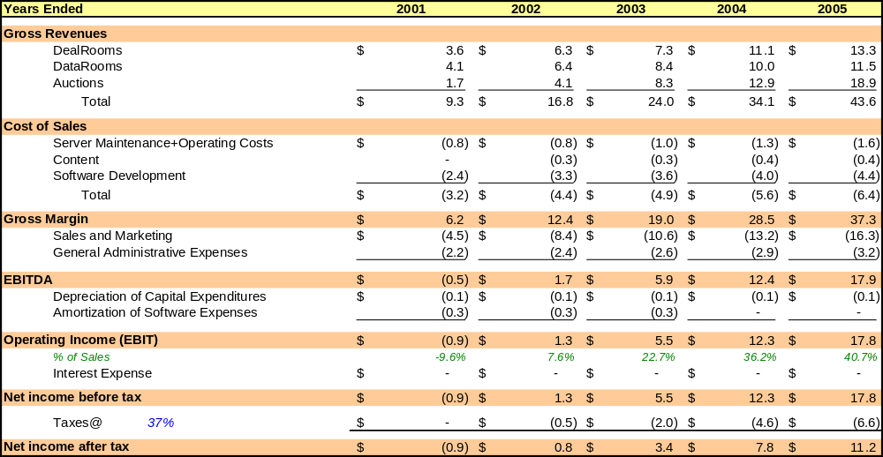
The following table summarizes the projected income statement based on assumptions contained within the DealBench Business Plan. Net Income is projected to increase from ($0.9) million to over $11 million during 2005.

12.2. Balance Sheet
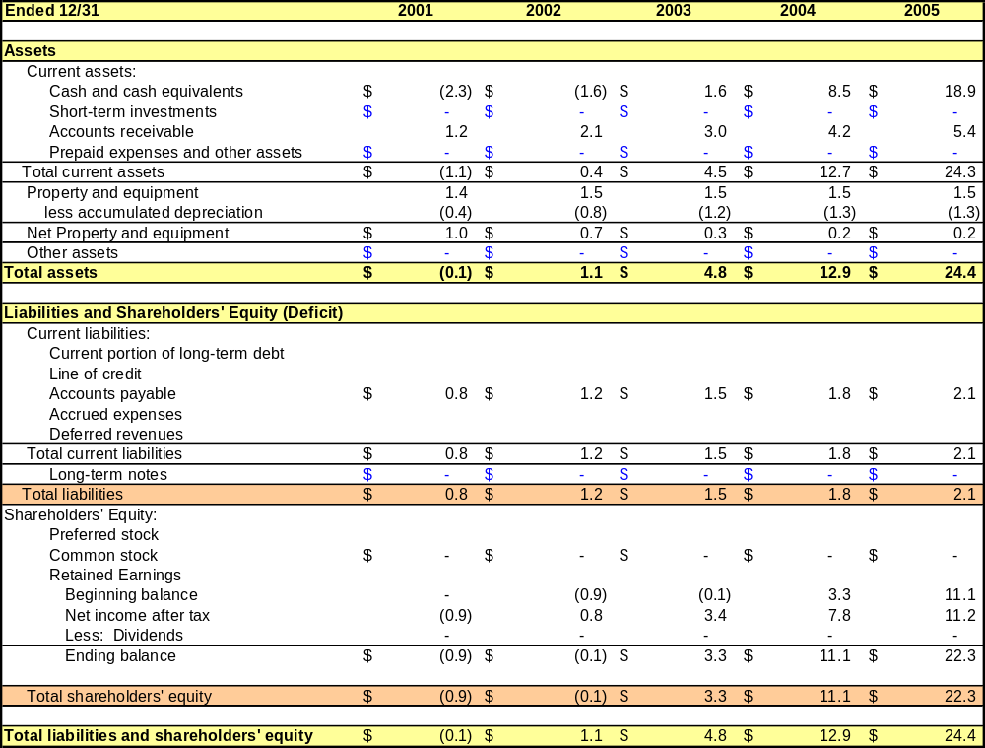
The following table summarizes the projected DealBench balance sheet based on assumptions contained within the Business Plan. Total shareholder equity is expected to grow from ($0.9) million at year-end 2001 to over $22 million at year-end 2005.

12.3. Statement of Cash Flows
The following table summarizes the projected DealBench statement of cash flows based on assumptions contained within the Business Plan. Operating cash flow is projected in increase from ($0.9) million during 2001 to over $10 million during 2005.
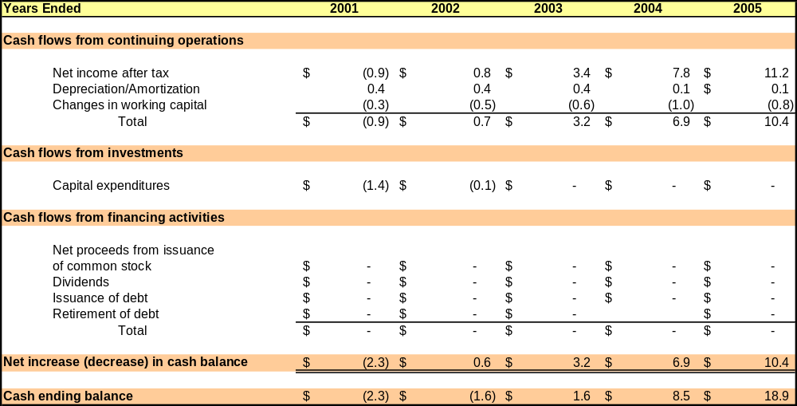

13. Management Team

13.1. Harry Arora, Chief Operating Officer
Mr. Arora has more than 8 years of experience in technology, trading and eCommerce. Prior to founding DealBench he was Vice President of financial trading with Enron where he was responsible for a team of eight traders, managing all fixed income and currency risk for the firm. Prior to his position with Enron he worked the automation group of Siemens. Mr. Arora holds a BS in electrical engineering from Delhi University and a MBA from University of Texas.

13.2. Jeff Bartlett, Director of Business Development
Mr. Bartlett has more than 9 years of experience in engineering, investment banking, private equity and corporate business development. Prior to his position with Enron Net Works, he was a Director with Enron North America’s Corporate Development Group and a Manager with Enron North America’s Merchant Finance Group. Prior to his positions with Enron, he was with the energy investment banking group of Merrill Lynch & Co. Mr. Bartlett holds a BS in Petroleum Engineering from University of Kansas and a MBA in Finance from the University of Texas at Austin.

13.3. Suresh Raghavan, Director of Technology AND Operations
Mr. Raghavan has over 11 years of experience in money management, insurance and information systems. Prior to his position with Enron Net Works, he was a Partner with Smith Graham & Co., a regional money management firm. Previously, he managed the North American book for CIGNA Investment Management International and served as a fixed income analyst for Schroder Capital Management. Mr. Raghavan holds a B.Com from Madras University and a MBA in Finance & Systems from Syracuse University and is a Chartered Financial Analyst.

13.4. Don Herrick, Director of MARKETING For Bank Syndications
Mr. Herrick has over 16 years of experience in the banking industry. Prior to his position with Enron Net Works, he was a Director with Enron Global Finance responsible for numerous banking relationships. Previously, he was a Director with Credit Suisse First Boston. Mr. Herrick holds a degree from University of St. Thomas and a MBA from Southern Methodist University.

14. Appendices

14.1. Projected Time Line
[To come = Insert graphic that shows 2 year forecast of key deliverables – launches of future technologies and other information.]

14.2. Historical Information
History
DealBench was originally organized in April 2000 with the business objective of syndicating certain Enron debt products to bank and institutional investors. The platform was first used in May 2000 to syndicate Enron’s $3.0 billion corporate revolver to over 80 financial institutions around the world. Following completion of the bank syndication transaction, the strategic scope of DealBench was expanded to address commercial transactions in an additional area within the DealRoom domain (Lease Syndications) and within two additional domains: DataRooms (M&A transactions) and Auctions (Energy Auctions and non-Energy Auctions).

DealBench was then used in July 2000 to sell Enron’s (and related parties’) $240mm interest in the Seneca Leasing Partners portfolio. The portfolio consisted of single-investor and leveraged-leases for certain airline, marine, rail and light-manufacturing assets. During the sale process, DealBench enabled deal managers to efficiently gauge the interest of over 140 institutions, invite over 60 institutions to view all transaction materials and receive indications of interest in one or more of the 15 portfolios from over 20 institutions. The platform enabled the deal manager to more efficiently disseminate deal materials (through DealLine and FAQ Updates), displayed audio/video presentations (of unique assets such as an Industrial Manufacturing Facility and a “roadshow” presentation of the transaction by Seneca’s partners)

In August 2000, DealBench was customized to enable the hosting of online auctions. Since that time, DealBench has been used several times as the platform over which more than $30mm of materials have been procured using live online reverse auctions.

Source: The State of the Industry Report, written for the Equipment Leasing Association (ELA) by the Financial Institutions Consulting, Inc. dated October 2000.
A Dutch auction is structured so that the auctioneer sets a price and then periodically lowers/raises the price for a good or service that it is selling/buying.
$720 billion is the addition of the lead arranged bank syndications by the top 10 banks in the United States. The source is the Loan Pricing Corporation League table for bank syndications in the United States for 1-3Q 2000.
Source: Forrester Research, Inc. report dated May 2000.
$1.7 trillion estimated by eBreviate on research paper posted on its website (http://ebreviate.com/esourcingcentral/research-papers-downward.html); $2.3 trillion estimate by Lehman Brothers in a equity research report on FreeMarkets, Inc. dated 6/20/2000.
$54B estimated by eBreviate; $69B estimated by DealBench based on Lehman Brothers report and FreeMarkets current customer penetration rate of total spend at 3%
DealBench estimate for 2001 based on eBreviate reserach
DealBench estimate based on 1% average fee charged by FreeMarkets, Inc.
eBreviate estimate
DealBench estimate based upon eBreviate research
Net Readiness of the Equipment Leasing and Finance Industry (B2B Report 2000)
Fortune magazine has named Enron the most innovative company in the United States for each of the past five years (1996 through 2000).

